New Hire Setup

Prior to using the new **New Hire Setup** process, there are a couple of things you’ll need to do.

**(NOTE: These next 6 steps only need to be done the first time you run the New Hire Script.)**

1. Install Quest ActiveRoles Management Shell for AD 64-bit from [here](http://www.quest.com/powershell/activeroles-server.aspx).
2. Install ActiveState ActivePython for 64-bit [here](http://www.activestate.com/activepython).
3. Copy the **New Hire** script folder from (T:\IT\IT Scripts) and save it to the root folder that your powershell opens in.  
   (ex. for me, it is C:\users\miovino)
4. Download the Google-Apps-Manager zip file [here](http://code.google.com/p/google-apps-manager/downloads/detail?name=gam-2.55-windows-x64.zip&can=2&q=) and then extract the files to C:\
   1. (this will create the folder c:\GAM with the files inside)
5. Open a command prompt and enter the following:
   1. cd c:\gam
   2. gam info domain tradingtechnologies.com

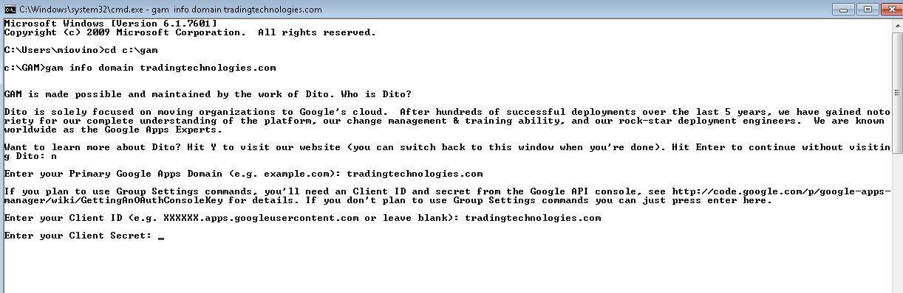

* 1. It will ask you if you want to learn more about Dito, hit n, and enter
  2. Client ID: tradingtechnologies.com
  3. To get a Client Secret, go to the Google Admin Control Panel under your google sign-in (go/apps)
     1. Adavanced Tools -> Authentication -> Manage OAuth domain key
     2. Enter the OAuth consumer secret for Client Secret, and then select yes to save for future use.
     3. The next screen will ask which permissions you’d like to allow. Leave all selected and hit 16 to continue.
     4. You will then be prompted to launch a browser to grant permissions to the various APIs. Please do so and grant permissions for all of these and then continue in the powershell window.

**New Hire Setup Process**

1. Open the New Hire spreadsheet from the new hire ticket.
2. Skim through the entire spreadsheet to make sure the appropriate fields are populated correctly.
   1. (If you go to page 3 of the workbook, you will see the information displayed in the top two lines)
3. Use the employee name in line 63 and plug into intellipages to get their extension and type it below to use later.

(we will use this to mirror their station for phone setup. In our example, since the employee to mirror is sspencer, the extension to mirror would be 6371.)

Extension to mirror: ____

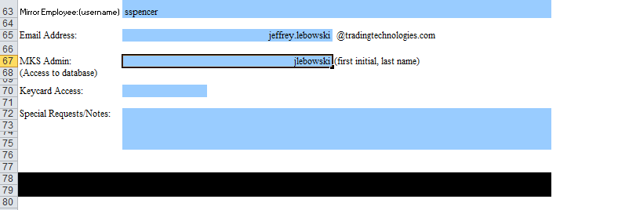

1. Save the New Hire spreadsheet as newhire.xlsx in the root folder that your powershell opens in.

(ex. For me, it is c:\users\miovino)

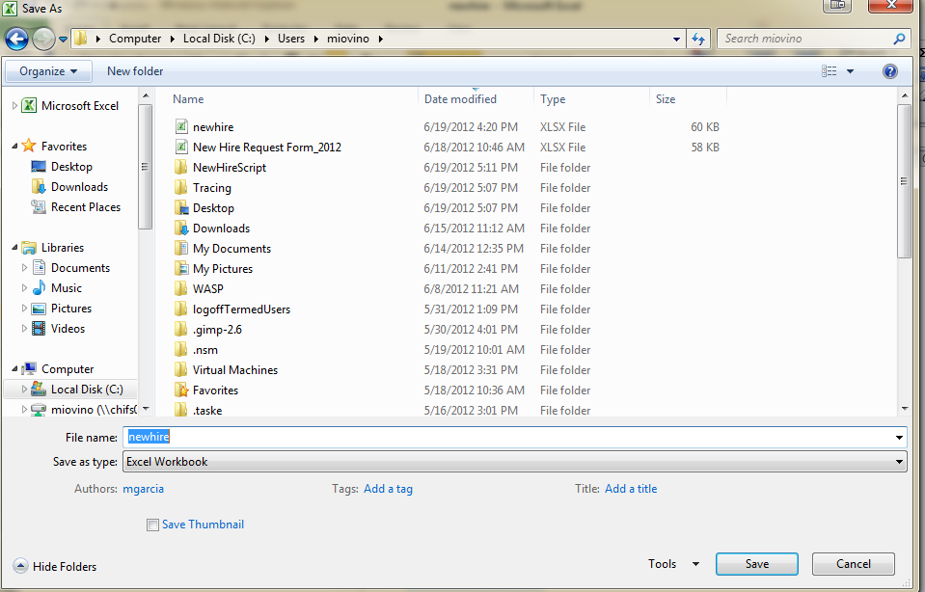

1. Open Powershell and run NewHireSetup.ps1.
2. This will launch a Avaya Site Admin for creating the users extension
   1. Start GEDI
   2. **Command:** duplicate station **xxxx** start **yyyy**
      1. **xxxx** will be the extension you found in step 3.
      2. **yyyy** is determined by the location:  
         *Chicago:* **1011 or 6350** (range 1011-1199, 6350-6599)  
          **(2500,6001,1600, or 4618)** *New York:* **5300** *Geneva:* **3426** *Houston:***2019** *London:***8100** *Tokyo:***8300** *Singapore/Hong Kong:***7000** *Sydney:***1700**

1. Hit enter, then type in the new hires name, and 1234 for the security code, then press the enter (or F3).

(This should produce a “Command successfully completed” message. You can now close the the window)

1. Return to the powershell screen and enter the 4 digit extension you just created.

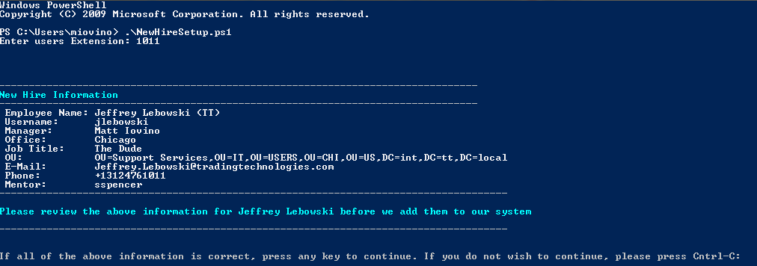

1. Once you have verified that all of the information looks correct, press any key to begin the creation process.
2. Follow the steps in the script to complete the New Hire Setup.
3. When the script runs successfully you will see something similar to the screenshot below.

