

**A REPORT ON**

**WORKSHOP ON ENTREPRENEURSHIP AND INNOVATION AS CAREER OPPORTUNITY**

**NAME OF ACTIVITY:** workshop on entrepreneurship and innovation as career opportunity

**DATE & DURATION:** 2025-02-18 & 11:23 AM - 12:24 AM

**TYPE OF ACTIVITY:** workshop on entrepreneurship

**SPONSORS & SUPPORTERS:** Poornima College of Engineering, Jaipur

**ORGANIZER(S):** Poornima Incubation and Innovation Cell (PIIC)

**ACTIVITY OBJECTIVE:** sdfdyfugihj

**PROGRAM OUTCOME:** dfhk

**FLYER / POSTER/BROCHURE:**

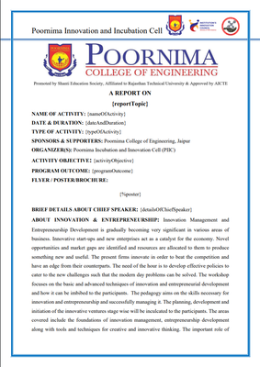

**BRIEF DETAILS ABOUT CHIEF SPEAKER:** ertryuihgsfghgj

**ABOUT INNOVATION & ENTREPRENEURSHIP:** Innovation Management and Entrepreneurship Development is gradually becoming very significant in various areas of business. Innovative start-ups and new enterprises act as a catalyst for the economy. Novel opportunities and market gaps are identified and resources are allocated to them to produce something new and useful. The present firms innovate in order to beat the competition and have an edge from their counterparts. The need of the hour is to develop effective policies to cater to the new challenges such that the modern day problems can be solved. The workshop focuses on the basic and advanced techniques of innovation and entrepreneurial development and how it can be imbibed to the participants. The pedagogy aims on the skills necessary for innovation and entrepreneurship and successfully managing it. The planning, development and initiation of the innovative ventures stage wise will be inculcated to the participants. The areas covered include the foundations of innovation management, entrepreneurship development along with tools and techniques for creative and innovative thinking. The important role of intellectual property along with the types will be discussed. The development of business models along with the budget and finance issues will be taken up by the experts. Besides, researches in these areas will also be part of the discussion. Lot of examples were produced related to innovation and entrepreneurship and tells lot of stories of successful businessman who were innovators.

**ABSTRACT/BRIEF DETAIL OF THE ACTIVITY:**  fyjguuhjgkbj

Following were the key learning objectives of this program.

1. **Understanding Entrepreneurship**
2. **Identifying Opportunities**

**Conclusion:** undefined

**GLIMPSES:**

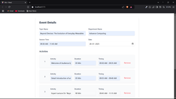

**ATTENDANCE SHEET:**

