Experiment-2

Study of Network Device in Detail

1. **REPEATER**

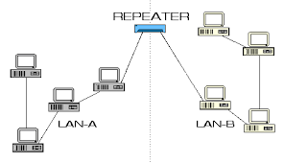

In digital communication systems, a repeater is a device that receives a digital signal on an electromagnetic or optical transmission medium and regenerates the signal along the next leg of the medium. In electromagnetic media, repeaters overcome the attenuation caused by free-space electromagnetic-field divergence or cable loss. A series of repeaters make possible the extension of a signal over a distance.

1. **SWITCHES**

In the traditional circuit-switched telephone network, one or more switches are used to set up a dedicated though temporary connection or circuit for an exchange between two or more parties. On an Ethernet local area network (LAN), a switch determines from the physical device (Media Access Control or MAC) address in each incoming message frame which output port to forward it to and out of. In a wide area packet-switched network such as the Internet, a switch determines from the IP address in each packet which output port to use for the next part of its trip to the intended destination.

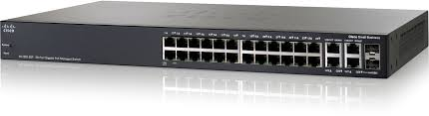

1. **HUB**

A hub is basically a multiport repeater. A hub connects multiple wires coming from different branches, for example, the connector in star topology which connects different stations. Hubs cannot filter data, so data packets are sent to all connected devices. In other words, collision domain of all hosts connected through Hub remains one. Also, they do not have intelligence to find out best path for data packets which leads to inefficiencies and wastage.

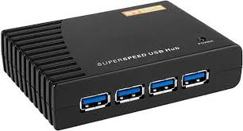

1. **BRIDGE**

A bridge operates at data link layer. A bridge is a repeater, with add on functionality of filtering content by reading the MAC addresses of source and destination. It is also used for interconnecting two LANs working on the same protocol. It has a single input and single output port, thus making it a 2 port device.

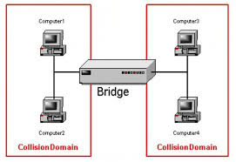

1. **ROUTER**

  A router is a device like a switch that routes data packets based on their IP addresses. Router is mainly a Network Layer device. Routers normally connect LANs and WANs together and have a dynamically updating routing table based on which they make decisions on routing the data packets. Router divide broadcast domains of hosts connected through it.

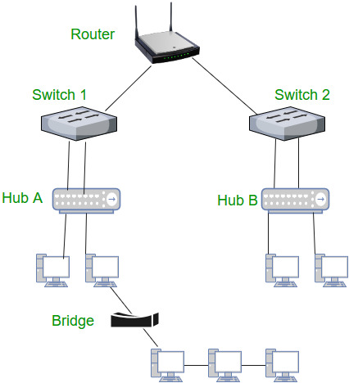

1. **GATEWAY**

A gateway, as the name suggests, is a passage to connect two networks together that may work upon different networking models. They basically works as the messenger agents that take data from one system, interpret it, and transfer it to another system. Gateways are also called protocol converters and can operate at any network layer. Gateways are generally more complex than switch or router.

