A

**Seminar Report**

on

**CRYPTO CURRENCY**

of

**Bachelor of Technology**

in

**Computer Science and Engineering**

**Submitted To-**  **Submitted By-**

Mr.Arvind kumar Vineet Kumar

CSE & IT Deptt. CSE(3rd year-B)  
 (1522910111)



**Department of Computer Science and Engineering**

**Vidya College of Engineering , Meerut**

**Batch 2015-2019**

**A**

**Seminar Report**

on

**CRYPTO CURRENCY**

of

**Bachelor of Technology**

in

**Computer Science and Engineering**

**Signature of Guide : Signature of HOD :**  
Mr.Arvind kumar Dr.Rajendra kumar

Assistant Professor Head of the Department  
CSE & IT Deptt. CSE & IT Deptt.



**Department of Computer Science and Engineering**

**Vidya College of Engineering , Meerut  
 Batch 2015-2019**

**TABLE OF CONTENTS**

**CHAPTERS PAGE NO**.   
   
 **DECLARATION 4**

**ACKNOWLEDGEMENT 5   
  
 ABSTRACT 7**

**CHAPTER 1 : INTRODUCTION 8-9**

**CHAPTER 2 :EVOLUTION OF 3G TECHNOLOGY 10-11**  
**CHAPTER 3 : FEATURES OF 3G TECHNOLOGY 12-14  
  
CHAPTER 4 :BENEFITS OF 3G TECHNOLOGY 15-16  
  
CHAPTER 5 : ADOPTION OF 3G TECHNOLOGY 17  
  
CHAPTER 6 : 3G TECHNOLOGY IN INDIA 18-19  
  
CHAPTER 7 : FUTURE OF 3G TECHNOLOGY 20-21**

**CHAPTER 8 : CONCLUSION 22**

**REFRENCES**

**DECLARATION** I hereby declare that the seminar Report **“CRYPTO CURRENCY”** is

my own work and effort and that it has not been submitted anywhere for any award

. The text embodied in this report has not been submitted to any other University or

Institute for the award of any degree or diploma .  
  
  
  
  
  
  
 **Date :**   **VINEET KUMAR**

**ACKNOWLEDGEMENT**

I give my special thanks to **Mr.Arvind Kumar**, *Asst. prof. CSE/IT* and **Dr. Rajendra Kumar**, *H.O.D CSE/IT* without their guidance this seminar work was not able to complete with success. I am indebted for their continuous help and support.

Other major contributors of useful comments and suggestions include my classmates and my friends. I am thankful to management and administration of Vidya Knowledge Park for providing necessary resources.

Last but not the least I thank my parents and God almighty .

**Vineet Kumar**

**ABSTRACT**

A cryptocurrency (or crypto currency) is a digital asset designed to work as a [medium of exchange](https://en.wikipedia.org/wiki/Medium_of_exchange) that uses [cryptography](https://en.wikipedia.org/wiki/Cryptography) to secure its transactions, to control the creation of additional units, and to verify the transfer of assets.Cryptocurrencies are a type of [digital currencies](https://en.wikipedia.org/wiki/Digital_currency), [alternative currencies](https://en.wikipedia.org/wiki/Alternative_currency) and [virtual currencies](https://en.wikipedia.org/wiki/Virtual_currency). Cryptocurrencies use decentralized control as opposed to centralized [electronic money](https://en.wikipedia.org/wiki/Electronic_money) and [central banking](https://en.wikipedia.org/wiki/Central_bank) systems. The decentralized control of each cryptocurrency works through a [blockchain](https://en.wikipedia.org/wiki/Blockchain), which is a public transaction database, functioning as a distributed [ledger](https://en.wikipedia.org/wiki/Ledger)

Cryptography is the study of information hiding and verification. It includes the protocols, algorithms and strategies to securely and consistently prevent or delay unauthorized access to sensitive information and enable verifiability of every component in a communication

Crypto currencies are created by a software developer called “Satoshi Nakamoto” In 2009 . Since then numerous crypto currencies have been created .Each unit of bit coin is called a satoshi

The blockchain is an incorruptible digital ledger of economic transactions that can be programmed to record not just financial transactions but virtually everything of value

Process mining is a family of techniques in the field of [process management](https://en.wikipedia.org/wiki/Process_management) that support the analysis of [business processes](https://en.wikipedia.org/wiki/Business_process) based on event logs. During process mining, specialized data mining algorithms are applied to event log data in order to identify trends, patterns and details contained in event logs recorded by an information system. Process mining aims to improve process efficiency and understanding of processes. Process mining is also known as Automated Business Process Discovery (ABPD).

**CHAPTER-1  
 INTRODUCTION**

A cryptocurrency (or crypto currency) is a digital asset designed to work as a [medium of exchange](https://en.wikipedia.org/wiki/Medium_of_exchange) that uses [cryptography](https://en.wikipedia.org/wiki/Cryptography) to secure its transactions, to control the creation of additional units, and to verify the transfer of assets.Cryptocurrencies are a type of [digital currencies](https://en.wikipedia.org/wiki/Digital_currency), [alternative currencies](https://en.wikipedia.org/wiki/Alternative_currency) and [virtual currencies](https://en.wikipedia.org/wiki/Virtual_currency). Cryptocurrencies use decentralized control as opposed to centralized [electronic money](https://en.wikipedia.org/wiki/Electronic_money) and [central banking](https://en.wikipedia.org/wiki/Central_bank) systems. The decentralized control of each cryptocurrency works through a [blockchain](https://en.wikipedia.org/wiki/Blockchain), which is a public transaction database, functioning as a distributed [ledger](https://en.wikipedia.org/wiki/Ledger).

[Bitcoin](https://en.wikipedia.org/wiki/Bitcoin), created in 2009, was the first [decentralized](https://en.wikipedia.org/wiki/Decentralization) cryptocurrency. Since then, numerous other cryptocurrencies have been created. These are frequently called altcoins, as a [blend](https://en.wikipedia.org/wiki/Blend_word) of alternative coin .

Decentralized cryptocurrency is produced by the entire cryptocurrency system collectively, at a rate which is defined when the system is created and which is publicly known. In centralized banking and economic systems such as the [Federal Reserve System](https://en.wikipedia.org/wiki/Federal_Reserve_System), corporate boards or governments control the supply of currency by printing units of [fiat money](https://en.wikipedia.org/wiki/Fiat_money) or demanding additions to digital banking ledgers. In case of decentralized cryptocurrency, companies or governments cannot produce new units, and have not so far provided backing for other firms, banks or corporate entities which hold asset value measured in it. The underlying technical system upon which decentralized cryptocurrencies are based was created by the group or individual known as [Satoshi Nakamoto](https://en.wikipedia.org/wiki/Satoshi_Nakamoto).

Most cryptocurrencies are designed to gradually decrease production of currency, placing an ultimate cap on the total amount of currency that will ever be in circulation, as mimicking [precious metals](https://en.wikipedia.org/wiki/Precious_metals). Compared with ordinary currencies held by financial institutions or kept as [cash](https://en.wikipedia.org/wiki/Cash) on hand, cryptocurrencies can be more difficult for [seizure](https://en.wikipedia.org/wiki/Search_and_seizure) by law enforcement.This difficulty is derived from leveraging cryptographic technologies.

After seeing all the centralized attempts fail, Satoshi tried to build adigital cash system without a central entity. Like a[Peer-to-Peer network](https://en.wikipedia.org/wiki/Peer-to-peer_file_sharing) for file sharing.

This decision became the birth of cryptocurrency. They are the missing piece Satoshi found to realize digital cash. The reason why is a bit technical and complex, but if you get it, you‘ll know more about cryptocurrencies than most people do. So, let‘s try to make it as easy as possible:To realize digital cash you

need a payment network with accounts, balances, and transaction. That‘s easy to understand. One major problem every payment network has to solve is to prevent the so-called double spending: to prevent that one entity spends the same amount twice. Usually, this is done by a central server who keeps record about the balances.In a[decentralized network](http://blockgeeks.com/guides/what-is-blockchain-technology-a-step-by-step-guide-than-anyone-can-understand/), you don‘t have this server. So you need every single entity of the network to do this job. Every peer in the network needs to have a list with all transactions to check if future transactions are valid or an attempt to double spend.

**CHAPTER – 2  
CRYPTOGRAPHY**

Cryptography is the study of information hiding and verification. It includes the protocols, algorithms and strategies to securely and consistently prevent or delay unauthorized access to sensitive information and enable verifiability of every component in a communication.

Cryptography is derived from the Greek words: kryptós, hidden, and gráphein, to write - or hidden writing. People who study and develop cryptography are called cryptographers. The study of how to *circumvent* the use of cryptography for unintended recipients is called cryptanalysis, or codebreaking. Cryptography and cryptanalysis are sometimes grouped together under the umbrella term cryptology, encompassing the entire subject. In practice, cryptography is also often used to refer to the field as a whole, especially as an applied science. At the dawn of the 21 century in an ever more interconnected and technological world cryptography started to be ubiquitous as well as the reliance on the benefits it brings, especially the increased security and verifiability.

Cryptography is an interdisciplinary subject, drawing from several fields. Before the time of computers, it was closely related to linguistics. Nowadays the emphasis has shifted, and cryptography makes extensive use of technical areas of mathematics, especially those areas collectively known as discrete mathematics. This includes topics from number theory, information theory, computational complexity, statistics and combinatorics. It is also a branch of engineering, but an unusual one as it must deal with active, intelligent and malevolent opposition.

An example of the sub-fields of cryptography is steganography  the study of hiding the very *existence* of a message, and not necessarily the *contents* of the message itself (for example, microdots, or invisible ink) and traffic analysis, which is the analysis of patterns of communication in order to learn secret information.

When information is transformed from a useful form of understanding to an opaque form of understanding, this is called encryption. When the information is reverted back into a useful form, it is called decryption. Intended recipients or authorized use of the information is determined by whether the user has a certain piece of secret knowledge. Only users with the secret knowledge can transform the opaque information back into its useful form. The secret knowledge is commonly called the key, though the secret knowledge may include the entire process or algorithm that is used in the encryption/decryption. The information in its useful form is called plaintext (or cleartext); in its encrypted form it is called ciphertext. The algorithm used for encryption and decryption is called a cipher **.**

Cryptography is associated with the process of converting ordinary plain text into unintelligible text and vice-versa. It is a method of storing and transmitting data in a particular form so that only those for whom it is intended can read and process it. Cryptography not only protects data from theft or alteration, but can also be used for user authentication.

**CHAPTER -3  
WHY WE USE CRYPTOCURRENCY ?**

It’s a good question and the answer is simple. We should use cryptocurrencies  
because it's a step in the right direction for global trade where everyone can be involved. To neglect the idea of Cryptocurrencies on a decentralized network today is like neglecting the idea of the Internet and the Hypertext Transfer Protocol (http) back   
People who research and begin to understand this technology can get a clearer picture of how it works will surely see the potential benefits for all mankind. It's the future of payments and It’s the peoples money!

Some benefits of using Cryptocurrency

1. Send Money to anyone, anytime, anywhere in the world, almost instantly, with no middle man, no banks and with little or no fees.
2. Include everyone in the financial system, not just people who have access to modern day banking.
3. The possibility to build on top of and around the block chain technology to eventually and fundamentally change the way we use, accept, distribute and interact with money.

What does the future of cryptocurrencies look like?  
Bitcoin was the first prominent cryptocurrency to gain the public’s attention, but it is unlikely that it will be the last. In the wake of Bitcoin’s popularity, many coin developers have sought to improve upon the basics of Bitcoin and offer a more fulfilling and feature rich experience to newcomers.  
There are too many Cryptocurrencies to name on this post but could one or more of these promising cryptocurrencies become the “Next Big thing?”.

Overall, the future appeal of cryptocurrencies lies in allowing users ultimate control over their money, with fast secure global transactions, and lower transaction fees when compared to all existing currencies. When used properly and fully understood the virtual currency ultimately serves its purpose.  
I believe that STEEM is one of the many Altcoins that have a bright future, spread the word, blog it, tweet it, post it, yell it out.!! Cryptocurrency is here to stay.

**CHAPTER – 4  
CREATION**

Crypto currencies are created by a software developer called “Satoshi Nakamoto” In 2009 . Since then numerous crypto currencies have been created .Each unit of bit coin is called a satoshi .

The idea was to produce a currency independent of any central authority , transferable electronically more or less instantly , with very low transaction fees . This currency isn’t physically printed in the shadows by a central bank These are created digitally , by a community of people that any one can join

They are mined using computing power in a distributed network . It is completely based on software programs that follow a mathematical formula This software is an open source. The algorithms are SHA – 256 , Scrypt , Scrypt – N , X11 , X13 .

 The actual start of the chaos existed when Bitcoin had been introduced to the world and eventually grew to become the most famous and wanted cryptocurrency. This project began primarily to answer the lurking complains of people whose cash and assets are kept by one centralized device (and often intervened through the government itself) and in whose transfers are limited as well as frozen at a timely foundation. With the start of Bitcoin, many had the option to get an online coin or foreign currency that they can use similarly along with fiat money. Although getting it is tedious and requires sources, many were attracted to this from the very start simply because many were wanting to break free of the confinement of a solitary entity controlling everything else when it comes to financing.

Slowly, Bitcoin began to gain actual monetary value and also new types of cryptocurrencies has been around since as a possible answer to the problems which Bitcoin imposes and also to produce their own currencies that people may opt to use as the 1 generated from the former is restricted and hard to acquire.

Even though cryptocurrency was not widely approved, it slowly gained the momentum and now, many other companies even accept it as a kind of payment or exchange. The same thing is slowly happening in order to new crypto currencies. Even though profits are not guaranteed as well as the software running them is actually open-source, many still attempt to vie to acquire these foreign currencies as another means of investment.

Issue kind of merge between technologies and finance continues to enhance over time, it will be no question whether more and more people will divert their own attention to acquiring these gold and silver coins and more businesses will open up themselves to exchanging along with accepting them as real reward or trade permanently and services. Like anything else, the slow but constant approach of crypto foreign money could result in major modifications in our way finance has been observed and treated in the past.

Much more people are opening their minds towards the existence and stability regarding such platforms and many tend to be craving to break away from the actual scrutinizing eyes of the regulating bodies involved in the storage in addition to the exchange of their assets. The near future may seem dim this day but since more creative minds interact to make more convenience in the manner finance and everything financial is treated. Who knows perhaps one day even fiat funds can disappear for good.

**CHAPTER -5**

**BLOCK CHAIN**

The blockchain is an incorruptible digital ledger of economic transactions that can be programmed to record not just financial transactions but virtually everything of value .

A blockchain, originally block chain, is a continuously growing list of [records](https://en.wikipedia.org/wiki/Record_(computer_science)), called blocks, which are linked and secured using [cryptography](https://en.wikipedia.org/wiki/Cryptography). Each block typically contains a [cryptographic hash](https://en.wikipedia.org/wiki/Cryptographic_hash_function) of the previous block, a [timestamp](https://en.wikipedia.org/wiki/Trusted_timestamping) and transaction data. By design, a blockchain is inherently resistant to modification of the data. It is "an open, [distributed ledger](https://en.wikipedia.org/wiki/Distributed_ledger) that can record transactions between two parties efficiently and in a verifiable and permanent way". For use as a distributed [ledger](https://en.wikipedia.org/wiki/Ledger), a blockchain is typically managed by a [peer-to-peer](https://en.wikipedia.org/wiki/Peer-to-peer) network collectively adhering to a [protocol](https://en.wikipedia.org/wiki/Protocol_(communication)) for inter-node communication and validating new blocks. Once recorded, the data in any given block cannot be altered retroactively without the alteration of all subsequent blocks, which requires collusion of the network majority.

Figure 5.1 Working of Block chain

Blockchains are [secure by design](https://en.wikipedia.org/wiki/Secure_by_design) and exemplify a distributed computing system with high [Byzantine fault tolerance](https://en.wikipedia.org/wiki/Byzantine_fault_tolerance). [Decentralized](https://en.wikipedia.org/wiki/Decentralized) consensus has therefore been achieved with a blockchain. This makes blockchains potentially suitable for the recording of events, medical records,and other [records management](https://en.wikipedia.org/wiki/Records_management) activities, such as [identity management](https://en.wikipedia.org/wiki/Identity_management), [transaction processing](https://en.wikipedia.org/wiki/Transaction_processing), documenting [provenance](https://en.wikipedia.org/wiki/Provenance), [food traceability](https://en.wikipedia.org/wiki/Traceability#Food_processing) or voting.

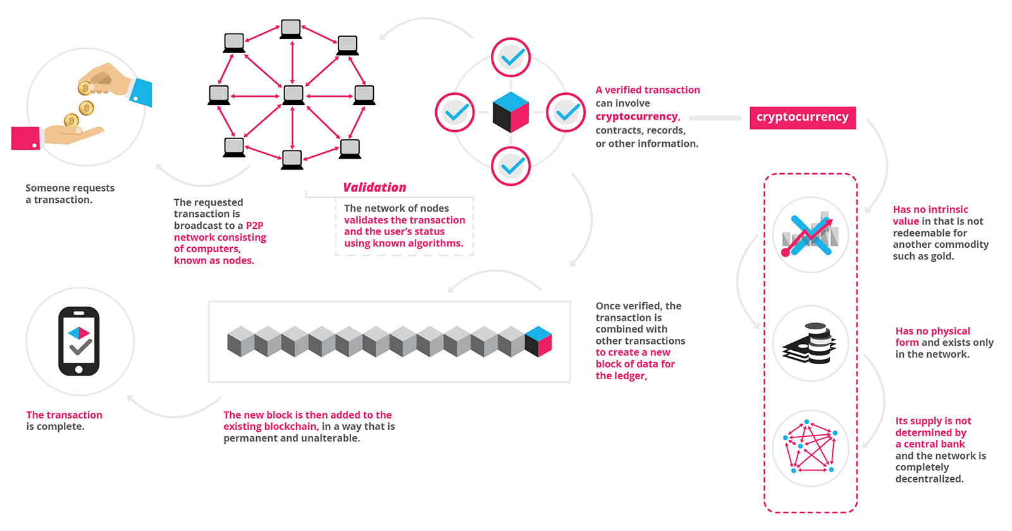Blockchain was invented by [Satoshi Nakamoto](https://en.wikipedia.org/wiki/Satoshi_Nakamoto) in 2008 for use in the [cryptocurrency](https://en.wikipedia.org/wiki/Cryptocurrency) [bitcoin](https://en.wikipedia.org/wiki/Bitcoin), as its public transaction [ledger](https://en.wikipedia.org/wiki/Ledger). The invention of the blockchain for bitcoin made it the first digital currency to solve the [double-spending](https://en.wikipedia.org/wiki/Double-spending) problem without the need of a trusted authority or central [server](https://en.wikipedia.org/wiki/Server_(computing)). The bitcoin design has been the inspiration for other applications .

Figure 5.2 Transaction in Block Chain

Blockchains are [secure by design](https://en.wikipedia.org/wiki/Secure_by_design) and exemplify a distributed computing system with high [Byzantine fault tolerance](https://en.wikipedia.org/wiki/Byzantine_fault_tolerance). [Decentralized](https://en.wikipedia.org/wiki/Decentralized) consensus has therefore been achieved with a blockchain.This makes blockchains potentially suitable for the recording of events, medical records, and other [records management](https://en.wikipedia.org/wiki/Records_management) activities, such as [identity management](https://en.wikipedia.org/wiki/Identity_management), [transaction processing](https://en.wikipedia.org/wiki/Transaction_processing), documenting [provenance](https://en.wikipedia.org/wiki/Provenance), [food traceability](https://en.wikipedia.org/wiki/Traceability#Food_processing) or voting.

Blockchain was invented by [Satoshi Nakamoto](https://en.wikipedia.org/wiki/Satoshi_Nakamoto) in 2009 for use in the [cryptocurrency](https://en.wikipedia.org/wiki/Cryptocurrency) [bitcoin](https://en.wikipedia.org/wiki/Bitcoin), as its public transaction [ledger](https://en.wikipedia.org/wiki/Ledger). The invention of the blockchain for bitcoin made it the first digital currency to solve the [double-spending](https://en.wikipedia.org/wiki/Double-spending) problem without the need of a trusted authority or central [server](https://en.wikipedia.org/wiki/Server_(computing)). The bitcoin design has been the inspiration for other applications.  
The first blockchain was conceptualized by a person (or group of people) known as [Satoshi Nakamoto](https://en.wikipedia.org/wiki/Satoshi_Nakamoto) in 2008. It was implemented the following year by Nakamoto as a core component of the [cryptocurrency bitcoin](https://en.wikipedia.org/wiki/Bitcoin), where it serves as the public [ledger](https://en.wikipedia.org/wiki/Ledger) for all transactions on the network.[[1]](https://en.wikipedia.org/wiki/Blockchain#cite_note-te20151031-1) Through the use of a blockchain, bitcoin became the first digital currency to solve the [double spending](https://en.wikipedia.org/wiki/Double_spending) problem without requiring a trusted authority and has been the inspiration for many additional applications.

**CHAPTER – 6**

**PROCESS OF MINING**

Mining can be called as “INVERSE HASHING”.

Bitcoin miningis the process by which transactions are verified and added to the public ledger, known as the block chain.

Anyone with access to the internet and suitable hardware can participate in mining

Process mining is a family of techniques in the field of [process management](https://en.wikipedia.org/wiki/Process_management) that support the analysis of [business processes](https://en.wikipedia.org/wiki/Business_process) based on event logs. During process mining, specialized data mining algorithms are applied to event log data in order to identify trends, patterns and details contained in event logs recorded by an information system. Process mining aims to improve process efficiency and understanding of processes. Process mining is also known as Automated Business Process Discovery (ABPD). However, in academic literature the term Automated Business Process Discovery is used in a narrower sense to refer specifically to techniques that take as input an event log and produce as output a business process model. The term Process Mining is used in a broader setting to refer not only to techniques for discovering process models, but also techniques for business process conformance and performance analysis based on event logs

* Bitcoin makes heavy use of the cryptographic hash function SHA256, which stands for Secure Hash Algorithm 256-bit.
* the SHA algorithms were originally developed by the NSA

**CHAPTER – 7   
 FUTURE OF CRYPTOCURRENCY IN INDIA**

**Is Bitcoin Is Legal IN INDIA ?**

On December 24, 2013, [the Reserve Bank of India (RBI) cautioned](https://www.ndtv.com/business/rbi-warns-bitcoin-traders-of-multitude-of-risks-in-virtual-currencies-1783973) the users, holders and traders of virtual currencies, including bitcoins, about the potential risks that they are exposed to.

"The creation, trading or usage of (virtual currencies) VCs including Bitcoins, as a medium for payment are not authorised by any central bank or monetary authority. No regulatory approvals, registration or authorisation is stated to have been obtained by the entities concerned for carrying on such activities," the RBI had said in a press release issued in the 2013-end.

The RBI had stated five major risks of trading in bitcoins. The first is the fact that digital currencies, being in electronic format, are prone to losses arising out of hacking, loss of password etc. The second risk is the lack of any authorized central agency to regulate the payments or to turn to for redressal of grievances. The third is that there is no underlying of asset for VCs, making the value a matter of speculation. Fourth is that the exchanges are located in various parts of the world, making the law enforcement a tricky thing for the multiple jurisdictions available. Fifth is that trading may subject the user to illicit and illegal activities since the VCs, can easily be used for illegal activities anonymously.

On February 1, 2017, the central bank again reminded the users of risk involved in bitcoin trading. "The Reserve Bank of India advises that it has not given any licence / authorisation to any entity / company to operate such schemes or deal with Bitcoin or any virtual currency. As such, any user, holder, investor, trader, etc. dealing with Virtual Currencies will be doing so at their own risk," said RBI in the released early this year.

On June 27 this year, Arun Jaitley held a meeting to examine risks related to virtual currencies (VCs) such as bitcoins. Although several issues concerning bitcoins were discussed, no concrete decision was taken. The meeting was attended by IT minister Ravi Shankar Prasad, NITI Aayog (then) vice chairman Arvind Panagariya, and other senior officials.

On the future of cryptocurrencies, [finance minister Arun Jaitley on November 30 said](https://www.ndtv.com/business/crypto-currency-not-legal-in-india-says-arun-jaitley-1782103)that recommendations are being worked at. "The government's position is clear, we don't recognise this as legal currency as of now," Jaitley said when asked whether the government has taken any decision on crypto currency.

**BENEFITS OF CRYPTOCURRENCY**

* International use
* Customer Anonymity
* No surprise fees or waiting periods
* No one can steal your information
* Decentralized
* Transparent
* Improving reputation

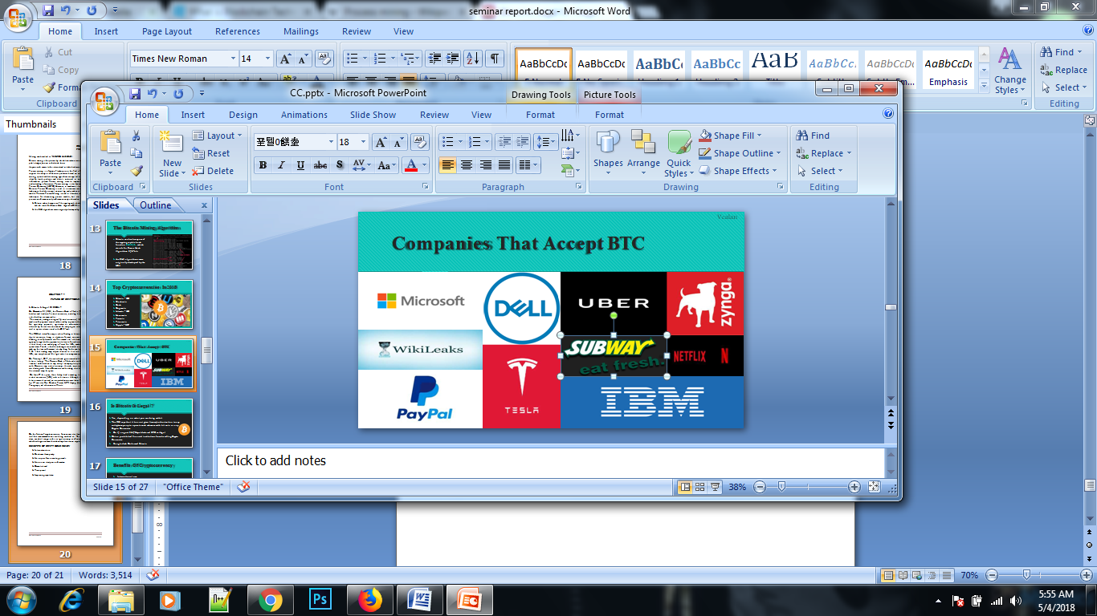

Figure 7.1 COMPANIES THAT ACCEPTS BTC

**TOP CRYPTOCURRENCY IN 2018**

* Bitcoin - BTC
* Blackcoin
* Dash
* Dogecoin
* Litecoin - LTC
* Namecoin
* Peercoin
* Primecoin
* Ripple - XRP

**CHAPTER -8**

**CONCLUSION**

Cryptocurrencies such as BitCoin still have numerous significant obstacles to overcome before they could totally replace current currency systems. The most immediate is the simple opposition from existing financial institutions, which wield great power and have incentives to discourage the proliferation of cryptocurrencies . Other large corporations, even when amenable to the idea of cryptocurrencies, do not currently consider them stable enough to keep as assets for long periods of time

In addition to battling the current economic system, cryptocurrencies have some internal challenges to overcome. Attempting to convert the entire world financial system to the BitCoin model, for example, could cause such a massive growth in blockchain size that the distributed ledger model would become impractical . It is also still unclear whether blockchain technology could be successfully adapted to use cases which require very high speeds with high volumes (on the order of seconds instead of hours), and would be poorly suited for any application which required some degree of reversibility . Finally, because of the substantial energy costs and diminished rewards over time associated with the "mining" process, users may eventually be forced to bear increasingly high and unreasonable transaction costs .

Since the 2008 financial crisis, large banks are increasingly feeling pressure to increase efficiency and cut costs wherever possible . To that end, a May 2016 report from Goldman Sachs estimates that the financial industry alone could realize up to $6 billion/year in savings through use of blockchain technology [4]. However, this would not necessarily include decentralized cryptocurrencies such as Bitcoin, but may involve the creation of new proprietary centralized cryptocurrencies (such as the Bank of England’s newly introduced RSCoin) .

The introduction of cryptocurrencies may also lead to increased levels of transparency and few incidents of fraud. Under current systems, the correct identification of fraud is very manual-labor intensive and prone to error . However, cryptocurrencies are designed to be explicitly transparent and automatically detect fraud, greatly alleviating the costs associated with managing associated systems

**REFRENCES**

1. <https://en.wikipedia.org/wiki/Process_mining>
2. https://blockgeeks.com/guides/what-is-blockchain-technology/
3. https://socialimps.dbogatov.org/
4. https://blockgeeks.com/guides/what-is-cryptocurrency/
5. <https://www.ndtv.com/business/>
6. <https://www.slideshare.net/crypt00/cryptocurrency-bitcoin-final>
7. https://www.blockchain.com/