Google Maps –DDT

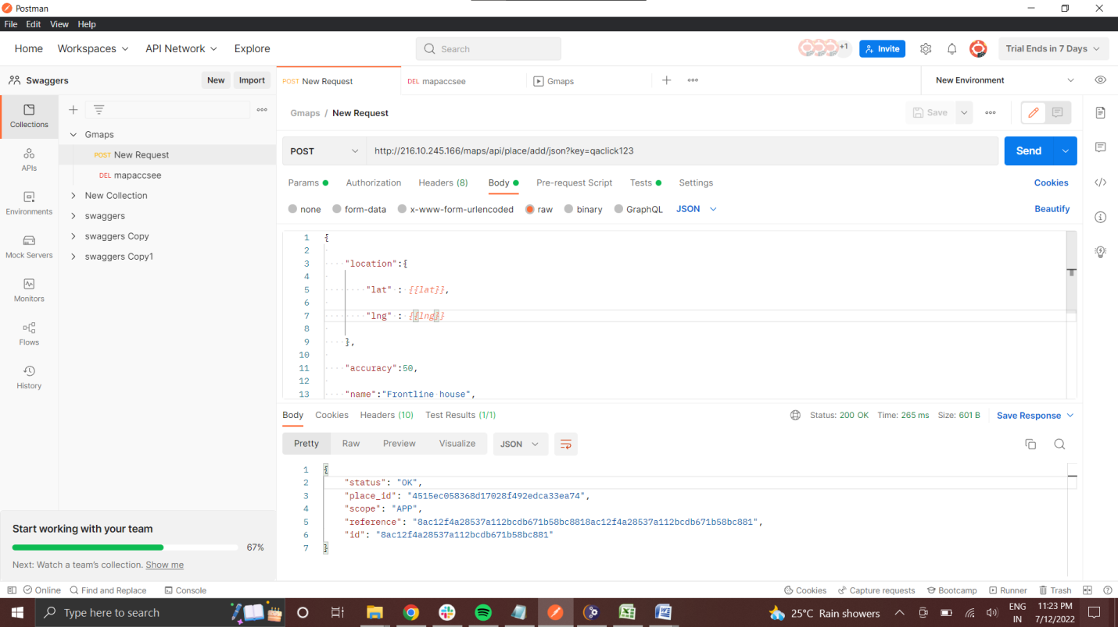

1. New request to server with latitude & longitude read from environment variable

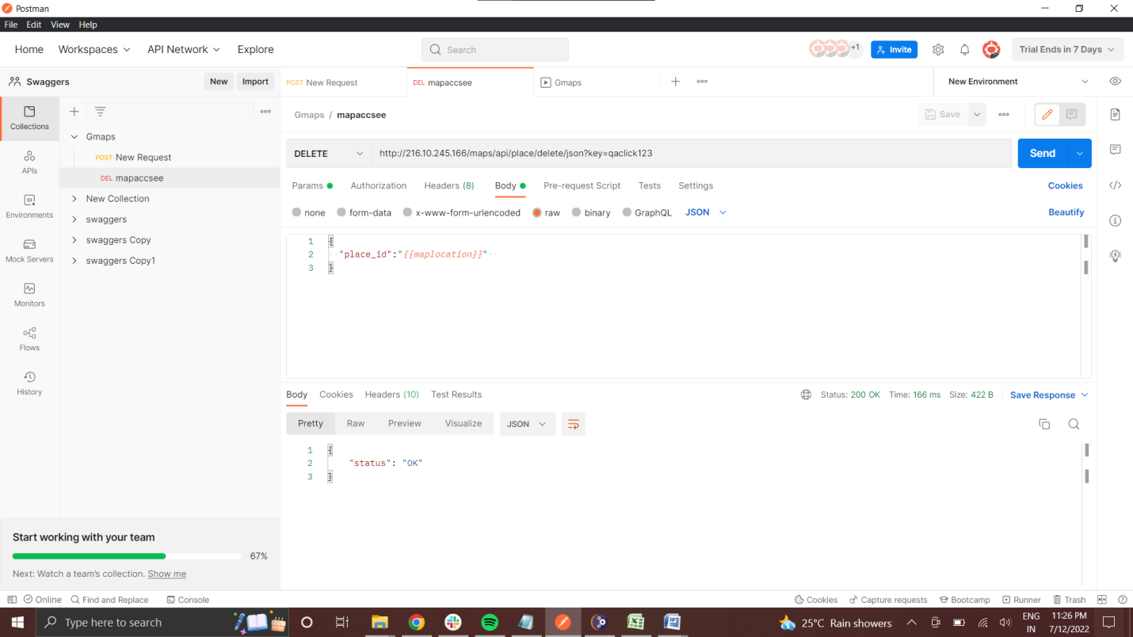

1. Map access with the data being deleted

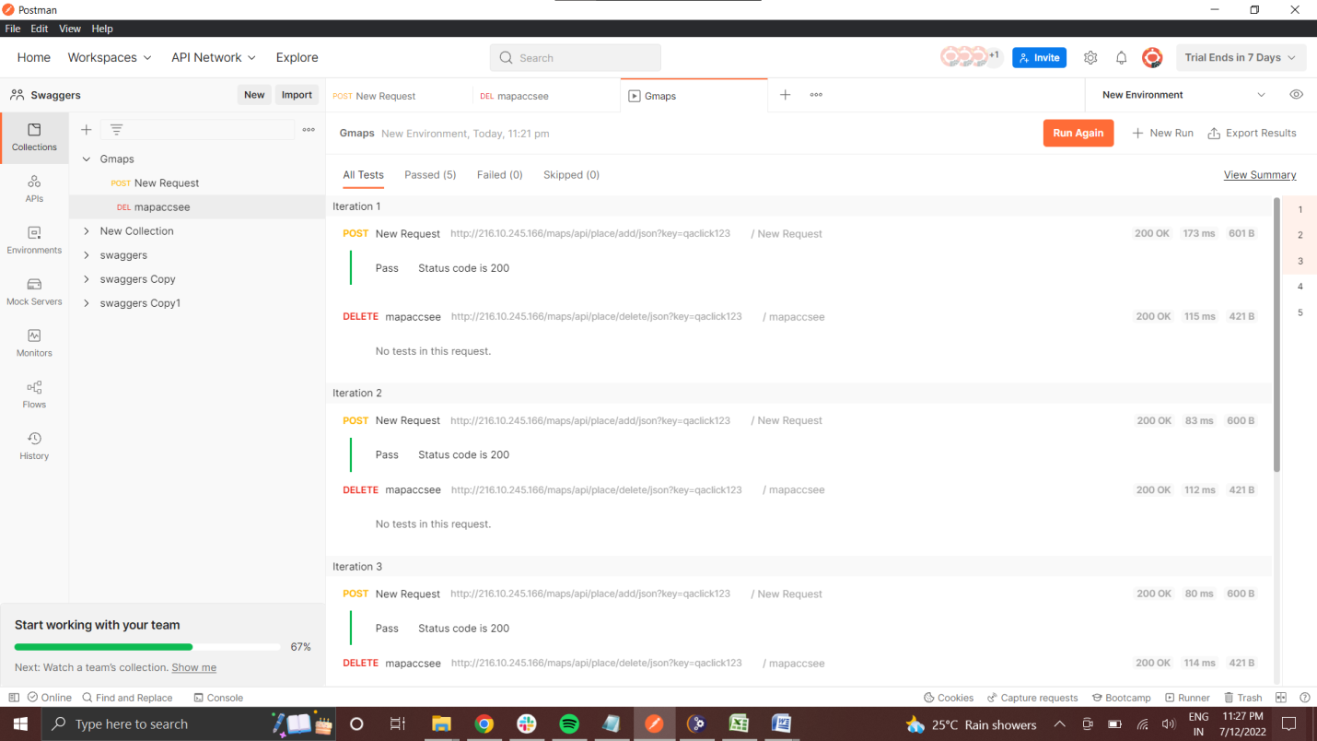

1. Collection run using data from a CSV file – DDT pass

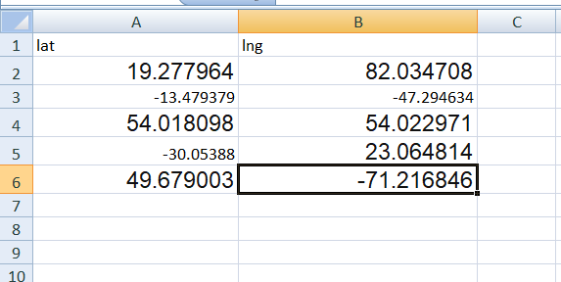

1. Used data in CSV for DDT