 Queen Mary, University of London
Room W117
Queen’s Building
Queen Mary University of London
Mile End Road
London E1 4NS

Queen Mary Ethics of Research Committee
Hazel Covill
Research Ethics Administrator
Tel: +44 (0) 20 7882 7915
Email: h.covill@qmul.ac.uk
c/o Dr Athen Ma
School of Electronic Engineering
and Computer Science
Queen Mary University of London
Mile End
London 25th November 2019

To Whom It May Concern:

Re: QMREC2212 - Final Year Project (Dissertation).

I can confirm that Paul Opong-Frimpong has completed a Research Ethics Questionnaire with regard to the above research.

The result of which was the conclusion that the proposed work does not present any ethical concerns; is extremely low risk; and thus does not require the scrutiny of the full Research Ethics Committee.

Yours faithfully
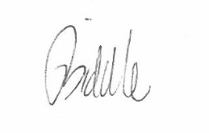
Mr Jack Biddle – Senior Research Management and Governance Officer

Patron: Her Majesty the Queen
Incorporated by Royal Charter as Queen Mary
and Westfield College, University of London

