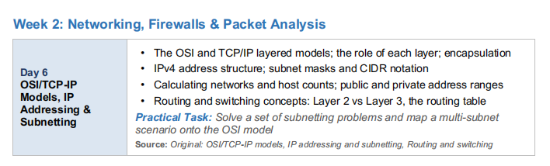

- The OSI and TCP/IP layered models; the role of each layer; encapsulation:-

OSI Model :-
Layer | Layer Name | Main Role | Examples / Protocols | PDU
7 | Application | Provides network services directly to applications and users. | HTTP, HTTPS, FTP, DNS, SMTP | Data
6 | Presentation | Handles data formatting, translation, encryption, and compression. | TLS/SSL, JPEG, ASCII, UTF-8 | Data
5 | Session | Establishes, manages, and terminates communication sessions. | RPC, NetBIOS | Data
4 | Transport | Provides end-to-end communication, reliability, flow control, and segmentation. | TCP, UDP | Segment / Datagram
3 | Network | Handles logical addressing and routing between networks. | IP, ICMP, OSPF | Packet
2 | Data Link | Provides node-to-node delivery, MAC addressing, and frame handling. | Ethernet, Wi-Fi, ARP | Frame
1 | Physical | Transmits raw bits through cables, fiber, or radio signals. | Ethernet cables, Fiber, Wi-Fi signals | Bits

TCP/IP Model:-
Layer | Layer Name | Main Role | Examples / Protocols
4 | Application | Provides network services to applications. Combines OSI Layers 5–7. | HTTP, HTTPS, DNS, FTP, SMTP
3 | Transport | Provides end-to-end communication and controls reliability and delivery. | TCP, UDP
2 | Internet | Handles IP addressing and routing packets between networks. | IPv4, IPv6, ICMP
1 | Network Access | Handles communication over the physical network, including frames and transmission. | Ethernet, Wi-Fi, ARP

Encapsulation:-

Step | Layer | What Happens | Data Unit
1 | Application | Application creates the data/message. | Data
2 | Transport | TCP/UDP adds a header containing information such as ports. | Segment / Datagram
3 | Network | IP adds source and destination IP addresses. | Packet
4 | Data Link | Ethernet/Wi-Fi adds MAC addresses and creates a frame. | Frame
5 | Physical | Frame is converted into electrical, optical, or radio signals. | Bits

- IPv4 address structure; subnet masks and CIDR notation:-

IPv4 address structure :-

Topic | Easy Explanation
IPv4 Address Structure | An IPv4 address is like a unique address for a device on a network. It has 32 bits and is divided into 4 parts called octets.
Example | 192.168.1.10 — each number is one octet.
Octet Range | Each part can contain a number from 0 to 255.
Network Part | Tells us which network the device belongs to.
Host Part | Tells us which device is on that network.
Simple Example | In 192.168.1.10/24, 192.168.1 represents the network, while 10 identifies the device.

Subnet Masks :-
A subnet mask tells us which part of an IP address represents the network and which part represents the device (host). It works together with the IP address to divide a network into smaller sections.
For example:192.168.1.10
255.255.255.0 Here, 255.255.255 represents the network part, while 0 represents the host part.
Common subnet masks include:
- 255.0.0.0 → /8
- 255.255.0.0 → /16
- 255.255.255.0 → /24
- 255.255.255.128 → /25
- 255.255.255.192 → /26

CIDR Notation :-
CIDR (Classless Inter-Domain Routing) is a short way of writing an IP address together with its subnet information. It uses a / followed by a number, such as /24.
For example:
192.168.1.0/24
Here, /24 means that the first 24 bits are used for the network, while the remaining 8 bits are available for hosts.
- Calculating networks and host counts; public and private address ranges:-

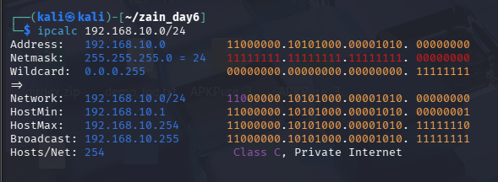

It is divided into a network and host addresses. It identifies the subnet mask, usable IP range, network address, and broadcast address.

- Routing and switching concepts: Layer 2 vs Layer 3, the routing table:-

Routing and Switching Concepts:-
- Layer 2 Switching:Uses MAC addresses to send data within the same network.
- Layer 3 Routing:Uses IP addresses to send data between different networks.
- Routing Table: A list of network routes that helps a router decide where to forward packets.

Destination Network | Subnet Mask | Next Hop | Interface
192.168.1.0 | 255.255.255.0 | Directly Connected | eth0
192.168.2.0 | 255.255.255.0 | 192.168.1.1 | eth1
10.0.0.0 | 255.0.0.0 | 192.168.1.1 | eth1
0.0.0.0 | 0.0.0.0 | 192.168.1.1 | eth1

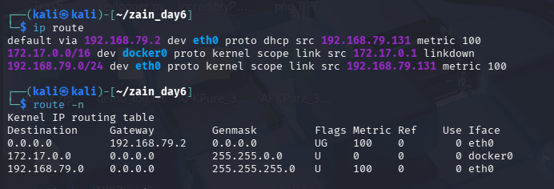

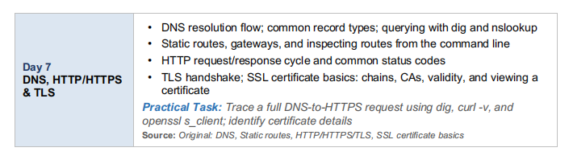

- DNS resolution flow; common record types; querying with dig and nslookup:-

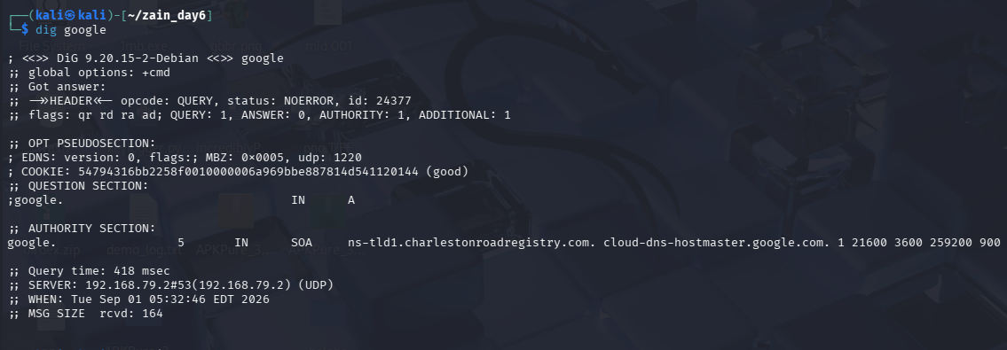

This command asks the DNS system to find the IP address. It shows the answer along with some extra details like how long it took.

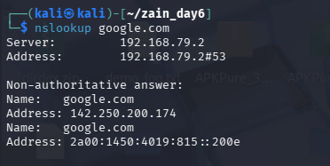

finds the IP address of a website name.

- Static routes, gateways, and inspecting routes from the command line:-

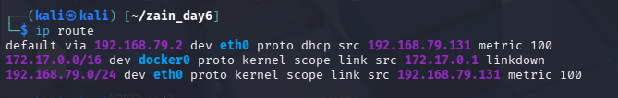

It shows the list of routes your computer uses to send data. It tells you which gateway your internet traffic goes through to reach other networks.

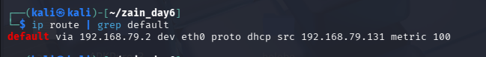

It s shows your default gateway

- HTTP request/response cycle and common status codes:-

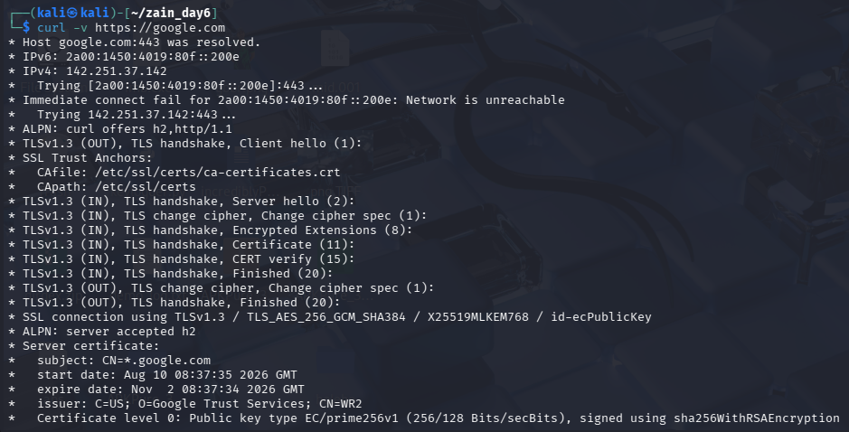

It sends a request to a website and shows you everything that happens step by step.

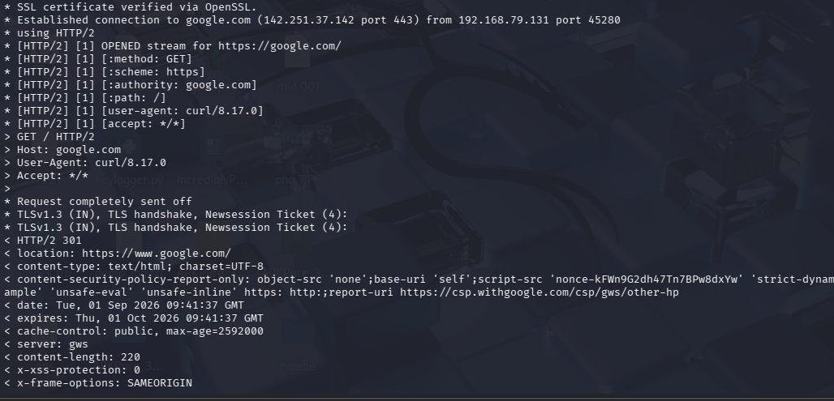

- TLS handshake; SSL certificate basics: chains, CAs, validity, and viewing a certificate:-

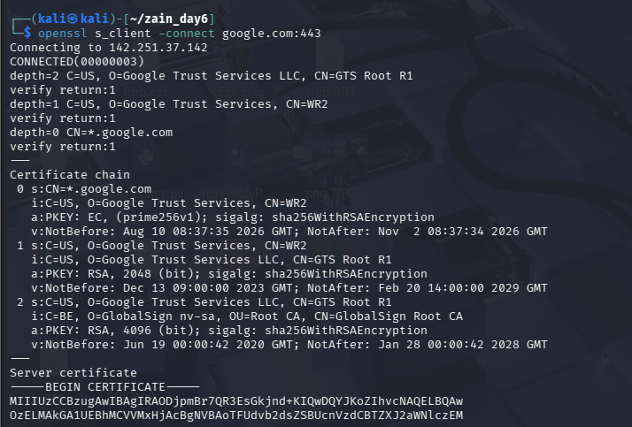

It connects to a website securely and shows the details of its safety certificate — like who issued it, when it was made, and when it expires.

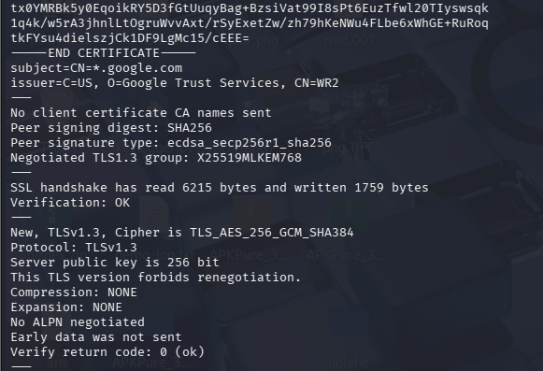

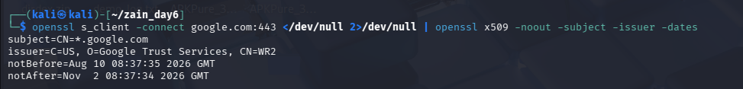

It picks out just the important parts of the certificate who it belongs to, who gave it out, and how long it stays valid.

Practical:-
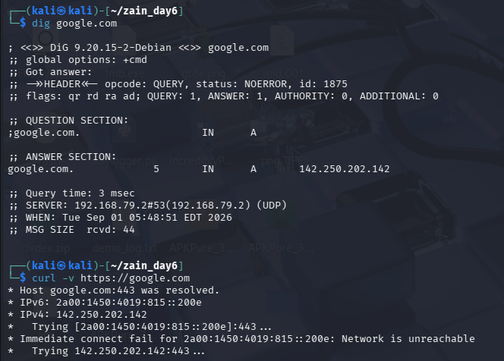
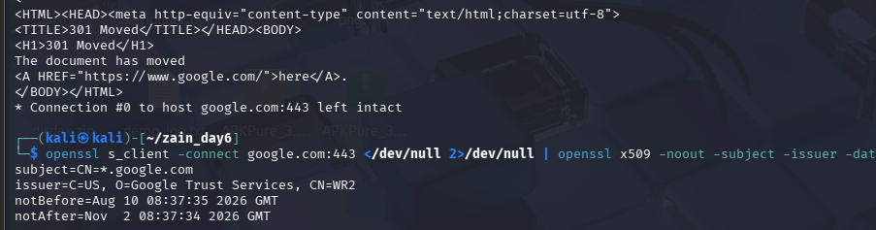

I used dig to find the IP address of a website. Then I used curl -v to see how my computer talks to the website and gets a reply back. Finally, I used openssl to check the website's security certificate and see who made it and when it expires.

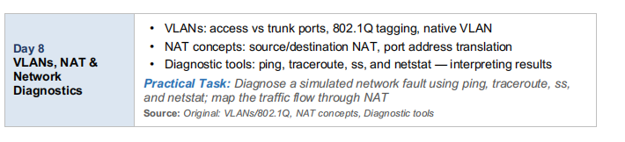

- VLANs: access vs trunk ports, 802.1Q tagging, native VLAN:-

VLAN — 802.1Q:

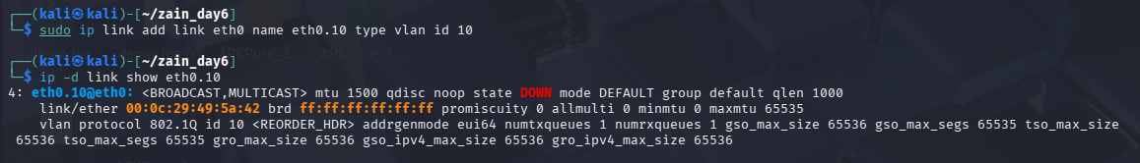

It creates a VLAN interface with tag number 10 on top of your main network card .

Access vs Trunk Port :

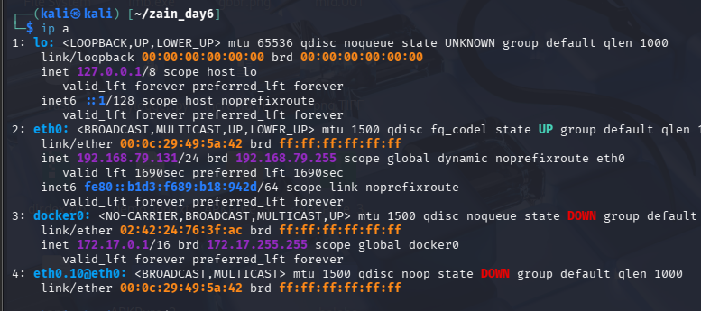

Native VLAN :
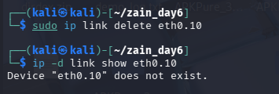
It is used to delete that link.

- NAT concepts: source/destination NAT, port address translation:-
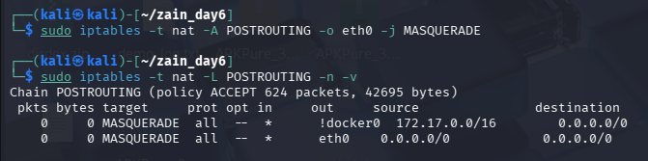
It changes the private (internal) IP address of outgoing traffic to the public IP address, so your device can talk to the internet without exposing its real internal address.

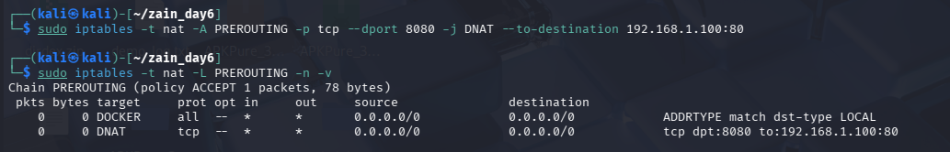
It takes incoming traffic on port 8080 and forwards it to a different internal device (192.168.1.100) on port 80.

3 .Diagnostic tools: ping, traceroute, ss, and netstat — interpreting results:-

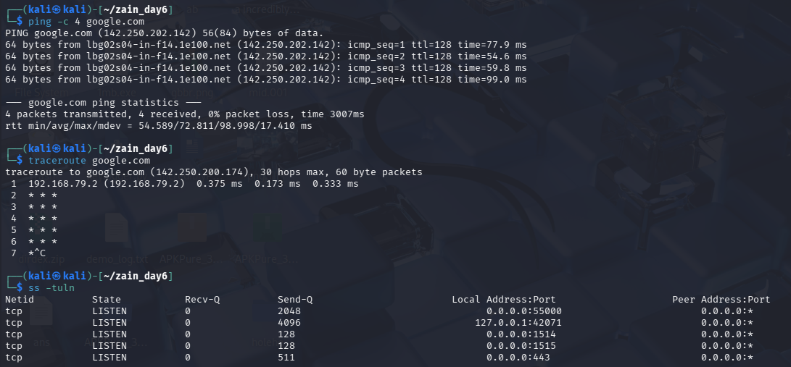
I checked ping and traceroute results to see connection speed and the path data takes to reach a website. I also looked at ss and netstat outputs to see which ports were open and which programs were using them.

Practical Task: Diagnose a simulated network fault using ping, traceroute, ss, and netstat; map the traffic flow through NAT :-

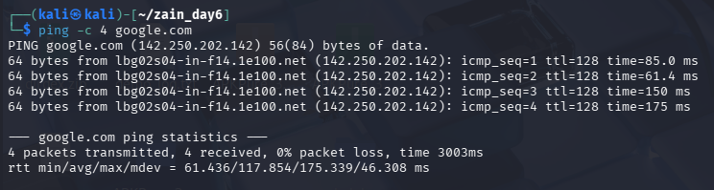

It sends small test messages to a website and checks if it replies. It tells you if the connection is working and how fast it is.

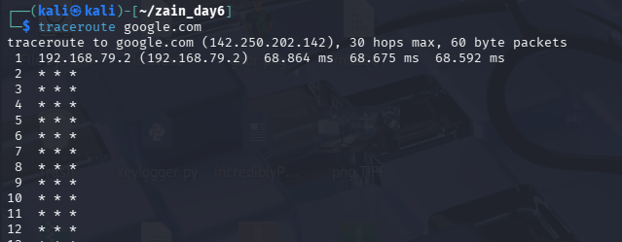

It helps you see where a connection might be slow or broken.

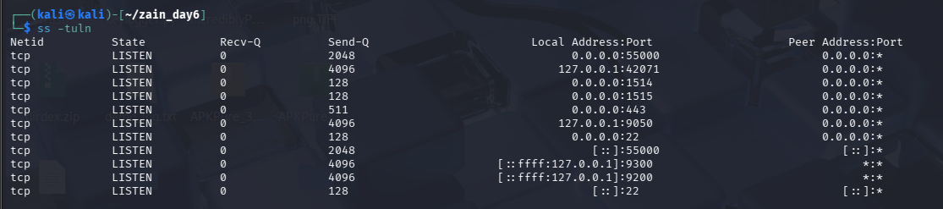

It shows all the open network connections and ports on your computer. It tells you which services are listening and waiting for connections.

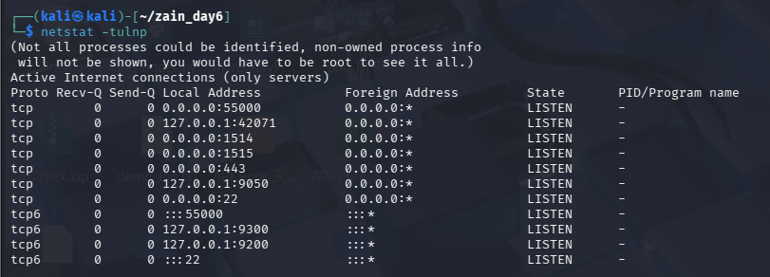
It shows open ports and active connections, and additionally tells you which program is using each one.

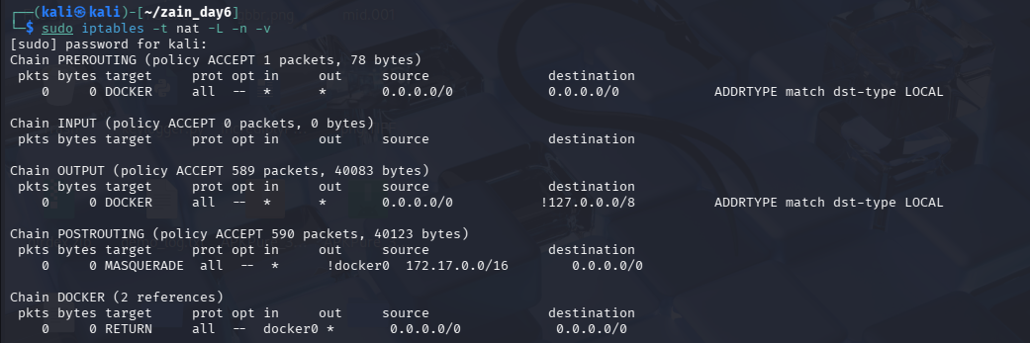
It shows NAT rules on system.

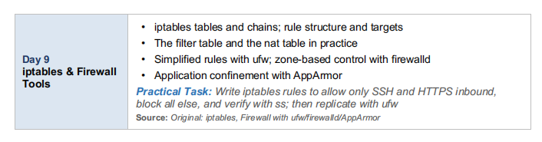

- iptables tables and chains; rule structure and targets:-

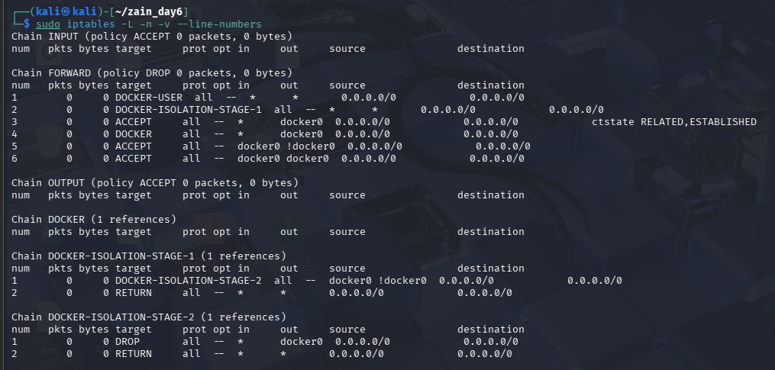

It shows all the current firewall rules, organized into chains (INPUT, OUTPUT, FORWARD). It tells you what traffic is allowed or blocked and in what order.

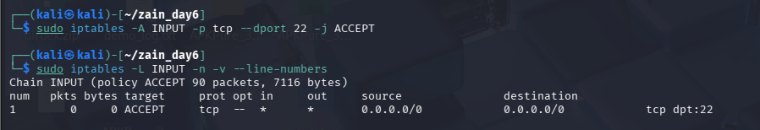

It adds a rule to the INPUT chain that allows incoming traffic on port 22 (SSH).

- The filter table and the nat table in practice:-

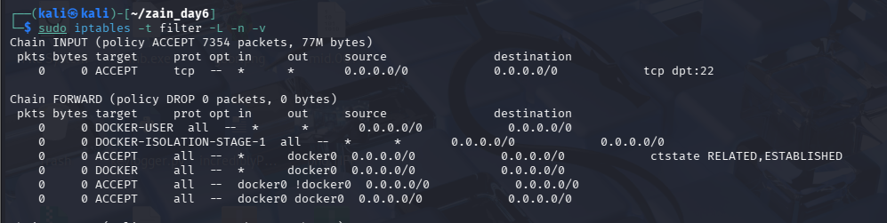

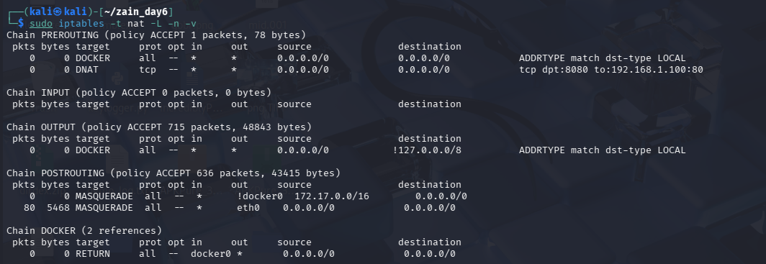

filter table controls "allow/block" decisions, while nat table controls "address translation" decisions.

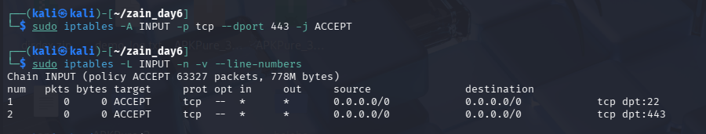

It adds another rule that allows incoming traffic on port 443 (HTTPS), so people can securely browse websites hosted on this machine.

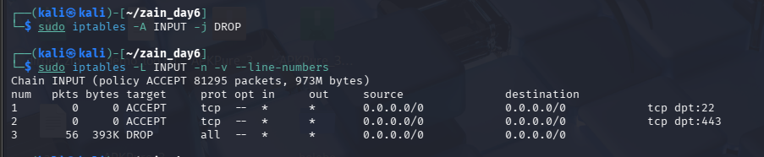

It adds a final rule at the end of the INPUT chain that blocks (drops) everything else that wasn't already allowed.

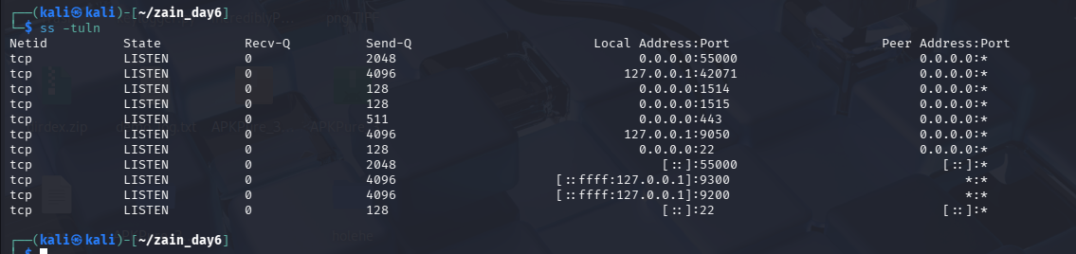

- Simplified rules with ufw; zone-based control with firewalld:-

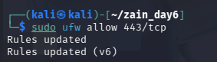

This is used to Allow port 443 through ufw command.

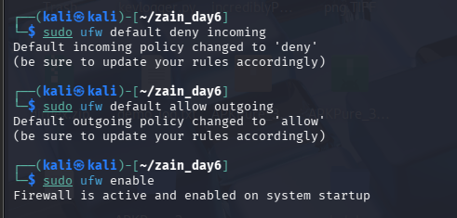

It block All incomming traffic and Allow all outgoing .
UfW enable It is used to activate firewall .

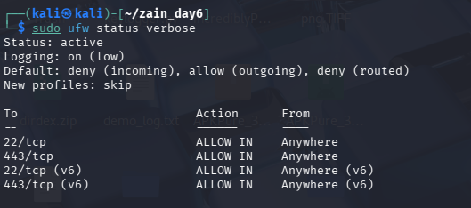

Firewalld :-

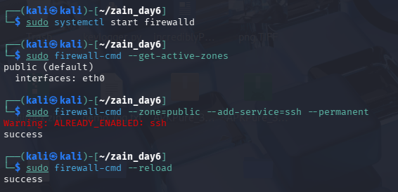

Firewall d use the zones and every zone has its own rules according to network type.

- Application confinement with AppArmor:-

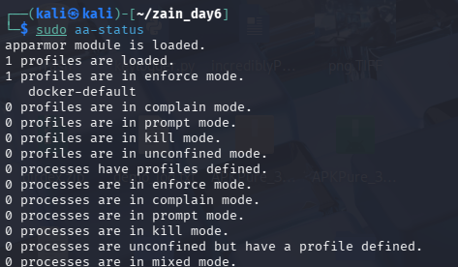

It shows whether AppArmor is running and lists which applications currently have security profiles .

Practical Task: Write iptables rules to allow only SSH and HTTPS inbound, block all else, and verify with ss; then replicate with ufw

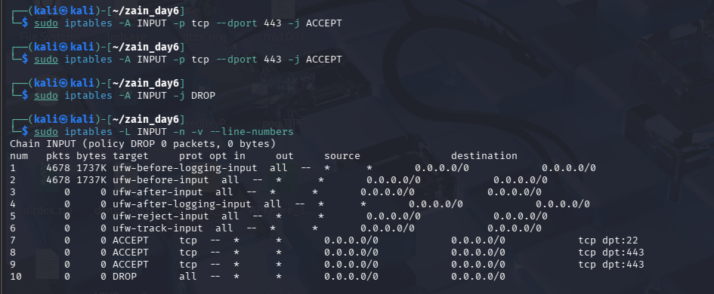

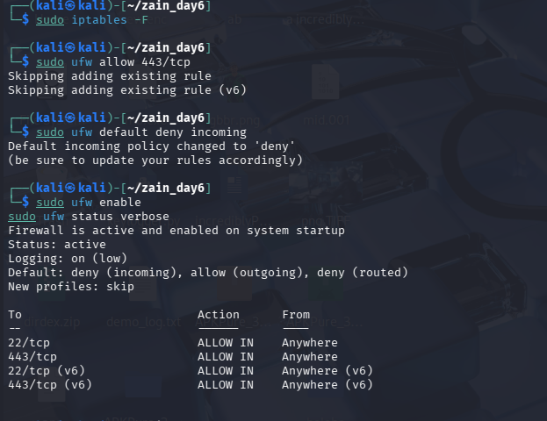

I wrote iptables rules to allow only SSH and HTTPS traffic and block everything else.then , I recreated the same setup using ufw which does the same job with simpler commands.

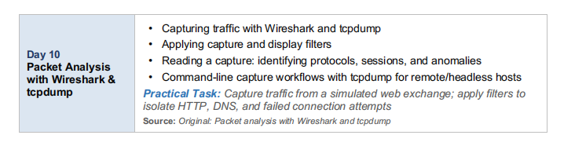

- Capturing traffic with Wireshark and tcpdump:-

Wireshark :-
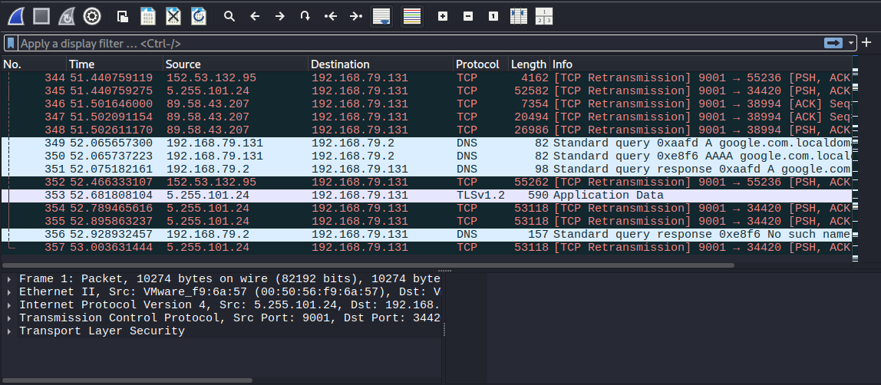

It shows network traffic captured in Wireshark. It displays packets with their source, destination, protocol, and other details, allowing us to analyze the communication.

TCPDUMP:-
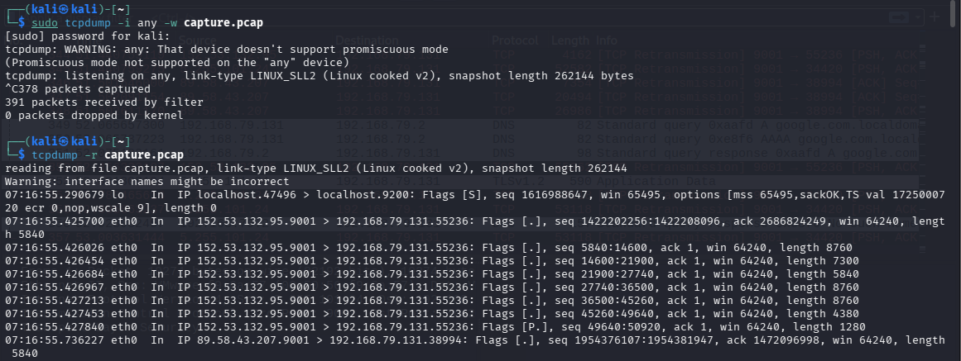

It shows network packets captured using tcpdump. The terminal output displays packet details such as source and destination IPs, ports, flags, and packet length.
- Applying capture and display filters:-

Wireshark:-

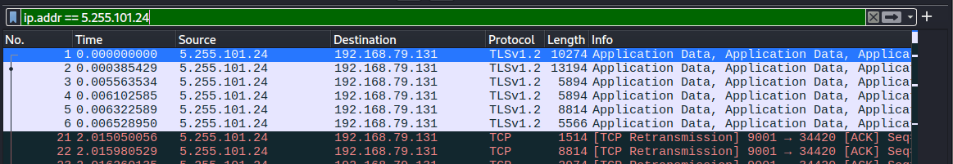
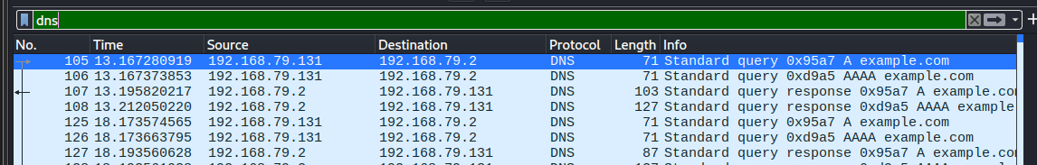
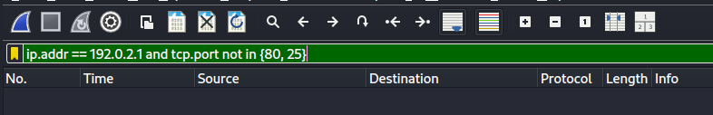

It shows captured network traffic filtered by different protocols such as TLS, DNS, and TCP.

TCP DUMP:-

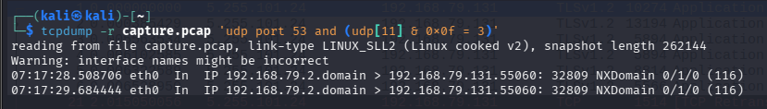
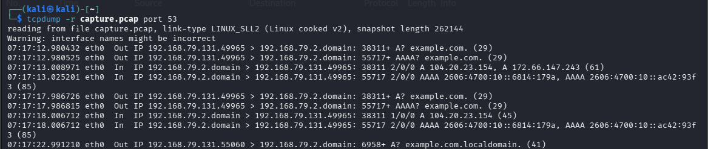

It shows packet capture from the terminal using tcpdump, including DNS queries, source and destination IPs, ports, and packet details.

- Command-line capture workflows with tcpdump for remote/headless hosts:-

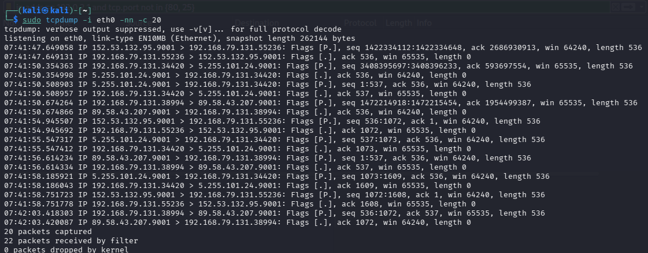

It shows live network traffic captured using tcpdump on the eth0 interface. It displays the source and destination IP addresses, ports, TCP flags, and packet details.

Practical Tasks:-

