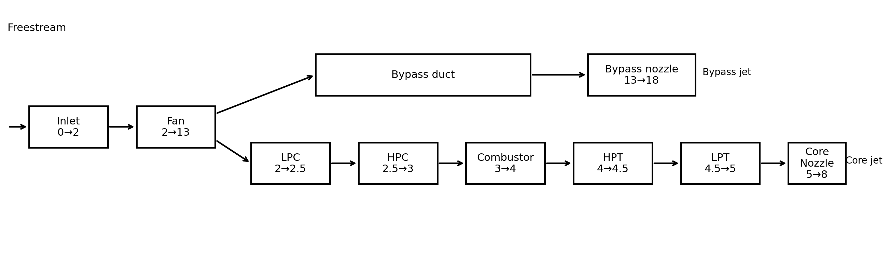
DEVELOPMENT AND CROSS-APPLICATION OF A MODULAR MATLAB TURBOFAN CYCLE MODEL
A personal propulsion engineering portfolio project
Author: Ching Zi Yang
MATLAB station-by-station Brayton-cycle analysis
Reference engines: CFM56-7B family-level configuration and IAE V2527-A5
Prepared as an independent personal project
Repository: [insert GitHub repository link here]

Executive Summary
This personal project develops a reusable zero-dimensional turbofan cycle model in MATLAB. The code evaluates a separate-flow high-bypass turbofan station-by-station from freestream conditions to the core and bypass nozzle exits. It calculates compressor work, combustor fuel-air ratio, turbine work balance, nozzle choking, momentum and pressure thrust, fuel flow, and thrust-specific fuel consumption (TSFC).
The solver was first configured for a CFM56-7B family-level case at 35,000 ft and Mach 0.8. It predicted 5,994.41 lbf of thrust, 0.6343 lb/(lbf·hr) TSFC, and an overall pressure ratio (OPR) of 32.88. Relative to the selected published benchmarks, the errors were +1.51% for thrust, -5.47% for TSFC, and +0.24% for OPR.
The same thermodynamic architecture was then applied to the IAE V2527-A5. Publicly available engine parameters were used for bypass ratio, fan pressure ratio, OPR, and fan diameter. Since cruise turbine inlet temperature and an engine-specific effective inlet-capture characteristic were not available in the selected public sources, these two quantities were calibrated against the published cruise TSFC and thrust benchmark. The final V2527-A5 design point reproduced 5,200.24 lbf of thrust and 0.5700 lb/(lbf·hr) TSFC at 35,000 ft and Mach 0.8. Because this calibration used two free parameters to match two published outputs, the resulting near-zero error is expected by construction and is examined critically in Section 5.4 rather than presented as an independent validation.
Parametric studies were completed for altitude, Mach number, and turbine inlet temperature (TIT). The model predicts a strong thrust lapse with altitude and increasing thrust with TIT. Its Mach-number response remains idealised because fan and compressor maps, corrected shaft speed, variable efficiencies, and engine control schedules are not included. The project therefore demonstrates both the usefulness and the limitations of a map-free design-point cycle model.

Project Outcomes
- A modular MATLAB solver with reusable component functions and engine data structures.
- A CFM56-7B family-level design-point comparison against published cruise data.
- A calibrated V2527-A5 application using the same thermodynamic solver, with an explicit sensitivity analysis testing whether the calibration is well-defined.
- A station-by-station property comparison between both engines as an internal consistency check.
- Altitude, Mach-number, and TIT sensitivity studies with highlighted design points, including a specific-thrust-vs-TSFC trade-off view.
- A documented debugging history and a clear statement of model limitations.

Report Structure
Section | Purpose
1. Project Context and Objectives | Personal-project motivation, scope, and deliverables
2. Model Architecture | Station convention, code structure, and reusable engine definitions
3. Thermodynamic Method | Atmosphere, compression, combustion, turbines, nozzles, thrust, and TSFC
4. Engine Data and Assumptions | Balanced comparison of CFM56-7B and V2527-A5 inputs, with primary sources
5. Design-Point Results | CFM56 comparison, V2527 calibration, calibration sensitivity, and station-level cross-engine comparison
6. Parametric Study | Altitude, Mach-number, TIT trends, and specific-thrust/TSFC trade-off
7. Model Limitations and Future Work | Off-design boundaries and recommended extensions
8. Conclusions | Technical findings and portfolio value
Appendix A | MATLAB repository structure and model capability summary

1. Project Context and Objectives
This work was completed as an independent personal engineering project rather than as a university assignment. Its purpose is to demonstrate practical understanding of gas-turbine thermodynamics, propulsion performance, engineering programming, and model validation in a form suitable for a technical portfolio, GitHub repository, internship application, or interview discussion.
The project focuses on a separate-flow high-bypass turbofan because this architecture is directly relevant to modern commercial propulsion systems. A station-by-station cycle model provides sufficient physical depth to explore compression, combustion, turbine work balance, nozzle expansion, and thrust production, while remaining transparent enough to build and debug from first principles.

1.1 Objectives
- 1. Build a complete station-by-station Brayton-cycle turbofan model in MATLAB.
- 2. Calculate net thrust, TSFC, fuel-air ratio, station temperatures and pressures, turbine work, and nozzle state.
- 3. Compare a CFM56-7B family-level model against published cruise performance data.
- 4. Transfer the same code architecture to a second engine, the V2527-A5.
- 5. Perform sensitivity studies for altitude, Mach number, and TIT, and test the well-posedness of the V2527-A5 calibration.
- 6. Document assumptions, calibration choices, debugging decisions, and known limitations.

1.2 Scope
The model is a zero-dimensional steady-state cycle solver. It does not resolve blade-row aerodynamics, transient spool dynamics, combustor chemistry, secondary-air systems, turbine cooling, installation drag, or detailed engine control logic. The work is therefore positioned as a preliminary cycle-analysis tool, not as a substitute for an OEM engine deck or a component-map-based off-design solver.

2. Model Architecture

2.1 Station Convention
The engine is represented using the station sequence 0 → 2 → 13 / 2.5 → 3 → 4 → 4.5 → 5 → 8 / 18. The bypass stream leaves the fan and expands through a separate bypass nozzle, while the core stream passes through the low-pressure compressor (LPC), high-pressure compressor (HPC), combustor, high-pressure turbine (HPT), low-pressure turbine (LPT), and core nozzle.

Figure 1. Station convention and component sequence used by the MATLAB model.
Station | Description
0 | Freestream static condition
2 | Fan exit / core inlet
13 | Bypass duct after fan
2.5 | LPC exit
3 | HPC exit
4 | Combustor exit / turbine inlet
4.5 | HPT exit
5 | LPT exit
8 | Core nozzle exit
18 | Bypass nozzle exit

2.2 MATLAB Code Structure
The original single-run script was refactored into a reusable engine-independent cycle solver. The function load_engine.m stores engine-specific parameters in a MATLAB structure, while run_cycle.m contains the common cycle equations. Individual component functions are reused for the fan, compressor stages, combustor, turbine stages, and nozzles.
turbofan_cycle/ main.m sweep_main.m validation_main.m functions/ load_engine.m run_cycle.m fan_compression.m compressor_stage.m combustor.m turbine_stage.m nozzle.m
This architecture allows the solver to switch engines by changing only the engine definition, for example load_engine("CFM56-7B") or load_engine("V2527-A5"). The cycle equations and station sequence remain unchanged.

3. Thermodynamic Method

3.1 Freestream and Stagnation Conditions
Static atmospheric properties are obtained using MATLAB atmosisa at the selected altitude. Flight speed is calculated from the local speed of sound and Mach number. Freestream stagnation temperature and pressure are then obtained using perfect-gas isentropic relations.
V₀ = M₀ a₀
Tₜ₀ = T₀ [1 + (γₐ − 1)M₀²/2]
Pₜ₀ = P₀ [1 + (γₐ − 1)M₀²/2]^(γₐ/(γₐ − 1))

3.2 Fan and Compressors
For each compression element, the isentropic outlet temperature is obtained from pressure ratio. Isentropic efficiency is then used to calculate the actual outlet temperature and specific compressor work.
Tₜ,out,s = Tₜ,in PR^((γ − 1)/γ)
Tₜ,out = Tₜ,in + (Tₜ,out,s − Tₜ,in)/ηc
wc = Cp,a (Tₜ,out − Tₜ,in)

3.3 Combustor
The combustor exit temperature is specified through TIT. A fractional pressure loss is applied, and fuel-air ratio is calculated from a steady-flow energy balance using a constant fuel lower heating value and combustor efficiency.
Pₜ₄ = Pₜ₃ (1 − ΔPb)
f = Cp,g (Tₜ₄ − Tₜ₃) / [ηb LHV − Cp,g (Tₜ₄ − Tₜ₃)]

3.4 Turbine Work Balance
The turbine pressure ratios are not prescribed. Instead, each turbine is sized from the work demanded by the compressor system on its shaft. The HPT drives the HPC, and the LPT drives the fan and LPC. Mechanical efficiency is applied to the shaft power balance.
w_HPT,req = w_HPC
w_LPT,req = w_fan + w_LPC
ΔT_actual = (w_req/ηm)/Cp,g
ΔT_ideal = ΔT_actual/ηt
A key debugging correction was made to the turbine-efficiency relation. The ideal temperature drop must be larger than the actual temperature drop for a turbine delivering a specified work output. Dividing by turbine efficiency is therefore required; multiplying by efficiency would produce an unrealistically small pressure drop.

3.5 Nozzle Expansion
The core and bypass nozzles are evaluated separately. Each nozzle first checks whether the ambient-to-stagnation pressure ratio is below the critical value. Choked flow is represented at Mach 1, while unchoked flow is expanded to ambient pressure with nozzle efficiency applied to the enthalpy drop.
(Pe/Pt)crit = [2/(γ + 1)]^(γ/(γ − 1))
Ve,choked = √(γ R Te)

3.6 Mass Flow, Thrust, and TSFC
Captured mass flow is estimated from fan frontal area, freestream density, flight speed, and an effective inlet-capture ratio. The total flow is divided between the core and bypass streams using BPR. Net thrust includes momentum and pressure terms for both nozzles.
ṁtotal = Ccapture ρ₀ Afan V₀
ṁcore = ṁtotal/(1 + BPR)
ṁbypass = BPR·ṁtotal/(1 + BPR)
FN = Fcore,mom + Fbypass,mom + Fp,core + Fp,bypass
TSFC = ṁfuel/FN

4. Engine Data and Assumptions
To avoid asymmetric presentation, the two engine configurations are shown in a single balanced input table. The table distinguishes published, assumed, derived, and calibrated quantities. The CFM56 case is best described as a family-level configuration because the public cruise benchmark and cycle parameters are not all tied to one exact production rating. The V2527-A5 is a specific V2500 variant.
Parameter | CFM56-7B | Classification | V2527-A5 | Classification
Reference altitude | 35,000 ft | Selected reference | 35,000 ft | Published benchmark condition
Reference Mach | 0.80 | Selected reference | 0.80 | Published benchmark condition
Bypass ratio | 5.1 | Published family value | 4.8 | Published
Published OPR | 32.8 | Published family value | 27.2 | Published
Fan diameter | 1.549 m | Published | 1.613 m | Published
Fan pressure ratio | 1.60 | Assumed | 1.60 | Published
LPC pressure ratio | 1.50 | Assumed | 1.50 | Assumed
HPC pressure ratio | 13.70 | Selected from OPR | 11.33 | Derived from OPR
Model OPR | 32.88 | Derived | 27.20 | Derived (by construction — see § 5.2 note)
TIT | 1700 K | Assumed | 1481 K | Calibrated to TSFC
Capture scale | 1.000 | Baseline | 0.8440 | Calibrated to thrust
Fan efficiency | 0.90 | Assumed | 0.90 | Assumed
LPC efficiency | 0.88 | Assumed | 0.88 | Assumed
HPC efficiency | 0.85 | Assumed | 0.85 | Assumed
HPT efficiency | 0.90 | Assumed | 0.90 | Assumed
LPT efficiency | 0.90 | Assumed | 0.90 | Assumed
Combustor efficiency | 0.99 | Assumed | 0.99 | Assumed
Combustor pressure loss | 3% | Assumed | 3% | Assumed
Shaft mechanical efficiency | 0.99 | Assumed | 0.99 | Assumed
Nozzle efficiency | 0.98 | Assumed | 0.98 | Assumed
Fuel LHV | 43 MJ/kg | Standard approximation | 43 MJ/kg | Standard approximation
Cp, air | 1005 J/(kg·K) | Constant property | 1005 J/(kg·K) | Constant property
γ, air | 1.40 | Constant property | 1.40 | Constant property
Cp, gas | 1150 J/(kg·K) | Constant property | 1150 J/(kg·K) | Constant property
γ, gas | 1.33 | Constant property | 1.33 | Constant property

4.1 Published Data Sources
The V2500 product sheet provides variant-level specifications including the V2527-A5 bypass ratio, OPR, fan pressure ratio, fan-tip diameter, and take-off thrust rating [1]. A NASA-hosted design report provides the selected V2527 cruise benchmark of 0.570 lb/(lbf·hr) SFC and 5,200 lbf thrust at Mach 0.8 and 35,000 ft [2]. CFM International identifies the CFM56-7B as the exclusive powerplant for the Boeing 737 Next Generation [3].
The CFM56-7B cruise benchmark of 5,905 lbf thrust and 0.671 lb/(lbf·hr) TSFC is drawn from a Purdue University propulsion engineering reference [4]. Bypass ratio (5.1), overall pressure ratio (32.8), and fan diameter (61.0 in / 1.549 m) are cross-confirmed across an independent CFM56 specification compilation [5], a Boeing 737 powerplant reference confirming the 61-inch titanium wide-chord fan [6], and a peer-reviewed exergo-economic analysis of the CFM56-7B that also documents the compressor and turbine stage counts used in the station convention of Section 2.1 [7].
The Mach-dependent inlet mass flow capture ratio used in the mass-flow model (Section 3.6) is taken directly from NASA cruise nacelle test data, which measured a mass flow ratio varying from 0.700 at Mach 0.6 to 0.645 at Mach 0.85 [8]. The Mach 0.8 / 35,000 ft reference condition follows the industry-standard ‘bucket cruise TSFC’ definition [9].

5. Design-Point Results

5.1 CFM56-7B Family-Level Comparison
At 35,000 ft, Mach 0.8, and TIT = 1700 K, the model predicts 5,994.41 lbf of thrust and 0.6343 lb/(lbf·hr) TSFC. The thrust error is small for a first-principles model with generic efficiencies and no component maps. The TSFC is underpredicted, which is consistent with idealised assumptions such as constant efficiencies, ideal inlet recovery, no turbine cooling, no bleed extraction, no accessory power, and no installation losses.

5.2 V2527-A5 Calibrated Application
The initial V2527-A5 run inherited generic assumptions and overpredicted both thrust and TSFC. A TIT sweep showed that TIT could be used to align the thermodynamic fuel-consumption level, while total thrust remained strongly dependent on effective captured mass flow. TIT was therefore calibrated to the published TSFC, giving 1481 K, and the inlet capture scale was calibrated to the published thrust, giving 0.8440. This is a calibrated application, not a blind validation.
Because TIT and inlet capture scale were solved to reproduce two published V2527-A5 benchmarks (cruise TSFC and cruise thrust) simultaneously, the near-zero errors in Table 2 are close to guaranteed by construction: a two-parameter calibration matched to two target outputs is an exactly-determined system, not an independent validation. The result that matters is therefore not the size of the residual error, but (a) whether the calibrated parameters land in physically credible ranges, and (b) whether the calibration solution is well-defined rather than one of many equally good fits. Both questions are addressed directly in Section 5.4.
Metric | CFM56 model | CFM56 benchmark | Error | V2527 model | V2527 benchmark | Error
Thrust | 5,994.41 lbf | 5,905 lbf | +1.51% | 5,200.24 lbf | 5,200 lbf | +0.005%
TSFC | 0.6343 | 0.671 | -5.47% | 0.5700 | 0.5700 | ≈0%
OPR | 32.88 | 32.80 | +0.24% | 27.20* | 27.20 | 0%*
* The V2527-A5 OPR is matched to the published value by construction, since HPC pressure ratio was directly derived from it (Table 1, Section 4). It is reported for completeness but, unlike thrust and TSFC, is not an independent check for this engine.
Table 2. Balanced design-point comparison. The V2527-A5 thrust and TSFC errors are near zero because TIT and capture scale were calibrated to those two benchmarks; see Section 5.4 for an assessment of what this does and does not demonstrate.
Fuel-air ratio is not included in the formal comparison table because no directly comparable published cruise benchmark was available for either engine. The CFM56 model produced a fuel-air ratio of 0.02625, which is a useful plausibility check but not an independent validation metric.

5.3 Cross-Engine Interpretation
The strongest result is not the near-zero V2527 error by itself. The stronger result is that the same atmosphere, compressor, combustor, turbine, nozzle, thrust, and TSFC functions were retained for both engines. Engine-specific data were isolated in load_engine.m. The project therefore demonstrates software modularity and cycle-model transferability, while transparently acknowledging where calibration was necessary.

5.4 Calibration Sensitivity and Parameter Plausibility
To assess whether the V2527-A5 calibration in Section 5.2 represents a well-defined solution rather than one of many similarly good fits, thrust and TSFC percentage error were evaluated across a grid of TIT and inlet capture scale values (Figure 5).
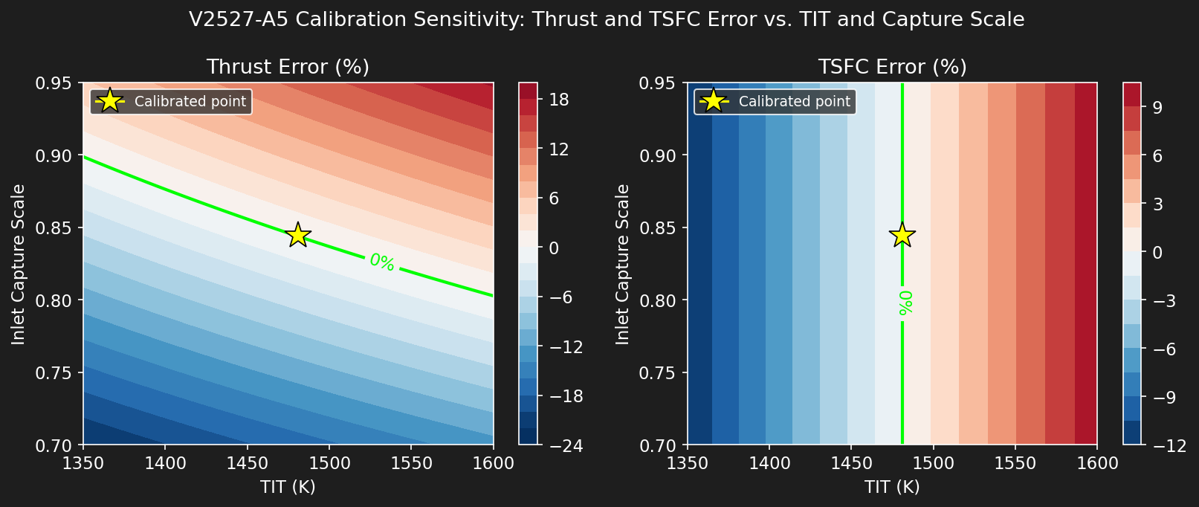
Figure 5. V2527-A5 calibration sensitivity: thrust and TSFC percentage error across the TIT / inlet-capture-scale plane. The lime contour marks zero error; the yellow star marks the selected calibration point (TIT = 1481 K, capture scale = 0.844).
The zero-error contours for thrust and TSFC intersect close to the selected calibration point, and each contour has a distinct, non-parallel slope in this region. This indicates the two-parameter calibration is reasonably well-conditioned: the two target metrics constrain the solution from different directions rather than being redundant, which would otherwise permit a wide range of equally valid (TIT, capture scale) pairs and make the near-zero error in Table 2 a weaker piece of evidence.
The calibrated values are also plausible on physical grounds. A TIT of 1481 K for the V2527-A5 is lower than the 1700 K assumed for the CFM56-7B, consistent with the V2527-A5’s lower overall pressure ratio (27.2 vs. 32.8) and the generally lower cycle temperatures associated with a less aggressively rated engine of this generation. The calibrated inlet capture scale of 0.844, however, sits noticeably above the 0.65–0.70 literature range applied directly to the CFM56-7B [8]. Because capture scale was used as a free calibration parameter for V2527-A5 rather than taken directly from cited data, it is likely absorbing additional unmodeled error elsewhere in the cycle. For example, differences in real fan/booster efficiency, or the simplified fixed-pressure-ratio compressor representation discussed in Section 7, rather than representing a physically distinct inlet capture behavior. This is flagged as a limitation of the calibration approach rather than presented as a validated engine characteristic.

5.5 Station-by-Station Property Comparison
Figure 6 compares stagnation temperature and pressure at each station for both engines at their respective design points, as an internal consistency check beyond the single-number thrust/TSFC comparison in Table 2.
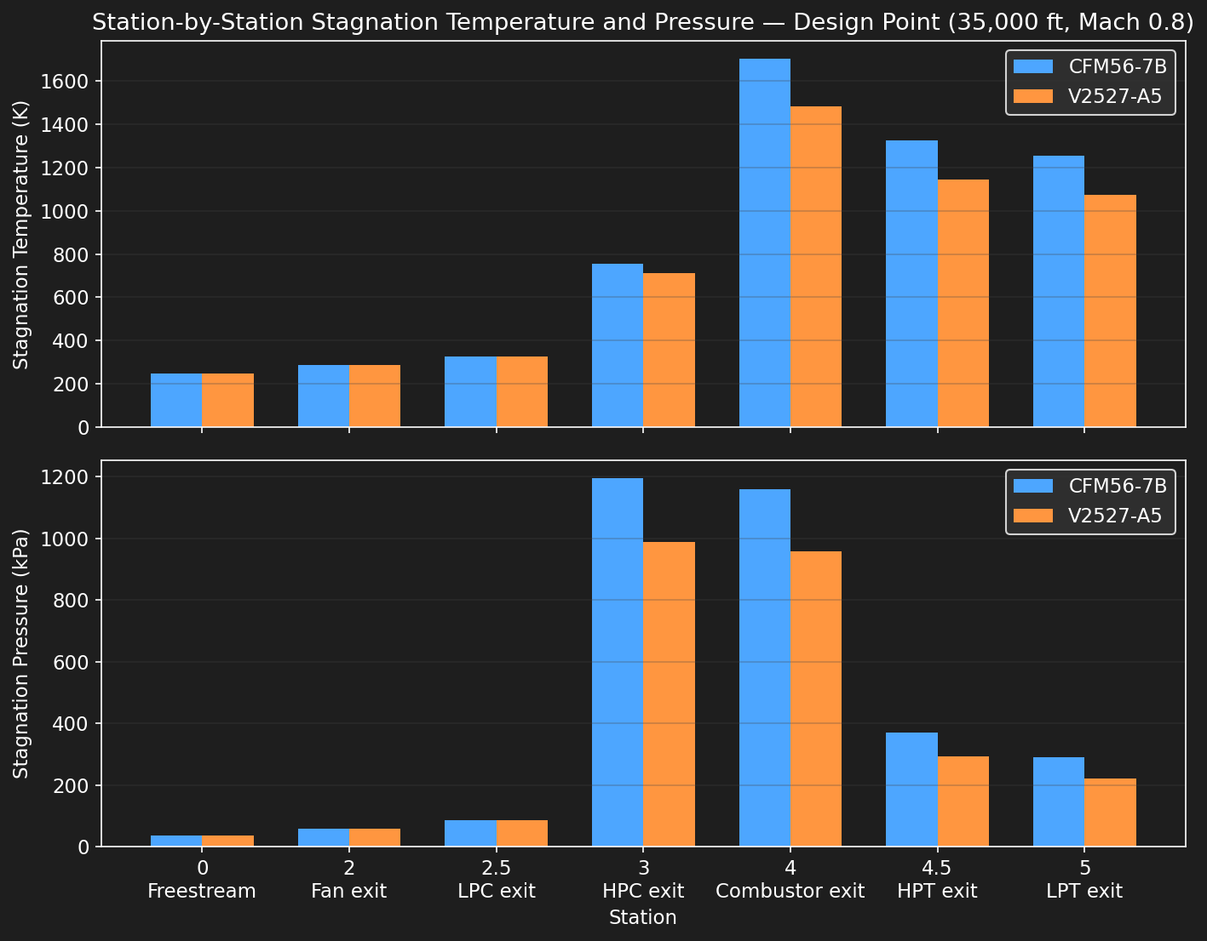
Figure 6. Station-by-station stagnation temperature and pressure comparison, CFM56-7B vs. V2527-A5, at each engine’s respective design point.
The two engines follow the same qualitative shape, as expected given the shared solver architecture, but the V2527-A5 shows a visibly lower combustor exit temperature (Station 4, reflecting its lower calibrated TIT) and a lower peak pressure (Station 3, reflecting its lower OPR). No station shows a non-physical reversal, for example, a pressure increase across a turbine, or a temperature increase across a nozzle. For either engine, which is a useful sanity check that the calibration did not push the cycle into an unphysical regime even while fitting the two target benchmarks.

6. Parametric Study
The parametric plots shown below use the final V2527-A5 configuration. Each pair of plots includes a highlighted design point corresponding to 35,000 ft, Mach 0.8, and TIT = 1481 K. The sweeps are intended to evaluate trends and model behavior rather than to claim full off-design accuracy.
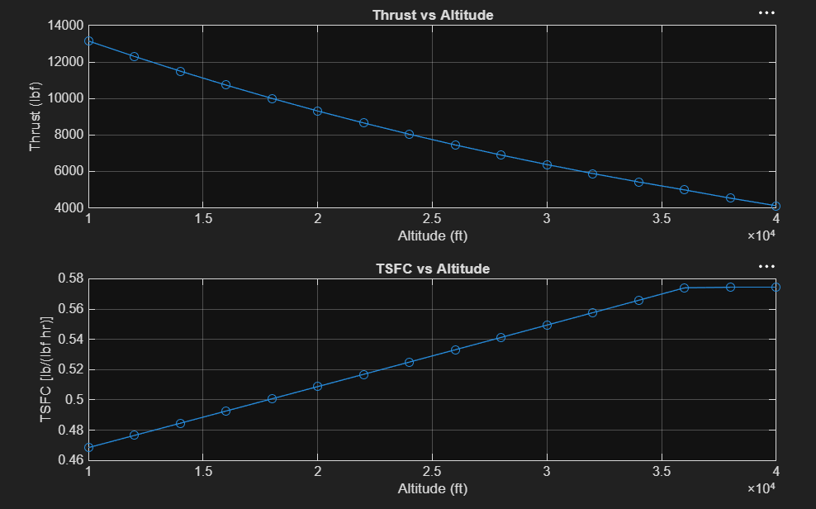
Figure 2. Predicted thrust and TSFC variation with altitude.
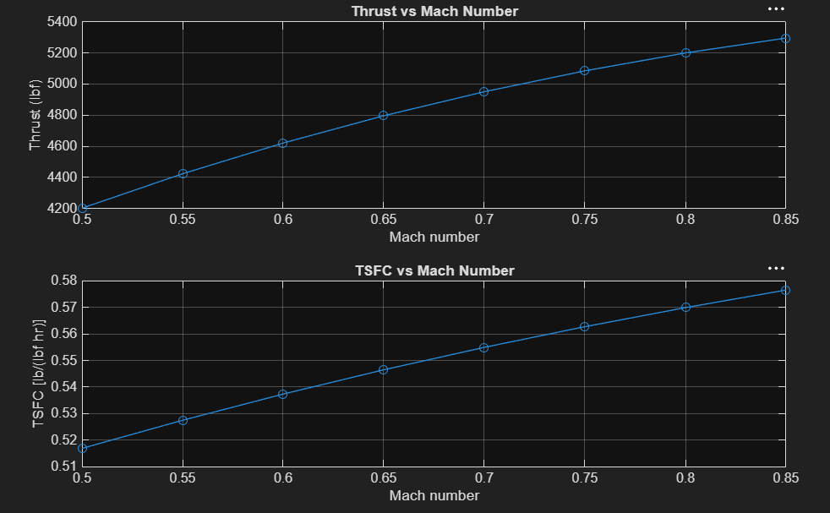
Figure 3. Predicted thrust and TSFC variation with flight Mach number.
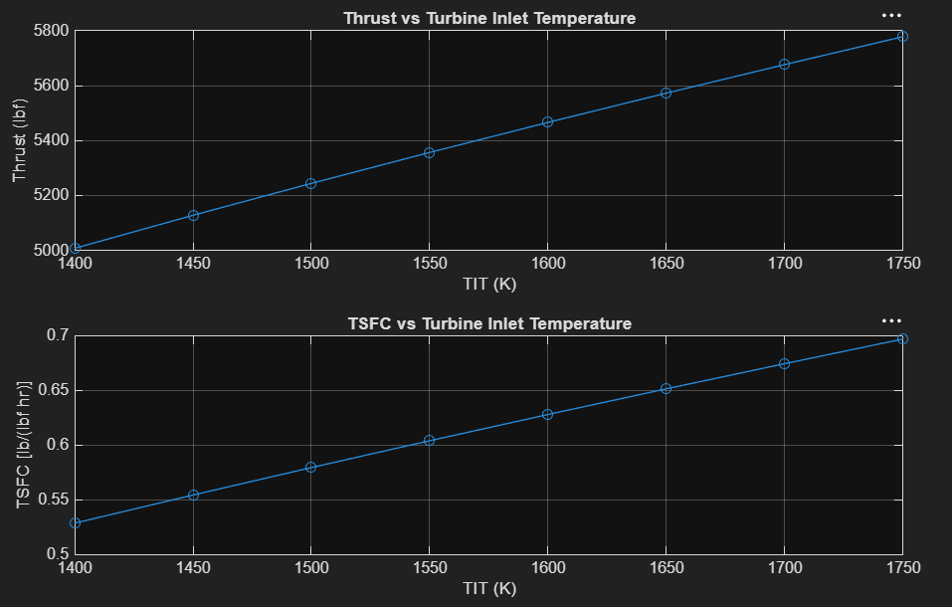
Figure 4. Predicted thrust and TSFC variation with turbine inlet temperature.

6.1 Altitude
Thrust decreases strongly with altitude, from roughly 13,000 lbf near 10,000 ft to approximately 4,000 lbf at 40,000 ft. The dominant cause is reduced atmospheric density, which lowers captured mass flow and therefore reduces both core and bypass momentum thrust. TSFC increases because thrust falls faster than fuel flow within the simplified fixed-cycle assumptions. A change in slope is visible near the upper end of the range as the ISA temperature profile approaches the tropopause region.
This kink coincides with the ISA tropopause at 11,000 m (≈36,089 ft), above which the standard atmosphere temperature stops decreasing with altitude and remains constant at 216.65 K. Because air density and freestream stagnation pressure both depend on this temperature profile, the rate of change of captured mass flow and therefore thrust and TSFC, with altitude changes measurably above the tropopause, producing the visible change in curve slope near the top of the sweep range rather than a smooth continuation of the trend established at lower altitudes.

6.2 Mach Number
The model predicts increasing thrust and TSFC over Mach 0.5 to 0.85. Within the current formulation, increasing flight speed raises captured mass flow and inlet stagnation pressure. However, a real engine does not hold fan pressure ratio, compressor pressure ratios, component efficiencies, and spool operating points fixed across this range. Because the model contains no fan or compressor maps, corrected shaft-speed matching, variable stator schedules, or control-law logic, this trend should be interpreted as an idealized map-free response rather than a realistic fixed-throttle thrust-lapse prediction.

6.3 Turbine Inlet Temperature
Increasing TIT produces a nearly linear increase in thrust because additional fuel raises the energy available to the core flow and increases core nozzle exhaust velocity. TSFC also increases across the selected range because fuel flow rises more rapidly than the resulting thrust gain. This trend highlights a key propulsion trade-off: higher TIT improves specific thrust but increases thermal loading, cooling demand, material requirements, and fuel consumption. Those durability effects are beyond the present model scope.

6.4 Specific Thrust vs. TSFC Trade-Off
Figure 7 recasts the TIT sweep results from Section 6.3 in specific-thrust-versus-TSFC form, the standard axes used in industry propulsion trade studies, for both CFM56-7B and V2527-A5.
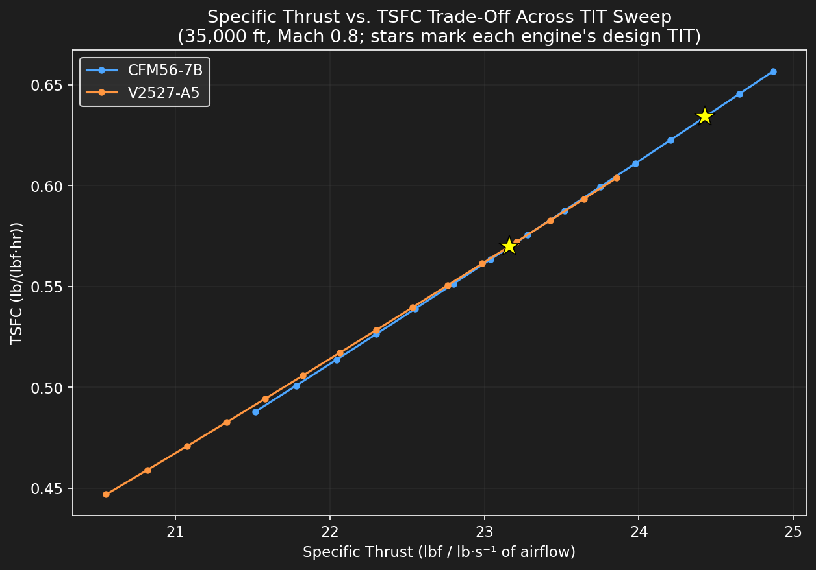
Figure 7. Specific thrust vs. TSFC trade-off across the TIT sweep, both engines, with each engine’s design-point TIT marked with a star.
Both engines trace a similar increasing trade curve: raising TIT increases specific thrust but also increases TSFC, illustrating the fundamental thermal-loading-versus-efficiency trade-off inherent to turbofan cycle design. The V2527-A5 curve sits below and to the left of the CFM56-7B curve across the shared range, consistent with its lower bypass ratio and OPR producing lower specific thrust at a given TSFC. Each engine’s design-point TIT falls within the interior of its respective sweep range rather than at either extreme, which is a physically reasonable place for a cruise design point to sit.

7. Model Limitations and Future Work
Limitation | Engineering consequence
No component maps | The model cannot couple corrected mass flow, corrected shaft speed, pressure ratio, efficiency, and surge margin. This is the largest limitation for off-design prediction.
Constant gas properties | Cp and γ are fixed separately for air and hot gas, even though both vary with temperature and composition.
Fixed efficiencies | Fan, compressor, turbine, and nozzle efficiencies remain constant throughout all sweeps.
Simplified inlet capture | Mass flow is estimated from fan area and an effective capture coefficient. Hub blockage, spillage, inlet distortion, boundary layers, and installation losses are not resolved.
No cooling or bleed | Turbine cooling, cabin bleed, anti-ice extraction, seal leakage, and accessory power are omitted.
No transient spool dynamics | The solver is steady-state and does not calculate spool acceleration, controller response, or surge during throttle transients.
Mixed CFM56 public data | The CFM56 case uses family-level cycle data and a selected cruise benchmark, so it is not an exact digital replica of a single subtype.
Calibration of V2527 | TIT and capture scale were inferred from published outputs. Section 5.4 shows the calibration is well-conditioned and physically plausible in one parameter (TIT) but likely absorbs unmodeled error in the other (capture scale).

7.1 Recommended Extensions
- Digitize or construct representative fan and compressor maps and solve for corrected mass flow and spool speed.
- Introduce temperature-dependent gas properties and a combustion-gas composition model.
- Add cooling, bleed, and accessory power extraction.
- Add inlet pressure recovery and nozzle discharge coefficients.
- Perform a Monte Carlo or local sensitivity study on TIT, efficiencies, pressure-ratio split, and capture coefficient, extending the two-parameter grid in Section 5.4 to the full assumption set.
- Create automated CSV export and publication-quality figure generation for GitHub and report updates.

8. Conclusions
A modular station-by-station MATLAB model was developed for preliminary separate-flow turbofan cycle analysis. The solver calculates atmospheric conditions, fan and compressor work, combustor fuel-air ratio, turbine work balance, nozzle choking, momentum and pressure thrust, fuel flow, and TSFC.
The CFM56-7B family-level configuration produced a cruise thrust error of +1.51% and a TSFC error of -5.47% relative to the selected reference values. This is credible agreement for a simplified model with generic component efficiencies and no cooling, bleed, accessory, or installation losses.
The same solver was transferred to the V2527-A5. Published cycle and geometry data were incorporated through the engine-definition structure, while unavailable cruise TIT and effective inlet-capture behaviour were calibrated against published TSFC and thrust. A calibration sensitivity analysis showed that this two-parameter fit corresponds to a well-defined solution rather than an arbitrary one, while also identifying that the calibrated capture scale likely absorbs unmodeled error rather than representing a validated physical characteristic, an important distinction for interpreting the V2527-A5 result correctly rather than overstating it as independent validation.
The altitude and TIT sweeps produced clear, physically interpretable trends, including a tropopause-linked change in altitude-sweep slope and a specific-thrust/TSFC trade-off consistent between both engines. The Mach-number sweep exposed the main limitation of a map-free design-point model: realistic off-design behaviour requires component maps, corrected spool-speed matching, and engine-control logic. This limitation is not hidden; it is a documented boundary of the model and a clear route for future development.
As a personal portfolio project, the work demonstrates propulsion thermodynamics, MATLAB programming, model verification, sensitivity analysis, debugging, technical communication, and honest treatment of assumptions and calibration limits. The project is therefore suitable for presentation in a GitHub repository, CV project section, or propulsion-focused interview.

Appendix A. Model Capability Summary
Capability | Status
ISA atmosphere and freestream stagnation state | Implemented
Fan, LPC, and HPC compression | Implemented
Combustor pressure loss and fuel-air ratio | Implemented
HPT and LPT shaft-work balance | Implemented
Core and bypass nozzle choking checks | Implemented
Momentum and pressure thrust | Implemented
TSFC calculation | Implemented
Altitude, Mach, and TIT sweeps | Implemented
Multiple engine definitions | Implemented
Calibration sensitivity analysis | Implemented
Station-by-station cross-engine comparison | Implemented
Component-map off-design solver | Not implemented
Variable gas properties | Not implemented
Cooling, bleed, and accessory loads | Not implemented
Transient spool dynamics | Not implemented

Appendix B. Suggested Portfolio Summary
Developed a modular MATLAB station-by-station turbofan cycle solver with compressor, combustor, turbine work-balance, choked-nozzle, thrust, and TSFC models; reproduced a CFM56-7B family-level cruise point within 1.5% thrust error and transferred the same architecture to a calibrated V2527-A5 application, verified with a two-parameter sensitivity analysis. Supported by altitude, Mach, TIT, and specific-thrust/TSFC sensitivity studies.

References
[1] Pratt & Whitney / International Aero Engines, "V2500 – The Engine of Choice," product factsheet. https://prd-sc102-cdn.rtx.com/-/media/pw/newsroom/collateral/documents/commercial-engines/ce_v2500_fact.pdf
[2] Meza, V. J. et al., "The FC-1D: The Profitable Alternative," NASA Technical Reports Server, 1994. Lists V2527 cruise SFC of 0.570 lb/(lbf·hr) and 5,200 lbf thrust at 35,000 ft and Mach 0.8. https://ntrs.nasa.gov/api/citations/19950006215/downloads/19950006215.pdf
[3] CFM International, "CFM56-5B & CFM56-7B," official engine-family overview. https://www.cfmaeroengines.com/cfm56/CFM56-5B-CFM56-7B
[4] Purdue University AAE Propulsion, "CFM56," turbofan engines reference page — cruise thrust 5,905 lbf and cruise SFC 0.671 lb/(lbf·hr). https://engineering.purdue.edu/~propulsi/propulsion/jets/tfans/cfm56.html
[5] CFM56 engine specification compilation — bypass ratio 5.1, overall pressure ratio 32.8, and fan diameter 61.0 in for the CFM56-7B26/7B27. https://www.slideshare.net/amineshinobie/air-sealing-48015569
[6] b737.org.uk, "The Boeing 737 Powerplant" — confirms the CFM56-7B’s 61-inch titanium wide-chord fan diameter. http://www.b737.org.uk/powerplant.htm
[7] Turan, O. et al., "Exergo-economic analysis of a CFM56-7B turbofan engine," Energy (ScienceDirect) — compressor/turbine stage counts, bypass ratio 5.1, overall pressure ratio 32.8. https://www.sciencedirect.com/science/article/abs/pii/S0360544222018370
[8] NASA Technical Memorandum TM X-3064 — cruise inlet mass flow ratio varying from 0.700 at Mach 0.6 to 0.645 at Mach 0.85. https://ntrs.nasa.gov/api/citations/19740020128/downloads/19740020128.pdf
[9] US Patent 8,756,908 — defines ‘bucket cruise TSFC’ as the industry-standard Mach 0.8 / 35,000 ft best-fuel-consumption reference condition. https://image-ppubs.uspto.gov/dirsearch-public/print/downloadPdf/8756908
[10] CFM International, "CFM56 Overview," official family overview. https://www.cfmaeroengines.com/cfm56
[11] MATLAB Aerospace Toolbox documentation, atmosisa function, International Standard Atmosphere implementation.

