Hidden Markov Regime-Switching Models for EU Carbon Allowance Prices
Math 467 Stochastic Processes Final Project by Zoe Tomlinson
Repo with all code, figures and tables: https://github.com/itszoetom/hmm-carbon-price-regimes

1. Intro
The European Union Emissions Trading System sets a market price for the right to emit one tonne of carbon, the European Union Allowance (EUA). Since 2008, the price has changed a lot from less than 3 euros to up to 100, and has cycled through calm periods, volatile stress, and sharp crashes (Yu et al.). A single fixed model cannot describe behavior that changes this much, so for this project I wanted to use a stochastic model to identify states, or regimes, that better model the EUA market price movement. A Hidden Markov Model (HMM) works best for this, as it uses a latent regime that evolves as a finite-state Markov chain, with daily returns drawn from a regime-specific Gaussian. This fits my goal because I am not trying to forecast prices, but rather estimate the regime dynamics and answer the long-run questions using Markov chain theory. Specifically, I am interested in how often and long the market sits in each regime, how fast the distribution settles, and how sensitive the long-run crash frequency is to the transition probabilities.

2. Data
I used the front December EUA futures daily settlement, the most liquid EU carbon benchmark, from 2008-01-03 to 2026-05-20 (4768 trading days). My modeling input is the daily log-return calculated using: $r_{t}=logP_{t}-logP_{t-1}$. The returns were very non-Gaussian, with an annualized volatility of 0.46, skewness of -0.76, and excess kurtosis of 15.1 (Table 1). A normal fit misses both the sharp peak and heavy tails of the distribution, which motivates a combination of regime-specific Gaussians (Fig. 1).

3. Model
The latent regime $S_{t}$ takes values in a finite state space and is assumed to be a homogeneous Markov chain, so that
$$P(S_{t+1}=j∣S_{t}=i,S_{t-1},…,S_{0})=P(S_{t+1}=j∣S_{t}=i)=p_{ij},$$
with the transition matrix $P=[p_{ij}]$ having nonnegative entries and rows that sum to one.
Depending on the regime, the return is Gaussian as expressed by the formula: $r_{t}∣\{S_{t}=k\}∼N(μ_{k},σ_{k}^{2})$. The deterministic structure is the number of regimes and Markov property, and the random structure is which regime holds and the within-regime return.

4. Transition Matrix
Estimating $P$ was the trickiest part in this project, because the regime is never observed. I decided to use a baseline method and my HMM methods and compare them to best estimate $P$.

1. Counting Baseline (observed chain) :
I labelled each day by rolling-volatility terciles (low, medium, high) and estimated $P$ by counting transitions and row-normalizing using the formula: pij=Nijk​Nik, where $N_{ij}$ is the number of days in state $i$ followed by a day in state $j$. For a fully observed Markov chain this “count and normalize” rule is the maximum likelihood estimator of $P$. The result (Table 3) is tridiagonal, suggesting the chain moves only to adjacent volatility states, never directly from low to high, reflecting the structure of a birth and death chain!

2. Baum-Welch (latent chain) :
I fit a Gaussian hidden Markov model by the Baum-Welch algorithm, an expectation-maximization method (Rabiner). I used the `hmmlearn` Python library (Lebedev) with twenty random initializations per candidate, storing the highest-likelihood fit. I chose the number of regimes using the Bayesian information criterion: $BIC=-2 l+mlogn,$where $l$ is the maximized log-likelihood, $m$ the number of free parameters, and $n$ the sample size, evaluated over two, three, and four states (Table 4).
BIC was lowest at three states, which I interpreted as three regimes: normal (annualized volatility 0.23, small positive drift), stressed (0.40), and crashed (0.95, strongly negative mean return) (Table 5, left figure). The estimated transition matrix (Table 6, right figure) is again tridiagonal, with persistent diagonals (0.98, 0.97, 0.92) and no direct move between normal and crashed. Both of my estimation methods found the same tridiagonal structure!

Left: The three estimated regime densities and their mixture (black). Right: The Baum-Welch transition matrix showing a tridiagonal structure, reflecting a birth-and-death pattern.
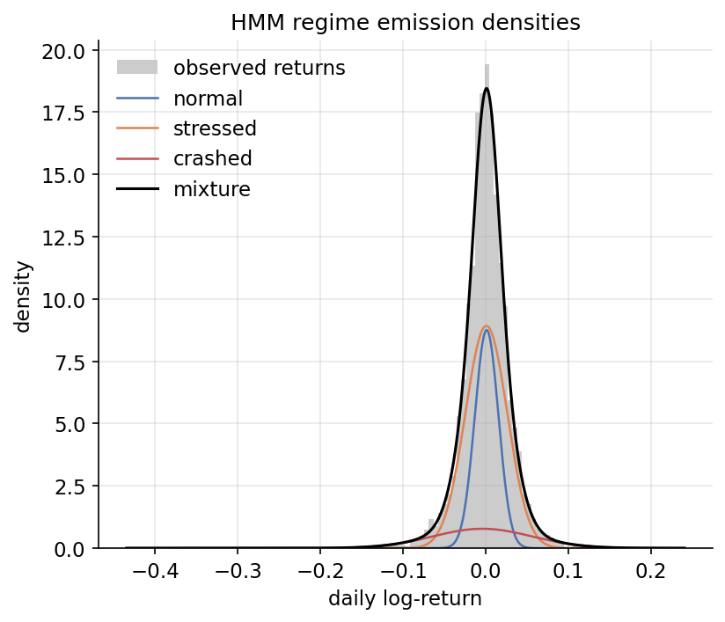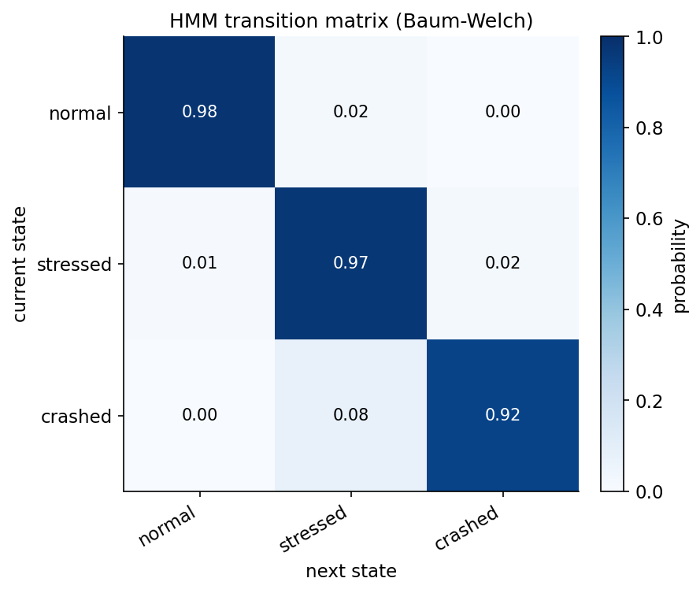

5. Markov Chain Analysis
Now that I’ve estimated $P$, I wanted to look at the long-run sensitivity using stationary distribution with formula: πP=π, i​πi=1, where the left eigenvector of $P$ at eigenvalue 1 gives the long-run fraction of time in each regime. For the HMM, $π=(0.315, 0.568, 0.117)$, meaning in the long run the market is crashed about 12% of the time. The chain is irreducible and aperiodic, so by the convergence theorem this $π$ is unique and is the limit of the distribution from any starting point.
The holding time in regime $i$ is geometric with success probability $1-p_{ii}$, so its expected duration is described by: $E\left[\text{duration in }i\right]=\frac{1}{1-p_{ii}}.$ This tells us that the price spent about 47 days in normal, 36 in stressed, and 13 in crashed. These numbers closely match the observed mean run lengths of the counting baseline (Table 2), which supports the Markov holding-time assumption.
The convergence theorem also tells us the rate. For an initial distribution $f$, $\left\|fP^{n}-π\right\|=O​\left(|λ_{2}|^{n}\right),$ where $λ_{2}$ is the second-largest eigenvalue modulus of $P$. Here $|λ_{2}|=0.97$, so mixing is slow, like a few months.

6. Decoding
Viterbi decoding identifies the most likely regime path behind the observed returns. The decoded crashed regime aligns on every known EU ETS crisis (the 2008-2009 financial crisis, the 2011-2013 oversupply collapse, 2018 reform, 2020 COVID outbreak, and the 2022 energy crisis). The fraction of days the decoded path spends in each regime (0.29, 0.61, 0.10; Table 8) closely matches the stationary distribution, suggesting the HMM did really well.
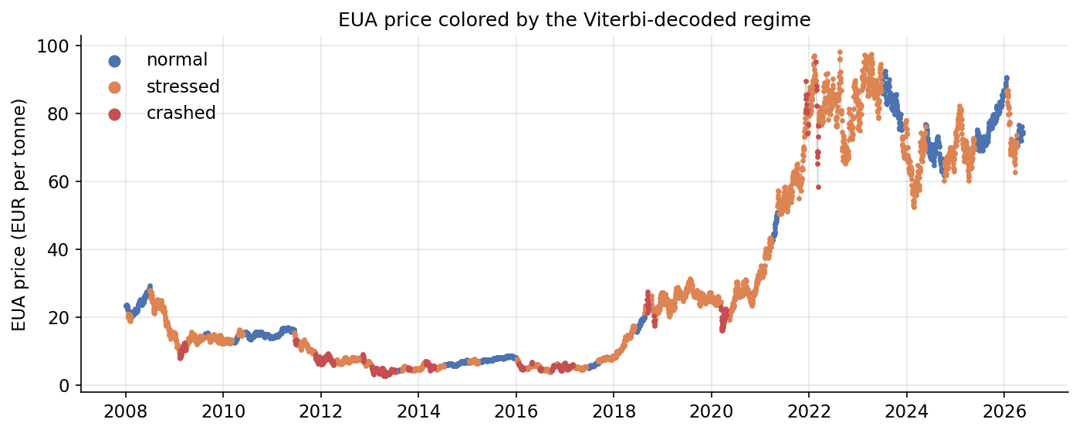

7. Conclusion
A three-regime hidden Markov model fits the EUA return series well and gives us interpretable long-run dynamics: the market spends roughly 12 percent of its time in a crashed regime, regimes are persistent (a month or more), and the chain mixes slowly. I used two independent estimates of the transition matrix, one from counting observed volatility states and one from Baum-Welch on the latent chain, and they agree on a tridiagonal birth-and-death structure. Additionally, the decoded regime path matches the historical crisis record.

Works Cited
- “Carbon Emissions Futures Historical Data.” Investing.com, www.investing.com/commodities/carbon-emissions-historical-data. Accessed 20 May 2026.
- Lebedev, Sergei, et al. hmmlearn: Hidden Markov Models in Python. Version 0.3.3, 2024, github.com/hmmlearn/hmmlearn.
- Rabiner, Lawrence R. “A Tutorial on Hidden Markov Models and Selected Applications in Speech Recognition.” Proceedings of the IEEE, vol. 77, no. 2, 1989, pp. 257-286, https://doi.org/10.1109/5.18626.
- Villar-Rubio, Elena, et al. “Using EGARCH Models to Predict Volatility in Unconsolidated Financial Markets: The Case of European Carbon Allowances.” Journal of Environmental Studies and Sciences, 2023, https://doi.org/10.1007/s13412-023-00838-5.
- Yu, Haixu, et al. “Carbon Market Volatility Analysis Based on Structural Breaks: Evidence from EU-ETS and China.” Frontiers in Environmental Science, vol. 10, 2022, art. 973855, https://doi.org/10.3389/fenvs.2022.973855.

