PCPro 3
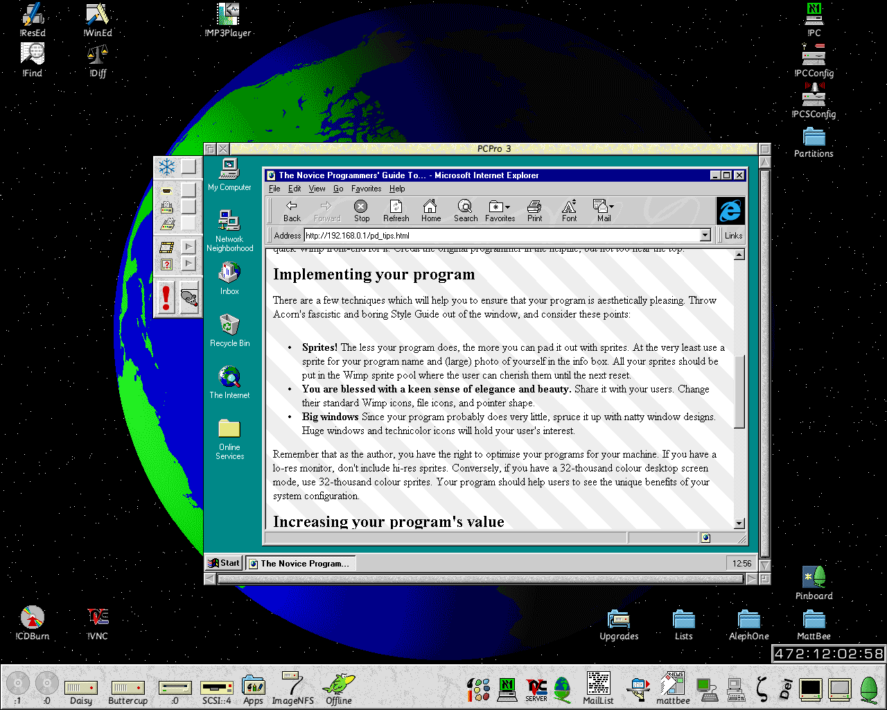
Users’ Guide
© Aleph One Limited, 1998

