**Algorithm result**

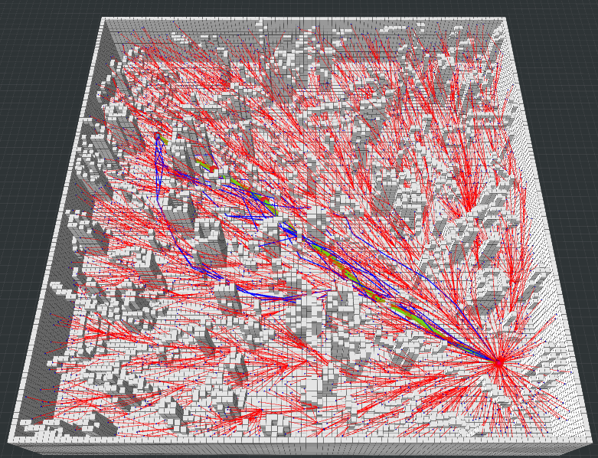

RRT*

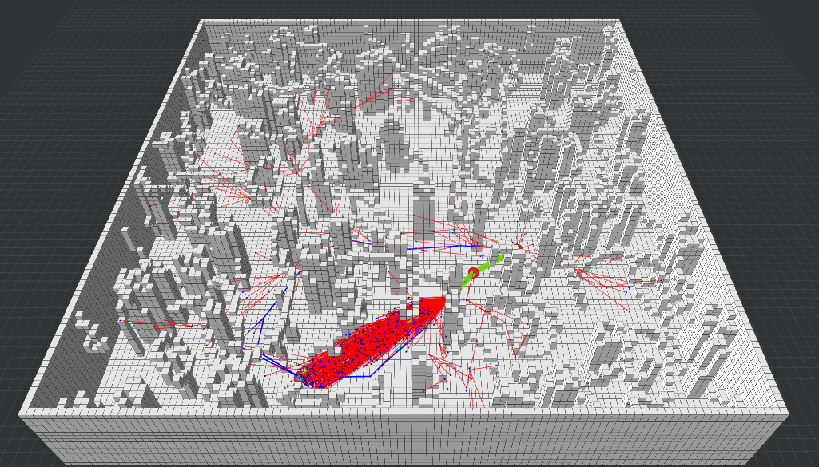

Informed RRT*

**Analysis**

**Informed RRT* just decreases the exploration space into a oval area rather than the whore map, which boosts and accelerates the convergence process.**