* **Unconstrained case**

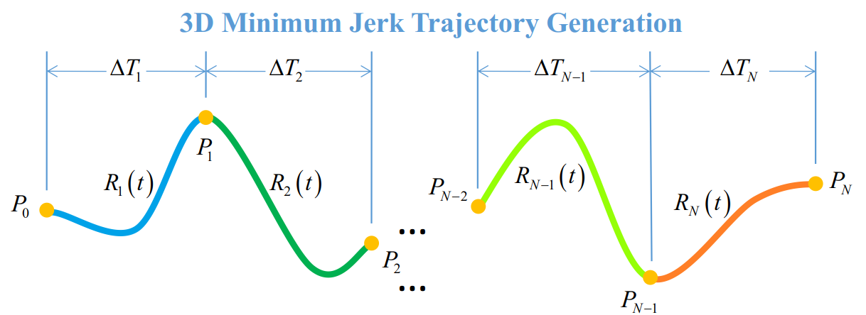

* **Use relative timeline**

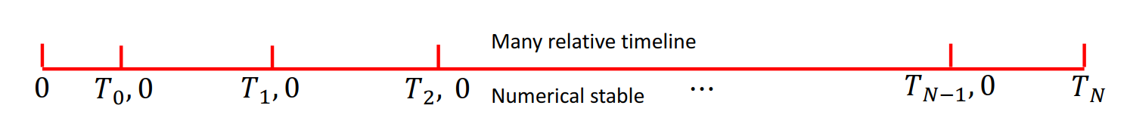

* **Optimization Equation**

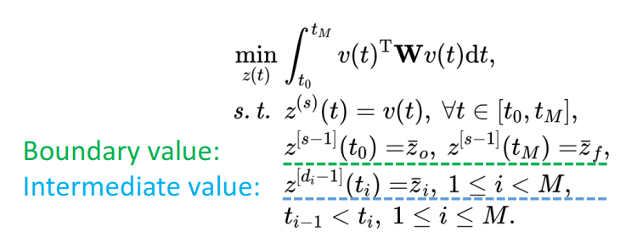

* **Theory**

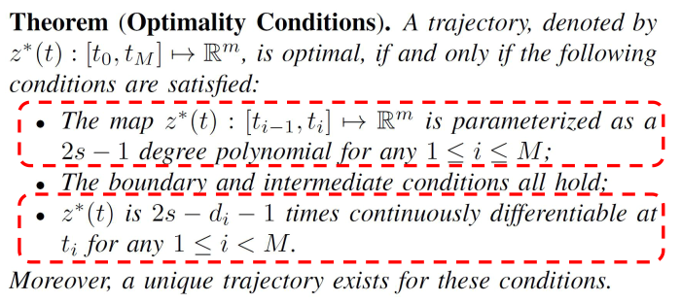

* **Problem become as linear equation system**

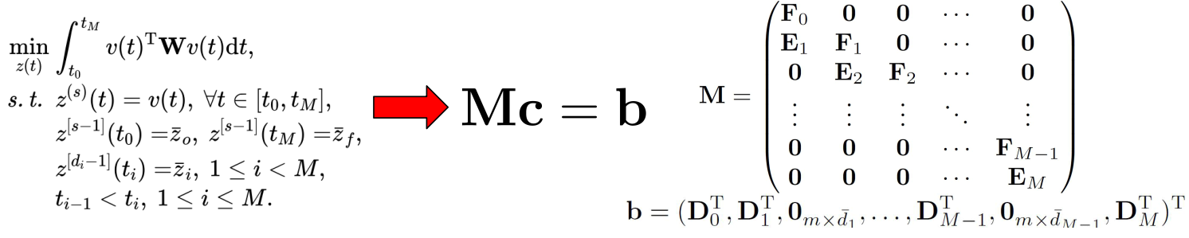

* **Deriving the matrix M**

**Derivative constraints P0:**

**We have 3 derivative constrains at initial point**

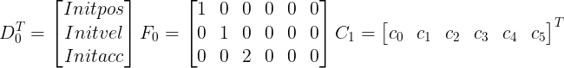

**Derivative constraints PN:**

**We have 3 derivative constrains at terminal point**

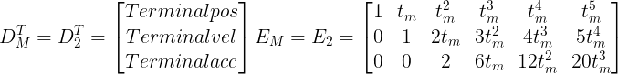



\large C_M=C_2=\begin{bmatrix} c_0'&c_1'&c_2'&c_3'&c_4'&c_5' \end{bmatrix}^T\large C_M=C_2=\begin{bmatrix} c_0'&c_1'&c_2'&c_3'&c_4'&c_5' \end{bmatrix}^T

**Continuity constraints :**

**We have 6 Continuity constraints at each intermediate Position**

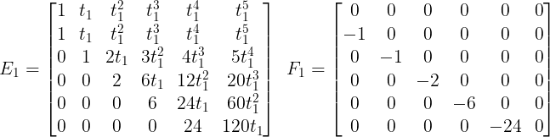

\large C_M=C_2=\begin{bmatrix} c_0'&c_1'&c_2'&c_3'&c_4'&c_5' \end{bmatrix}^T

* **Solve the equation**
$$c=M^{-1}b$$

* **Result**

