* **Get $A_{d} B_{d} g_{d}$**

Convert linear model to discrete-time using forward Euler method

$$\dot{x}=A_{c}x+B_{c}u+g_{c}$$

Linearization and discretization the model equation:

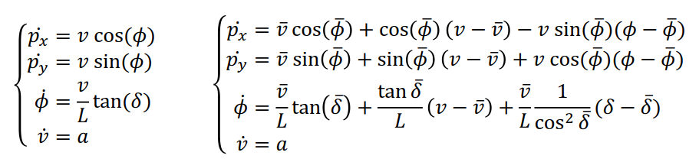

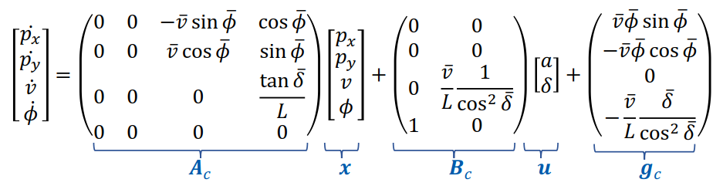

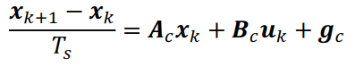



* **Set cost function**

The position error and polar angle error of the car are required to be as small as possible in the current position and trajectory:

\large J=(x-x_{ref})^2+(y-y_{ref})^2+\rho (\phi-\phi_{ref})^2

State maxtrix $x=\left(\begin{matrix}\begin{matrix}p_{x} \\ p_{y}\end{matrix} \\ \begin{matrix}ϕ \\ v\end{matrix}\end{matrix}\right)$，and $Q=\left(\begin{matrix}\begin{matrix}\begin{matrix}\begin{matrix}1 \\ 0\end{matrix} \\ \begin{matrix}0 \\ 0\end{matrix}\end{matrix} & \begin{matrix}\begin{matrix}0 \\ 1\end{matrix} \\ \begin{matrix}0 \\ 0\end{matrix}\end{matrix}\end{matrix} & \begin{matrix}\begin{matrix}\begin{matrix}0 \\ 0\end{matrix} \\ \begin{matrix}ρ \\ 0\end{matrix}\end{matrix} & \begin{matrix}\begin{matrix}0 \\ 0\end{matrix} \\ \begin{matrix}0 \\ 0\end{matrix}\end{matrix}\end{matrix}\end{matrix}\right)$

So the cost funtion become:

$$J_{i}={\left(x-x_{ref}\right) }^{T}\left(\begin{matrix}\begin{matrix}\begin{matrix}\begin{matrix}1 \\ 0\end{matrix} \\ \begin{matrix}0 \\ 0\end{matrix}\end{matrix} & \begin{matrix}\begin{matrix}0 \\ 1\end{matrix} \\ \begin{matrix}0 \\ 0\end{matrix}\end{matrix}\end{matrix} & \begin{matrix}\begin{matrix}\begin{matrix}0 \\ 0\end{matrix} \\ \begin{matrix}ρ \\ 0\end{matrix}\end{matrix} & \begin{matrix}\begin{matrix}0 \\ 0\end{matrix} \\ \begin{matrix}0 \\ 0\end{matrix}\end{matrix}\end{matrix}\end{matrix}\right)\left(x-x_{ref}\right)$$

Note that when i=horizon:

$$J_{N}={\left(x-x_{ref}\right)}^{T}\left(\begin{matrix}\begin{matrix}\begin{matrix}\begin{matrix}ρ_{N} \\ 0\end{matrix} \\ \begin{matrix}0 \\ 0\end{matrix}\end{matrix} & \begin{matrix}\begin{matrix}0 \\ ρ_{N}\end{matrix} \\ \begin{matrix}0 \\ 0\end{matrix}\end{matrix}\end{matrix} & \begin{matrix}\begin{matrix}\begin{matrix}0 \\ 0\end{matrix} \\ \begin{matrix}ρ_{N}*ρ \\ 0\end{matrix}\end{matrix} & \begin{matrix}\begin{matrix}0 \\ 0\end{matrix} \\ \begin{matrix}0 \\ 1\end{matrix}\end{matrix}\end{matrix}\end{matrix}\right)\left(x-x_{ref}\right)$$

* **Set the constrain**

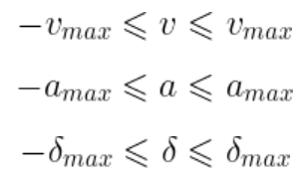

Note that the constrain of $dδ$:

$$-dδ_{max} *dt≤dδ=δ_{k}-δ_{k-1}≤dδ_{max} *dt$$

* **Solving quadratic programming problems**

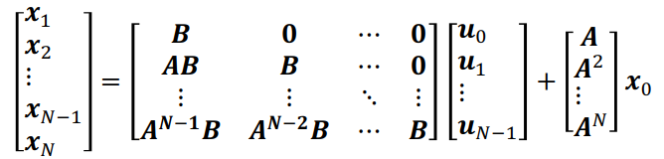

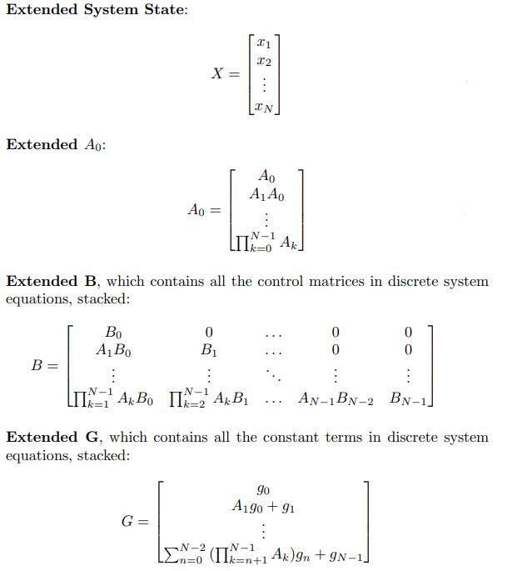

\large \textbf{q}_x = -\textbf{Q}^T\textbf{x}_{ref}

* **Get delay MPC ${new_x}_{0}$**

The initial state of the system can be defined as the amount of state after the current moment $τ$

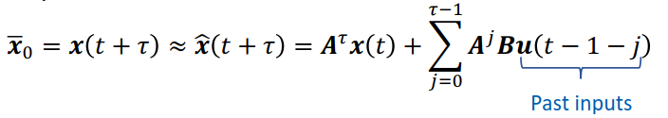

Let $N=t+τ$ we get ${new_x}_{0}=x_{N}$, and according $X=BB*U+AA*x_{0}+gg$, finally we can get ${new_x}_{0}$ from $X$

* **Simulation result**

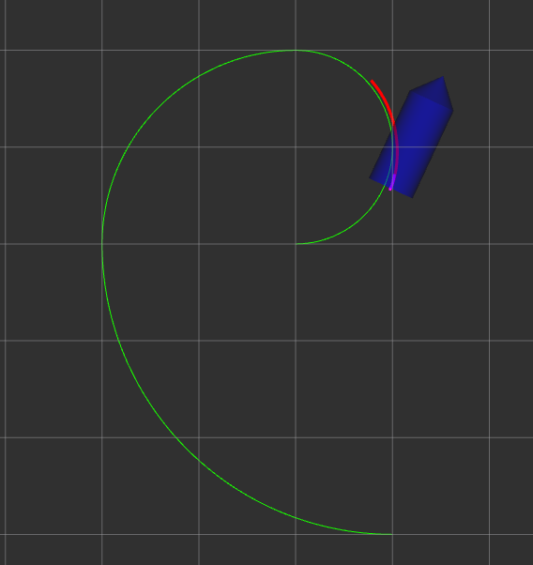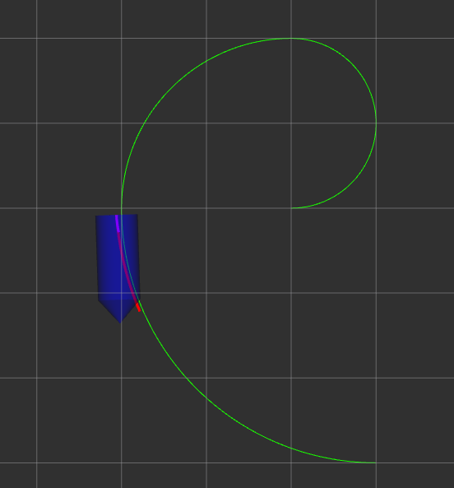

MPC performance is affected by the initial position and yaw angle and horizon, so the other two paths perform not very well

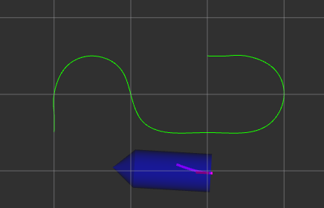

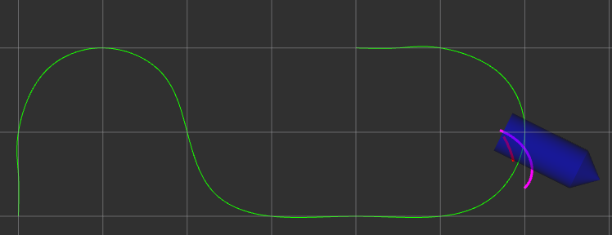

* **Bugs:**

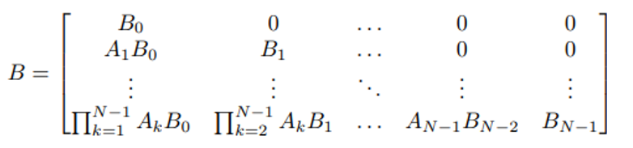

Multiplying A sequentially from right to left causes numerical instability when N\_ is large.

Dynamic programming from top to bottom multiplies one A at a time will not cause numerical instability