## 问题1

a：

|  |  |  |
| --- | --- | --- |
| x | f(x) | f’(x) |
| 1.1 | 9.025013 | $$17.769705$$ |
| 1.2 | 11.02318 | $$22.191635$$ |
| 1.3 | 13.46374 | $$27.10375$$ |
| 1.4 | 16.44465 | $$32.51085$$ |

计算过程：

$$f'\left(1.1\right)=\frac{1}{0.2}\left\{-3f\left(1.1\right)+4f\left(1.2\right)-f\left(1.3\right)\right\}=17.769705$$

$$f^{'}\left(1.2\right)=\frac{1}{0.2}\left\{f\left(1.3\right)-f\left(1.1\right)\right\}=22.191635$$

$$f^{'}\left(1.3\right)=\frac{1}{0.2}\left\{f\left(1.4\right)-f\left(1.2\right)\right\}=27.10375$$

$$f'\left(1.4\right)=\frac{1}{0.2}\left\{3f\left(1.4\right)-4f\left(1.3\right)+f\left(1.2\right)\right\}=32.51085$$

b:

|  |  |  |
| --- | --- | --- |
| x | f(x) | f’(x) |
| 8.1 | 16.94410 | 3.09205 |
| 8.3 | 17.56492 | 3.11615 |
| 8.5 | 18.19056 | 3.139975 |
| 8.7 | 18.82091 | 3.163525 |

计算过程：

$$f'\left(8.1\right)=\frac{1}{0.4}\left\{-3f\left(8.1\right)+4f\left(8.3\right)-f\left(8.5\right)\right\}=3.09205$$

$$f^{'}\left(8.3\right)=\frac{1}{0.4}\left\{f\left(8.5\right)-f\left(8.1\right)\right\}=3.11615$$

$$f^{'}\left(8.5\right)=\frac{1}{0.4}\left\{f\left(8.7\right)-f\left(8.3\right)\right\}=3.139975$$

$$f'\left(8.7\right)=\frac{1}{0.4}\left\{3f\left(8.7\right)-4f\left(8.5\right)+f\left(8.3\right)\right\}=3.163525$$

## 问题2

$$\left\{\begin{aligned}M=N\left(h\right)+k_{1}h^{2}+k_{2}h^{4}+k_{3}h^{6}+… ① \\ M=N\left(\frac{h}{3}\right)+k_{1}{\left(\frac{h}{3}\right)}^{2}+k_{2}{\left(\frac{h}{3}\right)}^{4}+k_{3}{\left(\frac{h}{3}\right)}^{6}+… ② \\ M=N\left(\frac{h}{9}\right)+k_{1}{\left(\frac{h}{9}\right)}^{2}+k_{2}{\left(\frac{h}{9}\right)}^{4}+k_{3}{\left(\frac{h}{9}\right)}^{6}+… ③\end{aligned}\right.$$

由①②消去h2可得：

由②③消去h2可得：

由④⑤消去h4可得：

## 问题3

a：

$$f\left(x\right)=f\left(x_{0}\right)\frac{\left(x-x1\right)\left(x-x2\right)\left(x-x3\right)\left(x-x4\right)}{\left(x0-x1\right)\left(x0-x2\right)\left(x0-x3\right)\left(x0-x4\right)}+f\left(x_{1}\right)\frac{\left(x-x1\right)\left(x-x0\right)\left(x-x3\right)\left(x-x4\right)}{\left(x1-x0\right)\left(x1-x2\right)\left(x1-x3\right)\left(x1-x4\right)}+f\left(x_{2}\right)\frac{\left(x-x0\right)\left(x-x1\right)\left(x-x3\right)\left(x-x4\right)}{\left(x2-x0\right)\left(x2-x2\right)\left(x2-x3\right)\left(x1-x4\right)}+f\left(x_{3}\right)\frac{(x-x0)(x-x1)(x-x2)(x-x4)}{(x3-x0)(x3-x1)(x3-x2)(x3-x4)}+f\left(x_{4}\right)\frac{(x-x0)(x-x1)(x-x2)(x-x3)}{(x4-x0)(x4-x1)(x4-x2)(x4-x3)}+\frac{\left(x-x0\right)\left(x-x1\right)\left(x-x2\right)\left(x-x3\right)\left(x-x4\right)}{5!}f^{\left(5\right)}(ε(x))$$

对x求导：将x0=x0-2h,x1=x0-h,x2=x0,x3=x0+h,x4=x0+2代入可得：

$$f^{'}\left(x0\right)=f\left(x0-2h\right)\frac{h*-h*-2h}{-h*-2h*-3h*-4h}+f\left(x0-h\right)\frac{2h*-h*-2h}{-h*h*-2h*-4h}+0+f\left(x0+h\right)\frac{2h*h*-2h}{3h*2h*h*-h}+f\left(x0+2h\right)\frac{2h*h*-2h}{3h*2h*h*4h}$$

$$+\frac{f^{\left(5\right)}\left(ε\left(x\right)\right)}{5!}*(2h*h*-h*-2h)$$

化简可得：

$$f^{'}\left(x0\right)=\frac{1}{12h}\left\{f\left(x0-2h\right)-8f\left(x0-h\right)+8f\left(x0+h\right)-f\left(x0+2h\right)\right\}+\frac{h^{4}}{30}f^{\left(5\right)}(ε)$$

b:

$$\left|f^{'}\left(x0\right)-\frac{1}{12h}\left\{\tilde{f}\left(x0-2h\right)-8\tilde{f}\left(x0-h\right)+8\tilde{f}\left(x0+h\right)-\tilde{f}\left(x0+2h\right)\right\}\right|≤\frac{ε+8ε+8ε+ε}{12h}+\frac{h^{4}}{30}M=\frac{3ε}{2h}+\frac{h^{4}}{30}M≥\sqrt[4]{\frac{3^{4}ε^{4}M}{8^{4}*30}}$$

当且仅当：

$$\frac{3ε}{8h}=\frac{3ε}{8h}=\frac{3ε}{8h}=\frac{3ε}{8h}=\frac{h^{4}}{30}M$$

所以：

$$h=\sqrt[5]{\frac{90ε}{8M}}$$

## 问题4

a: Trapezoidal rule：

$$\int_{-0.25}^{0.25}{{(cos⁡x)}^{2}}dx=\frac{(0.25--0.25)}{2}\left[f\left(-0.25\right)+f\left(0.25\right)\right]=0.46939564$$

Simpson’s rule:

$$\int_{-0.25}^{0.25}{{(cosx⁡)}^{2}}dx=\frac{0.25}{3}\left[f\left(-0.25\right)+4f\left(0\right)+f\left(0.25\right)\right]=0.489798547$$

b: Trapezoidal rule：

$$\int_{-0.5}^{0}{xln(x+1)}dx=\frac{(0--0.5)}{2}\left[f\left(0\right)+f\left(-0.5\right)\right]=0.08664339757$$

Simpson’s rule:

$$\int_{-0.5}^{0}{xln(x+1)}dx=\frac{0.25}{3}\left[f\left(-0.5\right)+4f\left(-0.25\right)+f\left(0\right)\right]=0.052854639$$

c: Trapezoidal rule：

$$\int_{0.75}^{1.3}{{((sinx⁡x)}^{2}-2xsinx+1)}dx=\frac{(1.3-0.75)}{2}\left[f\left(1.3\right)+f\left(0.75\right)\right]=-0.037024253$$

Simpson’s rule:

$$\int_{0.75}^{1.3}{{((sinx⁡x)}^{2}-2xsinx+1)}dx=\frac{0.275}{3}\left[f\left(0.75\right)+4f\left(1.025\right)+f\left(1.3\right)\right]=-0.02027159$$

d: Trapezoidal rule：

$$\int_{e}^{e+1}{\frac{1}{xlnx}}dx=\frac{1}{2}\left[f\left(e+1\right)+f\left(e\right)\right]=0.28633417248$$

Simpson’s rule:

$$\int_{e}^{e+1}{\frac{1}{xlnx}}dx=\frac{0.5}{3}\left[f\left(e\right)+4f\left(e+0.5\right)+f\left(e+\right)\right]=0.27267045244$$

**问题5**

a;

$$R_{1,1}=\frac{2}{2}\left(f\left(-1\right)+f\left(1\right)\right)=0.583853163$$

$$R_{2,1}=\frac{2}{4}\left(f\left(-1\right)+2f\left(0\right)+f\left(1\right)\right)=1.291926582$$

$$R_{3,1}=\frac{2}{8}\left(f\left(-1\right)+2[f\left(-0.5\right)+f\left(0\right)+f\left(0.5\right)]+f\left(1\right)\right)=1.416114444$$

$$R_{2,2}=R_{2,1}+\frac{1}{3}\left(R_{2,1}-R_{1,1}\right)=1.527951054$$

$$R_{3,2}=R_{3,1}+\frac{1}{3}\left(R_{3,1}-R_{2,1}\right)=1.457510398$$

$$R_{3,3}=R_{3,2}+\frac{1}{15}\left(R_{3,2}-R_{2,2}\right)=1.45281435$$

b:

$$R_{1,1}=\frac{1.5}{2}\left(f\left(0.75\right)+f\left(-0.75\right)\right)=1.09457445884$$

$$R_{2,1}=\frac{1.5}{4}\left(f\left(-0.75\right)+2f\left(0\right)+f\left(0.75\right)\right)=0.54728722942$$

$$R_{3,1}=\frac{1.5}{8}\left(f\left(-0.75\right)+2[f\left(-0.375\right)+f\left(0\right)+f\left(0.375\right)]+f\left(0.75\right)\right)=0.38452043101$$

$$R_{2,2}=R_{2,1}+\frac{1}{3}\left(R_{2,1}-R_{1,1}\right)=0.364858153$$

$$R_{3,2}=R_{3,1}+\frac{1}{3}\left(R_{3,1}-R_{2,1}\right)=0.330264832$$

$$R_{3,3}=R_{3,2}+\frac{1}{15}\left(R_{3,2}-R_{2,2}\right)=0.32795861$$

c:

$$R_{1,1}=\frac{3}{2}\left(f\left(1\right)+f\left(4\right)\right)=11.47845214$$

$$R_{2,1}=\frac{3}{4}\left(f\left(1\right)+2f\left(2.5\right)+f\left(4\right)\right)=3.28793835$$

$$R_{3,1}=\frac{3}{8}\left(f\left(1\right)+2[f\left(1.75\right)+f\left(2.5\right)+f\left(3.25\right)]+f\left(4\right)\right)=1.82340824$$

$$R_{2,2}=R_{2,1}+\frac{1}{3}\left(R_{2,1}-R_{1,1}\right)=0.557767088$$

$$R_{3,2}=R_{3,1}+\frac{1}{3}\left(R_{3,1}-R_{2,1}\right)=1.335231542$$

$$R_{3,3}=R_{3,2}+\frac{1}{15}\left(R_{3,2}-R_{2,2}\right)=1.38706251$$

d：

$$R_{1,1}=\frac{e}{2}\left(f\left(e\right)+f\left(2e\right)\right)=0.647654027$$

$$R_{2,1}=\frac{e}{4}\left(f\left(e\right)+2f\left(1.5e\right)+f\left(2e\right)\right)=0.560996426$$

$$R_{3,1}=\frac{e}{8}\left(f\left(e\right)+2[f\left(1.25e\right)+f\left(1.5e\right)+f\left(1.75e\right)]+f\left(2e\right)\right)=0.535608969$$

$$R_{2,2}=R_{2,1}+\frac{1}{3}\left(R_{2,1}-R_{1,1}\right)=0.532110558$$

$$R_{3,2}=R_{3,1}+\frac{1}{3}\left(R_{3,1}-R_{2,1}\right)=0.527146483$$

$$R_{3,3}=R_{3,2}+\frac{1}{15}\left(R_{3,2}-R_{2,2}\right)=0.526815545$$

**问题6**

a:

|  |  |
| --- | --- |
| $$t_{i}$$ | $$w_{i}$$ |
| 1.0 | 1.0 |
| 1.1 | 1.0 |
| 1.2 | 1.0082644628099173 |
| 1.3 | 1.0216894717270375 |
| 1.4 | 1.038514734248178 |
| 1.5 | 1.0576681921408762 |
| 1.6 | 1.0784610936317547 |
| 1.7 | 1.100432164699466 |
| 1.8 | 1.1232620515812632 |
| 1.9 | 1.1467235965295264 |
| 2.0 | 1.1706515695646647 |

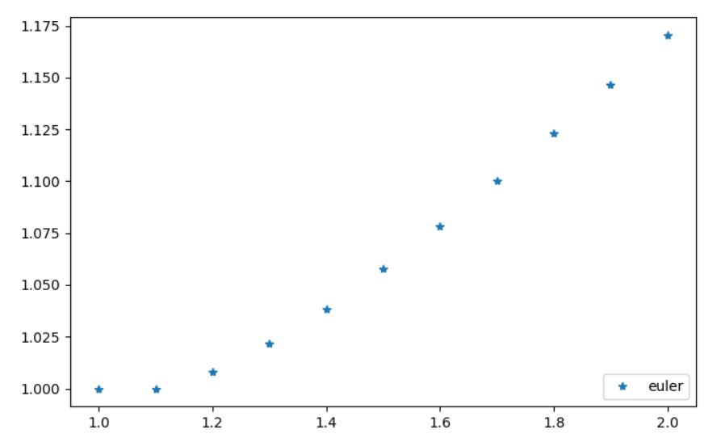b:

|  |  |
| --- | --- |
| $$t_{i}$$ | $$w_{i}$$ |
| 1.0 | 0 |
| 1.2 | 0.2 |
| 1.4 | 0.4388888888888889 |
| 1.6 | 0.721242756361804 |
| 1.8 | 1.0520380316573712 |
| 2.0 | 1.4372511475238394 |
| 2.2 | 1.884260805329153 |
| 2.4 | 2.4022695885615417 |
| 2.6 | 3.002837164557213 |
| 2.8 | 3.700600704932798 |
| 3.0 | 4.5142774281767 |

