Worked on Below Issues :

1. User Agent String in F120B device

2. Uniform Key sequence in F90M and F120B devices

3. FDR Battery percentage in F50Y

4.MMI Test LCD and Keypad Flickering issue in F50Y device

5. Rooted app in F220B ,F50Y .

6 . Boot optimization on F220B

- ISSUE : User Agent String in F120B device

ANALYSIS :

      - Analysed the QXDM logs and debugged the code in the gaia layer LINUX/android/gaia

      - Gone through some of the files to find the user agent string

ex: precomplete
ua-update.json

- Created new branch in code and triggered the build

FIX: Actually this issue is not present in the updated build.So automatically issue is resolved.

2) ISSUE : Uniform Key sequence in F90M and F120B devices

ANALYSIS :

- First Understand the key sequence for both devices in Recovery and EDL modes.

- Gone through the boot sequence

- Took the serial logs while pressing the keys and analysed that logs

- Debugged the source code according to the log analysis

- Gone through some of the files

EX: aboot.c
init.c
key.c

FIX (Still Working) : Ported F120B key sequence code into F90M ,compiled and flashed into the F90M device.

Expected output : In EDL mode press * + # + cable
Actual output : It goes to the different screen (like MMI test not exactly) .Below we can observe the image.But while pressing the 0 + # + cable it is going to EDL mode

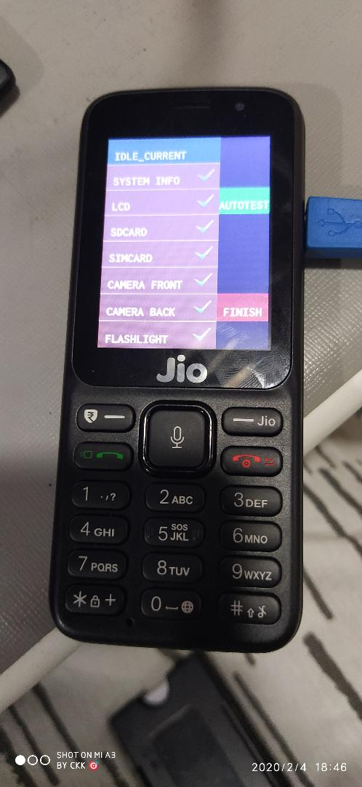

3) ISSUE : FDR Battery percentage in F50Y

ANALYSIS :

- Understand the requirement of battery percentage
- Debugged the code by particulat strings like
    - Battery
    - Reset phone
    - wipe data
- Gone through the files like
recovery.cpp
install.cpp

FIX : Added macro with #define BATTERY_OK_PERCENTAGE 25 and
bool is_battery_ok() function.

Checked the condition like

if (is_battery_ok() == false) {
if (err_no != NULL) err_no = RECOVERY_BATTERY_LOW;
return false;
}

Result : If the device having <= 25 % charging then it is not going to reset phone state.Below we can observe the image.

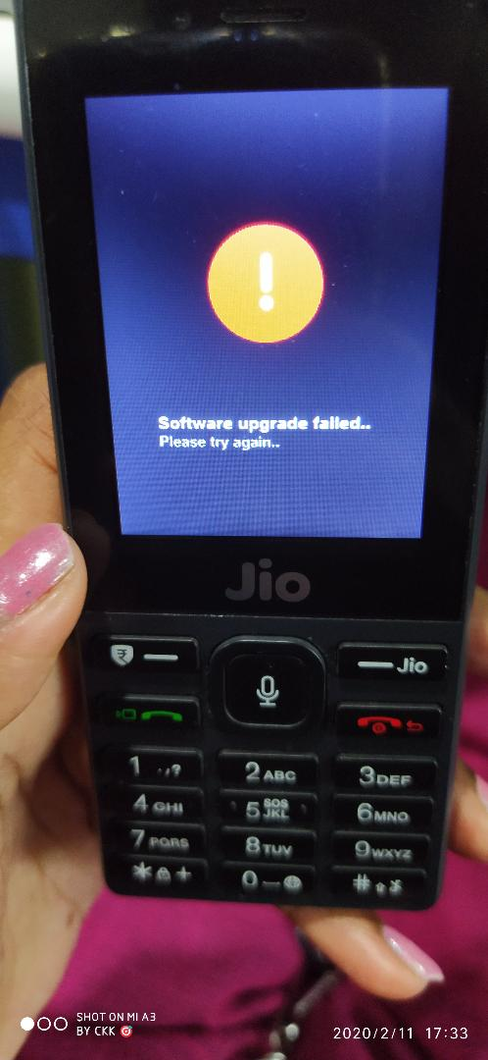

4) ISSUE : LCD and Keypad should blink for 3 times (MMI Test)

ANALYSIS : Today Started Working this issue

