What is Bootloader ?

A bootloader is the code that runs on a device (be it a phone or computer) before the operating system starts up. Almost all operating systems have bootloaders of some sort. This low-level code contains the instructions that tell a device how to start up and find the system kernel. The bootloader usually lives on the system board in non-volatile memory and is often specific to a device.

The bootloader is the program that is responsible for checking and loading the operating system. Hence manufacturers roll out their devices with locked bootloader so that some users who don’t know what they’re doing don’t damage their devices with bad software. Hence, we need to unlock the bootloader first in Android devices before installing any custom ROM.

Why Is Bootloader Locked?
A bootloader is usually locked on an Android device because although it’s an open source OS, still the manufacturers want you to stick to their Android OS version specifically designed for the device. In order to apply this concept, manufacturers lock the bootloader. With a locked bootloader on Android devices, it is virtually impossible to flash a Custom ROM and forced attempts void warranty as well as usually end up in bricks. Therefore, the first step is to always unlock the bootloader.
Android Modes :
You can boot into 3 different modes on Android: system, recovery, and bootloader/download.
System Mode :
Rebooting to system is just normal Android. Nothing special.
Recovery Mode :
If you boot to recovery, you can do stuff like factory reset your phone or install updates.
Recovery mode is used for factory data reset, clear cache, flash official update package(Stock) and can backup and restore whole rom and data, flash mods, custom roms (custom like CWM AND TWRP)
Recovery mode is used when your phone is unresponsive or frozen (can’t turn off phone, can’t interact, etc.)
Emergency Download mode (EDL Mode) :

What Can recovery Mode do for your Android?
With the growth of the mobile phone industry, we have experienced a complexity of the functions we can accomplish with our phones. These complexities also bring about a number of issues that your device can experience. Recovery mode can be used to fix some of these issues such as failed OS update, common Android Errors or even an unresponsive device. Android Recovery is also very useful when you are looking to install custom ROM as well as install OS updates successfully. It is therefore very necessary that you are aware of how to get into and out of Android Recovery. You never know when you might need it.
Difference of fastboot and recovery mode :
Whereas recovery mode could be said as an alternative to fastboot, what recovery does is, it lets you install various updates for the system,mods,kernels,etc. It is accessed from the device itself.
A recovery has an user interface whereas to use fastboot, commands have to typed from the PC.

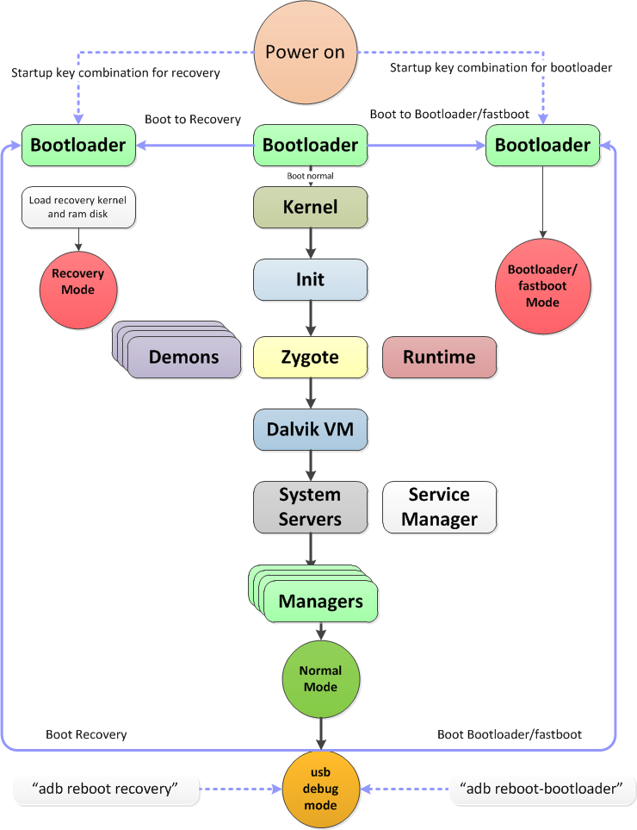
Android Boot sequence :
Android Boot Loader (Little Kernel) :
LK overview :
- Android boot loader is the LK boot loader.
- LK performs:
- Hardware initialization: setting up vector table, MMU, cache, initialize peripherals, storage, USB, crypto, etc.
- Loads boot.img from storage.
- Supports flashing and recovery.
LK call flow :
The sequence starts with arch/arm/crt0.S: _start.
a. Set up CPU.
b. Call __cpu_early_init() if necessary (platform-specific initialization sequence)
platform/msm8916/(arch_init.S): __cpu_early_init.
c. Relocate if necessary.
d. Set up stack.
e. Call kmain().
The function calls from kmain() are shown below:
Kernel/main.c: kmain()
- thread_init_early()
- arch_early_init()
- platform_early_init()
- target_early_init()
- init: heap, thread, dpc, timer
- bootstrap2()
          - Arch_init()
          - Platform_init()
          - Target_init()
          - Apps_init()
- app/init.c – apps_init()
- Init apps that are defined using APP_START and APP_END macros; aboot_init()is
called
- Run the app in a separate thread if it has .entry section
- app/aboot/aboot.c – aboot_init()
- Performs any one of the following operations based on settings/circumstances:
- Regular boot
- Fastboot mode to accept images
- Recovery mode to jump to recovery firmware
LK regular boot
- Recovery flag or fastboot keys not set.
- Pulls out boot.img from the MMC and loads it into the scratch region (base address =
0x80000000) specified in target/msm8916/rules.mk.
- Loads kernel from the scratch region into KERNEL_ADDR (retrieved from boot image
header).
- Loads RAM disk from the scratch region into RAMDISK_ADDR (retrieved from boot image header).
- Finds the right device tree (for the appropriate SoC) from the device tree table and loads it at TAGS_ADDR (retrieved from boot image header).
- Updates the device tree by:
          - Getting the offset for the ‘/memory’ node and ‘/chosen’ node.
          - Adding HLOS memory regions (start address and size) as “reg” properties to ‘/memory’ node.
          - Adding the cmd line as “bootargs” to the ‘/chosen’ node.
          - Adding the RAM disk properties as “linux, initrd-start” and “linux, initrd-end” to the ‘/chosen’ node.
          - Disable cache, interrupts, jump to kernel.
LK recovery mode
- aboot_init checks if KEY_HOME or VOLUME UP is pressed.
- Checks reason for reboot – check_reboot_mode().
- If value at restart reason address is RECOVERY_MODE, sets boot_into_recovery = 1.
boot_linux_from_mmc checks:
if (!boot_into_recovery) {
.........
...
else {
index = partition_get_index(“recovery”);
ptn = partition_get_offset(index);
...........
......
}
Gets image from recovery partition.
unsigned int target_freq, unsigned int relation);

To Make uniform Key Sequence in all devices :
For F90M Key Sequence :
EDL Mode : Volume up + Volume down + Power button
Recovery Mode : Volume up + Power button next long press soft left + soft right Key
For F120B Key Sequence :
EDL Mode : * + # + Cable
Recovery Mode : * + Power button
In F120b the key combinations are defined in aboot.c and init.c files
Path for that files are :
LINUX/android/bootable/bootloader/lk/app/aboot/aboot.c
LINUX/android/bootable/bootloader/lk/target/msm8909/init.c
By using serial logs , while performing EDL mode on device we can recognize the which keys are pressed.
Ex : For Recovery Mode
[10] [10] platform_init()
[10] [10] target_init()
[70] [70] GPIO[22] pull down
[70] [70] GPIO[98] pull down
[70] [70] Switch GPIO[14] PULL DOWN
[80] [80] GPIO[14] pull UP
[90] [90] GPIO[89] pull down
[90] [90] GPIO[88] pull down
[100] [100] Bluebank HWID: 0
[100] [100] Bluebank HWID DRAM config: 0
[100] [100] KEY_VOLUMEDOWN 0 KEY_VOLUMEUP 1
[120] [120] SDHC Running in DDR mode
[120] [120] Done initialization of the card
For EDL Mode :
[10] [10] platform_init()
[10] [10] target_init()
[80] [80] GPIO[22] pull down
[80] [80] GPIO[98] pull down
[80] [80] Switch GPIO[14] PULL DOWN
[90] [90] GPIO[14] pull UP
[100] [100] GPIO[89] pull down
[100] [100] GPIO[88] pull down
[110] [110] Bluebank HWID: 0
[110] [110] Bluebank HWID DRAM config: 0
[110] [110] KEY_VOLUMEDOWN 1 KEY_VOLUMEUP 1
[830] [830] dload mode key sequence detected
Code for F120B :
LINUX/android/bootable/bootloader/lk/target/msm8909/init.c
uint32_t target_key_8()
{
#if WITH_BLUEBANK_MARS_KEYS
#define KEY_8_ROW 94
// KEY_VOLUMEUP(Star) -- Recovery
// KEY_DOWN (POUND) -- Fastboot
// KEY_VOLUMEUP + KEY_DOWN Dload
uint32_t status = 0;
gpio_tlmm_config(KEY_8_ROW, 0, GPIO_INPUT, GPIO_PULL_DOWN, GPIO_2MA, GPIO_ENABLE);
gpio_tlmm_config(56, 0, GPIO_OUTPUT, GPIO_NO_PULL, GPIO_8MA, GPIO_DISABLE);
gpio_set(56,2);
thread_sleep(10);
status = gpio_status(KEY_8_ROW);
if(status != 0){// debouce
thread_sleep(10);
status = gpio_status(KEY_8_ROW);
}
return status;
#else
return 0;
#endif
}
uint32_t target_key_6()
{
#if WITH_BLUEBANK_MARS_KEYS
#define KEY_6_ROW 97
// KEY_VOLUMEUP(Star) -- Recovery
// KEY_DOWN (POUND) -- Fastboot
// KEY_VOLUMEUP + KEY_DOWN Dload
uint32_t status = 0;

gpio_tlmm_config(KEY_6_ROW, 0, GPIO_INPUT, GPIO_PULL_DOWN, GPIO_2MA, GPIO_ENABLE);
gpio_tlmm_config(56, 0, GPIO_OUTPUT, GPIO_NO_PULL, GPIO_8MA, GPIO_DISABLE);
gpio_set(56,2);
thread_sleep(10);
status = gpio_status(KEY_6_ROW);
if(status != 0){// debouce
thread_sleep(10);
status = gpio_status(KEY_6_ROW);
}
return status;
#else
return 0;
#endif
}
In LINUX/android/bootable/bootloader/lk/app/aboot/aboot.c
/ * Check power off reason if user force reset,
* if yes phone will do normal boot.
*/
if (is_user_force_reset())
goto normal_boot;

/* Check if we should do something other than booting up */
if (keys_get_state(KEY_VOLUMEUP) && keys_get_state(KEY_VOLUMEDOWN))
{
dprintf(ALWAYS,"dload mode key sequence detected\n");
if (set_download_mode(EMERGENCY_DLOAD))
{
dprintf(CRITICAL,"dload mode not supported by target\n");
}
else
{
reboot_device(DLOAD);
dprintf(CRITICAL,"Failed to reboot into dload mode\n");
}
boot_into_fastboot = true;
}
if (!boot_into_fastboot)

These above code ported into F90M code and compile and generated a build.
After that flashed into the devcie.while presseing actual key combination of EDL mode for F90M is not working .whatever the key combination for F120B is working on F90M device,.

