$ git fetch origin

git fetch really only downloads new data from a remote repository - but it doesn't integrate any of this new data into your working files

$git pull origin master

git pull= git fetch +git merge

- git pull, in contrast, is used with a different goal in mind: to update your current HEAD branch with the latest changes from the remote server. This means that pull not only downloads new data; it also directly integrates it into your current working copy files. This has a couple of consequences:

- Since "git pull" tries to merge remote changes with your local ones, a so-called "merge conflict" can occur. Check out our in-depth tutorial on How to deal with merge conflicts for more information.

- git fetch is similar to pull but doesn't merge. i.e. it fetches remote updates (refs and objects) but your local stays the same (i.e. origin/master gets updated but master stays the same) .
- git pull pulls down from a remote and instantly merges.
- git clone clones a repo.
- git rebase saves stuff from your current branch that isn't in the upstream branch to a temporary area. Your branch is now the same as before you started your changes. So, git pull -rebase will pull down the remote changes, rewind your local branch, replay your changes over the top of your current branch one by one until you're up-to-date.

Important points

I thought I'd update this to show how you'd actually use this in practice.

1. Update your local repo from the remote (but don't merge):
git fetch

2. After downloading the updates, let's see the differences:
git diff master origin/master

3. If you're happy with those updates, then merge:
git pull

Git pull: when you do a git pull, it gets all the changes from the remote or central repository and attaches it to your corresponding branch in your local repository.
Git fetch: when you do a git fetch, it gets all the changes from the remote repository, stores the changes in a separate branch in your local repository and if you want to reflect those changes in your corresponding branches, use a git merge to do that.
To summarize,
git pull = git fetch + git merge

- Fetch simply keeps your local copy of the remote repository up to date by transferring commits from remote repository to your local repository. Importing commits to local branches will allow you to keep up with the changes made by other people.

- Merge conflict: That is when you try to merge files where either two people make changes to the same line in the same file or when two people add files with same name unknowingly etc.

- git clone is used for just downloading exactly what is currently working on the remote server repository and saving it in your machine's folder where that project is placed. Mostly it is used only when we are going to upload the project for the first time. After that pull is the better option.
- git pull is basically a (clone(download) + merge) operation and mostly used when you are working as teamwork. In other words, when you want the recent changes in that project, you can pull.

- git clone means you are making a copy of the repository in your system.
- git fork means you are copying the repository to your Github account.
- git pull means you are fetching the last modified repository.
- git push means you are returning the repository after modifying it.
- git clone is downloading and git pull is refreshing.

What is the difference between rebase and merge in Git?

- Let’s say we have two branches feature1 and feature2 that have diverged from a common commit “a” to have four commits each.

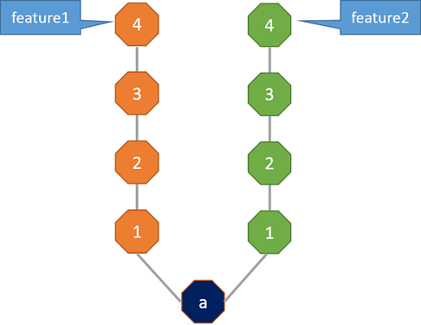

Merge will seem like a fairly obvious thing, if you look at the end result. It is pretty much like taking two threads and tying them up in a knot.
Here the commit ‘b’, has the information regarding all the commits in feature1 and feature2. So, Merge preserves the history of the repository.

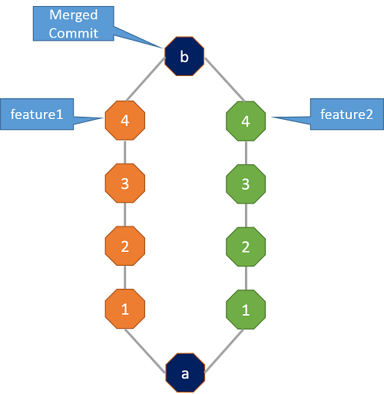

Rebase on the other hand doesn’t preserve the history. It quite literally re-bases one branch on top of the other i.e., it changes the base of the branch. Let’s see rebasing with the same example.
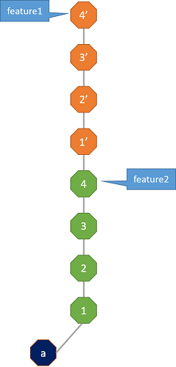

Let’s say I want to rebase feature1 onto feature2, what that means is that I want all the commits in the branch feature1 on top of the commits of feature2. So, after rebase your commit history would look like the following.
As you see in the picture, the base of feature1 which was previously the commit “a”, has been shifted to the green commit “4”. Hence the name Re-Base. Here feature1 is sitting on top of feature2 as opposed to being on “a”.

- Also Anyone who looks at the commit history now, would think that feature1 was added after feature2 which is not what actually happened. If this is the end result you’re going for, then it’s absolutely fine but if you want to show that feature1 and feature2 both started off simultaneously, then you need to use Merge.
- Both Merge and Rebase have their pros and cons. Merge keeps the history of the repository but can make it hard for someone to understand and follow what’s going on at a particular stage when there are multiple merges. Rebase on the other hand ‘rewrites’ history (read - creates new history) but makes the repo look cleaner and is much easier to look at.

Combining tasks from public branch into local branch -- use git rebase
Combining tasks from local branch to public branch -- use git merge

- If you Git merge it into master, it will combine the tasks of feature into master by creating a single new commit at the tip of master.
- On the other hand, if you Git rebase it, it will place the entire commit history of the feature branch on the tip of master. It means that your entire feature branch will be reattached to the tip of master and it will look like a linear sequence of commits.

