Aim : To solve the “ Kernel Oops “ .

Occurrence : Mainly it occurs due to memory issues in loadable modules.

Methods & Tools : GDB, Cscopes.

Explanation :
Kernel oops is occured due to memory issue happens when loadable module get invoke. This logs can be collected by using “ dmesg “ we can trace out the list there it can observed like a “ Kernel oops “ .It can be solved by debugging the “ .ko “ ( Kernel Object) , with the help of gdb tool. Then we need to trace out the files which line of error get occurs ,
there is “ Call Trace “ , “ CPU registers ”, by using some of it can trace out the particular bug line which indicates in Red color.

Commads are :

$ make
$ sudo insmod oops.ko
$ dmesg
...................
$ gdb oops.ko
$ ( gdb ) add-symbols-file oops.ko 0x87654321
$ ( gdb ) disassemble my_oops_init
$ ( gdb ) list *0x12345678

Contd..

Observations :

Step 1: dmesg

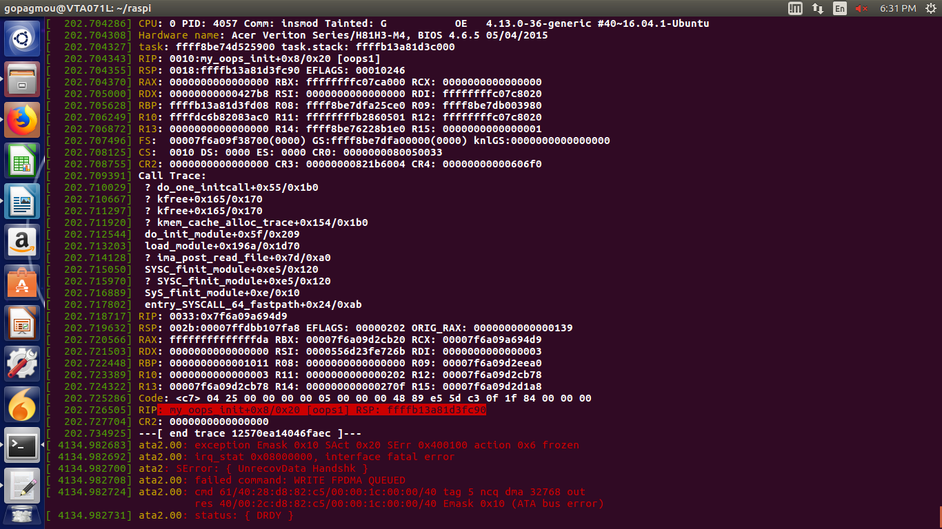

Contd..

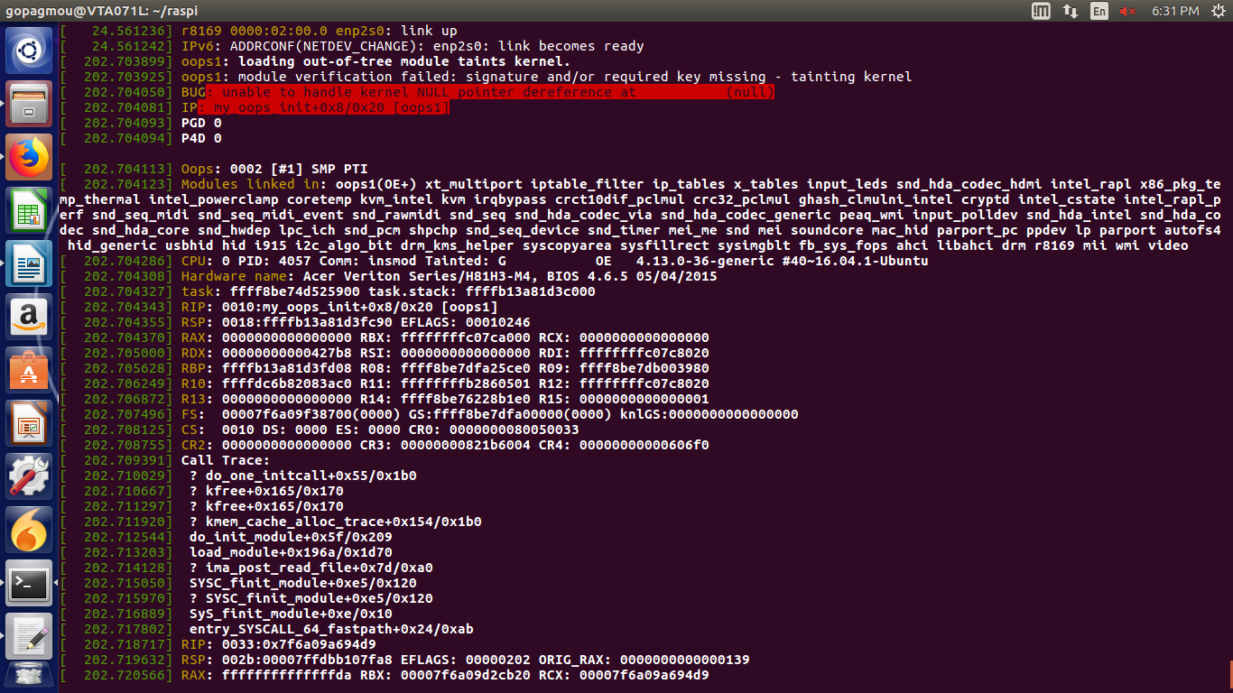

Contd..
Step 2 :
$ gdb oops.ko

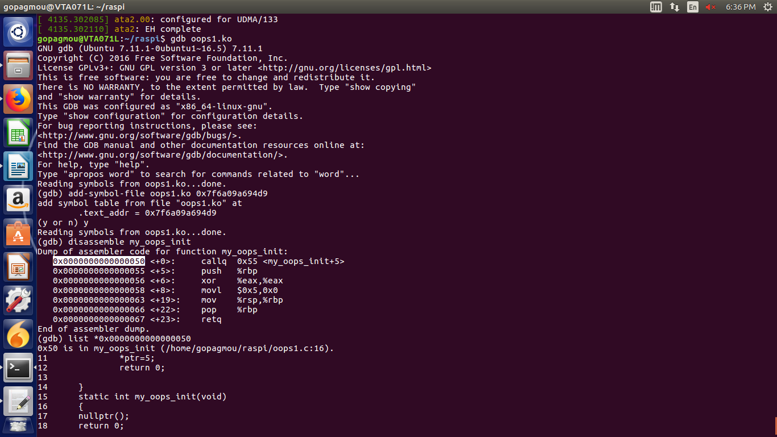

References :

1. https://opensourceforu.com/2011/01/understanding-kernel-oops/.
2. https://www.kernel.org/doc/html/v4.19-rc2/dev-tools/gdb-kernel-debugging.html.
3. https://gist.github.com/robbie-cao/32af7001443ac0b959abdf6ad6de2c9f

