Presented by:
Madhusudhana rao chenikala

Version [0.0]



BUILD AND INTEGRATION

CONTENTS

- INTRODUCTION
- BUILD ARCHITECTURE
- VTECH MACHINE’S CONFIGURATIONS
- PRE-REQUISITES
- BUILD INTEGRATION PROCEDURE
  - SOURCE CODE SYNCING FROM CKT
  - DOWNLOAD TAGS FROM KAIOS
  - INTEGRATE CKT AND KAIOS CODE
  - QUALTOOLS SETUP
  - TRIGGERING BUILD FOR USER && USER-DEBUG
  - UPLOAD IMAGES ON VSFTP SERVER
- FOTA GENERATION
  - FOTA TOOLS PKG SETUP
  - FOTA GENERATION MECHANISM
  - FOTA UPLOADING MECHANISM
- BUILD AUTOMATION

INTRODUCTION

The Build System Document describes the system requirements, build architecture , Qualcomm drop(qdrop, ckt changes and ADUPS ) and KaiOS_profile_save code syncing procedure ,KaiOS source code(TAGs) downloading procedure ,ckt and KaiOS source code integration, usage of third party tools like qualtools ,updateKaiosAndNFC ,types of builds and image flashing mechanism, FOTA generation and Uploading mechanism, Issues triage or reproduce procedure

BUILD ARCHITECTURE

4
12
Downloading TAGs (.tar.gz)
CKT GERRIT
git clone <gerrit_url>

Integrate Qdrop &KaiOS KaiOSading
Build for User or Debug
Deploy and boot the image
7
8
9
11
10
Reproduce the issues at RIL
Get fixes
Images on VSFTP
Full Fledged Testing
FOTA Gen
StS
13
1
2
3
5
6

Quick description on build flow

- CKT repo which has QUALCOMM drop ,CKT changes ,ADUPS and KaiOS_profile_save code
- KaiOS repo which has three branches .i.e. v1.0(freeze),v2.0and v2.5.Where we are using v2.0branch
- Vtech repo which has BSP drop (qdrop, ckt changes and adups), KaiOS_profile_save, UpdateKaiosAndNFC and qualtools.
- Clone the source code from CKT by using following gerrit link
- Download KaiOS source code as tag based by manually(tar.gzformat only)
- Integrate KaiOS with CKT code(for more details in below)
- Build the source code for user or user-debug(details in below)
- Deploy final binaries in VSFTP serverand also verifying the basic booting of target
- Run the full-fledged testing on the target and publish the report
- Verification done with no issues, will generate the FOTA and verify offline then upload FOTA FTP server.
- If getting any issues in testing will do basic triage and report onsite.
- Onsite folks will reproduce the issues
- Get the fixes for those issues which are raised from us

VTECH MACHINE’S CONFIGURATION

Types of Machines | OS | HDD/RAM | Count
Build Machines | Ubuntu 14.04 | 2TB/16GB | 4
Testing Machine | Windows-7 | 1TB/16GB | 1
Configuration Machine | Ubuntu 16.04 | 1TB/16GB | 1
VSFTP Machine | Ubuntu 16.04 | 1TB/16GB | 1

BUILD SYSTEM SETUP:

PRE-REQUISITES:
- Ubuntu 14.04
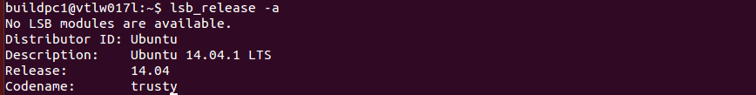

- Android build initialization setup
sudo apt-get install git-core gnupg flex bison gperf build-essential zip curl zlib1g-dev gcc-multilib g++-multilib libc6-dev-i386 lib32ncurses5-dev x11proto-core-dev libx11-dev lib32z-dev ccache libgl1-mesa-dev libxml2-utils xsltproc unzip

More Details: https://source.android.com/setup/build/initializing

- Java-Open-JDK7 installation
- sudo apt-get install software-properties-commonpython-software-properties
- sudo add-apt-repository ppa:openjdk-r/ppa
- sudo apt-get update
- sudo apt-get install openjdk-7-jdk
- Check Java in this path cd /usr/lib/jvm/java-7-openjdk-amd64/bin
- Git installation
sudo add-apt-repository ppa:git-core/ppa
sudo apt-get update
sudo apt-get install git
- Required python – 2.7.12
- Required perl-5 version

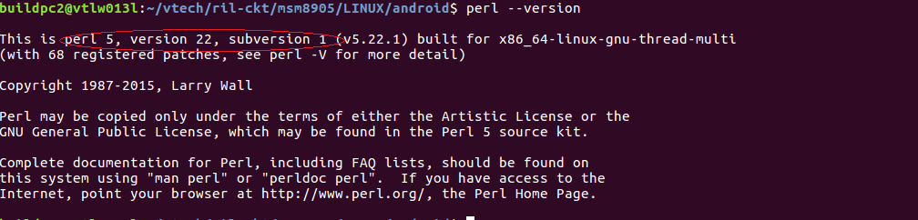.

- Install perl package
sudo apt-get install libxml-parser-perl
- Run below command to change default shell
sudo dpkg-reconfigure dash
- SSL certification setup
sudo apt-get purge ca-certificates curl openssh-server
- Other software
sudo apt-get install xpad
sudo apt-get install unrar
sudo apt install curl

BUILD INTEGRATION PROCEDURE

SOURCE CODE SYNCING FROM CKT:
- msm8905 source syncing:

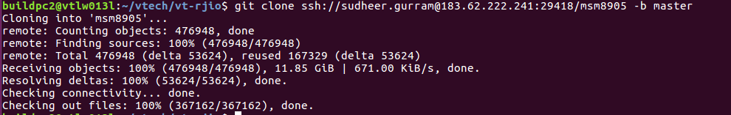
- KaiOS_profile_save syncing:
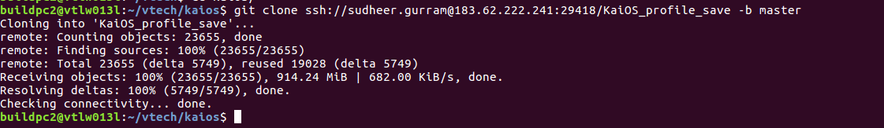
- DOWNLOAD SPECIFIED VERSIONS OF TAG’s FROM KAIOS:
- We need to download 16 projects from KaiOS which are shown below

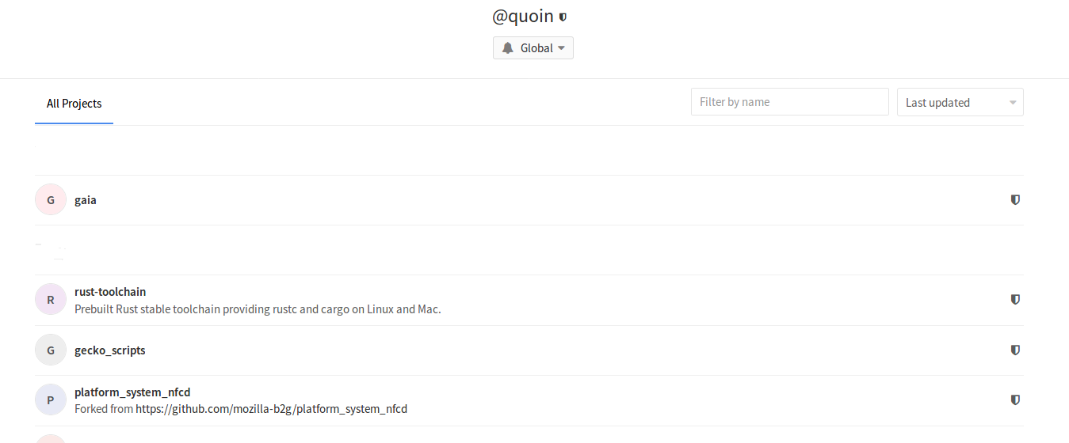
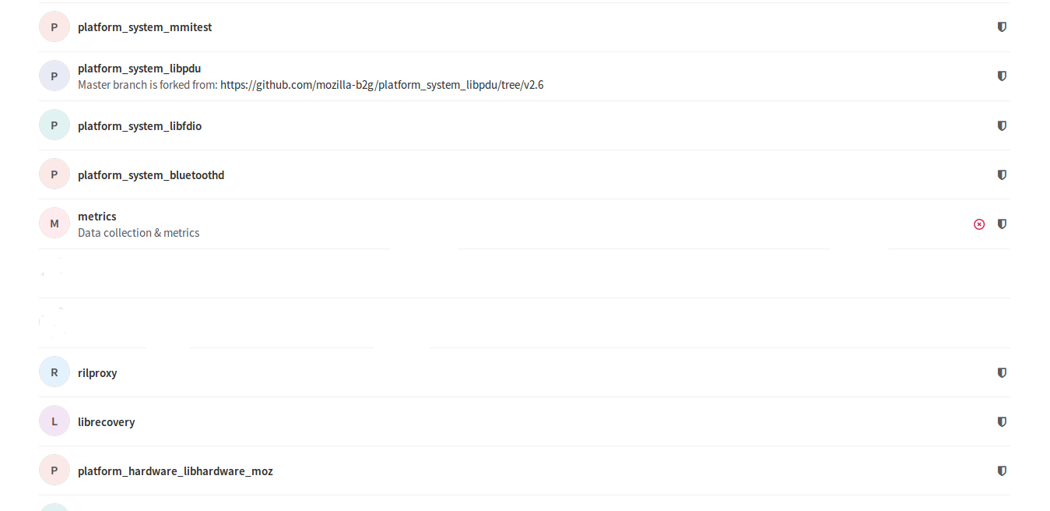
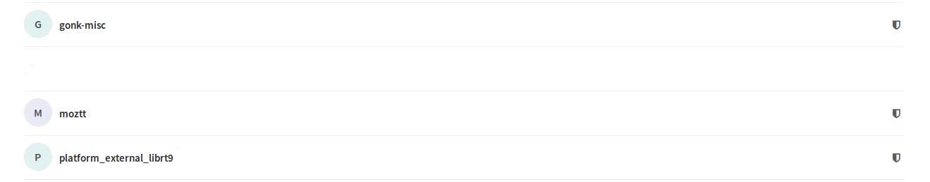

gonk ,gaia , platform_system_nfcd ,platform_system_mmitest,platform_system_libpdu
Platform_system_libfdio, platform_system_bluetoothd, metrics, rilproxy,
rust-toolchain, librecovery, platform_hardware_libhardware_moz, gecko_scripts,
moztt, platform_external_librt9, fake-libdvm

- Downloading procedure:
Example:
Click on Gaia➔

We can have different formats of downloadable files where we can we can download whose suffix is tar.gz

p.s.:A hash value will be displayed in different versions. This value can be used to determine whether there is any change in the project after the version is updated. Please confirm which items are changed at each update

- UpdateKaiosAndNFC:
- Download “updateKaiosAndNfc” (This will be provided by ODMs) directory from VT-FTP server (FTP://183.82.111.241)

- Keep all tar.gz under “updateKaiosAndNFC/kaios_from_git”
- Update “msmfilepath” and version in “updateAll.sh” file which is part of updateKaiosAndNFC directory.
- Change permissions(chmod +x updateAll.sh) and run updateAll.sh and check the modifications by using “git status” at root dir(msm8905)

- update profile_save.tar.gz
- Syncing “Kaios_profile_save” from CKT repository
- Placed profile_save.tar.gz file which is picked from Gaia in “Kaios_profile_save” directory
- Run “unZipprofile.sh” and add and commit changes(KaiOS tag should be mentioned in commit message) into git
- Run “zipprofile.sh” which would generate new “profile_save.tar.gz” file then copy to “msm8905/LINUX/android/gaia” folder

- Commit KAIOS changes:
- Cancel modification by running “git checkout” command in following paths
LINUX/android/gaia
LINUX/android/gaia/build/config/common-settings. son
LINUX/android/system/mmitest
LINUX/android/system/nfcd
- Please check whether the updated items appear in the modification.(If moztt is updated, it should be seen in modification.)After checking, use git add and git commit to submit code.

- Compilation steps:
- setup qualtools: Unzip “qualtools.tar.gz” which is provided by Qcom(keep msm8905 and qualtools in same directory)
- Run “qualtools.sh”(This should be run only once)
- Moved to “msm8905/LINUX/android” directory and run below commands.

source build/envsetup.sh
lunch
Select required build .i.e. msm8909_512-user or msm8909_512-userdebug
mk n all 2>&1 | tee build.log

- Artifacts Paths:
- Images:msm8905/LINUX/android/out/target/product/msm8909_512
- Vmlinux: msm8905/LINUX/android/out/target/product/msm8909_512/obj/KERNEL_OBJ
- Splitted Images(zip): msm8905/LINUX/android/out/msm8909_512
- Upload all zip/fota on VSFTP server(ftp://183.82.111.241/RIL )

FOTA GENERATION

- FOTA TOOLS PKG SETUP:
- FOTA Tool :
- FOTA Setup :
  - cd fota_root_dir
  - Run ‘make’ and ‘make links’
  - Export PATH=$PATH: fota_root_dir/bin
  - Change the permission for fota_root_dir (chmod -R +x fota_root_dir )

- FOTA GENERATION mechanism
- FOTA Gen :
- FOTA Offline Testing:

- fota uploading mechanism

Known bUILD ISSUES:

Issue:”B2G_SDK” Downloading … ‘SSL connection refuse/failed/timeout’
Solution: Required sites are blocked on internet or lack of internet speed

Issue: “CA-CERTIFICATION” issues
Solution: Install ca-certificate and open ssh

Issue:“error: linking with `/home/buildpc2/vtech/ril-ckt/msm8905/LINUX/android/prebuilts/gcc/linux-x86/arm/arm-linux-androideabi-4.9/bin/arm-linux-androideabi-gcc` failed: exit code: 1➔ services/metrics/Android.mk:23: recipe for target 'services/metrics/target/armv7-linux-androideabi/release/metrics_daemon' failed
make: *** [services/metrics/target/armv7-linux-androideabi/release/metrics_daemon] Error 101”
Solution: cd service/metrics and run “mma” command once this module is success then run full build

Issue: system.img chunks alignment failed
Solution: Lack of openjdk-7-java.We should install jdk7

