About RAM DUMP:

Used for forensic analysis of a crashed or freeze kernel/system.
As the name points, its the dumping of complete ram contents for further investigation.

During booting, boot-loader has to decide whether it has to enter in to ramdump mode or to boot linux normally. This is done by monitoring a magic value in any predefined location(typically SRAM register or any other, value should persists across reboot or reset). There are two magic numbers for example 0x12345678(for crash scenario) and 0x87654321(for freeze scenario). If the SRAM register is having any of the two magic number, the booloader will enter into ramdump mode and wait for the host side application to initiate upload. And if SRAM is not having any of these magic numbers, the bootloader will proceed with normal booting.

During a crash
------------------
Panic notifier registered from the ramdump driver will be called by kernel. Ramdump driver has to do few things.
a) Invoke cache sycn api to make sure all the content the ram is coherent.(flush_cache_all(), outer_flush_all())
b) save core registers to ram
c) save MMU registers
d) write MAGIC_CRASH to SRAM regiter.
Then do a reboot. Now boot-loader finds the MAGIC_CRASH in SRAM register and goes to ramdump mode.

.........................................................................................................................................................

vmstat -s Displays the amount of memory used and available
vmstat command is used to display virtual memory statistics of the system. This command reports data about the memory, paging, disk and CPU activities, etc.

Free Displays the amount of memory which is currently available and used by the system(both physical and swapped). free command gathers this data by parsing /proc/meminfo. By default, the amount of memory is display in kilobytes.

Top top command displays all the currently running process in the system. This command displays the list of processes and thread currently being handled by the kernel. top command can also be used to monitor the total amount of memory usage

...........................................................................................................................................

The Application Manifest File | Android
The manifest file is an important part of our app because it defines the structure and metadata of our application, its components, and its requirements.

The manifest file also specifies the application metadata, which includes its icon, version number, themes etc. and additional top- level nodes can specify any required permissions, unit tests and define hardware, screen, or platform requirements.

A manifest file includes the nodes that define the application components, security settings, test classes and requirements that make up the application. Some of the manifest sub-node tags that are mainly used are:

uses-sdk– It is used to define a minimum and maximum SDK version that must be available on a device so that our application function properly,and target SDK for which it has been designed using a combination of minSdkVersion, maxSdkVersion, and targetSdkVersion attributes, respectively.

<uses-sdk android:minSdkVersion=”6”
android:targetSdkVersion=”15”/>

uses-configuration– The uses-configuration nodes are used to specify the combination of input mechanisms that are supported by our application. It is useful for games that require particular input controls.

<uses-configuration android:reqTouchScreen=”finger”
android:reqNavigation=”trackball”
android:reqHardKeyboard=”true”
android:reqKeyboardType=”qwerty”/>
<uses-configuration android:reqTouchScreen=”finger”
android:reqNavigation=”trackball”
android:reqHardKeyboard=”true”
android:reqKeyboardType=”twelvekey”/>

uses-features– It is used to specify which hardware features your application requirement. This will prevent our application from being installed on a device that does not include a required piece of hardware such as NFC hardware, as follows:

<uses-feature android:name=”android.hardware.nfc”/>

permission– It is used to create permissions to restrict access to shared application components. We can also use the existing platform permissions for this purpose or define your own permissions in the manifest.

<permission android: name=”com.paad.DETONATE_DEVICE”
android:protectionLevel=“dangerous”
android:label=”Self Destruct”
android:description=”@string/detonate_description”>
</permission>

supports-screens– It is used to describe the screen support for our application:
<supports-screens android:smallScreens=”false”
android:normalScreens=”true”
android:largeScreens=”true”
android:xlargeScreens=”true”/>

application– A manifest can contain only one application node. It uses attributes to specify the metadata for your application (including its title, icon and theme). During development we should include a debuggable attribute set to true to enable debugging, then be sure to disable it for your release builds.
<application android:icon="@drawable/icon"
android:logo-"@drawable/logo"
android:theme="@android:style/Theme.Light"
android:name=".MyApplicationClass"
android:debuggable="true">
[....application nodes.....]
</application>
..........................................................................................................................................................

Android Modes :
You can boot into 3 different modes on Android: system, recovery, and bootloader/download.
Rebooting to system is just normal Android. Nothing special.
If you boot to recovery, you can do stuff like factory reset your phone or install updates.
you can boot into download mode (aka bootloader). The way you do this varies by phone, but you usually have to press volume down and power. If you have adb installed, you can also run
adb reboot bootloader
In download mode, you can flash firmware to your phone.
Bootloader is code that executed when your operating system starts. Bootloader is a set of instructions that how operating system starts to run apps smoothly.
Bootloader executed before android system starts. It have set of instructions that how system starts and runs operations.
Bootloader is the code executed before android system boots.
Download mode, Bootloader mode and fastboot mode are same. Download mode is related to samsung devices. "adb reboot download" command is used for boot samsung device in download mode for flashing purpose.
"adb reboot bootloader" command used for other devices to boot in fastboot mode for flashing.
Recovery mode and fastboot are different.
fastboot mode used for flashing roms.
Recovery mode is used for factory data reset, clear cache, flash official update package(Stock) and can backup and restore whole rom and data, flash mods, custom roms (custom like CWM AND TWRP)
Recovery mode is used when your phone is unresponsive or frozen (can’t turn off phone, can’t interact, etc.)
With fastboot mode you can modify system partitions which is usually done from PC via USB cable.
Fastboot mode is basically used to unlock bootloader or install a custom recovery (also many other functions).
Whereas recovery mode could be said as an alternative to fastboot, what recovery does is, it lets you install various updates for the system,mods,kernels,etc. It is accessed from the device itself.
A recovery has an user interface whereas to use fastboot, commands have to typed from the PC.

The difference is, fastboot mode is the mode designed for flashing the device when fastboot is functioning correctly.
Qhsusb dloader 9008 is when the device has been bricked. The device has to be restored by a specific method when in this state.

Every Android phone has a bootloader that instructs the operating system kernel to boot normally. But you need to understand one thing here that as Android OS is an open source OS and is available on a variety of different hardware, every manufacturer has their own version of bootloader specific for the hardware present in it’s environment.
Why Is Bootloader Locked?
A bootloader is usually locked on an Android device because although it’s an open source OS, still the manufacturers want you to stick to their Android OS version specifically designed for the device. In order to apply this concept, manufacturers lock the bootloader. With a locked bootloader on Android devices, it is virtually impossible to flash a Custom ROM and forced attempts void warranty as well as usually end up in bricks. Therefore, the first step is to always unlock the bootloader.

Custom ROMS are aftermarket Android distributions. These are used to add new features or new android version to any Android phone, without an official firmware release for the device.

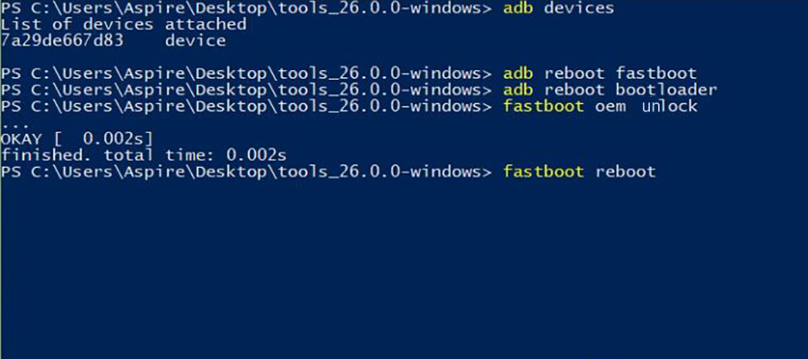
What is recovery mode ?
In Android devices, recovery mode refers to the bootable partition in which the recovery console is installed. This partition contains tools that that help to repair installations as well as to install official OS updates. This can be done by pressing a combination of keys or instruction from a command line. Because Android is open the recovery source code is available and accessible making the building of customized ROM relatively easy.

What Can recovery Mode do for your Android?
With the growth of the mobile phone industry, we have experienced a complexity of the functions we can accomplish with our phones. These complexities also bring about a number of issues that your device can experience. Recovery mode can be used to fix some of these issues such as failed OS update, common Android Errors or even an unresponsive device. Android Recovery is also very useful when you are looking to install custom ROM as well as install OS updates successfully. It is therefore very necessary that you are aware of how to get into and out of Android Recovery. You never know when you might need it.

