- The UART full form is “Universal Asynchronous Receiver/Transmitter”, and it is an inbuilt IC within a microcontroller but not like a communication protocol (I2C & SPI).

- The transmitter section includes three blocks namely transmit hold register, shift register and also control logic. Likewise, the receiver section includes a receive hold register, shift register, and control logic.
- The hold register in the transmitter comprises the data-byte to be transmitted. The shift registers in transmitter and receiver move the bits to the right or left till a byte of data is transmitted or received. A read (or) write control logic is used for telling when to read or write.
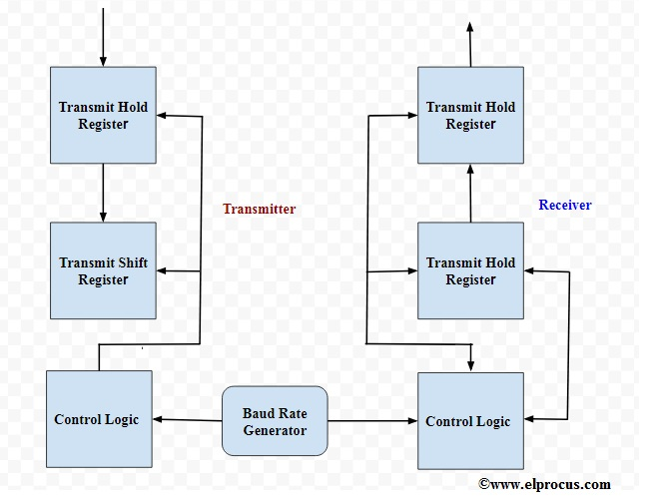

- One chip’s Tx (transmit) pin connects directly to the other’s Rx (receive) pin and vice versa. Commonly, the transmission will take place at 3.3 or 5V. UART is a single-master, single-slave protocol, where one device is set up to communicate with only one partner.

- The data transmission of a UART can be done by using a data bus in the form of parallel by other devices like a microcontroller, memory, CPU, etc. After receiving the parallel data from the bus, it forms a data packet by adding three bits like start, stop and parity. It reads the data packet bit by bit and converts the received data into the parallel form to eliminate the three bits of the data packet. In conclusion, the data packet received by the UART transfers in parallel toward the data bus at the receiving end.
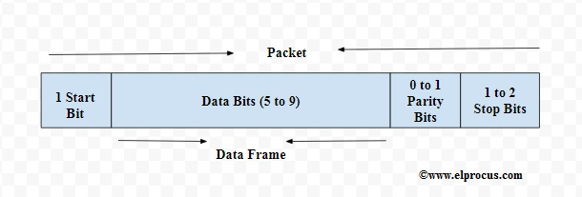
- Start Bit :In order to begin the data transmission, the UART transmission drags the data-line from a high voltage level (1) to a low voltage level (0).
- Stop Bit :In order to stop the broadcast, the UART keeps the data-line on high voltage.
- Parity Bit : Parity bit lets the receiver to ensure whether the collected data is right or not.Actually, this bit is not widely used so it is not compulsory.
- Data Bits or Data Frame :The data frame length could be between 5 & 8. If the parity bit is not used when the data frame length could be 9-bit long. Generally, the LSB of the data to be transmitted first then it is very useful for transmitting.
APPLICATIONS:
- These are also available in various communication devices like wireless communication, GPS units, Bluetooth module, and many other applications.
- It can be interfaced with a PC (personal computer) using a RS232-TTL converter or USB-TTL converter.
- example, we have 4-bit data, to convert it into the serial form, we need a parallel to serial converter. Generally, D flip-flops or latches are used to design the converters.
- Suitable for low speed communications
- Communication can be “full duplex” (both send and receive at the same time) or “half duplex” (devices take turns transmitting and receiving).
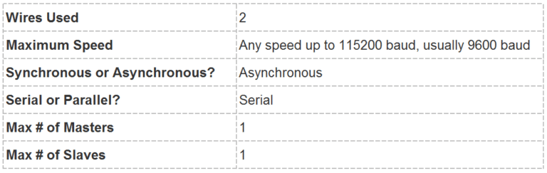
Check uart is invented by ...........................

STEPS OF UART TRANSMISSION
1. The transmitting UART receives data in parallel from the data bus:
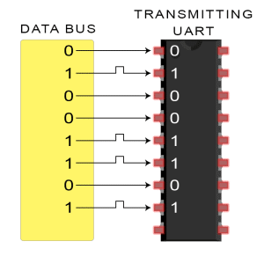
2. The transmitting UART adds the start bit, parity bit, and the stop bit(s) to the data frame:
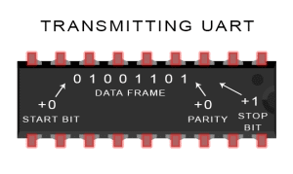
3. The entire packet is sent serially from the transmitting UART to the receiving UART. The receiving UART samples the data line at the pre-configured baud rate:
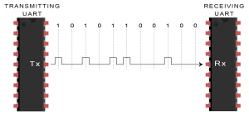
4. The receiving UART discards the start bit, parity bit, and stop bit from the data frame:
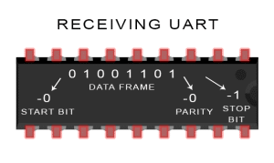
5. The receiving UART converts the serial data back into parallel and transfers it to the data bus on the receiving end
I2C
It was invented by Philips and now it is used by almost all major IC manufacturers.

I²C Address
- 7-bit address represents bits 7 to 1 while bit 0 is used to signal reading from or writing to the device. If bit 0 (in the address byte) is set to 1 then the master device will read from the slave I2C device.
- Master device needs no address since it generates the clock (via SCL) and addresses individual I2C slave devices.
- Serial Data Transfer
- For each clock pulse one bit of data is transferred. The SDA signal can only change when the SCL signal is low – when the clock is high the data should be stable.
Start and Stop Condition
- A high to low transition of SDA is considered as START and a low to high transition as STOP.
- For both conditions SCL has to be high.
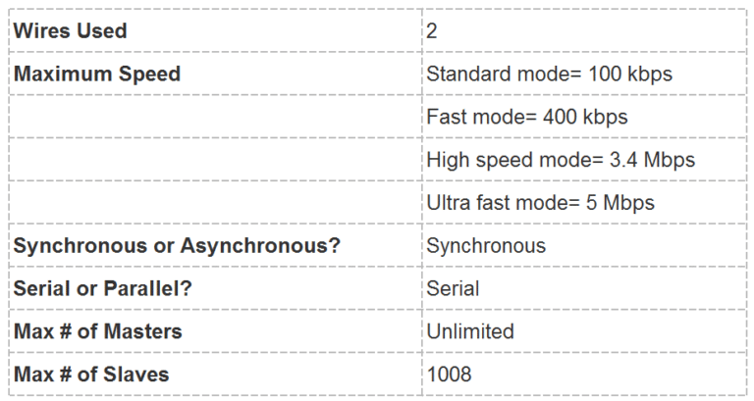
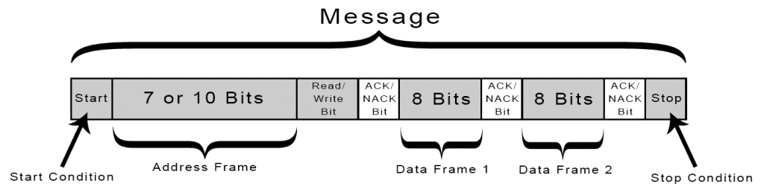
Start Condition:The SDA line switches from a high voltage level to a low voltage level before the SCL line switches from high to low.
Stop Condition:The SDA line switches from a low voltage level to a high voltage level after the SCL line switches from low to high.
Address Frame:A 7 or 10 bit sequence unique to each slave that identifies the slave when the master wants to talk to it.
Read/Write Bit: A single bit specifying whether the master is sending data to the slave (low voltage level) or requesting data from it (high voltage level).
ACK/NACK Bit: Each frame in a message is followed by an acknowledge/no-acknowledge bit. If an address frame or data frame was successfully received, an ACK bit is returned to the sender from the receiving device.

ADDRESSING
- The master sends the address of the slave it wants to communicate with to every slave connected to it. Each slave then compares the address sent from the master to its own address. If the address matches, it sends a low voltage ACK bit back to the master. If the address doesn’t match, the slave does nothing and the SDA line remains high.
READ/WRITE BIT
- The address frame includes a single bit at the end that informs the slave whether the master wants to write data to it or receive data from it. If the master wants to send data to the slave, the read/write bit is a low voltage level. If the master is requesting data from the slave, the bit is a high voltage level.
- THE DATA FRAME
- After the master detects the ACK bit from the slave, the first data frame is ready to be sent.
- The data frame is always 8 bits long, and sent with the most significant bit first. Each data frame is immediately followed by an ACK/NACK bit to verify that the frame has been received successfully. The ACK bit must be received by either the master or the slave (depending on who is sending the data) before the next data frame can be sent.
- After all of the data frames have been sent, the master can send a stop condition to the slave to halt the transmission. The stop condition is a voltage transition from low to high on the SDA line after a low to high transition on the SCL line, with the SCL line remaining high.

STEPS OF I2C DATA TRANSMISSION
1. The master sends the start condition to every connected slave by switching the SDA line from a high voltage level to a low voltage level before switching the SCL line from high to low:
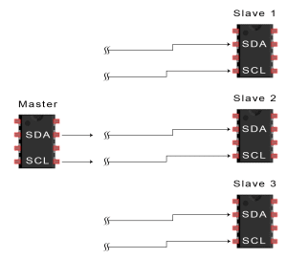
2. The master sends each slave the 7 or 10 bit address of the slave it wants to communicate with, along with the read/write bit:
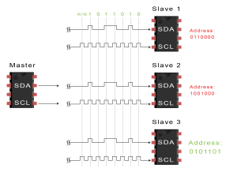
3. Each slave compares the address sent from the master to its own address. If the address matches, the slave returns an ACK bit by pulling the SDA line low for one bit. If the address from the master does not match the slave’s own address, the slave leaves the SDA line high.
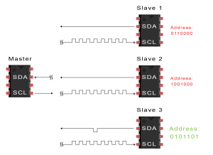
4. The master sends or receives the data frame:
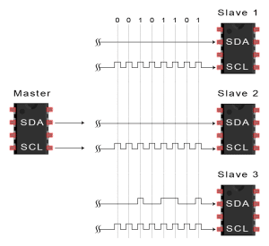
5. After each data frame has been transferred, the receiving device returns another ACK bit to the sender to acknowledge successful receipt of the frame:
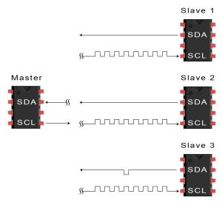
6. To stop the data transmission, the master sends a stop condition to the slave by switching SCL high before switching SDA high:
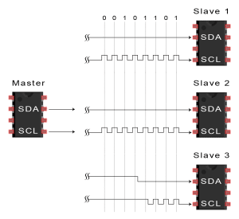
http://www.circuitbasics.com/basics-of-the-i2c-communication-protocol

Clock Synchronization and Handshaking
- Slave devices that need some time to process received byte or are not ready yet to send the next byte, can pull the clock low to signal to the master that it should wait. Once the clock is released the master can proceed with the next byte.
- The allocation of I2C addresses is administered by the I2C bus committee which takes care for the allocations. Two groups of 8 I2C addresses are reserved for future uses and one address is used for 10-bit I2C addressing.
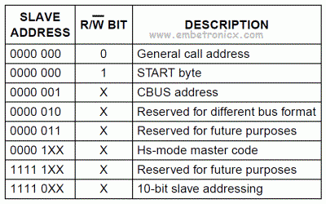

- Fast Mode – supports transfer rates up to 400 kbit/s
- High-speed mode (Hs-mode) – supports transfer rates up to 3.4 Mbit/s
- 10-bit addressing – supports up to 1024 I2C addresses

10-bit I2C Addressing
- 10-bit addressing can be used together with 7-bit addressing since a special 7-bit address (1111 0XX) is used to signal 10-bit I2C address. When a master wants to address a slave device using 10-bit addressing, it generates a start condition, then it sends 5 bits signaling 10-bit addressing (1111 0), followed by the first two bits of the I2C address and then the standard read/write bit.
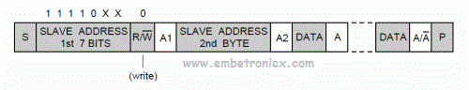
- If the master will write data to the slave device it must send the remaining 8 bits of slave address as the second byte.
- If the master will read data from the slave device it must send the complete 10-bit address (two bytes) as for writing, then a repeated start is sent followed by the first address byte with read/write bit set to high to signal reading. After this procedure the data can be read from the slave device.
SPI
- One unique benefit of SPI is the fact that data can be transferred without interruption. Any number of bits can be sent or received in a continuous stream. With I2C and UART, data is sent in packets, limited to a specific number of bits. Start and stop conditions define the beginning and end of each packet, so the data is interrupted during transmission.
- The simplest configuration of SPI is a single master, single slave system, but one master can control more than one slave

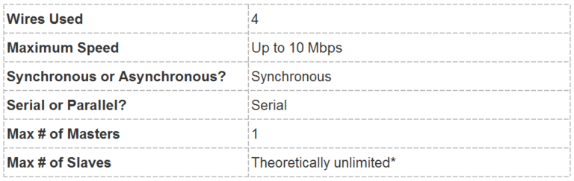
- SPI communication is always initiated by the master since the master configures and generates the clock signal.

SLAVE SELECT
- The master can choose which slave it wants to talk to by setting the slave’s CS/SS line to a low voltage level. In the idle, non-transmitting state, the slave select line is kept at a high voltage level. Multiple CS/SS pins may be available on the master, which allows for multiple slaves to be wired in parallel. If only one CS/SS pin is present, multiple slaves can be wired to the master by daisy-chaining.
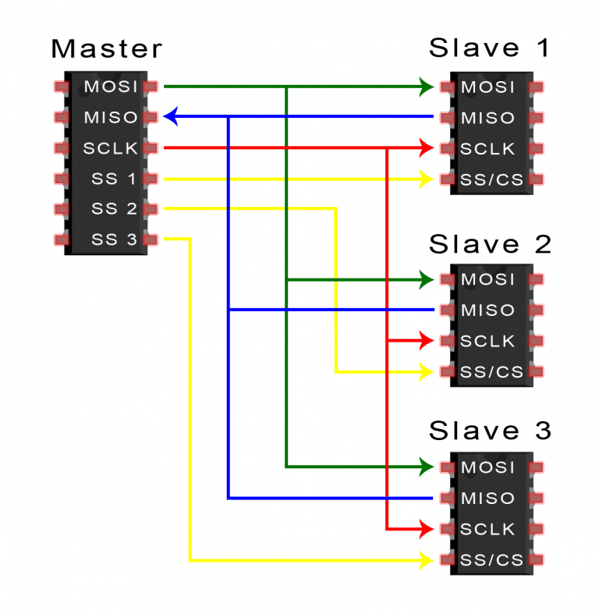
- There are two ways to connect multiple slaves to the master. If the master has multiple slave select pins, the slaves can be wired in parallel like this:

If only one slave select pin is available, the slaves can be daisy-chained like this:
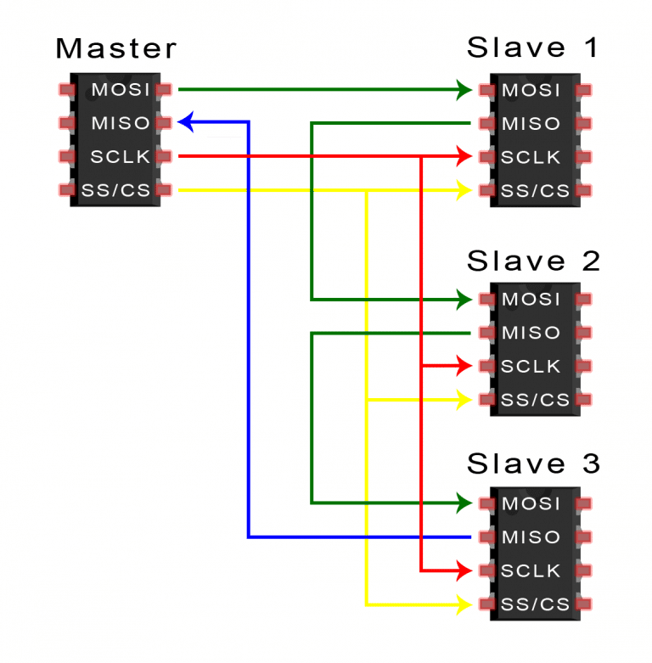
- Data sent from the master to the slave is usually sent with the most significant bit first.
- The data sent from the slave back to the master is usually sent with the least significant bit first.
STEPS OF SPI DATA TRANSMISSION
1. The master outputs the clock signal:
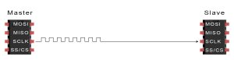
2. The master switches the SS/CS pin to a low voltage state, which activates the slave:
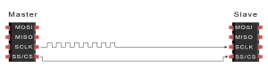
3. The master sends the data one bit at a time to the slave along the MOSI line. The slave reads the bits as they are received:
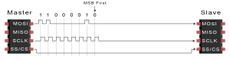
4. If a response is needed, the slave returns data one bit at a time to the master along the MISO line. The master reads the bits as they are received:
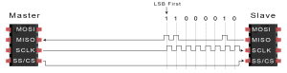

- Only allows for a single master

