C/Python & Shell Scripting

Problem 1:
Once a monk was watching a fight between an array and a tree, of being better. Tree got frustrated and converted that array into a Binary Search Tree by inserting the elements as nodes in BST, processing elements in the given order in the array. Now Monk wants to know the height of the created Binary Search Tree.
Help him for the same.
Note:
1) In Binary Search Tree, the left sub-tree contains only nodes with values less than or equal to the parent node; the right sub-tree contains only nodes with values greater than the parent node.
2) Binary Search Tree with one node, has height equal to 1.
Input Format:
The first line will consist of 1 integer N, denoting the number of elements in the array.
In next line, there will be N space separated integers, A[i] , where 1≤i≤N, denoting the elements of array.
Output Format
Print the height of the created Binary Search Tree.
Constraints:
1≤N≤103
1≤A[i] ≤106
SAMPLE INPUT

4
2 1 3 4
SAMPLE OUTPUT

3
Explanation
N=4.
Insert 2. It becomes root of the tree.
Insert 1. It becomes left child of 2.
Insert 3. It becomes right child of 2.
Insert 4. It becomes right child of 3.
Final height of tree = 3.

Problem: 2
Monk has an array A having N distinct integers and a Binary Search Tree which is initially empty. He inserts all the elements of the array from index 1 to N in the BST in the order given in the array. But wait! The tree so formed turns out to be cursed. Monk is having some weird experiences since he made that tree.
So, now to stop all that, Monk has two options, to destroy the BST or to pray to God and ask for a solution. Now since Monk has to use this BST in a Code Monk Challenge, he cannot destroy it. So he prays to God.
God answer his prayers and sends an angel named Micro. Now, Micro asks Monk to find something. He tells him two values, X and Y, present in the BST and ask him to find the maximum value that lie in the path between node having value X and node having value Y. (including X and Y ).
Now since, Monk is very afraid of that tree he asks for your help.
Input:
First line consists of a single integer denoting N.
Second line consists of N space separated integers denoting the array A.
Third line consists of two space separated integers denoting X and Y.
Output:
Print the maximum value that lie in the path from node having value X and node having value Y in a new line.
Constraints:
1≤N≤105
1≤A[i]≤109
It is ensured that values X and Y are present in the array.
SAMPLE INPUT

5
4 7 8 6 3
3 7

SAMPLE OUTPUT

7
Explanation
Binary Search Tree for the given array is given below
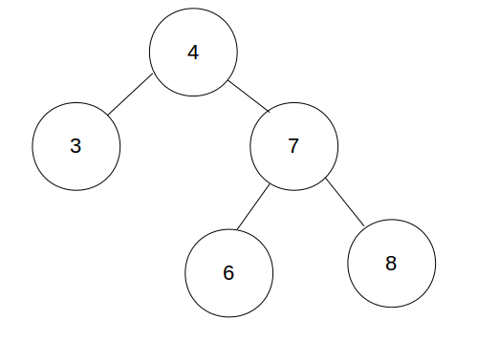
Path between node having value 3 and node having value 7 is 3 -> 4 -> 7. Maximum value that lies on this path is 7.

Problem: 3
Given a Binary tree T consisting of N nodes rooted at node 1 and a number K. each node has a number written on it, where the number written on the ith node is A[i].
Now, Monk needs to find the number of unordered triplets (i,j,k), such that node i is an ancestor of node j as well as node k, j≠k, and A[i]+A[j]+A[k]≥K.
A node x is considered an ancestor of another node y if x is parent of y or x is an ancestor of parent of y.
Help Monk for the same.
Input Format :
The first line contains 2 space separated integers N and K. The next line contains N space separated integers, where the ith integer denotes A[i].
The next line contains N−1 space separated integers, where the ith integer represents the parent of node i+1.
Output Format :
Print the required answer on a single line.
Constraints :
1≤N≤500
0≤A[i],K≤109
1≤parent[i]<i, where 2≤i≤N
Note :
It is guaranteed that the given input forms a valid binary tree.
SAMPLE INPUT

5 6
1 2 3 4 5
1 2 2 1
SAMPLE OUTPUT

7
Explanation
Image of the tree is given below
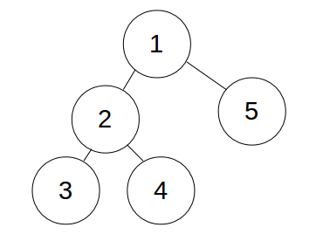
The triplets forming part of the answer are :
- (1,2,3)
- (1,2,4)
- (1,2,5)
- (1,3,4)
- (1,3,5).
- (1,4,5).
- (2,3,4)

Problem: 4
Given a complete binary tree with N nodes and each node have an distinct integer ai attached with it, find the minimum number of swaps you can make to convert the binary tree into binary search tree. In one swap, you can select any two nodes and swap their values.
You will be given the array representation of the binary tree. Root of the tree will be at a1. Left child of root will be at a2 and right child of root will be at a3. Left child of node at array position k will be at a2∗k and right child of node at array position k will be at a2∗k+1.
Input format:
First line contains an integer, N (1≤N≤105), denoting the number of nodes. Second line contains N space separated integers, ai (1≤ai≤105),, denoting the value attached to ith node.
Output format:
Print a single integer, denoting the minimum number of swaps needed to convert binary tree into a binary search tree.
SAMPLE INPUT

3
1 2 3
SAMPLE OUTPUT

1

Explanation
We need to only one swap (1,2) to convert the given binary tree into binary search tree.
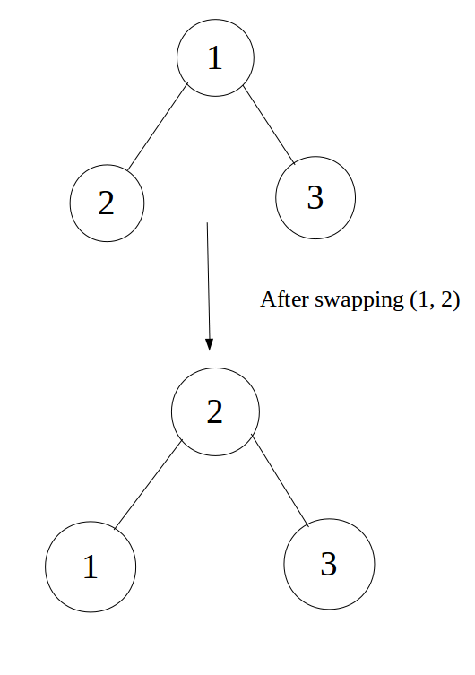

Problem: 5
Monk as always has brought a new task for Fredo. He asks Fredo to create a Binary Search Tree (BST) with L levels and 2L−1 nodes. Let the sum of all node values in the BST be M. He further adds that M should be smallest possible integer greater than S, where S is an integer given by Monk. He states the rules of creating BST as follows:
- The left sub-tree contains only nodes with values less than or equal to the parent node; the right sub-tree contains only nodes with values greater than the parent node.
- If a node has level i, then the subtree rooted at that node should have exactly 2L−i number of distinct values in the subtree. Note that it is the number of distinct values in the subtree and not the number of nodes in the subtree.
- If a is the smallest value in the tree and b is the largest value, then all values from a to b must come atleast once in the tree.
Level of root is 1, next level is 2 and so on.
Now, he will ask two type of queries to Fredo.
Type 0: Find the closest node to root whose value is equal to val and print path to that node from the root. If root has value equal to val, print "root". Else print "l" when we visit left child of any node and "r" when we visit right child of any node.
Type 1: Tell the value of kth node in the tree. The nodes are numbered as:
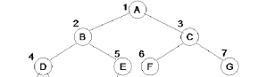
Here 1,2 and so on are node numbers and A,B etc. are values of nodes.
Finally, he will ask Fredo Q queries, each query belonging to one of the types mentioned above. Since, Fredo is new to this concept, help him complete this task.
Input Format:
First line consists of two integers L and S as described in the question.
Second line consists of Q, denoting the number of queries.
Each of the following Q lines consists of two integers. The first integer denoting the type of query and second denoting either val or k as described in the queries.
Output Format:
For each query, print the required answer in a separate line.
Input Constraints:
1≤L≤30
1≤S≤1018
1≤Q≤105
0≤type≤1
1≤k≤2L−1
val is in between minimum and maximum value in tree(inclusive).
Values of S, val and k are such that answer would always exist for them.
Node values will be non-negative for all inputs.
M will never exceed 2×1018
SAMPLE INPUT

3 16
5
0 3
0 4
1 4
1 7
0 5
SAMPLE OUTPUT

root
r
2
5
rr
Explanation
The tree would look like:
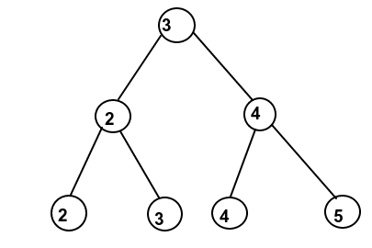
Sum = 3+2+4+2+3+4+5=23 which is smallest possible sum which we can get which is greater than 16.
Query 1: Node with value 3 which is closest to root is root itself.
Query 2: Node with value 4 which is closest to root is right child of root. So, we print "r".
Query 3: Value of node at number 4 is 2.
Query 4: Value of node at number 7 is 5.
Query 5: Node with value 5 which is closest to root is grandchild of root. So, we print "rr" which is path to node from root.

Shell Scripting:
Problem 1:

The awk interpreter may be used for a lot of text-munging and data-processing tasks that require some quick scripting work.
The following links show examples with awk:
Print Examples
Conditionals with Awk
Task
You are given a file with four space separated columns containing the scores of students in three subjects. The first column contains a single character (A - Z), the student identifier. The next three columns have three numbers each. The numbers are between 0 and 100, both inclusive. These numbers denote the scores of the students in English, Mathematics, and Science, respectively.
Your task is to identify whether each of the students has passed or failed.
A student is considered to have passed if (s)he has a score 50 or more in each of the three subjects.
Input Format
There will be no more than 10 rows of data.
Each line will be in the following format:
[Identifier][English Score][Math Score][Science Score]
Output Format
Depending on the scores, display the following for each student:
[Identifier] : [Pass]
or
[Identifier] : [Fail]
Sample Input
A 25 27 50
B 35 37 75
C 75 78 80
D 99 88 76
Sample Output
A : Fail
B : Fail
C : Pass
D : Pass
Explanation
Only student C and student D have scored ≥50 in all three subjects.

Problem: 2
In a given fragment of text, replace all sequences of multiple spaces with just one space.
Input Format
A block of ASCII text.
Output Format
Replace all sequences of multiple spaces with just one space.
Sample Input
He llo
Wor ld
how are you
Sample Output
He llo
Wor ld
how are you

Problem: 3
Given a text file, remove the consecutive repetitions of any line.
Sample Input
00
00
01
01
00
00
02
02
Sample Output
00
01
00
02
Problem: 4
In a given fragment of text, replace all parentheses ( ) with box brackets [ ].
Input Format
A block of ASCII text.
Output Format
Output the text with all parentheses ( ) replaced with box brackets [ ].
Sample Input
int i=(int)5.8
(23 + 5)*2
Sample Output
int i=[int]5.8
[23 + 5]*2

