Android Camera Architecture

- The goal of android project is to create succesfully real-world product that improves the mobile experience for end users.
- Java laguage is mainly used to write the android code even though other languages can be used

Camera use cases

- Live Previwe of camrea stream
- capture a frame
- video recording of a camrea stream

Android Camera

- The Android framework includes support for various cameras and camera features available on devices, allowing you to capture pictures and videos in your applications. This document discusses a quick, simple approach to image and video capture for users.

- The Android framework supports capturing images and video through the android.hardware.camera2 API or camera Intent. Here are the relevant classes:

android.hardware.camera2
This package is the primary API for controlling device cameras. It can be used to take pictures or videos when you are building a camera application.
Camera
This class is the older deprecated API for controlling device cameras.
SurfaceView
This class is used to present a live camera preview to the user.
MediaRecorder
This class is used to record video from the camera.
Intent
An intent action type of MediaStore.ACTION_IMAGE_CAPTURE can be used to capture images or videos without directly using the Camera object.

Camera Architecture

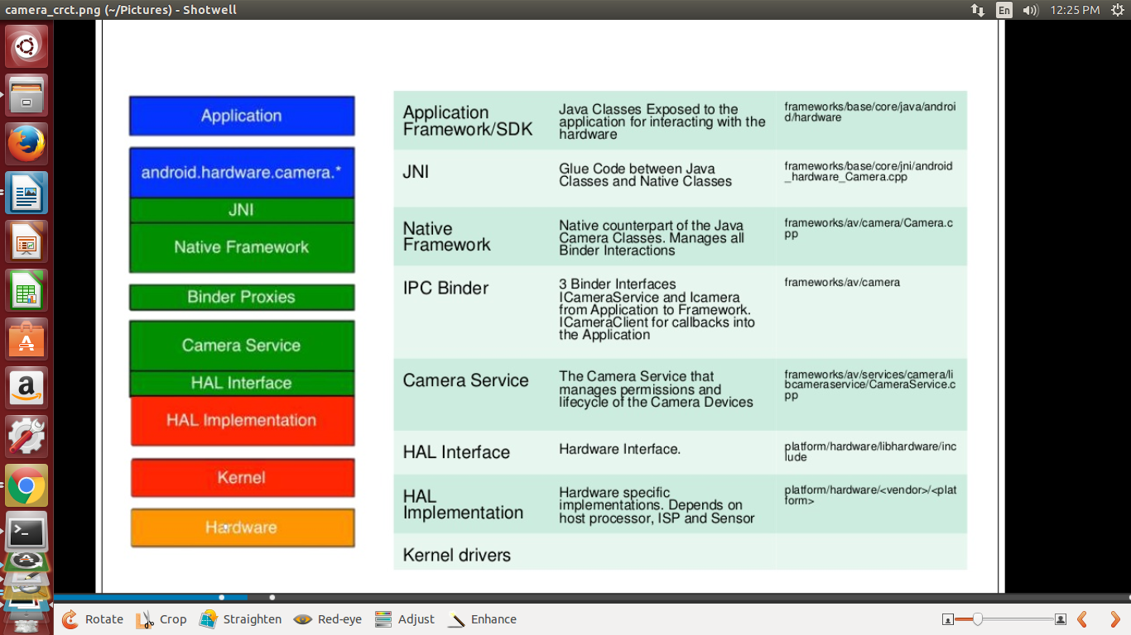
Application Framework :

- At the application framework level is the app's code, which utilizes the android.hardware.Camera API to interact with the camera hardware. Internally, this code calls a corresponding JNI glue class to access the native code that interacts with the camera.
- Java classes Exposed to the application for interfacing with the hardware.
Framework/base/core/java/android/harware/camera.java

JNI :

- It is the glue code between java classes and native classes
- The JNI code associated with android.hardware.Camera is located in frameworks/base/core/jni/android_hardware_Camera.cpp. This code calls the lower level native code to obtain access to the physical camera and returns data that is used to create the android.hardware.camera object at the framework level.
Native framework :

- The native framework defined in frameworks/av/camera/Camera.cpp provides a native equivalent to the android.hardware.Camera class. This class calls the IPC binder proxies to obtain access to the camera service.

Binder IPC proxies :

- The IPC binder proxies facilitate communication over process boundaries. There are three camera binder classes that are located in frameworks/av/camera directory that calls into camera service.
- ICameraService is the interface to the camera service, ICamera is the interface to a specific opened camera device.
- and ICameraClient is the device's interface back to the application framework.

Camera service :

- The camera service, located in frameworks/av/services/camera/libcameraservice/CameraService.cpp, is the actual code that interacts with the HAL.
- It manages permissions and lifecycle of the camera devices.

HAL interface :

- hardware intercace loactaed in hardware/libhardware/include/hardware see camera.h and camera_common.h files

HAL implementation :

- hardware specific implementations depends on host processor ,isp and sensor located in hardware/<vendor>/camera/Qcamera2/HAL/wrapper in that see .h and .cpp files

Kernel drivers :

- In general, the low-level implementation of the Camera APIs is V4L2,the camrea driver itself in kernel/drivers/media/v4l2/dev.c

- Android's camera Hardware Abstraction Layer (HAL) connects the higher level camera framework APIs in Camera 2 to your underlying camera driver and hardware.
- The HAL sits between the camera driver and the higher level Android framework and defines an interface you must implement so apps can correctly operate the camera hardware.

- A typical binderized HAL must implement the following HIDL interfaces:
ICameraProvider: For enumerating individual devices and managing their status.
ICameraDevice: The camera device interface.
ICameraDeviceSession: The active camera device session interfac
- The HAL interface is defined in the hardware/libhardware/include/hardware/camera.h and hardware/libhardware/include/hardware/camera_common.h header files.

- camera_common.h defines camera_module, a standard structure to obtain general information about the camera, such as the camera ID and properties common to all cameras (i.e., whether it is a front- or back-facing camera).

- camera.h contains code that corresponds to android.hardware.Camera. This header file declares a camera_device struct that in turn contains a camera_device_ops struct with pointers to functions that implement the HAL interface. For documentation on the camera parameters developers can set, refer to frameworks/av/include/camera/CameraParameters.h. These parameters are set with the function pointed to by int (*set_parameters)(struct camera_device *, const char *parms)in the HAL.

Capturing videos

  - Video capture using the Android framework requires careful management of the Camera object and coordination with the MediaRecorder class. When recording video with Camera, you must manage the Camera.lock() and Camera.unlock() calls to allow MediaRecorder access to the camera hardware, in addition to the Camera.open() and Camera.release() calls.

  - Unlike taking pictures with a device camera, capturing video requires a very particular call order. You must follow a specific order of execution to successfully prepare for and capture video with your application, as detailed below.
1. Open Camera- Use the Camera.open() to get an instance of the camera object.
2. Connect Preview- Prepare a live camera image preview by connecting a SurfaceView to the camera using Camera.setPreviewDisplay().
3. Start Preview- Call Camera.startPreview() to begin displaying the live camera images.
4. Start Recording Video- The following steps must be completed in order to successfully record video :
a) Unlock the Camera- Unlock the camera for use by MediaRecorder by calling Camera.unlock().
b) Configure MediaRecorder- Call in the following MediaRecorder methods in this order.
1. SetCamera() - Set the camera to be used for video capture, use your application's current instance of Camera.
2. SetAudioSource()- Set the audio source, use MediaRecorder.AudioSource.CAMCORDER.
3. SetVideoSource() - Set the video source, use MediaRecorder.VideoSource.CAMERA.
4. Set the video output format and encoding. For Android 2.2 (API Level 8) and higher, use the MediaRecorder.setProfile method, and get a profile instance using CamcorderProfile.get(). For versions of Android prior to 2.2, you must set the video output format and encoding parameters:
a) SetOutputFormat() - Set the output format, specify the default setting or MediaRecorder.OutputFormat.MPEG_4.
b) setAudioEncoder()- Set the sound encoding type, specify the default setting or MediaRecorder.AudioEncoder.AMR_NB.
c) setVideoEncoder() - Set the video encoding type, specify the default setting or MediaRecorder.VideoEncoder.MPEG_4_SP.
d) setOutputFile()- Set the output file, use getOutputMediaFile(MEDIA_TYPE_VIDEO).toString()from the example method in the Saving Media Files section.
e) setPreviewDisplay() - Specify the SurfaceView preview layout element for your application. Use the same object you specified for Connect Preview.
c) Prepare MediaRecorder- Prepare the MediaRecorder with provided configuration settings by calling MediaRecorder.prepare().
d) Start MediaRecorder - Start recording video by calling MediaRecorder.start().
5 .Stop Recording Video- Call the following methods in order, to successfully complete a video recording:
a) Stop MediaRecorder- Stop recording video by calling MediaRecorder.stop().
b) Reset MediaRecorder - Optionalsly, remove the configuration settings from the recorder by calling MediaRecorder.reset().
c) Release MediaRecorder- Release the MediaRecorder by calling MediaRecorder.release().
d) Lock the Camera- Lock the camera so that future MediaRecorder sessions can use it by calling Camera.lock(). Starting with Android 4.0 (API level 14), this call is not required unless the MediaRecorder.prepare() call fails.
6 .Stop the Preview - When your activity has finished using the camera, stop the preview using Camera.stopPreview().
7. Release Camera- Release the camera so that other applications can use it by calling Camera.release().

