================ Code Sync Commands ===============

- Blue bank:
- NON-HLOS(Bluebank) : git clone git@192.168.2.50:platform/crm/bb/cpl/bluebank/lf13/nhlos.git -b LYF_BB_MSM8905.1.3_DEV msm8905

- HLOS(Bluebank) : git clone git@192.168.2.50:platform/crm/bb/cpl/bluebank/lf13/hlos.git -b LYF_BB_MSM8905.1.3_DEV android

- Build Structure: (msm8905/LINUX/android)

- F300B(CERES): git clone git@192.168.2.50:platform/crm/bb/cpl/ceres/msm8905.git -b LYF_F300B_MSM8905.1.3.1_DEV

- F220B(VENUS): git clone git@192.168.2.50:platform/crm/bb/cpl/venus/msm8905.git -b LYF_F220B_MSM8905.1.3.1_DEV

- F90M(Meghaphone): git clone git@192.168.2.50:platform/crm/f90m/cpl/msm8905.git -b LYF_F90M_MSM8905.1.3_DEV
F30C:
- Build Structure : (msm8905/LINUX/android)

- F30C(CKT)::HLOS : git clone git@192.168.2.50:platform/crm/f30c/hlos.git -b LYF_F30C_MSM8905.1.3_DEV android

- F30C(CKT)::NHLOS :git cone git@192.168.2.50:platform/crm/f30c/nhlos.git -b LYF_F30C_MSM8905.1.3_DEV msm8905

F50Y(Huiye)-NHLOS:
Automation scripts:
- git clone git@192.168.2.50:platform/crm/f50y/modem.git
- git clone git@192.168.2.50:platform/crm/f50y/scripts.git
- NON-HLOS: git clone git@192.168.2.50:platform/crm/f50y/nhlos.git -b LYF_F30C_MSM8905.1.3_DEV msm8905

HLOS:
- repo init -u ssh://caerus@192.168.2.154:22/crux/F50Y/LYF13/huiye/vtech/lf/manifest.git -b LYF_F50Y_MSM8905.1.3_DEV -m f50y.xml
- repo sync -j4
F20A source:
- NON-HLOS: git clone git@192.168.2.50:platform/crm/f20a/QRD8905.git -b LYF_F20A_QRD8905_MPL
HLOS:
- repo init -u ssh://caerus@192.168.2.154:22/crux/HLOS/F20A/huiye/vsmart/lf/manifest -b LYF_F20A_MSM8905.1.3.1_DEV -m F20A.xml
- repo sync -j4
- repo start LYF_F20A_MSM8905.1.3.1_DEV --all

======== Compilation Steps ================
NON-HLOS:
✓ F30C: make all
✓ BB: modem_build_lwg.bat ALL / modem_build_lwgf3.bat ALL (bluebank_amss_env.bat)
✓ F50Y:
- build.bat X68N all secure
- put the all compiled image of ap code into LINUX\android\out\target\product\msm8909_512
- build.bat X68N update
- run copy_ap_secure.bat and copy_modem_secure.bat
- python binary_pack.py
- F20A:
- build.bat X68_TRX01 all secure
- put the all compiled image of ap code into LINUX\android\out\target\product\msm8909_512
- build.bat X68_TRX01 update secure
- run copy_ap_secure.bat and copy_modem_secure.bat
- python binary_pack.py

✓ F220B : modem_build_lwg.bat ALL / modem_build_lwgf3.bat ALL (bluebank_amss_env.bat)
✓ F300B: modem_build_lwg.bat ALL / modem_build_lwgf3.bat ALL (bluebank_amss_env.bat)
✓ F90M: ./BuildScriptQCT.sh // ./BuildScriptQCT.sh RELEASE // python pack.py
✓ F10Q : ./ build_modem_F10_userdebug.sh // build_modem_F10_user.sh (Need to update env paths)
✓ F210Q: build_modem_F10_userdebug.sh // build_modem_F10_user.sh (Need to update env paths)
❖ HLOS:
✓ F30C: source build/envsetup.sh;lunch22/lunch 23; make –j8/mk n all (HLOS & NHLOS)
✓ BB & F220B& F300B:
➢ cd msm8905/LINUX/android
➢ source build/envsetup.sh
➢ Lunch (Choose a combo by input its number)
- LF2403_MSM8909_512-user
- LF2403_MSM8909_512-userdebug
- LF2403S_MSM8909_512-user
- LF2403S_MSM8909_512-userdebug
- LF2403N_MSM8909_512-user
- LF2403N_MSM8909_512-userdebug
- LF2403N_L3_MSM8909_512-user
- LF2403N_L3_MSM8909_512-userdebug
- F120B_MSM8909_512-user
- F120B_MSM8909_512-userdebug
➢ choose a combo:5
➢ make –j8
➢ back to root dir (cd ../../)
➢ pack_all_signed.sh/pack_all_unsigned.sh(LF2403)

✓ F50Y:
➢ source build/envsetup.sh
➢ choosecombo 1 msm8909_512 user/ choosecombo 2 msm8909_512 userdebug
➢ make –j8
✓ F20A:
➢ source build/envsetup.sh
➢ choosecombo 1 msm8909_512 user/ choosecombo 2 msm8909_512 userdebug
➢ make –j8
✓ F10Q & F210Q:
➢ cd scripts
➢ ./android_build_f10q.sh
➢ Pass BUILD_ID as parameter
V. FOTA setup:
- Download the FOTA Tool from KaiOS Gitlab.
- Run Gen.sh script which is generated “KaiOS-QC-Block-V1.5.6” directory
- make clean
- make
- make links
- make install
- export PATH=$PATH:{PWD}
- cp {LEGA_OTA_PATH} /* software/src/
- cp {CURR_OTA_PATH}/* software/tgt/
- ./prepare_pkg_start.sh
- mkdir tmp
- mv software/source.zip tmp/
- unzip source.zip
- rm source.zip
- cd RADIO/
- rm NON-HLOS.bin
- zip -qry source.zip ./*
- mv source.zip ../software/
- cd ..
- ./gen_update_pkg_start.sh (Before running need to verify passwd & keys are configured or not)

- VI. MBN Generation process:
PATH:\modem_proc\mcfg\mcfg_gen\generic\APAC\Reliance
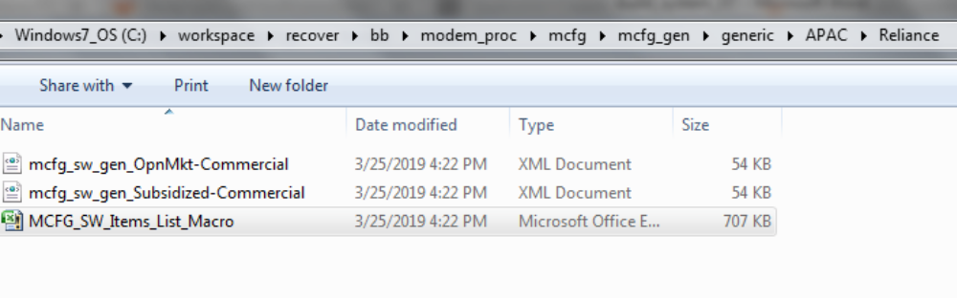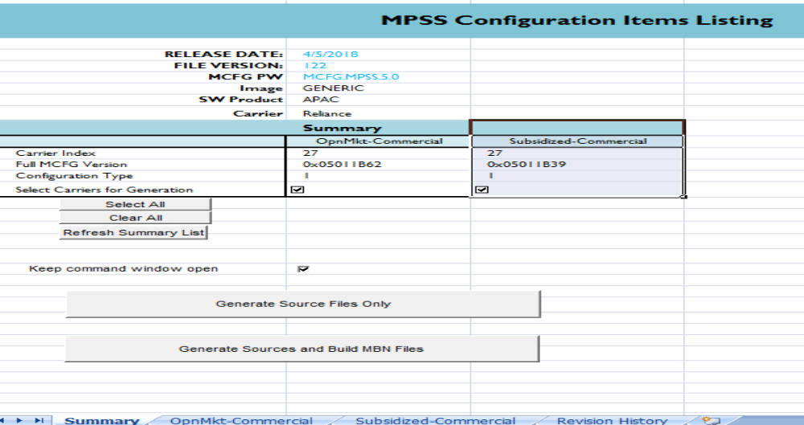
❖ opnMkt_Commercial:
- go to I513 => VT Calling Enabled => F513 change from 0 to 1
- go to I514 => mobile_data_enabled => F514 change from 0 to 1
- go to I518 => video_feature_tag => F518 add video
- Then changed MCFG version:
  - go to F739 => 0x05011B62 => change as 0x05011B63

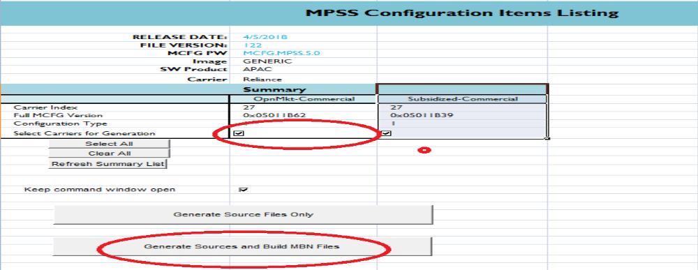
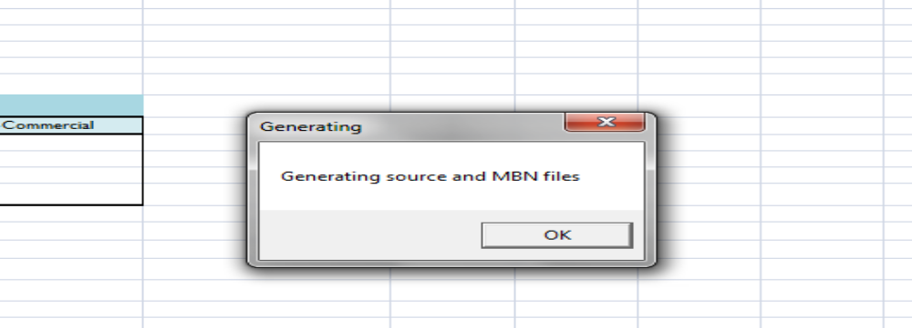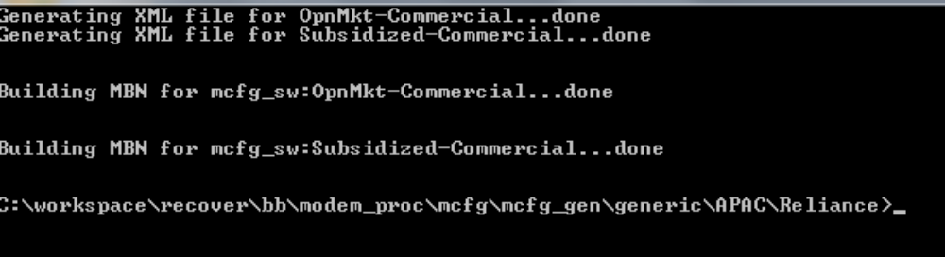
Generated@ modem_proc\mcfg\configs\mcfg_sw\generic\APAC\Reliance\Commercial\OpnMkt
Placed@ modem_proc\mcfg\configs\mcfg_sw\generic\mbn_ota and renamed in below
