- https://developer.android.com/guide/topics/media/camera
camera flow

- https://source.android.com/devices/camera#configuring...............
flow of camera

- https://inducesmile.com/android/android-camera2-api-example- tutorial/............. most imp steps

- https://developer.android.com/guide/platform ..............architecture of android
- https://www.e-consystems.com/blog/system-on-module-SOM/android-hal-and device-driver-architecture/ ................about HAL layer
- https://www.slideshare.net/pickerweng/android-camera-architecture-8098156 ..............imp for camera diagram
- https://www.slideshare.net/boochlin/camera1-46414495?next_slideshow=3 ...........imp for camera call flow
- https://www.slideshare.net/MadhuSelvarangam/android-cameraoverview?qid=4ecf8339-c6a9-4793-a0c4-074f805c6033&v=&b=&from_search=5 ............theory of each layer
- https://www.slideshare.net/lbk003/android-builderssummit2013-kaurguptafinal?qid=4ecf8339-c6a9-4793-a0c4-074f805c6033&v=&b=&from_search=2 for HAL layer

- Starting from Android L (SDK version 21), android introduced a new Camera API called Camera.2 API. Although the Camera API before this version has been deprecated but it still works and we are going to focus this tutorial on this API.

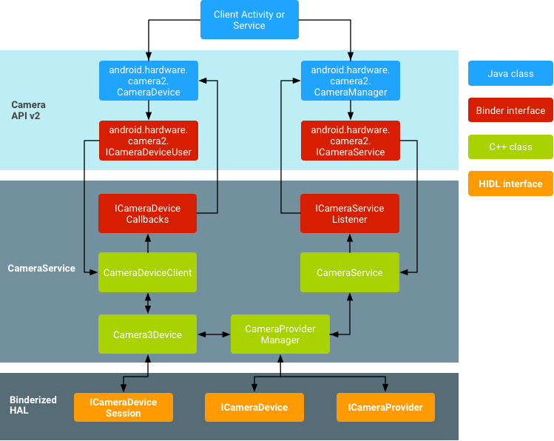
- Android's camera Hardware Abstraction Layer (HAL) connects the higher level camera framework APIs in Camera 2 to your underlying camera driver and hardware.

Figure 1. Camera architecture

- Application framework
At the application framework level is the app's code, which uses the Camera 2 API to interact with the camera hardware. Internally, this code calls corresponding Binder interfaces to access the native code that interacts with the camera.

