**Qualcomm Sanpdragon Mobile Platforms**

A computer requires a processor to compute all the processes. A processor is known as “The heart of The Computer”. Similarly a mobile phone requires a processor for computation of the tasks.

There are many companies manufacturing processors of computers like

1. Intel
2. AMD

Similarly, a processor in a mobile is known as SOC (System on Chip)

There are many manufacture for mobile Soc like

1. Qualcomm
2. Samsung
3. Mediatek
4. Huawei

Qualcomm is one of leading manufacturer for Mobile Soc. This company has named its processor as Snapdragon. Collectively called as Qualcomm Snapdragon.

Snapdragon uses ARM-based Architecture and a simple SoC which includes CPU (Central Processing Unit), GPU (Graphics Processing Unit), Wireless Modem and other support of Hardware like GPS, Camera, Gesture Recognition, Biometric Recognition, Measuring Tool and many other. Snapdragon Processor is found in Smartphone of Android, Microsoft, Smart watch of Android, they are also used in Netbook and various another device.

**Mobile Processor Snapdragon Series and Its Features**

There are four main tiers of Snapdragon processors, each with its own set of features and focuses.

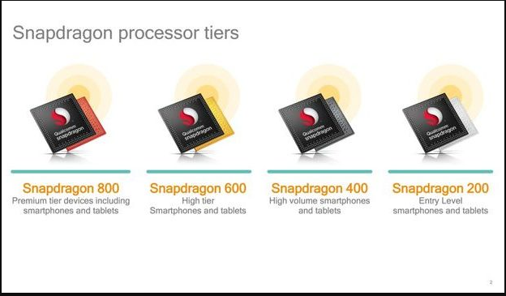

**Qualcomm’s Snapdragon 200 Series:**

Qualcomm entry-level mobile processors are designed for OEMs that service consumers who may otherwise be unable to gain access to quality, affordable, reliable mobile devices.

Snapdragon 200 is entry level Processor lineup as this processor made from 28nm Process which made this SoC to absorb less power and perform efficiently. As this lineup starts with the 1GHz processor to dual or quad core model as the model available in different model number. Some Microsoft Smartphones also uses this Soc as they are powerful and efficient. While recently there is 212 Snapdragon is running which feature F-HD playback and record, LTE Bands and powerful CPU.

**Some of the well-known Qualcomm Snapdragon 200 series chipsets are:** MSM8909, MSM8905

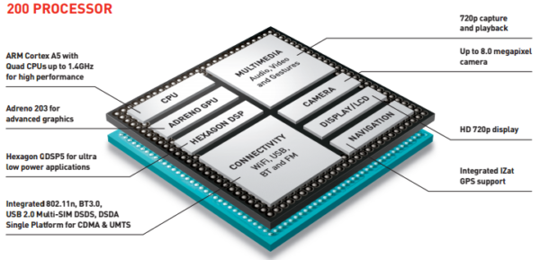

**Qualcomm’s Snapdragon 200 Series Architecture**

**Qualcomm’s Snapdragon 400 Series:**

Qualcomm mid-tier mobile processors are designed to support the most popular smartphone and IoT features, including comprehensive Internet connections, cutting-edge camera technologies, full HD displays, and high-fidelity audio.

Basically, this Processor lineup is the main base mark of Snapdragon as new development made this chip capable of performing multitasking, HD graphics rendering and many other things too. This processor comes in various range start with Dual Core SoC to Quad Core or Octa Core also. While recently there is Snapdragon 430 Processor is up and running which uses Octa Core CPU and way more powerful than previous one.

**Some of the well-known Qualcomm Snapdragon 400 series chipsets are:** SDM450, MSM8940, MSM8937, MSM8920

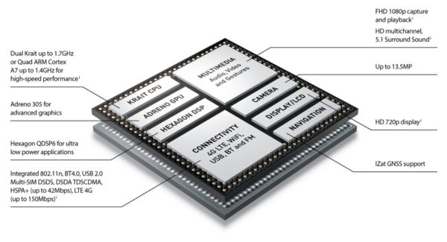

**Qualcomm’s Snapdragon 400 Series Architecture**

**Snapdragon 600 Series:**

Qualcomm high-tier mobile processors are designed for performance, efficiency and versatility by offering superior mobile user experiences in a variety of form factors, from smartphones and tablets to embedded designs and connected cars.

This Group of series has a significant market share which made this SoC more consumable as many mobile manufacturers use this Soc as their base mark, as this SoC is capable of performance various task, able to render 4K content (Now), High graphics rendering capabilities and many Bands. While recently there is Snapdragon 650 or 652 is running on the various device which is best in all aspects.

**Some of the well-known Qualcomm Snapdragon 600 series chipsets are:** MSM8953, MSM8953Pro, MSM8976, MSM8976Pro, SDM630, SDM660, SDM670, SDM710

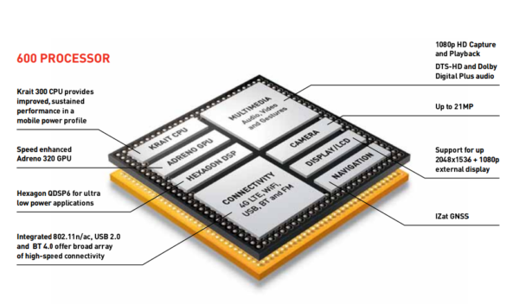

**Qualcomm’s Snapdragon 600 Series Architecture**

**Snapdragon 800 Series:**

Qualcomm premium-tier mobile processors with multi-core CPUs can expand the possibilities of connected computing and represent the ultimate in performance, power efficiency and 4G LTE connectivity.

Snapdragon 800 or Flagship Processor as this processor is used by each and every flagship device which have Qualcomm’s SoC. As this benchmark of whole Qualcomm and this SoC support many things like capturing 4K content, heavy multitasking, biometric support and various other capabilities you won’t find on previous one. Current the king is Snapdragon 821 which is running on all the flagship like Pixel or various other.

**Some of the well-known Qualcomm Snapdragon 800 series chipsets are:** MSM8996, MSM8996Pro, MSM8998, SDM845, SDM850

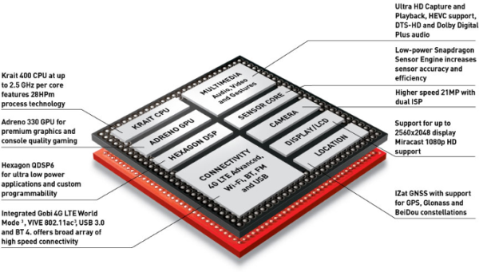

**Qualcomm’s Snapdragon 800 Series Architecture**

While at the end of this article I would like to mentioned about Adreno GPU also owned by Snapdragon and this GPU are featured inside the Snapdragon SoC, as nowadays GPU are capable of giving console level graphics on a mobile device which was never thought on past days. But this GPU are best GPU for the mobile device while Apple GPU which uses PowerVR which is benchmark king in GPU. But Adreno GPU is capable of giving out some nice result. As recently Android start supporting Vulkan API which means that heavy graphics can now render more easily on a mobile device.

**Note:**

Keep in mind that because a chip supports a technology does not necessarily mean that a phone comes with it. It simply means that the processor could, theoretically, handle such technology. For example, the new Snapdragon 845 supports the 801.11ad wireless standard, but no OEM makes a phone with that technology.

**Qualcomm latest Snapdragon 845 Mobile Platform architecture**

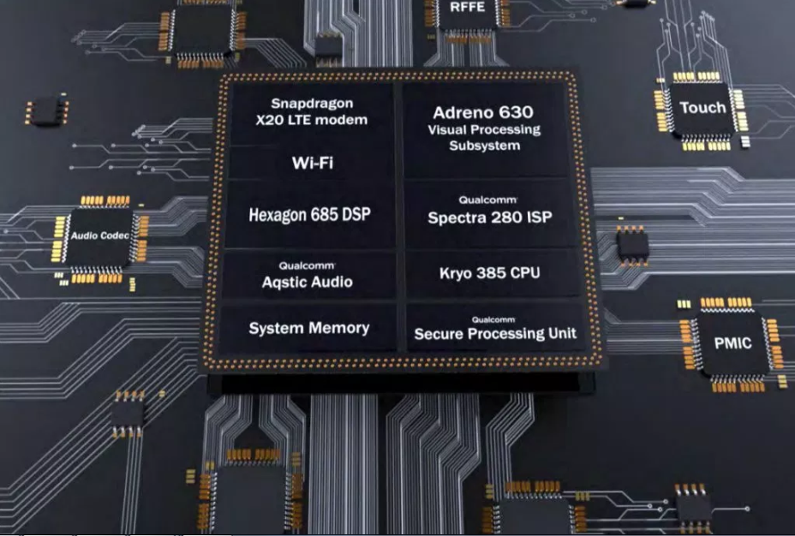

**Features:**

The Snapdragon 845 is designed to deliver immersive multimedia experience, lightning-fast connectivity, vault-like security and on-device Artificial Intelligence (AI) on premium, flagship mobile devices.

The Qualcomm Snapdragon 845 Mobile Platform is built using Samsung’s 10nm LPP FinFET process technology and features the new Kryo 385 architecture. The CPU eight Kyro 385 cores’ ‎includes 4x Cortex-A75 cores up to 2.8 GHz + 4x Cortex-A55 cores up to 1.8 GHz, which sees a 25% uplift in performance.

The new Adreno 630 visual processing subsystem (GPU, VPU and DPU) promises up to 30-percent faster graphics and 30-percent better power efficiency when compared to previous generation (Adreno 540). It also features 2.5x faster display throughput i.e a 2K x 2K display can efficiently run at 120 Hz.

In the aspect of connectivity, the SDM845 is ‎equipped with the Snapdragon X20 LTE modem to deliver Gigabit LTE service (‎up to 1.2 Gbps peak download speeds and up to 150 Mbps peak upload speed). It also supports Bluetooth 5.0, Dual SIM Dual VoLTE, 802.11ad multi-gigabit Wi-Fi and integrated 2×2 802.11ac.

Other key components include the new Hexagon 685 DSP (3x faster than the previous generation – Hexagon 682) which serves as the AI mobile co-processor, Qualcomm Aqstic audio codec and Qualcomm Spectra 280 ISP for premium camera and extended reality (XR) experience.

The company has also introduced an entirely new Qualcomm Secure Processing Unit (SPU) to help protect personal data with vault-like security.

**Some of the Snapdragon 845 Phones in the market are:** Xiaomi Poco F1, OnePlus 6, Samsung Galaxy S9, S9 Plus and Galaxy Note 9, Asus Zenfone 5Z, Oppo Find X, Sony Xperia XZ3