**QXDM Professional Document**

QXDM Professional provides a diagnostic client for rapid prototyping of new clients, protocol packets and messages. QXDM diagnose monitor allows to watch phone and network settings.

**DUT Physical Connectivity:**

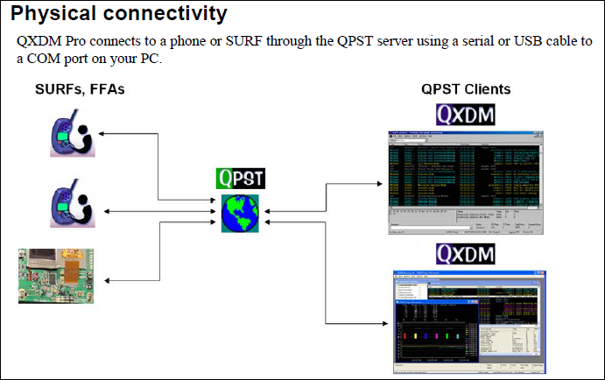

**QXDM working process:**

To work with QXDM, **diag port and com port** should be enabled in device manager and also need to select the device **com port**.

* **Diag mode:** To work Diagnostics Mode, DIAG port should be enabled, you can see it in your Device Manager. Here is the snapshot of diag port. If it is not visible, you've to install the correct drivers for the device and the device should has Qualcomm Chipset!

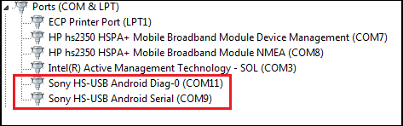

* **COM Port selection:**

Start QXDM Professional 🡪Options🡪Communications

In the Communications dialog box, in Target Port, select the COM port which is related to your DUT (the one that QPST is connected to)

Click on: OK 🡪the window should now become active.

In the View drop down menu, select: Status (Static) <F9>

The window should fill with information about your phone.

**Features of QXDM**

* **Real-time Monitor:** It utilizes a graphical user interface to display real time data transmitted to and from the subscriber station.
* **Data Capture:** Capture diagnostic logs, events, and messages as .isf files for data analysis during the Integrate and Verify phases. Review regression, lab, and field test results during verification.
* **NV Browser:** NV items stored in the nonvolatile memory of the connected target can be viewed and modified using the NV Browser. The Category Filter can be used to view just NV items belonging to a single category.

To read an NV item, select the item to display the names of all the fields for that item and click the Read button to read the values from the phone. To write an NV item, select the item to display the names of all the item fields. To change the values, click the value in the Input column. After modifying the values, click the Write button to write the updated values back to the phone.

**Procedure:** Read->Write->Offline->Reset

* **To enable different logs in message view/log packets view:** Message View->right click->config->enable the logs that you want and collect the logs and File->save items. Once you’re done with failures test case logs, save the logs using below process.

**File**🡪save items: Then this file gets saved in the format of .isf (This file contains all traffic that occurs between QXDM Pro and the target).

* **Command Interface:** This can be used to view/change device's radio band & modem settings and other stuff like changing IMEI address or MAC Address, SSR (Sub System Restart) and to perform target/device crash, for reading/writing NV items and setting the device in different modes (FTM/LPM/Offline-A/Offline-B/Online/Reset), pause (to pause the script), echo (to display messages on the output screen-test started/completed).

**Loopback commands:** To check subsystem functionality (Whether it is working or not)

If it is working, we’ll get 0x4b output in command output window

If it is not working, we’ll get 0x14b output in command output window

**To check name of subsystem:** adb shell

cat /sys/bus/msm_subsys/devices/subsys3/name (modem/adsp/wcnss/tz/rpm/slpi-sensors)

To check the state of DUT: adb shell

cat /sys/bus/msm_subsys/devices/subsys2/restart_level (system/related)

To put the DUT in related mode: adb shell

echo related > /sys/bus/msm_subsys/devices/subsys2/restart_level

<<Modify subsystem number to work with other subsystem names>>

**If the DUT is in system state:** SSR will put the device in target crash

**If the DUT is in related state:** SSR will restart respective sub system

**Loopback command for ADSP:** send_data 75 18 42 0 1 2 3

**SSR command for ADSP:** send_data 75 37 03 48 00

We can crash the target in below ways. (Change 00 from above command to 00/01/02)

**00:** Software error fatal

**01:** watchdog bite

**02:** null pointer exception

**Usage:** Mode FTM/LPM/Offline-A/Offline-B/Online/Reset

FTM – Change to Factory Test mode

LPM – Change to Low Power mode

Offline-A – Change to Offline Analog mode

Offline-D – Change to Offline Digital mode

And this interface can also be used to automate the device. We’ve to write our automation script in the format of .scr only.

**Call Manager:** To make MO calls (to work with non-display devices-MPQ, ThreadX and normal phones as well for automation purposes)

**Status (Dynamic):** To check modem state (online/offline), RF band, Frequency.

**Status (Static):** To check the device properties like build, model, IMEI numbers.

**Item view:** The Item View is a special item list view that shows all items generated during a QXDM Pro session. This includes the Item View, Filtered Views, Messages View, Log View, and the Command Output display.

**Message view:** This view contains the logs that are selected by the user from config setting.

**Other Features:**

* QXDM helps to narrow down in which layer the issue exists i.e., in modem (NAS/RRC/RLC/Physical/MAC layers)
* QXDM supports all RATs (Radio Access Technology) like CDMA, TDSCDMA, GSM, WCDMA, LTE, etc.
* **GSM/UMTS/LTE Cell Reselection:** The window should change and various colored lines with dots on them should appear which indicates that the phone is communicating with cell towers. This can be like as below.

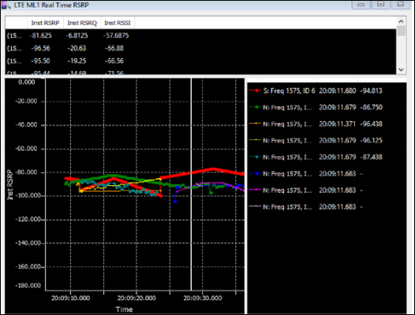

If there's no activity, it means that the phone's cell radio is either not working/burnt out, faulty SIM card, or something is preventing the phone from communicating with the cell towers, or something else.