1. snmp监控软件OpenNMS：
参考：FAQ:How can I monitor my system with SNMP?

2. snmp上报trap消息如何配置：
参考：FAQ:How can I monitor my system with SNMP? snmpd.conf(5)->ACTIVE MONITORING

3. The Net-SNMP agent has not been designed for multi-threaded use.
参考：FAQ:Is Net-SNMP thread safe?
问题：？？如何编写thread-safe程序

- 向snmp tools添加MIB
作用：向snmp tools添加MIB后，可以通过名字指定MIB 对象，且能以更有意义的方式显示结果
步骤： 1. cp MY-MIB.txt {prefix}/share/snmp/mibs
(或者cp MY-MIB.txt $HOME/.snmp/mibs)
        - 告诉tools加载此MIB
snmpwalk -m +MY-MIB .....
(load it for this command only)
or
export MIBS=+MY-MIB
(load it for this session only)
or
echo "mibs +MY-MIB" >> $HOME/.snmp/snmp.conf
(load it every time)
注： snmp tools和agent的运行不必需要MIB文件

参考：FAQ: Where should I put my MIB files?

- 调试：snmp tools调试参数 “-d”
Net-SNMP agent调试参数-f -Le -d

- Agent配置
参考： snmpd.conf (5)

- snmp tools指定MIB的方式:
snmpget -m +FTS-GLOBAL-REG …...
snmpget SNMPv2-MIB::sysUpTime.0 …...

- walking a tree:

    - SNMP PDU解析
BER作为ANS.1的基本编码规则，描述具体的ANS.1对象如何编码为比特流在网络上进行传输。BER编码规则由三部分组成：

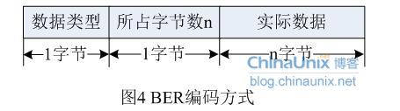

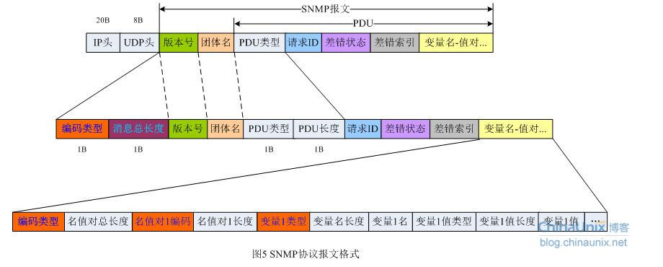

https://blog.csdn.net/u010566813/article/details/50490858
        - snmptrapd 配置：
<1> snmptrapd -Ls 7 (log to syslog using 'LOCAL7')
<2> snmptrapd -f -Lo (log to standard output)
<3> snmptrapd.conf: traphandle .1.3.6.1.6.3.1.5.1 /path/to/page_me up
<4> snmptrapd.conf: forward .1.3.6.1.4.1.8072.4.0.3 10.0.0.1
11. 如何把net-snmp编译成调试版：configure --with-cflags=-g

- net-snmp扩展MIB module的方法：AgentX, SMUX 、 proxied SNMP
其中，AgentX是最佳方法，其它两种是淘汰的方法
- ??How can I run AgentX with a different socket address
- 获取网络接口的类型和速度：有些系统参数可以通过猜测获取，有些不能，比如告诉网络接口的类型和速度，这时需要通过在snmpd.conf中用interface声明。
- ？？查看当前snmpd支持的MIB module
- 动态加载MIB module：编写代码、Makefile；启动snmpd -f -L -DnstAgentPluginObject,dlmod
- gdb调试：
gdb /root/snmp_app/sbin/snmpd (要把调试目标程序的路径写全，否则可能导致断点设置有问题)
r -f -L -DnstAgentPluginObject,dlmod (r -Lo)
//Server Exiting with code 1
b /root/snmp/net-snmp-5.7.3/agent/snmpd.c:977
b /root/snmp/net-snmp-5.7.3/agent/mibgroup/mibii/tcpTable.c:tcpTable_handler
为调试目的配置项目时，尽量要代码目录下执行配置，否则调试时会出现源码路径问题
??? 调试时无法返回gdb命令行状态: 在另一个窗口执行gdb attach
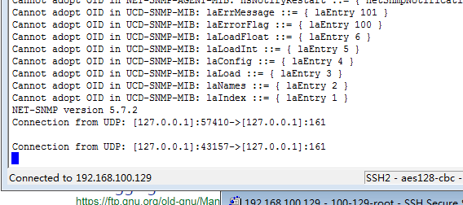
- MIB module 的文档和例子：
Many of the MIB modules shipped with the Net-SNMP agent still
use the v4 "traditional" MIB module API, but an increasing number
use one of the newer v5 helper-based handlers. All of these can
be found under 'agent/mibgroup'

The 'tdata' helper is used in the new DisMan Event, Expression
and Schedule MIB modules (see 'disman/{event,expr,schedule}/*').
The similar 'dataset' helper is used in the older DisMan Event
MIB implementation (see 'disman/mteEvent*') and the Notification
Log MIB (see 'notification-log-mib/*'), used by 'snmptrapd' to
log incoming traps.

The basic iterator handler is used in the TCP and UDP table
implementations (mibII/tcpTable & mibII/udpTable), VACM context
handling (mibII/vacm_context) and various tables relating to agent
internals (agent/*). These show a number of different approaches
to using the iterator helper, so it's worth comparing them.

The two examples/netSnmpHostsTable* modules provide a contrast
between the iterator and iterator_access helpers.

There are several examples based on the MfD framework (see
'{if,ip,tcp,udp}-mib/'). Much of this code is not intended to
be viewed directly, but individual files are clearly commented
to distinguish between internal implementation and public code.

The Net-SNMP agent does not currently include any MIB modules
using the array-user container-based helper. The best examples
of this are to be found in the net-policy project.
See http://net-policy.sourceforge.net/
- reg = netsnmp_create_handler_registration
table_info = SNMP_MALLOC_TYPEDEF( netsnmp_table_registration_info );
netsnmp_register_table( reg, table_info );
- mib2c.mfd.conf 作用：使MIB module的编写更容易
- MIB table module:
mib2c.table_data.conf （参考代码alarmTable.c 库接口table_tdata.c）
netsnmp_tdata_create_table; netsnmp_tdata_create_row；netsnmp_tdata_register；netsnmp_tdata_add_row；netsnmp_tdata_extract_entry；
netsnmp_tdata_extract_row；netsnmp_tdata_extract_table；
netsnmp_insert_tdata_row（associate row with requests）
mib2c.iterate_access.conf（ipCidrRouteTable.c/netSnmpHostsTable.c： netsnmp_oid_stash_add_data）
??? netsnmp_register_table_iterator2; netsnmp_oid_stash_add_data
netsnmp_tdata_create_table;get_first_data_point;get_next_data_point;make_data_context;
free_data_context
mib2c.iterate.conf（nsVacmAccessTable.c）
netsnmp_register_table_iterator；netsnmp_insert_iterator_context；get_first_data_point；get_next_data_point；netsnmp_extract_iterator_context

- ??? Baby_steps.c、Cache_handler.c、table_data.c(extend.c调用)、hrSWRunTable.c
- tdata：disman/{event,expr,schedule}/*
dataset（old）： disman/mteEvent*；notification-log-mib/*
iterator： mibII/tcpTable； mibII/udpTable；mibII/vacm_context；agent/*
（iterator and iterator_access: examples/netSnmpHostsTable*）
mfd: {if,ip,tcp,udp}-mib/

- tcpTable.c实现： cache方式（？？netsnmp_inject_handler( netsnmp_get_cache_handler））；由tcpTable_load负责table初始化；tcpTable_first_entry和tcpTable_next_entry为数据获取插件实现。
- 吴老师意见：网管信息全部放在agent的某个文件里，其他板卡通过这个文件与网管server端交互; mib库先实现一个简单的版本，然后逐步添加东西
26. MIB 数据文件解析（fts.dat）: 问题分解；问题隔离；首先验证文件格式正确性
- 代码修改技巧（ftsNtpTable.c）：拷贝代码(从ftsRefTable.c)，生成代码(mib2c)，使用工具（bcompare）-----善于利用工具
- ubuntu 桥接网络总是断网（用ifconfig设置的临时IP过一段时间自动清除）。
解决：vmware -> 虚拟机设置 -> 桥接模式 -> “复制物理网络的连接”，设为取消
- snmpd测试步骤：
<1> 开发板端：
mount -t nfs 192.168.1.100:/root/ /root/
snmpd
<2> vmware ubuntu:
get:
snmpget -c public -Oa -v 1 192.168.1.11 FTS-GLOBAL-REG::ftsRefCfg.0
snmpwalk -c public -v 1 192.168.1.11 FTS-GLOBAL-REG::ftsRef
snmptable -c public -v 1 192.168.1.11 FTS-GLOBAL-REG::ftsRefTable
set: snmpset -c public -v 1 192.168.1.11 FTS-GLOBAL-REG::ftsClkState.0 i holdover
- snmptrap -v 1 -c public localhost "" "" 1 0 ""
snmptrap -v 1 -c public localhost FTS-GLOBAL-REG::ftsRefTrap "" 6 17 "" ftsRefState i 1 ftsRefCurren i 2
snmptrap -v 2c -c public localhost "" UCD-SNMP-MIB::ucdStart
snmptrap -v 2c -c public localhost "" ucdStart sysContact.0 s "Dave"
/root/snmp_app/sbin/snmptrapd -f -Lo
snmptrapd.conf: authCommunity log,execute,net public
snmpd.conf: trap2sink localhost
- SNMP Trap文档：
TUT:snmptrap： http://www.net-snmp.org/wiki/index.php/TUT:snmptrap
TUT:Configuring snmptrapd： http://www.netsnmp.org/wiki/index.php/TUT:Configuring_snmptrapd#Trap_Handlers
notification.c ：http://www.net-snmp.org/dev/agent/notification_8c-example.html
- 运行snmpd出错： Error opening specified endpoint ""
原因：系统运行多个snmpd进程
- agentX + subagent：
net-snmp-config --compile-subagent --norm mysubagent nstAgentSubagentObject.c
snmpd.conf: master agentx
snmpd -Lo -Dagentx
- IP multicast is a technique for one-to-many communication over an IP network. The destination nodes send Internet Group Management Protocol join and leave messages, for example in the case of IPTV when the user changes from one TV channel to another. IP multicast scales to a larger receiver population by not requiring prior knowledge of who or how many receivers there are. Multicast uses network infrastructure efficiently by requiring the source to send a packet only once, even if it needs to be delivered to a large number of receivers. The nodes in the network take care of replicating the packet to reach multiple receivers only when necessary.
- 初版PTP: 仅支持多播主从模式（？多级 ？多播）; 不支持IP设置（通过其他方式设置）；
？？多播不需配置IP；仅支持单端口
- ptp文档： https://qulsar.com/Support/Online_Resources/Documents.html
- c语言错误处理：https://stackoverflow.com/questions/385975/error-handling-in-c-code
- eclipse 工程导入： https://wiki.eclipse.org/CDT/Autotools/User_Guide#Creating_New_Project_When_Importing
- eclipse调试： debug configurations —> c/c++ attach to application
调试时SIGPIPE信号导致程序中断：(gdb) handle SIGPIPE nostop
Windows ——> show view——> Breakpoints;Expressions;DebuggerConsole
- jdk安装：
update-alternatives --install /usr/bin/java java /root/tmp/snmp/jdk1.8.0_162/bin/java 100
update-alternatives --config java
update-alternatives --install /usr/bin/javac javac /root/tmp/snmp/jdk1.8.0_162/bin/javac 100
update-alternatives --config javac
update-alternatives --install /usr/bin/jar jar /root/tmp/snmp/jdk1.8.0_162/bin/jar 100
update-alternatives --config jar
export JAVA_HOME=/root/tmp/snmp/jdk1.8.0_162
export JRE_HOME=/root/tmp/snmp/jdk1.8.0_162/jre
export PATH=$PATH:/root/tmp/snmp/jdk1.8.0_162/bin:/root/tmp/snmp/jdk1.8.0_162/jre/bin
https://www.tecmint.com/install-java-jdk-jre-in-linux/
- 嵌入式调试：
arm端： gdbserver localhost:2001 /root/snmp_arm/sbin/snmpd
gdbserver localhost: 2001 --attach 2493
pc端：arm-none-linux-gnueabi-gdb -q /root/snmp_arm/sbin/snmpd
target remote 192.168.10. 2001
eclipse： debug configurations —> c/c++ attach to application——>
Debuger——>gdbsever；connection
eclipse： debug configurations —> c/c++ Remote Application——>
Debuger——>Using GDB (DSF) Manual Remote Debugging Launcher
41. can波特率设置：ip link set can0 up type can bitrate 250000
42. 网络管理技术：1. 周期性请求-相应；2. 定期保存需要管理的快照，然后打包上传
参考：《深入理解Net-SNMP 张春强》
43. 内核编译错误：......fatal error: error writing to /tmp/ccTyLwnL.s: No space left on device
解决：
# df -h
Filesystem Size Used Avail Use% Mounted on
tmpfs 101M 1.3M 99M 2% /run
# export TMPDIR=/mnt/work/tmp/
44. mfgtool烧写失败： 关闭杀毒软件
45. ubuntu 网络配置：
ln /run/resolvconf/resolv.conf /etc/resolv.conf
/etc/resolvconf/resolv.conf.d/base：nameserver 8.8.8.8
resolvconf –u
46. yocto使用：
source poky/oe-init-build-env
47. ubuntu 自动屏保关闭： Select the System Settings from the icon located on the far right in your top panel. Once there select the Brightness & Lock settings.
48. net-snmp demon 在windows下的安装：
<1> 运行net-snmp-5.6.1.1-1.x86.exe
<2> 创建、编辑配置文件C:\usr\etc\snmp\snmpd.conf：
sysLocation "beijing xindilian"
sysContact ittechbay111@163.com
rwcommunity public
<3> 注册服务registeragent.bat，然后启动服务
<4> 测试：snmpget -v 1 -c public localhost sysDescr.0
49. net-snmp监控端程序开发
http://www.net-snmp.org/wiki/index.php/TUT:Simple_Application
50. OID: 对象标识
snmpget [COMMON OPTIONS] [-Cf] OID [OID]...
OID对象定义：internet OBJECT IDENTIFIER ::= { iso org(3) dod(6) 1 }
MIB-II:

51. imx 6通过uboot烧写固件：
uboot通过网口下载内核到板子内存，然后用mmc命令将内核烧写到MMC芯片，然后配置uboot从nfs启动，引导linux系统，在linux系统中，将rootfs拷贝到MMC分区；

tftp安装：apt-get install tftpd tftp openbsd-inetd；
修改 tftp 服务器配置文件/etc/inetd.conf：/srv/tftp改为/tftpboot/
mkdir -p /tftpboot/；
/etc/init.d/openbsd-inetd restart；

setenv ipaddr 192.168.1.100
setenv ethaddr 00:01:02:03:04:05
setenv serverip 192.168.1.101
tftp 0x12000000 zImage
mmc write ${loadaddr} 0x800 0x4000

参考：《i.MX Linux? User's Guide》

52. ubuntu网络配置的两种方法：
<1> 全部通过在NetworkManager配置；此时通过ifconfig配置的IP会自动恢复；优先选用/etc/nework/interfaces中的配置
<2> 关闭NetworkManager：sudo service network-manager stop，通过/etc/network/interfaces配置网络

53. libqxt下载：登录bitbucket.org账户，
git clone https://ittechbay@bitbucket.org/libqxt/libqxt.git

54. git版本回退
git reflog
git reset --hard 799b494
55. net-snmp编译：用build.bat在win7下编译成功
56. ? net-snmp动态库版本命名方式
use libtool versioning the way they recommend.
LIBCURRENT = 30
LIBAGE = 0
LIBREVISION = 3
libnetsnmp.so.30.0.3
57. 配置文件snmpd.conf生成
进入/net-snmp-5.7.3/local，执行make; make install
然后执行export xxx/bin; snmpconf -g basic_setup

58. sqlite 数据库减少写flash次数方案：
开机，读取flash中的数据库文件到内存文件系统tmpfs，系统运行时数据访问都访问tmpfs中的数据库文件，周期性拷贝tmpfs中的数据库文件到flash文件系统

59. sqlite数据库互斥访问解决方案：读、写数据库时，监测返回状态，直到由SQLITE_BUSY变成SQLITE_OK，才表示读写成功
do {
ret = sqlite_exec(db, "INSERT INTO mytable (col1, col2) VALUES (1, 2)", NULL, NULL,
&errmsg);
switch(ret) {
case SQLITE_OK: break;

case SQLITE_BUSY: fprintf(stderr, "Database locked, sleeping...\n");
sleep(1);
break;
default: fprintf(stderr, "Error: %s\n", errmsg);
sqlite_freemem(errmsg);
return(ret);
}
} while (ret != SQLITE_OK);

60.

