ESL Flashcard system.

Overview (Big heading):

The Red Panthers project idea is to create an ESL (English as a Second Language) flashcard system for teaching basic English nouns to children learning English. The application will be created using Unity3D alongside Microsoft Visual Studio and will be written in C#. This software could be used to teach basic English to children using a flashcard system with mini games to keep the children interested and engaged through the process.

Motivation (Big heading):

As English is still considered world-wide to be the most valuable language in the world to learn as a second language [1], the market for learning English as a second language is predicated to grow at 7.1%, expecting to hit the $54.8 billion mark by 2025 [2]. Our motivation is to try and create a basic ESL learning application to try and tap into this growing market as well as create a tool to help children learn some English in areas of the world that do not have access to native English speakers to teach them, such as Vietnam where there is currently a lack of English teachers available [3].

Description (Big heading):

Features (small heading):

The ESL flashcard system will have the following features originally, with the possibility to expand and add more features later as needed.

* A main menu.
* A collection of stock flashcards. All flashcards show a picture of the noun and the English word below them.
* A flashcard selection screen to choose the appropriate flashcards.
* A system which allows users to add their own flashcards and associated voice recording.
* A ‘Click the correct card’ mini game.
* A ‘Memory’ mini game.

Program Flow Overview (small heading):

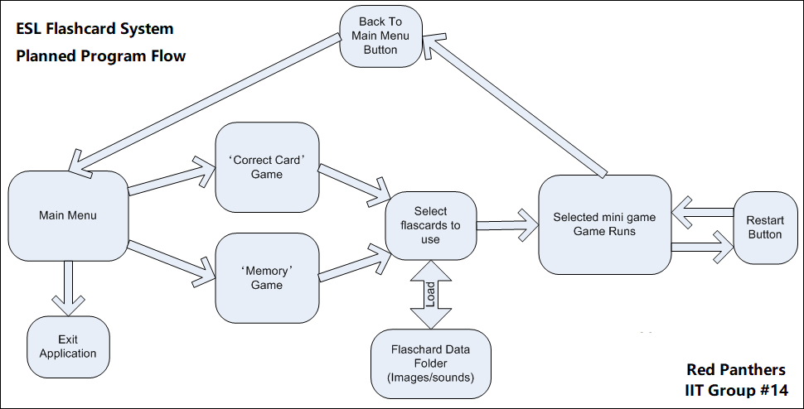

Main Menu (small heading):

The main menu will consist of three buttons: ‘Correct Card Game’, ‘Memory Game’ and ‘Exit Application’. Clicking either of the ‘Game’ Buttons will proceed to load up the selected mini game, whereas the ‘Exit Application’ button will simply exit the application back to desktop. An appropriate background image will be displayed behind the buttons as well as a basic music loop.

Flashcard Selection (small heading):

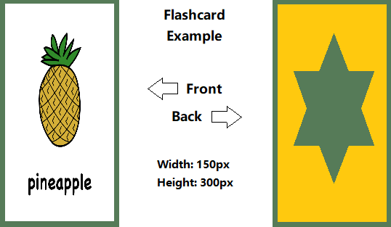A large pane that will consist of all flashcards currently in the flashcard data folder, which will be dynamically loaded at runtime based on the folder contents. If the pane size is too small a scrollbar will allow users to scroll. All flashcards must be of the same image size for the software to load correctly, with an .mp3 file that matches the image name for the audio to work. The user will have to select six flashcards to progress to the next screen. As the user clicks flashcards, they will turn green to let the user know which flashcards they have selected. Once all six flashcards are selected, the user will continue into whatever game has been selected.

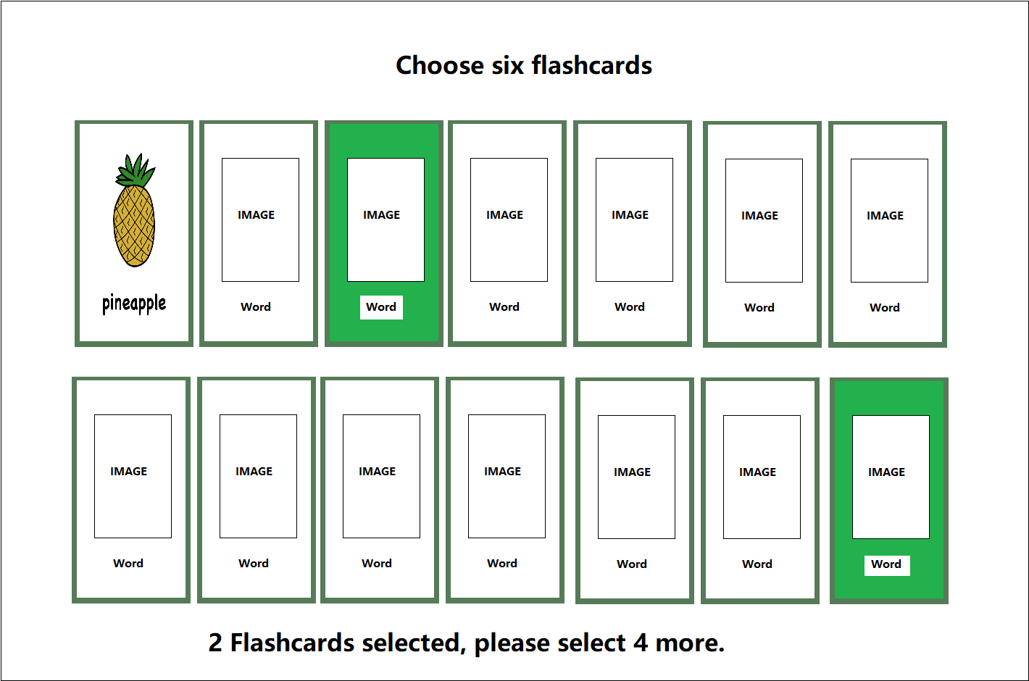

‘Correct Card Game’ (small heading):

A row of six flashcards are displayed along a horizontal pane in the centre of the screen. A random flashcard is read out and the user then has 10 seconds to click on the correct flashcard. If the user clicks on the correct flashcard, a point is added to the user. If the incorrect flashcard is clicked, a point will be deducted from the flashcard. The round will end once all flashcards have been read out. The game will not repeat the same flashcard twice.

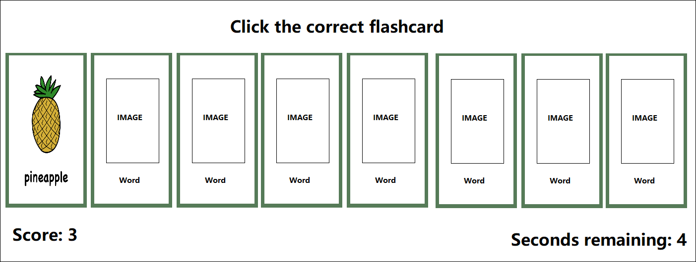

‘Memory Game’ (small heading):

A grid of 2x6 flashcards will be displayed on screen. Each flashcard will be loaded twice to ensure there are two of each flashcard present. The flashcards are displayed turned over at first, so that the user cannot see what the flashcard picture/word says. The user will then click a flashcard to flip the card over and reveal the flashcard image plus the word and then the word on the card will be read aloud to the user. The user must then click another flashcard hoping to find the same card. If the same card is found, a point is added, and the cards remained flipped over. If not, the cards turn back over, and no point is awarded. The round ends when the timer runs out, or all pairs are found.

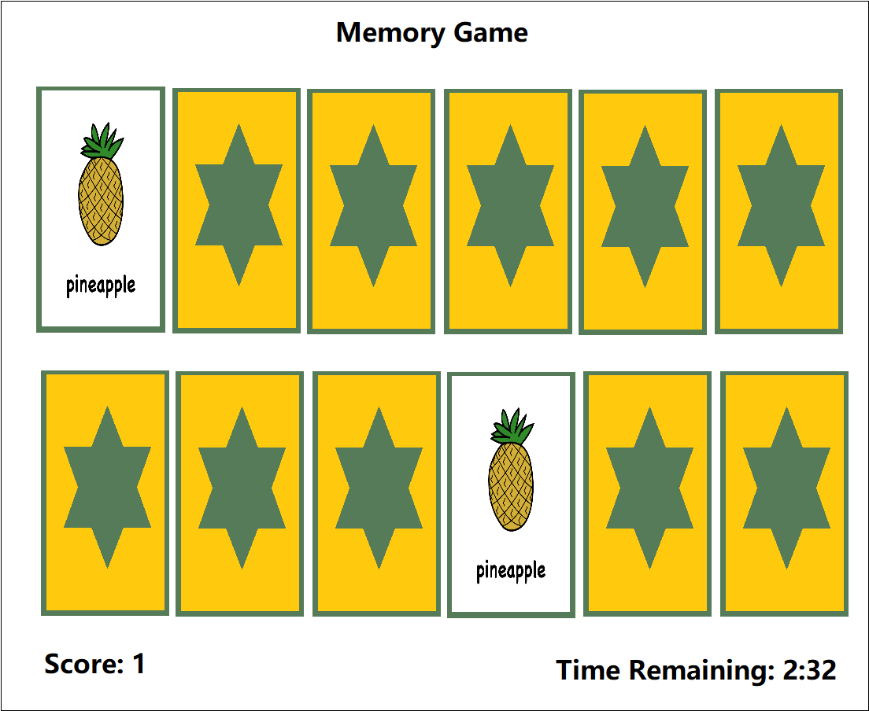

Tools And technology:

The software required for this project will be Unity3d, Microsoft Visual studio, Gimp photo manipulation suite. All the required software is license free for non-commercial use and so is acceptable to use for this project.

The hardware required for our group is a computer capable of running Unity3d and Microsoft Visual Studio, a microphone for recording audio and an internet connection so that we can collaborate online.

Skills Required:

This project will require many skills, which our team will need to use together to create this project. We will need programming skills to create the software in Unity3D, graphic design skills to create the flashcards and backgrounds in Gimp or another suitable image manipulation software, technical writing and video editing skills to help us create manuals, documentation and a video for presentation purposes, basic audio editing skills to create sounds for the flashcards and repeating background music as well as someone with project management and leadership skills to help us stay focused and on task.

Outcome:

The outcome of this project will be the creation of a flashcard system that can be used to help children learn basic English words and create a small but workable product that our team would be able to market on a standalone website or put on APP stores.

As the flashcards can be dynamically loaded via the flashcard folder, the program will be able to be customized by the end user to create more customized flashcards for use with their own ESL curriculum and will allow for a lot of flexibility and re-usability.

Hopefully the software will even able to help remote communities who don’t have high end technology or qualified teachers to teach English.

[1]C. Taylor, "People around the world still think English is the most valuable language to learn, study shows", *CNBC*, 2020. [Online]. Available: https://www.cnbc.com/2019/06/28/people-still-think-english-is-the-most-valuable-language-to-learn.html. [Accessed: 08- Jan- 2020].

[2]A. Research, "English Language Learning Market to grow at 7.1% to hit $54.8 billion by 2025 – Insights on Recent Trends, Size, Share, Growth Opportunities, Key Developments and Future Outlook: Adroit Market Research", *GlobeNewswire News Room*, 2020. [Online]. Available: https://www.globenewswire.com/news-release/2019/07/26/1892347/0/en/English-Language-Learning-Market-to-grow-at-7-1-to-hit-54-8-billion-by-2025-Insights-on-Recent-Trends-Size-Share-Growth-Opportunities-Key-Developments-and-Future-Outlook-Adroit-Mar.html. [Accessed: 08- Jan- 2020].

[3]T. News, "Vietnam lacks teachers to achieve language targets", *Thepienews.com*, 2020. [Online]. Available: https://thepienews.com/news/vietnam-teachers-language-targets/. [Accessed: 08- Jan- 2020].