
Document Number | IA-MPEG-H-3D-Audio-Dec-Browser-Plugin-UG
Version | 1.0
Ittiam Systems Confidential

MPEG-H 3D Audio Low Complexity Profile Decoder
Browser Plugin User Guide

Ittiam Systems (P) Ltd,
The Consulate, 1 Richmond Road,
Bangalore 560 025, India
Notice
Ittiam Systems reserves the right to make changes to its products or discontinue any of its products or offerings without notice.
Ittiam warrants the performance of its products to the specifications applicable at the time of sale in accordance with Ittiam’s standard warranty.

Revision History

Version | Date | Changes
1.0 | November 7, 2026 | Original
Copyright © 2022, Ittiam Systems (P) Ltd

Contents
1. Introduction 6
1.1 About this Guide 6
1.2 Package contents 6
2. Installation and Configuration 7
2.1 Installation Overview 7
2.1.1 Prerequisites 7
2.1.1.1 Hardware 7
2.1.1.2 Software 7
3. Start local HTTP server 8
3.1 Launching Server 8
3.2 Verifying the URL in Browser 8
4. Stop HTTP server 10
5. Appendix A: Limitations 11

Figures
Figure 3-2 Launching Server for Browser Plugin 8
Figure 3-3 Browser Plugin for MPEG-H 3D Audio Decoder 9

Tables
Table 1-1 Package Content Details 6
Table 2-1 Hardware Details 7
Table 2-2 Software Details 7

Introduction

About this Guide
This document describes the procedure to enable server on local machine to run MPEG-H 3D Audio Low Complexity Profile Decoder on browsers. The document provides information about the configurable features of plugin

Package contents
Details of the contents of directories are as follows
File | Description
index.html | Main HTML page
decode-mpegh3da.js | Javascript file to load decode-mpegh3da.wasm
decode-mpegh3da.wasm | Web assembly code for decoder with SIMD support disabled
style-index.css | CSS script for styling of web page
ittiam.png | Ittiam logo used on the web page
Table 1-1 Package Content Details

Installation and Configuration

Installation Overview
This section provides a brief description of the system requirements and instructions for installing the decoder component.

Prerequisites

Hardware
Table 2-2 Hardware Details
Configuration | Device Details
x64/Windows [64 bit version] | PC with x64 Intel processor

Software
Configuration | Requirements
x64/Windows | PHP
Table 2-3 Software Details

Start local HTTP server

Launching Server

Navigate to the decoder package directory
cd E:\MPEG_H\libmpegh\web_plugin

Command to start the server using php
php -S localhost:8000

This will run the contents of the directory on a local web server, on port 8000

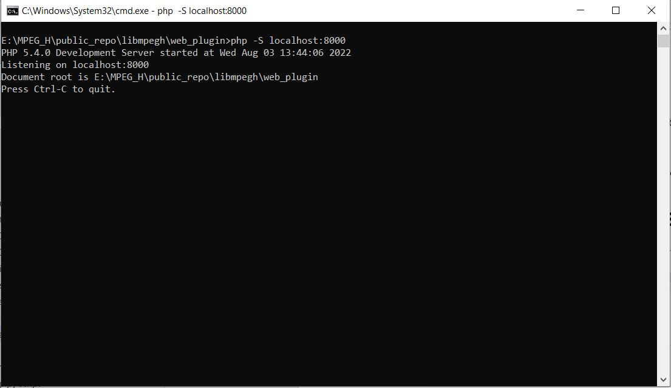
Figure 3-1 Launching Server for Browser Plugin

Verifying the URL in Browser
Go to the URL localhost:8000 in your web browser. You should be able to see the MPEG-H 3D Audio Decoder Demo page.
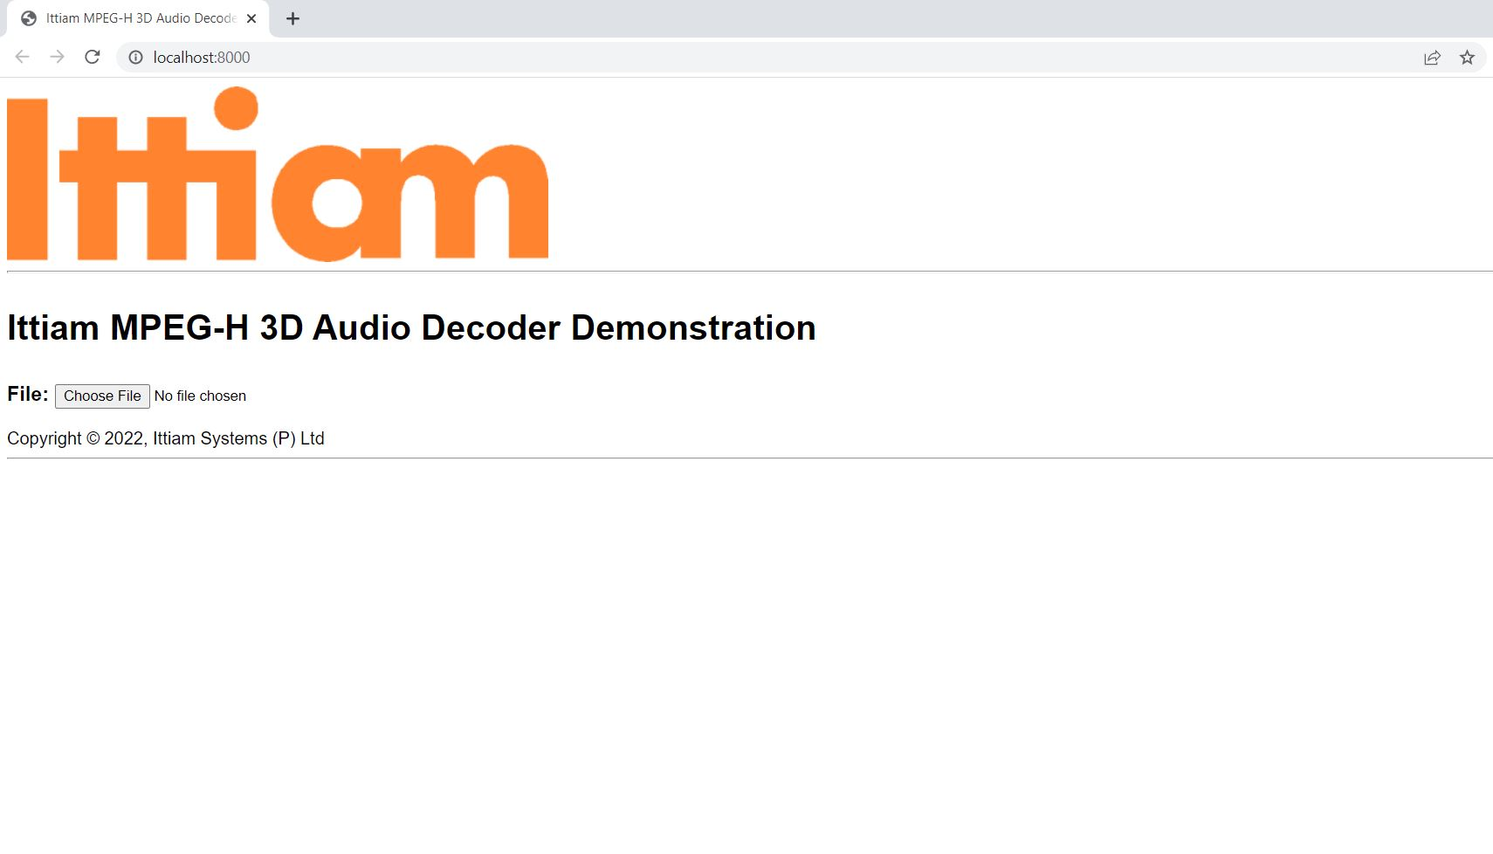
Figure 3-2 Browser Plugin for MPEG-H 3D Audio Decoder

Stop HTTP server
To stop the HTTP server, press Ctrl + C in the command prompt

Appendix A: Limitations
The MPEG-H 3D Audio decoder web plugin demo package has the following limitations:
- Accepts only “.mhas” files as input
- Decodes and plays up to a maximum of 2000 frames of data.

