**Report on Project 1**

The final results can be seen from the 3 graphs:

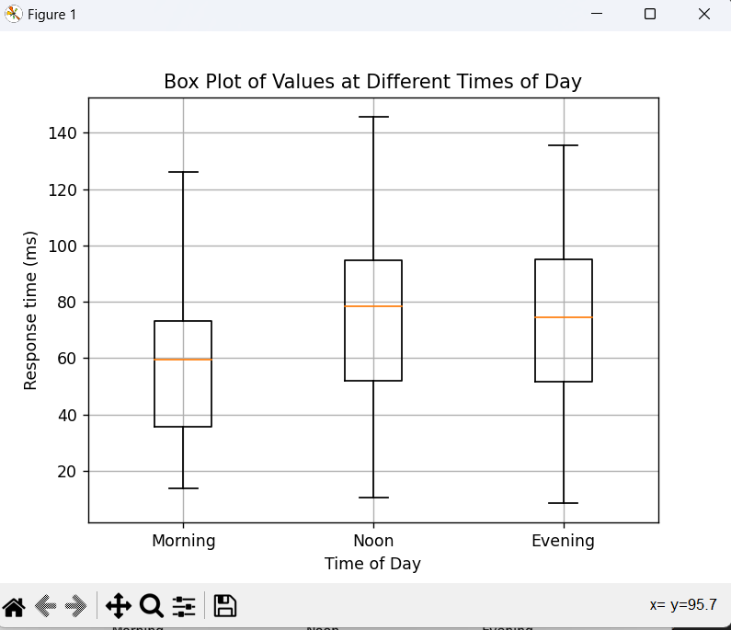

From this time plot we can observe that the delay was the least in the morning compared to the Noon and the Evening. When it comes to the Noon and Evening times, we can observe no significant difference between the two. The latter fact probably due to similar internet traffic during those times. The largest difference between the min and the max values was in the noon. It can be assumed that more traffic on the routers in the noon cause more time variability in the delays.

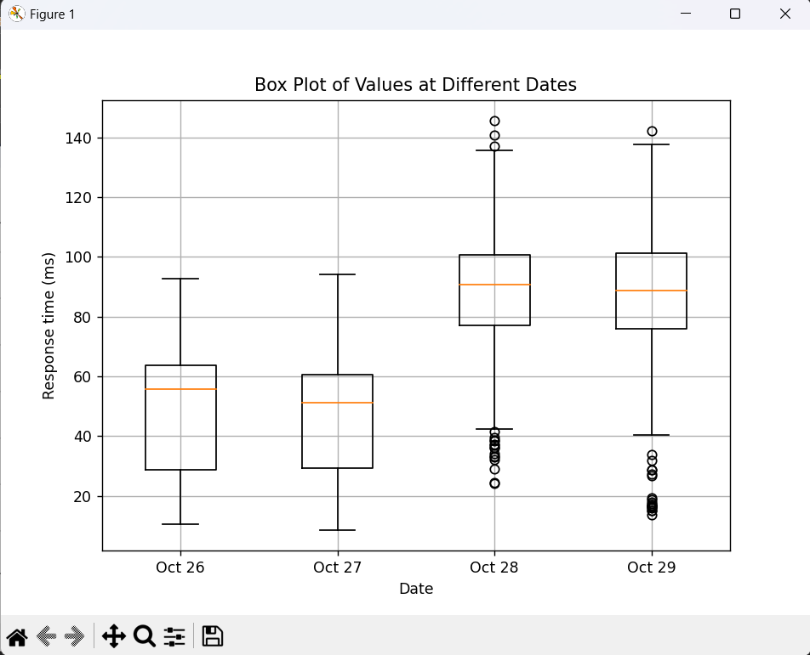

When it comes to Date data, we can observe that the holiday days Oct 28 (Saturday) and Oct 29 (Sunday), both had more delay times than the work days. Furthermore, the difference between the min and the max was much higher in the weekends. We can even observe some outlier value in those day. On the other hand, the delay in the week days was less on avg but the STDV was higher as can be seen by the graph.

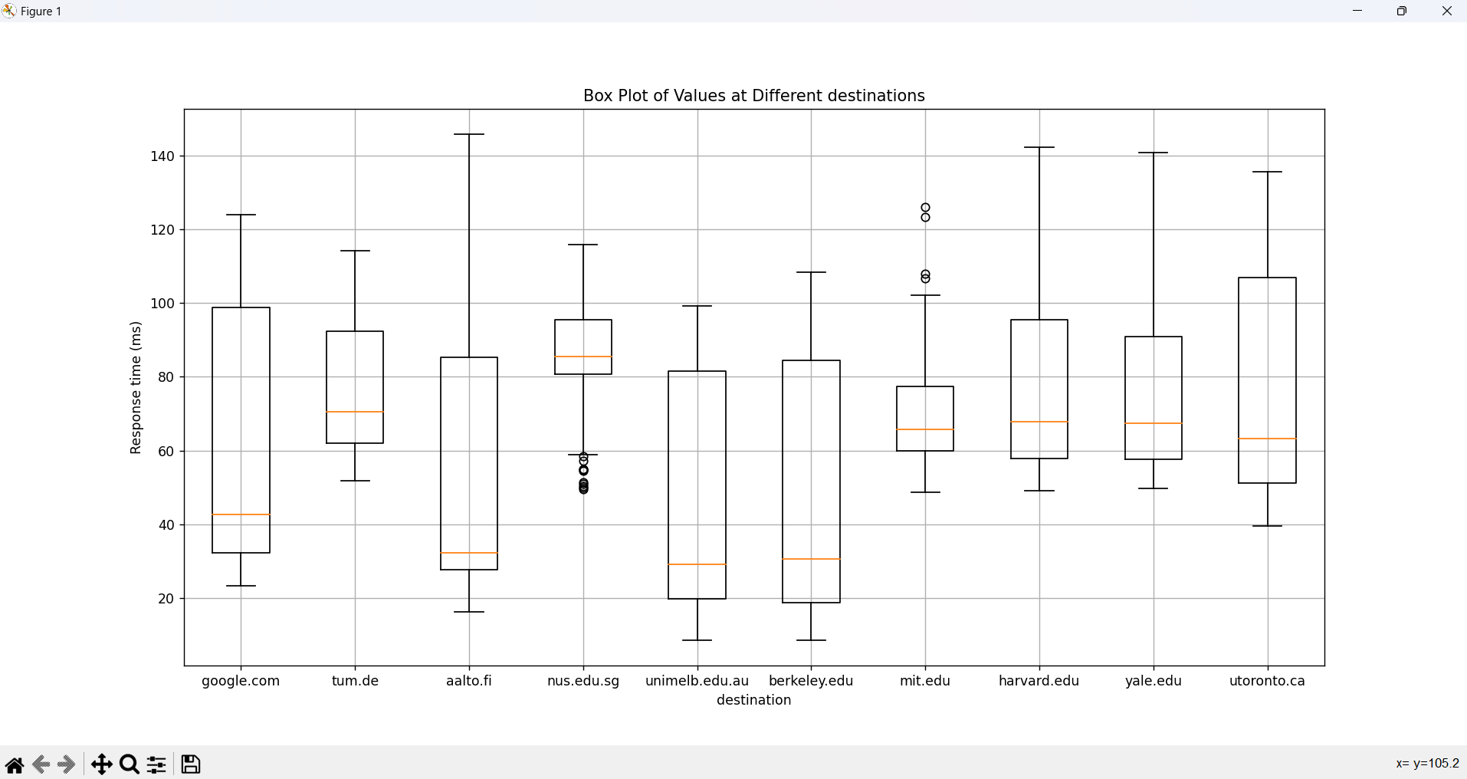

Now when it comes to the destinations graph, it is easier to see the difference in delay be directly dependent on the distance. For example, the highest delays were in both university of Toronto and Nus (Singapore). Furthermore, we can see that locations that are geographically close to each other had similar delays; for example, Harvard, yale, and MIT all had close delay results. Now, some results were harder to explain; for instance, why TUM and Harvard university both had very similar results. This fact along with some outliers requires further study to the network and its routers in order to interpret it correctly.