**Introduction To Python**

**Problem Set 1**

# Problem 1

Write a login program that asks for username and password…

Check if the entered password complies with the password rules…(must contain at least one number and be longer than 8 characters.)

| #Paste your code here |
| --- |

# 

# 

# Problem 2

Write a program to find out, if the given number is abundant…

Note: In number theory, an abundant number or excessive number is a number for which the sum of its proper divisors is greater than the number itself. The integer 12 is the first abundant number. Its proper divisors are 1, 2, 3, 4 and 6 for a total of 16.

| #Paste your code here |
| --- |

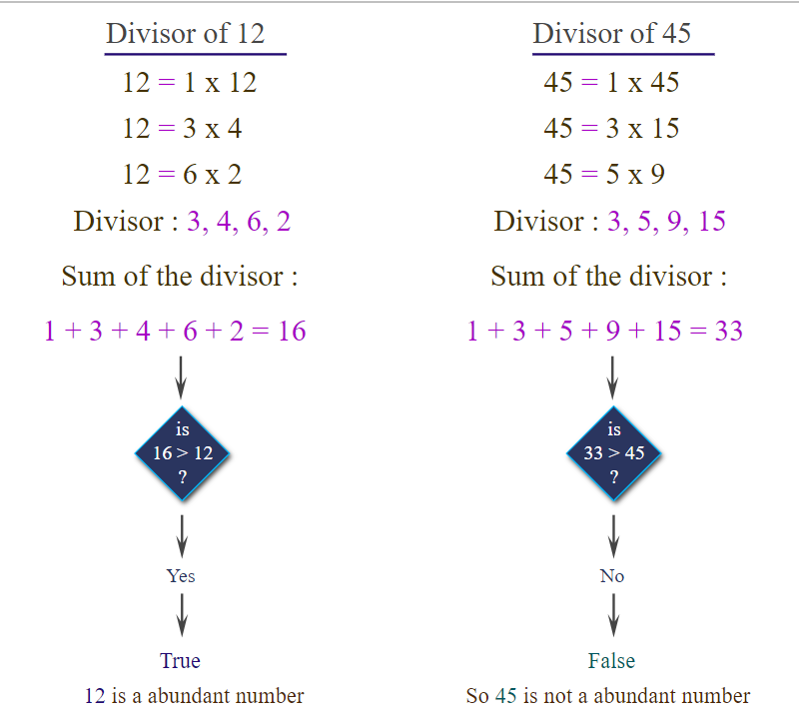

# Problem 3

Write a program that calculates the area and perimeter of selected 3 different geometric shapes…

Two values must be received from the user:

1)Kind of the geometric shape(1:Circle, 2:Square, 3:Equilateral Triangle).

2)The lengths of the sides or the radius of the circle.(If 2 or 3 are selected, the lengths of the sides. If 1 is selected, the radius of the circle.)

(Note: Assume the geometric shapes are regular, pi=3)

Example output should look like this (red text represents user input):

| Kind of shape: 1  Radius of circle: 5  Calculated area: 75  Calculated perimeter: 30  Do you want to calculate another shape? Y  Kind of shape: 2  Edge length: 2  Calculated area: 100  Calculated perimeter: 40  Do you want to calculate another shape? N  Operation finished. |
| --- |

# 

| #Paste your code here |
| --- |

# 