**Introduction To Python**

**Problem Set 1**

# Problem 1

Write a login program that asks for username and password…

Check if the entered password complies with the password rules…(must contain at least one number and be longer than 8 characters.)

| #Paste your code here  username = input("Lütfen kullanıcı adını gir: ")  password = input("Lütfen parolanı gir: ")  control = 0  digits = "0123456789"  if len(password) >= 8: # counting digits  for i in password:  if (i in digits):  control += 1  if control != 0:  print(f"Hoşgeldin {username}")  else:  print("Geçersiz parola!") |
| --- |

# 

# 

# Problem 2

Write a program to find out, if the given number is abundant…

Note: In number theory, an abundant number or excessive number is a number for which the sum of its proper divisors is greater than the number itself. The integer 12 is the first abundant number. Its proper divisors are 1, 2, 3, 4 and 6 for a total of 16.

| #Paste your code here  while True:  print(sum)  number = input("Çıkış için 'a'ya bas!\nÖğrenmek istediğin sayıyı gir: ")  if number == "a":  print("Çıkış yapılıyor")  break  number = int(number)  for i in range(1,number):  remainder = number%i  if remainder == 0:  sum+=i  if sum > number:  print(f"{number} bir abundant sayıdır.")  else:  print(f"{number} bir abundant sayı değildir.") |
| --- |

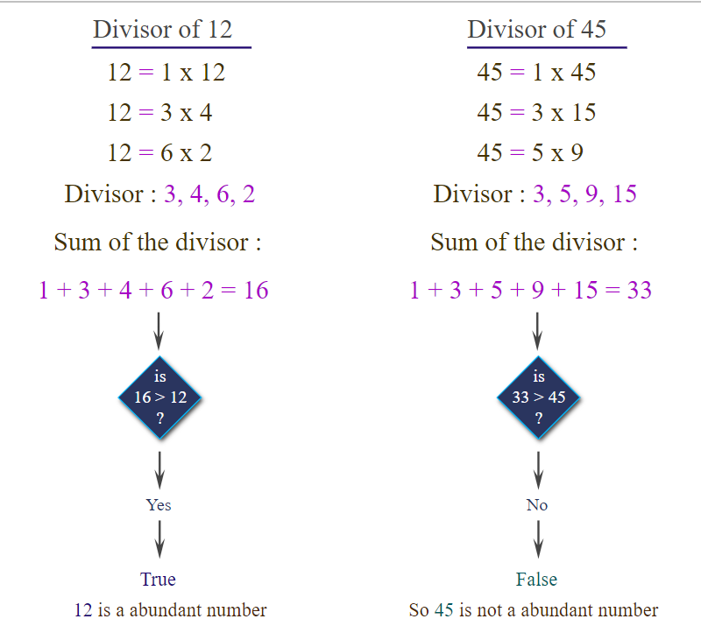

# Problem 3

Write a program that calculates the area and perimeter of selected 3 different geometric shapes…

Two values must be received from the user:

1)Kind of the geometric shape(1:Circle, 2:Square, 3:Equilateral Triangle).

2)The lengths of the sides or the radius of the circle.(If 2 or 3 are selected, the lengths of the sides. If 1 is selected, the radius of the circle.)

(Note: Assume the geometric shapes are regular, pi=3)

Example output should look like this (red text represents user input):

| Kind of shape: 1  Radius of circle: 5  Calculated area: 75  Calculated perimeter: 30  Do you want to calculate another shape? Y  Kind of shape: 2  Edge length: 2  Calculated area: 100  Calculated perimeter: 40  Do you want to calculate another shape? N  Operation finished. |
| --- |

# 

| #Paste your code here  while True:  kind = input("Daire için 1.\nKare için 2.\nEşkenar üçgen için 3.\nGeometrik Şekil: ")  if kind =="1":  r = int(input("Daire!\nYarıçap gir: "))  circle_area = 3 * r * r  circle_perimeter = 2 * 3 * r  print(f"Dairenin çevresi: {circle_perimeter} ve alanı: {circle_area}")  elif kind =="2":  sides_4 = int(input("Kare!\nKarenin kenarını gir: "))  square_area = sides_4 ** 2  square_perimeter = 4 * sides_4  print(f"Karenin çevresi: {square_perimeter} ve alanı: {square_area}")  elif kind =="3":  sides_3 = int(input("Eşkenar Üçgen!\nEşkenar Üçgenin kenarını gir:"))  triangle_area = ((3**1/2)*sides_3*sides_3)/4  triangle_perimeter = 3*sides_3  print(f"Eşkenar üçgenin çevresi: {triangle_perimeter} ve alanı: {triangle_area} ")  else:  print("you chose wrong number. Please choose 1,2 or 3")  control = input("Devam etmek istersen 'd'ye bas!")  if control == "d":  continue  else:  print("Çıkılıyor")  break |
| --- |

# 