Faculty of Automation and Computer Science

Distributed Systems

Laboratory – Assignment 1

Request-Reply Communication Paradigm

Online Energy Utility Platform

Student: Itu Anca

Group: 30441

1. Assignment objective

The objective of this assignment was to develop an online energy utility platform with 2 types of users, administrator of the platform and client, having specific capabilities. The platform is designed for managing users and their associated smart energy metering devices, along with the data registered by these.

1. Conceptual Architecture Diagram

This platform contains 3 main modules: a visualization platform – frontend, a data platform – backend, and a database.

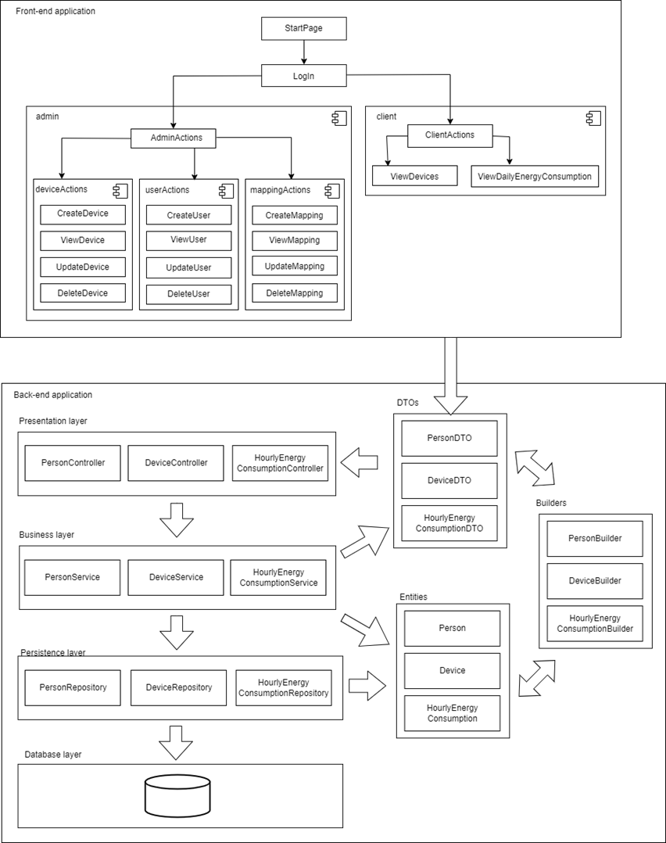

! controllerele intra la business logic layer; presentation layer e asociat cu frontend

Ar trebui sa am doua tipuri de relatii(sageti) DTOurile si entitatile sunt **folosite**, layerele **comunica**

The backend is built using RESTful services having the purpose of sending data from the frontend to the database or vice versa.

In the diagram above there can be seen the 4 layers from the backend application. The first one is the presentation layer, containing the controllers of the backend application. This is the layer which is accessed through the REST APIs from the frontend application. The controllers receive data from or send data to frontend as DTOs. Data is transferred between the controller and the business layer in the same format. The business logic layer is intermediary between the presentation layer and the persistence layer, and it is responsible for the data processing. Here an object is received from the first layer as DTO and sent to the third layer as entity. The builders are used for this transformation. When data is retrieved from the database in the persistence layer, it is sent to the business logic layer as an entity and here it is converted to DTO in order to be sent to the above layer, and then to frontend.

The frontend application represents the user interface, and it gives the user the possibility to perform operations on the data existing in the database. First, the start page is displayed to the user. Then, the user has to log in. According to his type (client or admin), he is redirected to the client page or to the admin page. If the user is a client, he can view the smart energy metering devices he owns or he can view the daily energy consumption of each one of his devices in a visual way. If the user is an admin, then he can manage the users, the devices or the associations between these two. He can create, update, view or delete objects from the database. Each operation for receiving data from the database or for sending data to it is done through REST APIs to the backend.

1. Database Design

The database contains three tables. One table contains the details of a person, another table contains the details of a metering device and the third contains the hourly energy consumption for each device. There is a one-to-many relationship between the person table and the device table and another one-to-many relationship between the device table and the hourly energy consumption table.

1. UML Deployment Diagram

The deployment diagram contains a node which represents the Web Browser, where the user can access the platform, a node for the Web Services which take care of sending the requests to the Application Server, which is another node which contains the Data platform of the application, and a node for the database server.