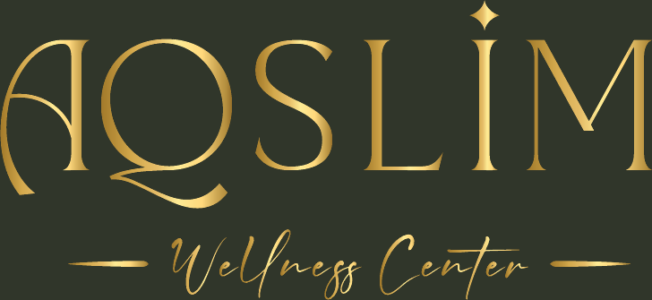
English Communication Templates

Copy and paste any of these templates directly into your email, WhatsApp, or messaging app. Personalize the sections marked in [brackets] with your client's specific details.
Tip: Save these in a notes app for quick access, or adapt them to develop your own communication style.

1. Welcome Email — New Client
📌 When to use: Send within 24 hours of a new English-speaking client signing up with AQSLIM.

SUBJECT LINE
Welcome to AQSLIM Wellness Center, [Client Name]! Your journey starts now ✨

EMAIL BODY
Hi [Client Name],

Welcome to AQSLIM Wellness Center! I'm so glad you're here, and I'm looking forward to supporting your [weight loss / muscle gain / wellness] journey.

Here's what happens next:

1. Your personalized nutrition plan is now available in the AQSLIM app.
2. Please review your plan and let me know if you have any questions.
3. Our first check-in will be on [date] to review your progress.

A few things to know before you start:

✅ Log your meals daily in the app — the more consistent you are, the better I can adjust your plan.
✅ Drink at least [2–3] liters of water every day.
✅ Weigh yourself once a week, on [day], at the same time (morning, before eating).
✅ If something doesn't feel right — digestive issues, low energy, hunger — message me right away.

I'm here every step of the way. Don't hesitate to reach out through the app or at this email.

Here's to your health,

[Your Name]
AQSLIM Wellness Center | Nutritionist
[Email] | [Phone / WhatsApp]

2. Weekly Check-In Message
📌 When to use: Send every week (or set a recurring reminder) to track progress and maintain engagement.

SUBJECT LINE
AQSLIM Weekly Check-in — How are you doing, [Client Name]?

MESSAGE BODY
Hi [Client Name],

Hope your week has been going well! Time for your weekly check-in.

Please share the following:

⚖️ Current weight: ______ kg / lbs
😴 Sleep quality this week: Poor / Fair / Good / Excellent
💪 Energy levels: Low / Medium / High
🍽️ How well did you follow your plan? (1–10): ______
🤔 Any challenges, cravings, or symptoms to mention?

Based on your update, I'll review your plan and let you know if any adjustments are needed.

Keep going — consistency is everything!

[Your Name] — AQSLIM Wellness Center

3. Plan Update Notification
📌 When to use: Use when you've made changes to a client's plan based on progress or feedback.

SUBJECT LINE
AQSLIM — Your nutrition plan has been updated

MESSAGE BODY
Hi [Client Name],

I've reviewed your recent progress and made some adjustments to your plan. The updated version is now live in the AQSLIM app.

Summary of changes:

[e.g., Increased daily protein target from 120 g to 140 g]
[e.g., Added a pre-workout snack on training days]
[e.g., Slightly reduced evening carbohydrates]

Why these changes?
[Brief explanation — e.g., Based on your plateau this week and training schedule, more protein will help you preserve muscle while continuing to lose fat.]

Please review the updated plan and let me know if anything doesn't fit your schedule.

You're doing great — keep it up!

[Your Name] — AQSLIM Wellness Center

4. Encouragement / Re-engagement Message
📌 When to use: Send when a client is struggling, hitting a plateau, or hasn't logged in a few days.

SHORT MESSAGE (WHATSAPP OR EMAIL)
Hi [Client Name]! 👋

I noticed you haven't logged in for a few days — no worries at all, life gets busy! I just wanted to check in.

Progress isn't always linear, and that's completely normal. Even small, consistent actions make a real difference over time.

When you're ready, come back to the app and let me know how you're feeling. We'll pick up right where we left off.

You've got this! 💪

[Your Name] — AQSLIM Wellness Center

5. Milestone Celebration
📌 When to use: Send when a client reaches a goal — weight target, first month completed, consistent logging streak, etc.

MESSAGE
Hi [Client Name]!

I just saw your update and I had to reach out — [insert milestone: e.g., You've lost 5 kg / You've hit your protein goals every day this week / One month in!] 🎉

This is a real achievement, and you should be proud. It's not just about the number — it's the consistency, the commitment, and the habits you've been building.

I'm updating your targets to reflect this new stage, and I'll have a refreshed plan ready for you shortly.

Amazing work,
[Your Name] — AQSLIM Wellness Center

6. Frequently Asked Questions — Ready Responses
Quick copy-paste answers to the most common questions from English-speaking clients.
Q: Can I eat out / go to restaurants?
Absolutely — eating out is part of life! A few tips to stay on track:
• Choose grilled, baked, or steamed options over fried.
• Ask for sauces and dressings on the side.
• Swap fries for a salad or vegetables as your side dish.
• Watch portion sizes — restaurant servings are often larger than one portion.
• You don't need to be perfect. Just make the best available choice!

Q: I'm not losing weight — what's wrong?
Plateaus are completely normal and don't mean you're doing anything wrong. Let's check a few things:
• Are you logging everything in the app, including sauces, oils, and drinks?
• How has your water intake been this week?
• Any stressful events or changes in sleep recently?
• The scale isn't always the best measure — are your clothes fitting differently?

Send me your latest logs and I'll review your plan to see if adjustments are needed. Keep going!

Q: I'm hungry all the time — is that normal?
Some hunger is normal at first, but persistent hunger means we should adjust your plan. Let me know:
• Which meals leave you most hungry?
• Are you eating within the recommended times?
• How much water are you drinking?

I may increase your protein or fiber, or adjust your meal timing. Just message me and we'll sort it!

Q: Can I drink alcohol?
Moderate alcohol can fit into your plan, but it's worth knowing:
• Alcohol has calories (7 kcal/gram) with no nutritional value.
• It can disrupt sleep, increase appetite, and slow fat loss.
• If you drink, prefer lower-calorie options: dry wine, spirits with sparkling water.
• Limit to 1–2 drinks and always eat something beforehand.
Let me know how often you drink so I can factor it into your plan!

Q: What if I miss a meal or eat something off-plan?
One meal doesn't make or break your results — what matters is the overall pattern.
• Don't try to compensate by skipping your next meal.
• Log what you ate and continue as normal.
• If it happens frequently, we can adjust your plan to better fit your real lifestyle.

Progress, not perfection! 🌿

AQSLIM Wellness Center · English Communication Templates

