Subject: RE: ORG CPS — two clusters with negative savings
To: Sergej Petrovski <sergej.petrovski@siemens.com>
Cc: Lars Marin (tecracer) | From: Ebrahim Ramadan <ebrahim@cast.ai> | Date: 2026-10-08
——————————————————————————————————————————————
Hello Sergej,
short answer first: nothing is wrong — neither cluster is in minus. I verified this today, claim by claim, against your own console and our API. Claims and proofs below.
Claim 1 — Both clusters have positive realized savings. Right now, every day.
Proof: the Savings Report of ORG CPS as of this morning (October, org scope). Baseline spend $6,841 minus actual spend $3,849 = realized savings +$2,992 in the first week of October alone. A cluster losing money cannot produce this picture.
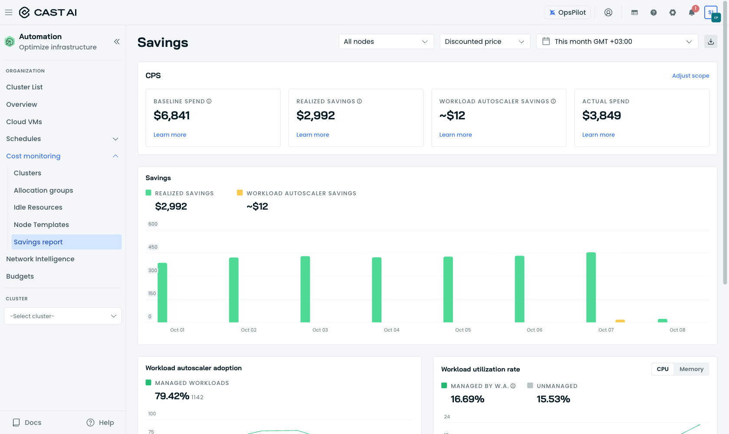
Proof 1: CPS Savings Report, this month (console, today 2026-10-08 00:53 EET).
Claim 2 — On the first cluster, node autoscaling is configured and working — the low score has a different cause.
Proof: the Savings Report of dema-platform-services. Realized savings +$2,930 this month, and under "Node autoscaler impact": baseline 684 CPU vs. 485 CPU actually provisioned — CAST AI removed ~199 CPU of waste. Node autoscaling has managed this cluster since July 22.
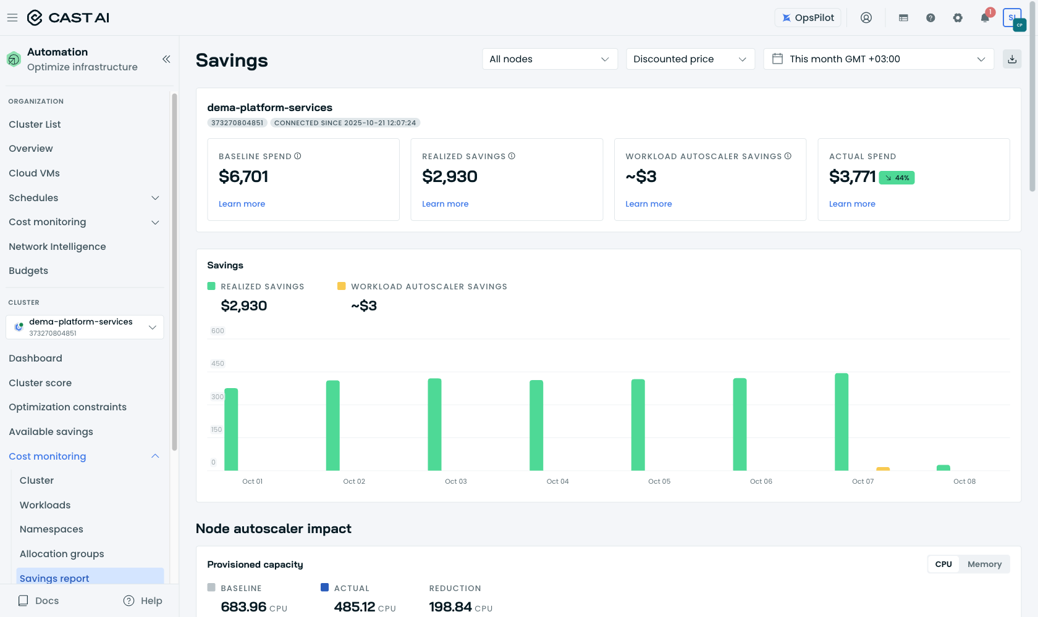
Proof 2a: dema-platform-services Savings Report (console, today).
The 4.9 score (your screenshot showed 4.6 — it drifts) comes from remaining headroom, not from missing configuration: 0% Spot usage and a pending rebalancing recommendation. That headroom is also the next saving: Spot scenarios estimate −48.7% to −73.5% of the current ~$12.6k per month.
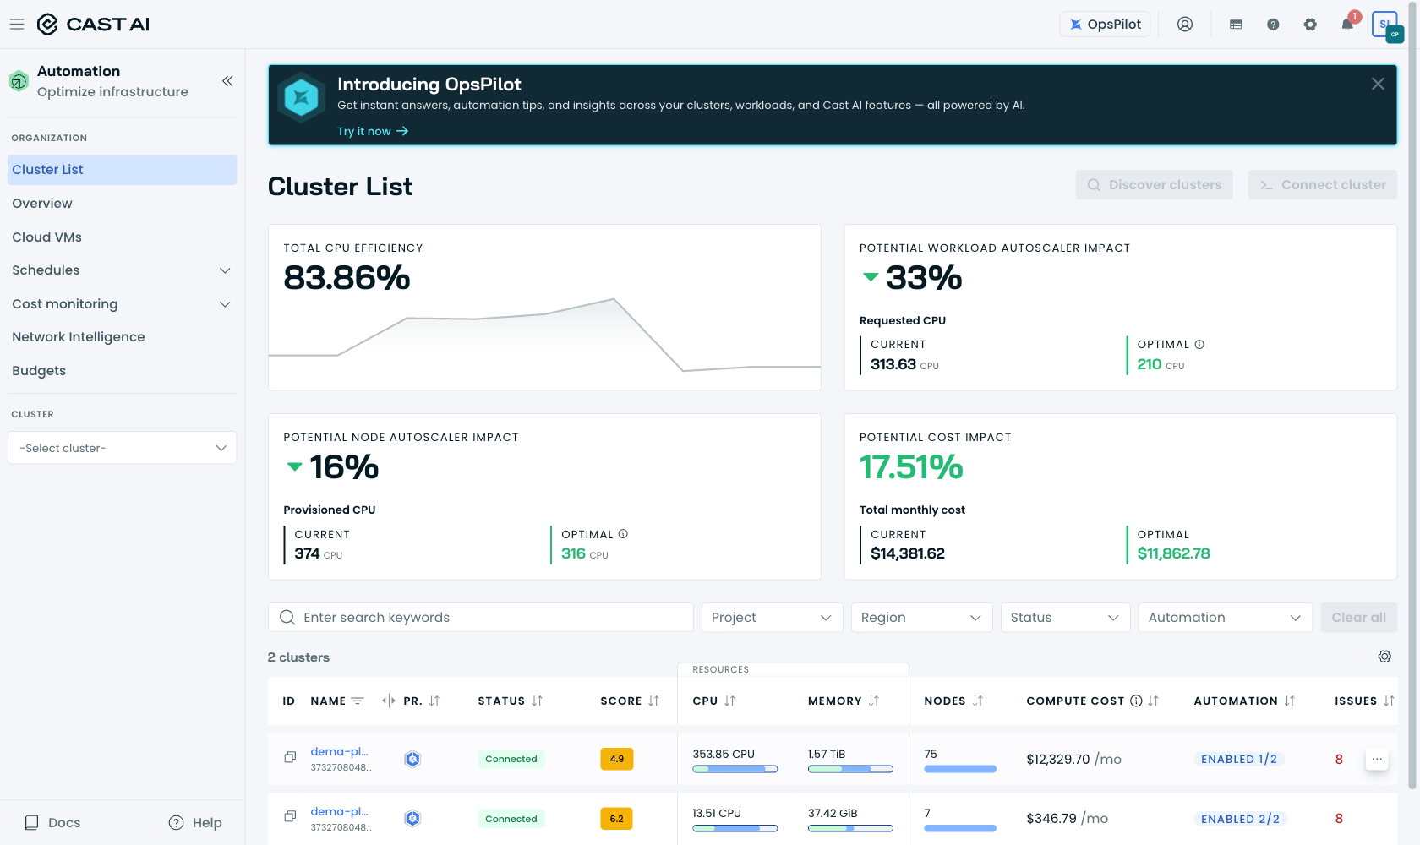
Proof 2b: Cluster list, today — scores 4.9 / 6.2 side by side.
Claim 3 — The "couple of dozen Euro in minus" on the well-configured cluster is the Workload Autoscaler line — negative by definition, not by error.
Documented formula (docs.cast.ai/docs/savings-baseline):
workload autoscaler savings = (original requests − current requests) × max(current price, baseline price)
On both clusters the Workload Autoscaler raised requests that were set too low — a stability correction. Your test cluster recorded 348 OOM kills in the last 30 days; under-requested memory is a classic cause. When current requests are higher than the originals, this line is negative by construction. In August it was −$24.81 ≈ −€22 — exactly the figure you saw. Two things matter here:
1. This value is already contained in Total savings. It is a sub-attribution, not an additional loss on top (documented behavior — Total savings = node autoscaler savings; the workload effect enters it via reduced demand).
2. It turned positive on September 24, once rightsizing caught up.
Proof: the same report for dema-platform-services-test, today — realized savings +$66 (45% under baseline), and the Workload Autoscaler line ≈ +$9, positive.
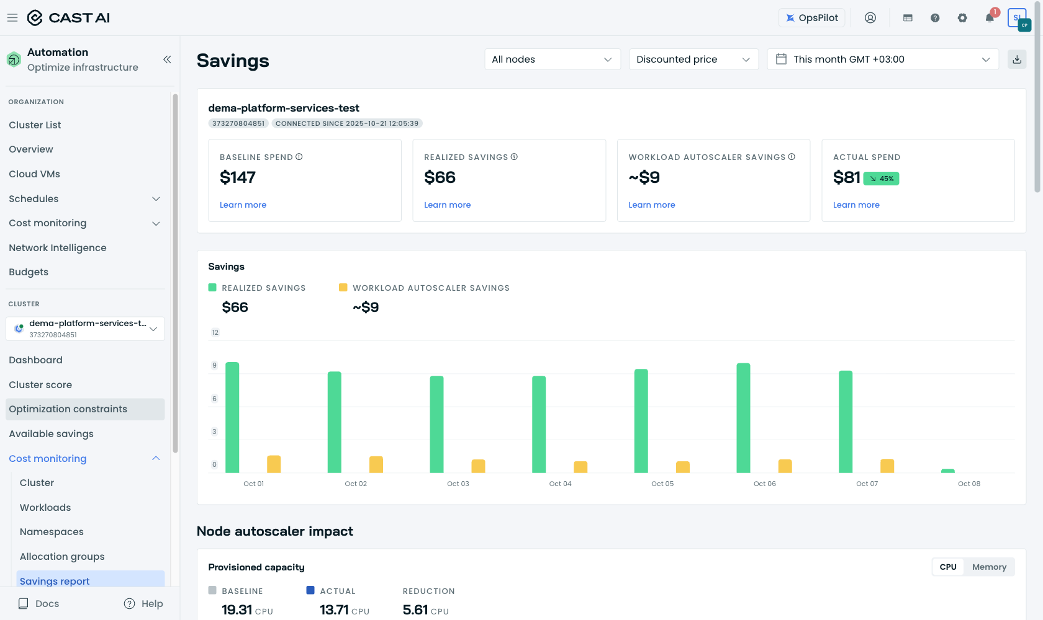
Proof 3: dema-platform-services-test Savings Report (console, today).
The calculation, compressed
Month | dema-platform-services — realized / workload line | dema-platform-services-test — realized / workload line
Jul 22–31 | +$2,567 / −$17 | +$70 / −$6
August | +$9,951 / −$75 | +$213 / −$25 (≈ −€22 ← your figure)
September | +$11,690 / −$81 | +$202 / −$9
October 1–8 (console today) | +$2,930 / ≈ +$3 | +$66 / ≈ +$9

Verdict: nothing is broken on either cluster. The minus you see is the Workload Autoscaler sub-attribution for corrected under-sizing — stability money, not lost money. The real remaining lever is Spot adoption (−48.7% to −73.5% estimated on dema-platform-services). Say the word and we walk through it in 30 minutes.
One note from our side, for completeness: the cloud-cost telemetry for both clusters has been stale since September 16 (some report tiles under-count as a result). We are correcting this — no action needed from you.
Sources: Savings Report https://docs.cast.ai/docs/savings-report — methodology and formulas https://docs.cast.ai/docs/savings-baseline. Screenshots taken today, 2026-10-08, from your console; monthly history from the CAST AI reporting API (the console offers rolling time windows only).

Best regards,
Ebrahim Ramadan
CAST AI — ebrahim@cast.ai

