FPT INTERNATIONAL ACADEMY
International Programmers Training FPT-Aptech Center

--o0o—



eProject Document
Online Shop DVDS

Group 2
Group Member | Phung Van Thuc | Student510977
Group Member | Vu Hoang Chien | Student540242
Group Member | Dinh Ngoc Hung | Student510955
Instructor | Le Thi Hao
Batch | C1007I
Semester | 4

- Ha Noi, 10/2012 -

Contents

1. Introduction
Music, Game, Movie is an important part of our life. Nowadays, listening to music online is hobby of most modern people. So you need to build website where users will get relevant information about the latest music, game, movie releases in the market.
This website has web pages that give information about the new releases in the field of music, game, and movie in the National market.

2. Problem Definition

2.1. Problem Abstraction
The site will allow users to view all kinds of music, game, movie - includes National and International, listen to some music, see trailers game, movie, and download them for free some but not full, vote for an album, game, movie and send feedback about the site, etc. In addition, this website also provides a forum that users could discuss. The website has search and browse functions too.

2.2. The Current System

The site will allow users to view all kinds of music, game, movie - includes National and International, listen to some music, see trailers game, movie, and download them for free some but not full, vote for an album, game, movie and send feedback about the site, etc. In addition, this website also provides a forum that users could discuss. The website has search and browse functions too..

2.3. The Proposed System
When users need to know information about recent releases of music, game, movie they can open this website to see or search some information, and naturally, they can buy some DVDs if they want.
If users want to know information regarding music, game, movie or they wish to buy a new DVDs, they need not visit a shop at all. Instead of this, they can just open the website to refer to information about music displayed on the web pages and place an order.
Finally, what’s thing that we want customers: come to see, and buy new releases albums.

FUNCTIONAL REQUIREMENTS :

ADMIN
Admin is the manager of this website. Admin manages these main functions:
- Manage Categories :
This function contains view categories, adding a new category, deleting, editing, search.
- Manage Artists:
Artist is a composer or a singer or both.
This function contains view artists, adding a new artist, deleting, editing, search.
- Manage Albums:
This function contains view albums, adding a new album, deleting, editing, search.
- Manage Songs, games, movies:
This function contains view, adding a new, deleting, editing, search.

- Manage Users:
- User can be a guest or a member or a customer.
- A user hasn’t registered at website is a Guest.
- A user has already registered at website is a Member.
- Member is called a Customer if he buys album from the website or he had an account at Website.
- This function contains view users, adding a new user, deleting, editing, search and recovery user.
- Manage Feedback:
This function contains view, deleting, reply and search feedback of users.
- Manage Suppliers:
Supplier is company which supplies music’s discs for website.
This function contains view suppliers, adding a new supplier, deleting, editing, search and recovery supplier.
- Manage Producers:
Producer is a company which publishes.
This function contains view producers, adding a new producer, deleting, editing, search and recovery producer.
- Manager Permissions:
Permission of website is divided into many module functions. Each module function has own functions such as view, adding, deleting and editing.
This function contains view permissions of an administrator, assigning permissions, unassigned permissions and editing permission.
- Manage Products:
A product is an album which is sold on the website.
This function contains view products, adding a new product, deleting, editing, search.
- Manage Purchasing Invoices:
This function contains view purchasing invoices, adding a new purchasing invoice, deleting, editing, search.
- Manage Orders:
This function contains view orders, deleting, editing, search.
- Manage Reports:
This function helps admin can view reports.
- Manage Advertising:
This function contains changing banner of website, and changing all ads of website. The Ads can be placed in any position.
- Manage News:
This function contains view, adding, deleting, editing, search and recovery news of music, game, movie. Include National and International news.
- Manage Administrators:
Admin manages website and manage other administrators.
This function contains view administrators, adding a new administrator, deleting, editing, search and recovery administrator.
- Manage Album Reviews:
Admin manages all reviews about album of users.
This function contains adding, deleting, editing and search album reviews.
- Manage Promotion:
Admin manages promotion on website.
This function contains view all promotions and adding new promotion.
GUEST
- Guest is a user who doesn’t register at website. He can use these below functions:
- Read news about music, game, movie on website.
- Browse or search information about an artist, an album, a song or a lyric, or see trailer game, movie or information content about them.
- Listen to free trailer movie, and some music online (but not full DVD)
- Join the forum of website.
MEMBER
- Member is a user who registered at website. Signing in the website, a Member can use these below functions:
- All functions of Guest.
- Download music, trailer movie, or movie game.
- Buy DVD on website:
- Write the review about album, movie, game or rating.
- Change profile (view profile, edit profile, change password, cancel account)
- Send feedback.
- Member can manage his Website Account (such as Check Balance, View Transactions Log).
- Member can manage history orders (such as view history orders …).

2.4. The System Requirement
- Java virtual machine
- GlassFish v3 server
- IE 8 /Chrome 21 / Firefox 12
- Microsoft SQL Sever 2008

2.5. Development Enviroment
- Microsoft Windows 7
- Microsoft SQL Sever 2008
- Netbean 7.1.2
- GlassFish Server

3. Requirements and Business Flow

3.1. System Administrator
a. Login to system:
Purpose:
Allow use declared identification to used application.
Object used:
Administrator
Functional request:
- Allow user input username and password and validate information.
- The program will display error if username or password is invalid.
Execute condition:

b. Manage Categories:
Purpose:
Allow admin to manage Categories: view categories, adding a new category, deleting, editing, search.
Object used:
Administrator
Functional request:
The application must allow admin to view categories, adding anew categories, edit, delete, search.
Execute condition:
Administrator has to log in to the system
c. Manage Artists:
Purpose:
Allow admin to manage composer or a singer or both
Object used:
Administrator
Functional request:
The application must allow admin to view Artists, adding anew Artists, edit, delete, search.
Execute condition:
Administrator has to log in to the system
d. Manage Artists:
Purpose:
Allow admin to manage Albums
Object used:
Administrator
Functional request:
The application must allow admin to view Albums, adding anew Albums, edit, delete, search.
Execute condition:
Administrator has to log in to the system
e. Manage Songs, games, movies
Purpose:
Allow admin to manage Songs, games, movies
Object used:
Administrator
Functional request:
The application must allow admin to view, adding anew, edit, delete, search.
Execute condition:
Administrator has to log in to the system

f. Manage Users
Purpose:
Allow admin to manage Users
Object used:
Administrator
Functional request:
The application must allow admin to insert, edit, delete, search user’s information The application allow admin to recovery users
Execute condition:
Administrator has to log in to the system

g. Manage FeedBack
Purpose:
Allow admin to manage Feedback
Object used:
Administrator
Functional request:
This function contains view, deleting, reply and search feedback of users
Execute condition:
Administrator has to log in to the system

h. Manage Suppliers
Purpose:
Allow admin to manage Suppliers
Object used:
Administrator
Functional request:
This function contains view suppliers, adding a new supplier, deleting, editing, search and recovery supplier
Execute condition:
Administrator has to log in to the system

i. Manage Producers
Purpose:
Allow admin to manage Producers
Object used:
Administrator
Functional request:
This function contains view Producers, adding a new Producers, deleting, editing, search and recovery Producers
Execute condition:
Administrator has to log in to the system

j. Manage Permissions
Purpose:
Allow admin to manage Permissions
Object used:
Administrator
Functional request:
Permission of website is divided into many module functions
Execute condition:
Administrator has to log in to the system

k. Manage Products
Purpose:
Allow admin to manage Products
Object used:
Administrator
Functional request:
This function contains view Products, adding a new Products, deleting, editing, search
Execute condition:
Administrator has to log in to the system

l. Manage Purchasing Invoices
Purpose:
Allow admin to manage Purchasing Invoices
Object used:
Administrator
Functional request:
This function contains view purchasing invoices, adding a new purchasing invoice, deleting, editing, search.
Execute condition:
Administrator has to log in to the system

m. Manage Orders
Purpose:
Allow admin to manage Orders
Object used:
Administrator
Functional request:
This function contains view orders, deleting, editing, search
Execute condition:
Administrator has to log in to the system

n. Manage Reports
Purpose:
Allow admin to manage Reports
Object used:
Administrator
Functional request:
This function helps admin can view reports
Execute condition:
Administrator has to log in to the system

o. Manage Advertising
Purpose:
Allow admin to manage Advertising
Object used:
Administrator
Functional request:
This function contains changing banner of website, and changing all ads of website. The Ads can be placed in any position
Execute condition:
Administrator has to log in to the system

p. Manage News
Purpose:
Allow admin to manage news
Object used:
Administrator
Functional request:
This function contains view, adding, deleting, editing, search and recovery news of music, game, movie. Include National and International news.
Execute condition:
Administrator has to log in to the system

q. Manage Administrators
Purpose:
Allow admin to manage Administrators
Object used:
Admin
Functional request:
Admin manages website and manage other administrators.
This function contains view administrators, adding a new administrator, deleting, editing, search and recovery administrator.
Execute condition:
Admin has to log in to the system

t. Manage Album reviews
Purpose:
Allow admin to manage Album reviews
Object used:
Administrator
Functional request:
This function contains adding, deleting, editing and search album reviews.
Execute condition:
Administrator has to log in to the system

u. Manage Promotion
Purpose:
Allow admin to manage Promotion
Object used:
Administrator
Functional request:
This function contains view all promotions and adding new promotion.
Execute condition:
Administrator has to log in to the system

3.2. Website
a. Register
Purpose:
Allow visitor to register to be an user so that they can post their information
Object used:
Visitor
Functional request:
Allow visitor to fill Register form then submit their information
Execute condition:
Visitor has to input real information and it must be in right format

b. Search information
Purpose:
Allow visitor, user to find any information
Object used:
Visitor
Functional request:
Allow visitor and user to search information about an artist, an album, a song or a lyric, or see trailer game, movie or information content about them.
Execute condition:
Visitor and member

c. Manage feedback
Purpose:
Allow member to take a feedback about website and services
Object used:
Member
Functional request:
The website allow member to take a feedback about website and services
Execute condition:
Member has login to website

d. Download music, trailer movie, or movie game
Purpose:
Allow member to download music, trailer movie, or movie game
Object used:
Member
Functional request:
The website allow member to Allow member to download music, trailer movie, or movie game
Execute condition:
Member has login to website

e. Buy DVD
Purpose:
Allow member to buy DVD on website
Object used:
Member
Functional request:
The website allow member to buy DVD online
Execute condition:
Member has login to website

f. Write the review about album, movie, game or rating.
Purpose:
Allow member to write the review about album, movie, game or rating.
Object used:
Member
Functional request:
The website allow member to write the review about album, movie, game or rating.
Execute condition:
Member has login to website

f. Change profile.
Purpose:
Allow member to change profile
Object used:
Member
Functional request:
The function allow member to view, edit, change password, cancel account.
Execute condition:
Member has login to websit

3.3 Activity Diagram
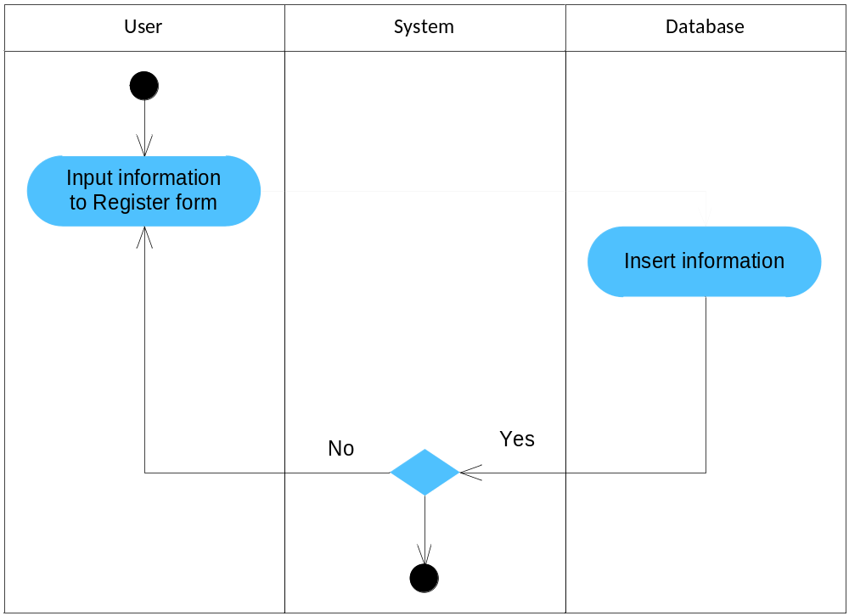Figure 1 : Register Information

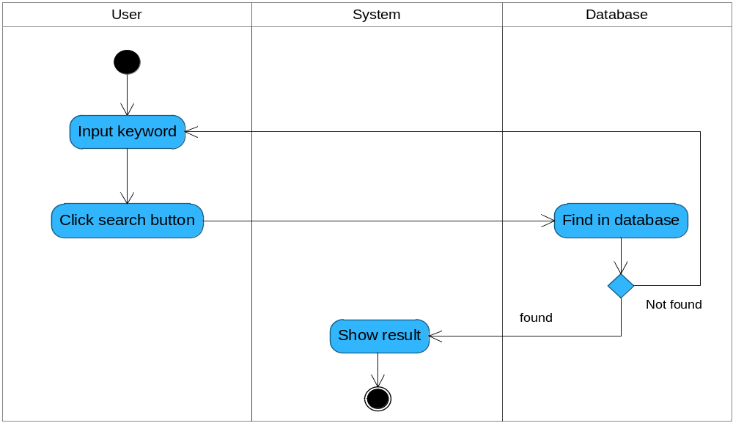
Figure 2 : Search infomation

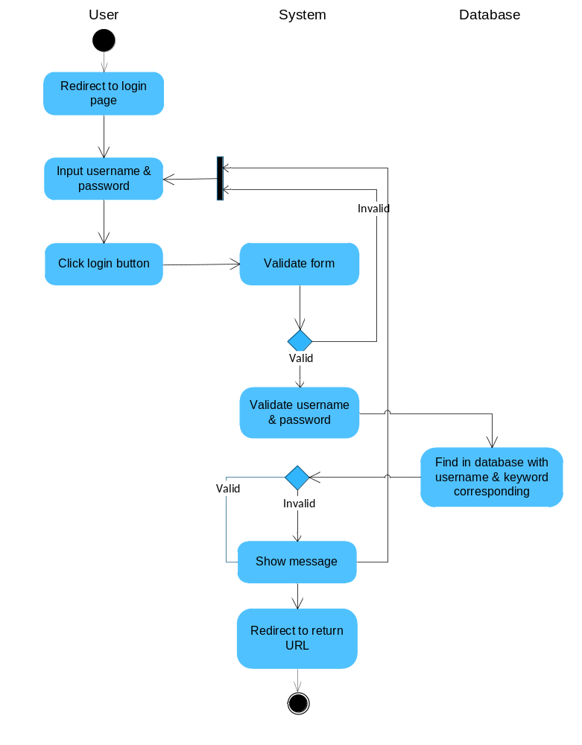Figure 3 : Login to System

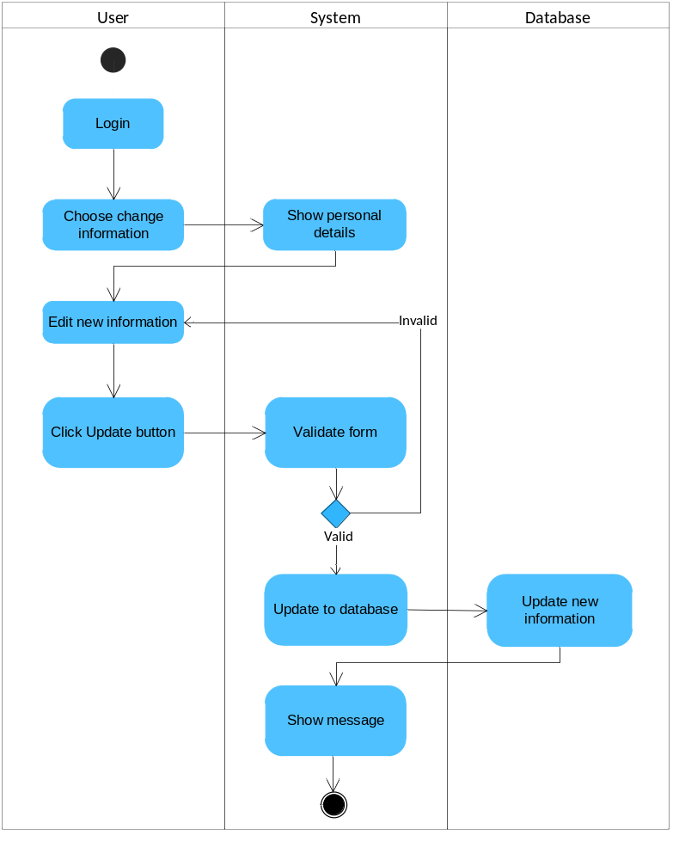
Figure 4 : Change Information

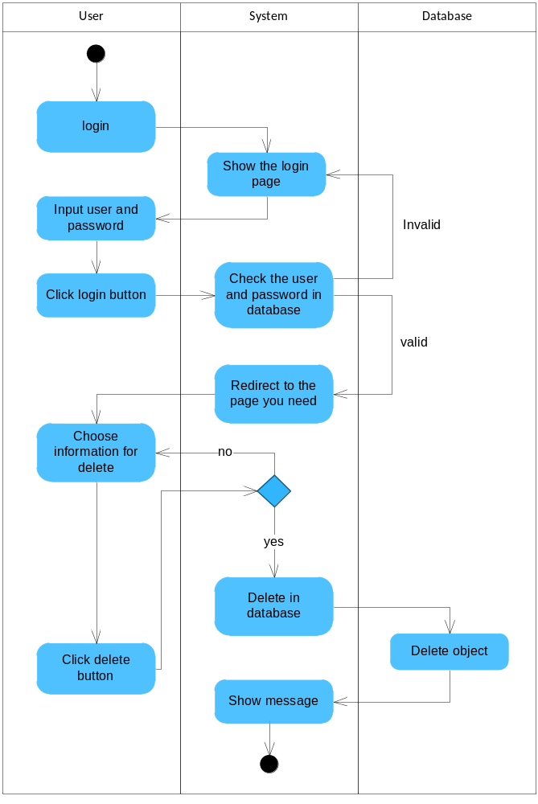
Figure 5 : Delete information

3.4 Use Case Diagram
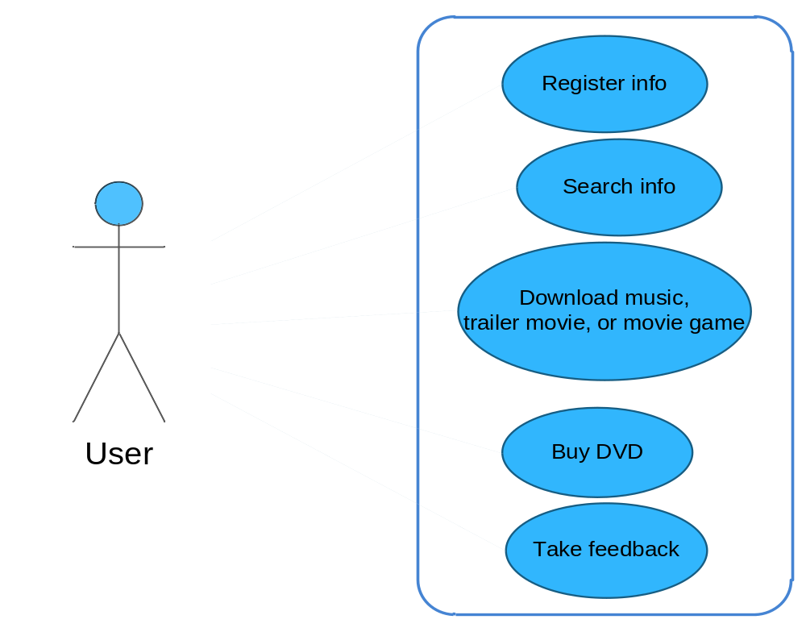
Figure 1: Use Case Diagram User

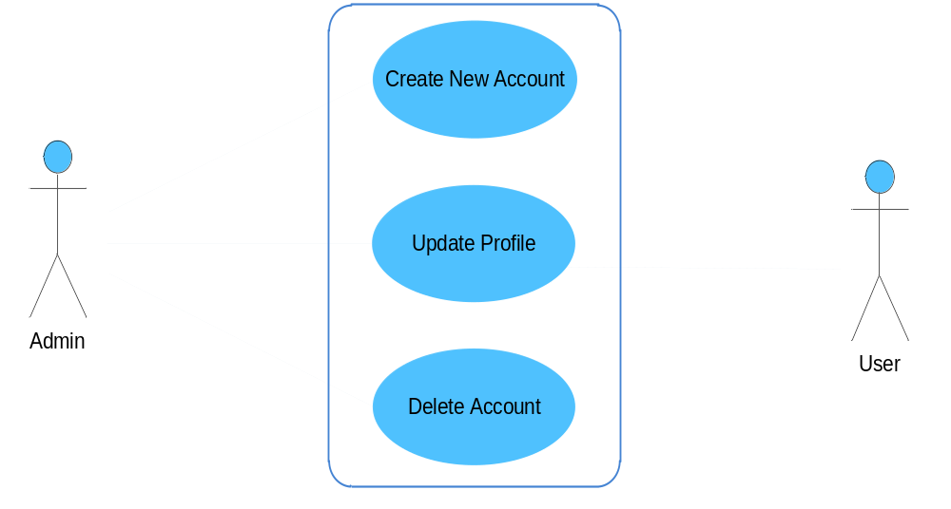Figure 2: Account Management

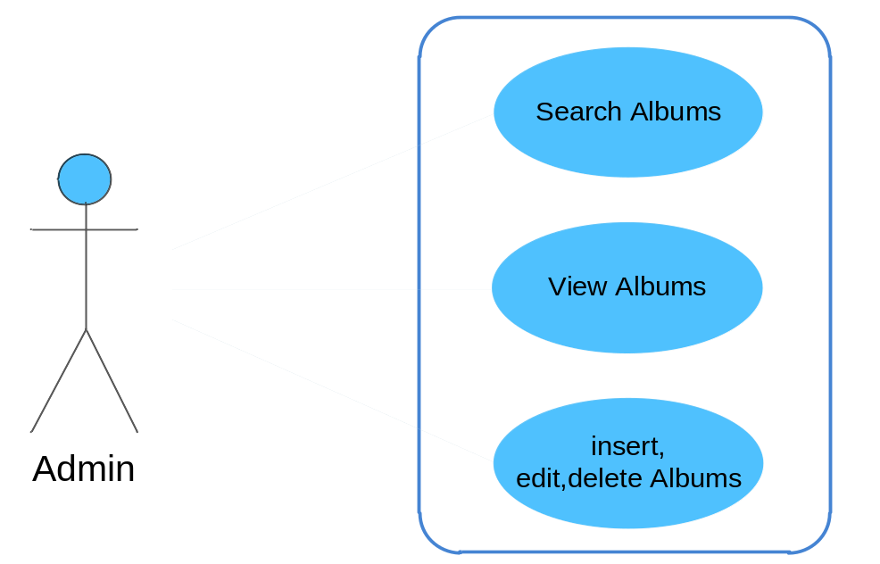

Figure 4: Albums Management

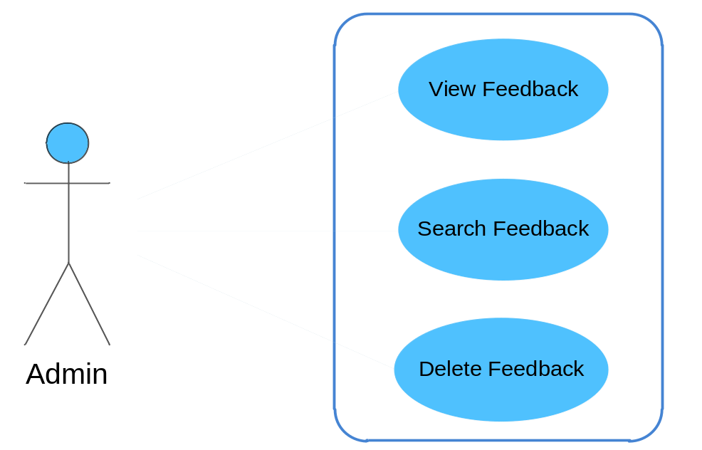

Figure 6: Feedback Management
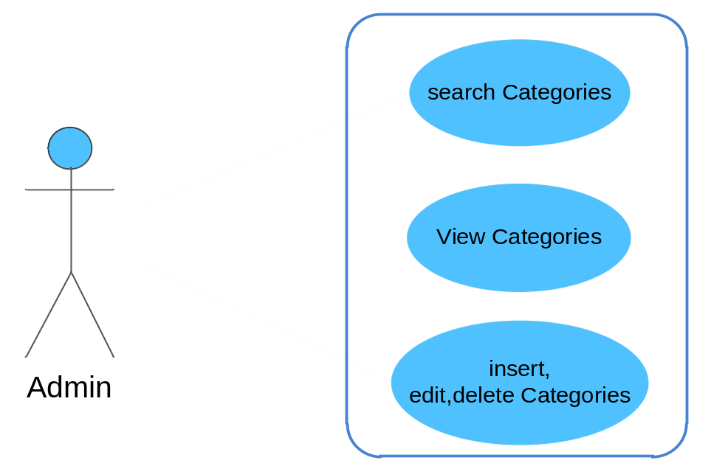
7. Manage Categories

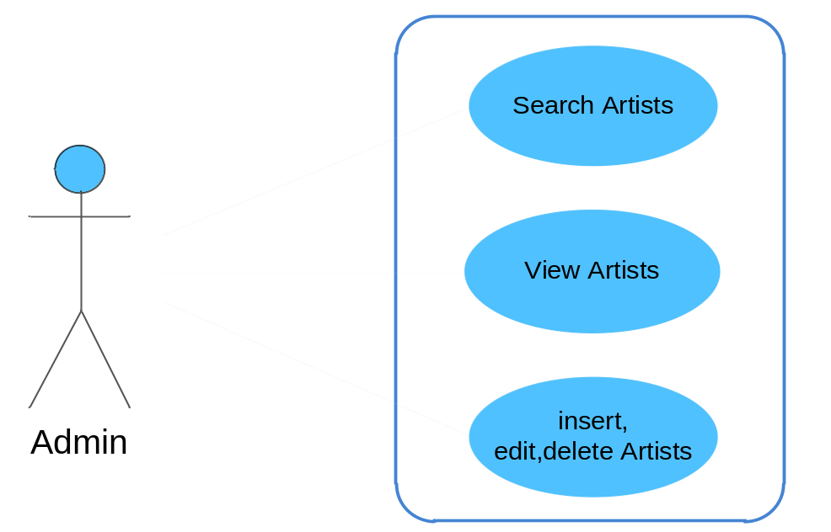
8.Manage Artists

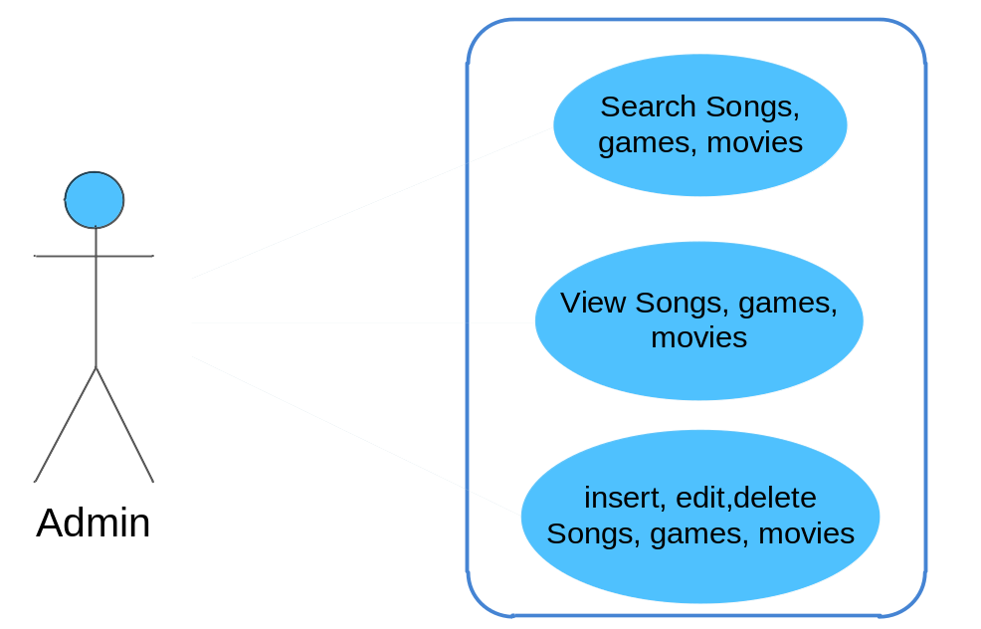
9.Manage Songs, games, movies

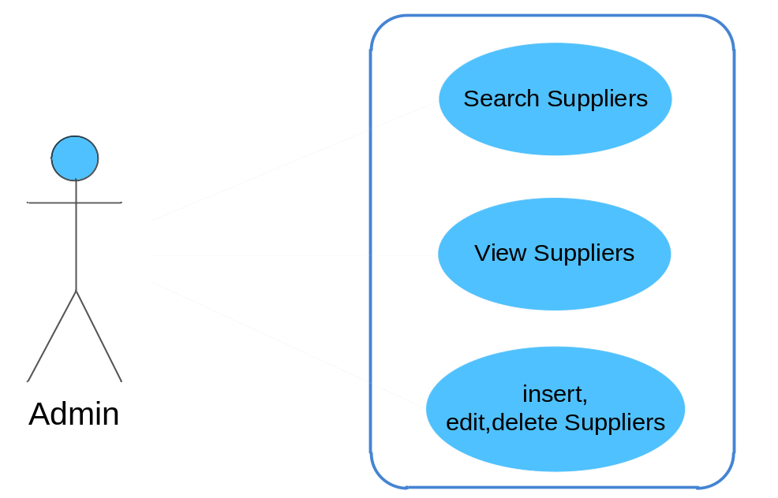
10. Manage Suppliers

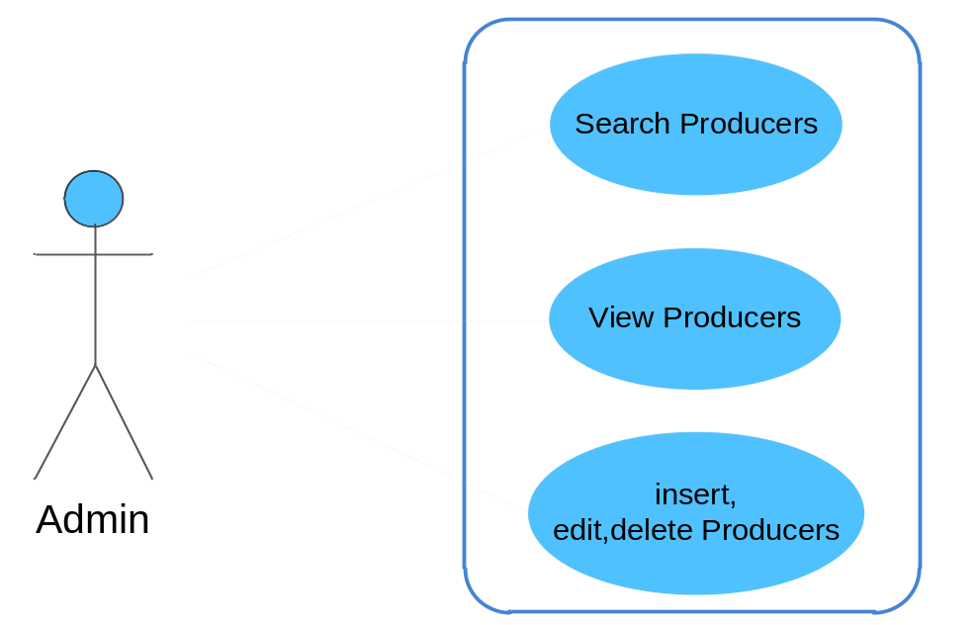
10. Manage Producers

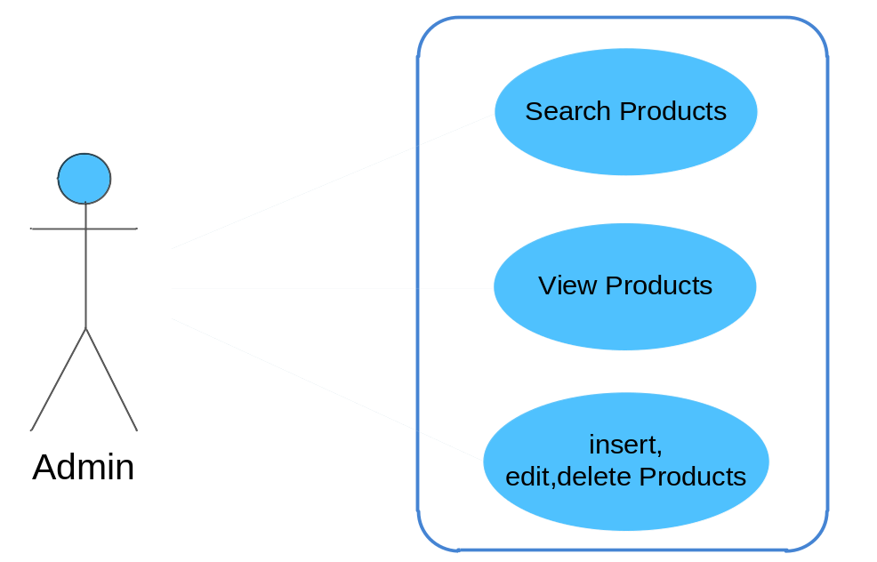
11. Manager Products

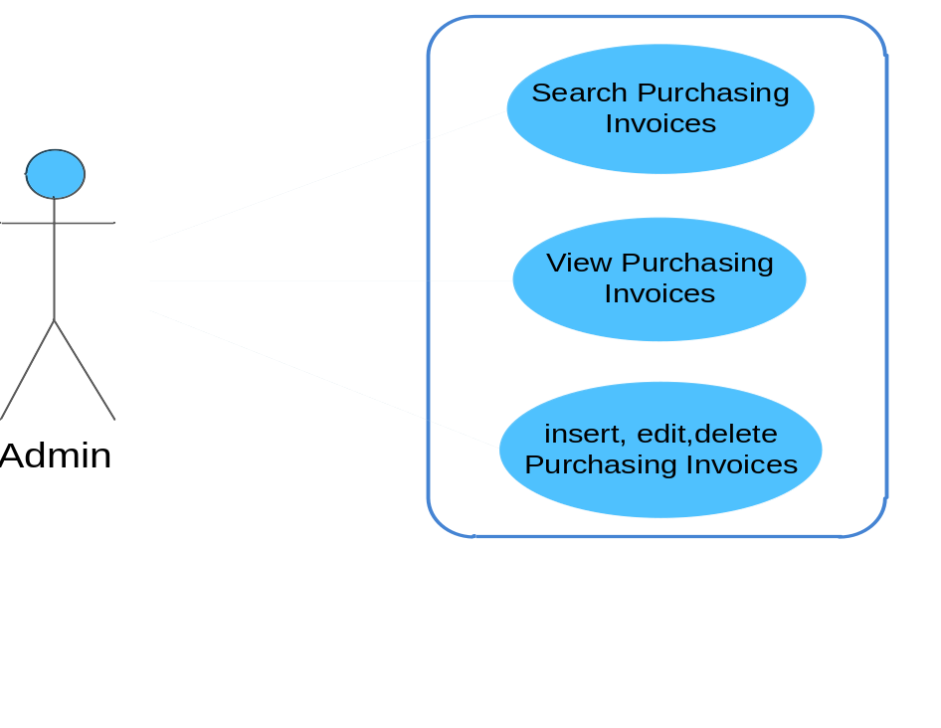
12. Manage Purchasing Invoices

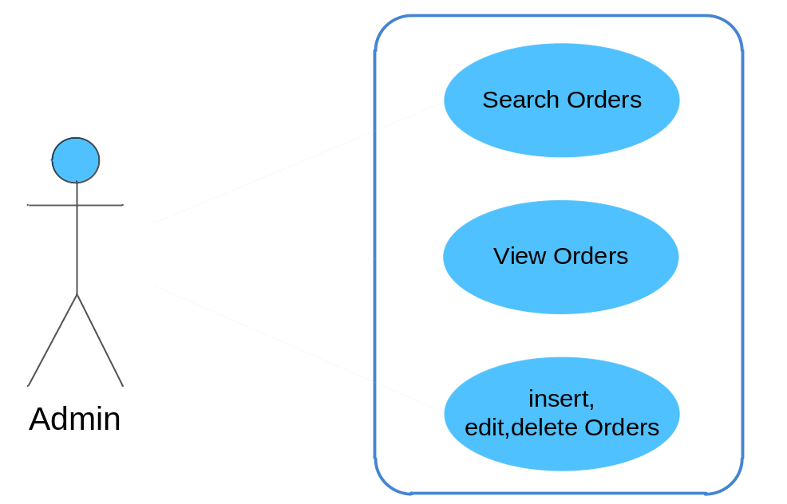

13. Manage Orders

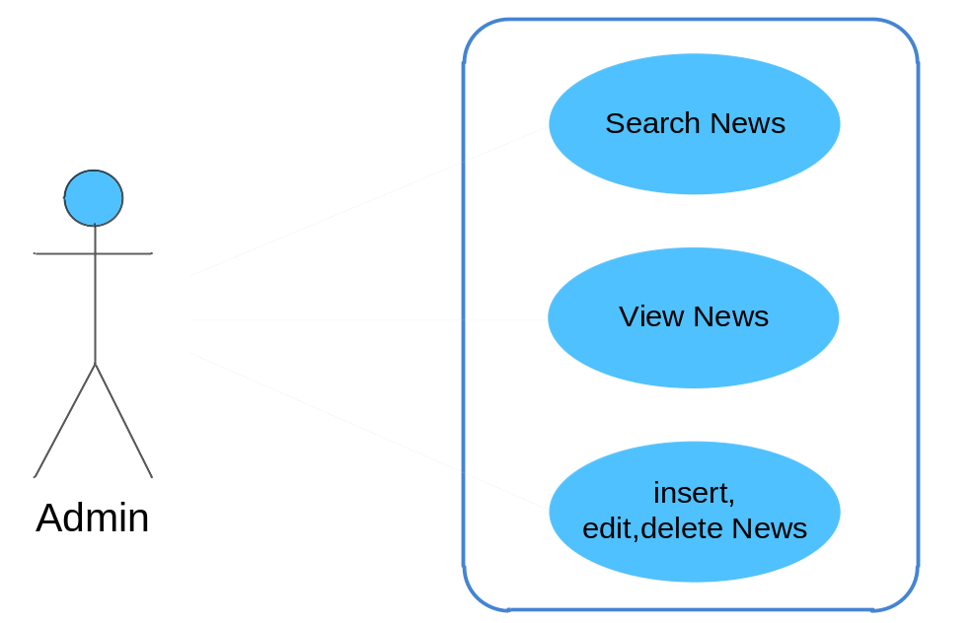
14. Manager News

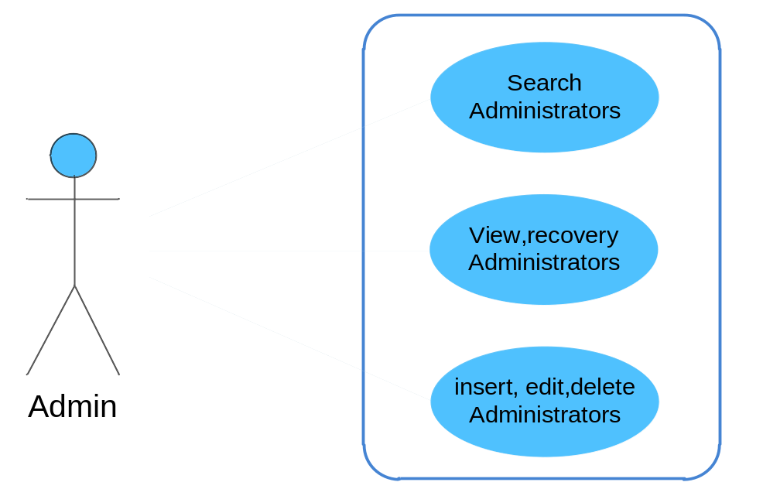
15. Manage Administrators
16. Manage Album Reviews

3.5. Use Case Specification
USE CASE # | UC01
USE CASE Name | Register
ACTOR | Visitor
Purpose (1 phrase) | Register Information

Overview and scope
Level | Primary

Preconditions

Post conditions in words
Trigger | User clicks Register button
Included Use Cases | None
Extended Use Cases | None
MAIN SUCCESSFUL SCENARIO | Actor Action | System Action
MAIN SUCCESSFUL SCENARIO | 1. User enter information to Register Form
MAIN SUCCESSFUL SCENARIO |  | 2. System will check if that information is correct or not.  If it is correct, display a message Register successfully  If it is not correct, ask User to enter again
MAIN SUCCESSFUL SCENARIO |  | 3. Display message
OTHER SUCCESSFUL SCENARIOS | Step | Branching Action
UNSUCCESSFUL SCENARIOS | Conditions | Actions
Developer
Creation date and last modified date
USE CASE # | UC02
USE CASE Name | Login
ACTOR | Admin, Users
Purpose (1 phrase) | Login to system

Overview and scope
Level | Primary
Preconditions | - User has already had an account .  - User needs to register.

Post conditions in words
Trigger | User click Login button
Included Use Cases | None
Extended Use Cases | None
MAIN SUCCESSFUL SCENARIO | Actor Action | System Action
MAIN SUCCESSFUL SCENARIO | 1. User logins to system
MAIN SUCCESSFUL SCENARIO |  | 2. System validates account
MAIN SUCCESSFUL SCENARIO | 3. User logins successfully
MAIN SUCCESSFUL SCENARIO |  | 3. System shows a message to user
OTHER SUCCESSFUL SCENARIOS | Step | Branching Action
UNSUCCESSFUL SCENARIOS | Conditions | Actions
UNSUCCESSFUL SCENARIOS | 1. User hasn’t had an account yet.  2. User puts wrong username or password | 1. User needs to register.  2. User retypes username or password
Developer
Creation date and last modified date

USE CASE # | UC03
USE CASE Name | listen to music, watch online trailer
ACTOR | Visitor, user
Purpose (1 phrase) | Allow user to play music, trailer movie, trailer game

Overview and scope
Level | Primary

Preconditions

Post conditions in words
Trigger | Allow user to play music, trailer movie, trailer game
Included Use Cases | None
Extended Use Cases | None
MAIN SUCCESSFUL SCENARIO | Actor Action | System Action
MAIN SUCCESSFUL SCENARIO | 1. vistor, users will click to the song, trailer game, trailer movie to watch.
MAIN SUCCESSFUL SCENARIO |  | 2. system will display the songs,trailer movie,trailer game that users want to see
OTHER SUCCESSFUL SCENARIOS | Step | Branching Action
UNSUCCESSFUL SCENARIOS | Conditions | Actions
Developer
Creation date and last modified date
USE CASE # | UC04
USE CASE Name | Login
ACTOR | Admin, Member
Purpose (1 phrase) | Login to system

Overview and scope
Level | Primary
Preconditions | - User has already had an account .  - User needs to register.

Post conditions in words
Trigger | User click Login button
Included Use Cases | None
Extended Use Cases | None
MAIN SUCCESSFUL SCENARIO | Actor Action | System Action
MAIN SUCCESSFUL SCENARIO | 1. User logins to system
MAIN SUCCESSFUL SCENARIO |  | 2. System validates account
MAIN SUCCESSFUL SCENARIO | 3. User logins successfully
MAIN SUCCESSFUL SCENARIO |  | 3. System shows a message to user
OTHER SUCCESSFUL SCENARIOS | Step | Branching Action
UNSUCCESSFUL SCENARIOS | Conditions | Actions
UNSUCCESSFUL SCENARIOS | 1. User hasn’t had an account yet.  2. User puts wrong username or password | 1. User needs to register.  2. User retypes username or password
Developer
Creation date and last modified date
USE CASE # | UC05
USE CASE Name | Change personal information
ACTOR | Admin
Purpose (1 phrase) | Allow to change personal information existing in the system

Overview and scope
Level | Primary
Preconditions | - User needs to login before changing information  - User chooses information which are wanted to be change
Post conditions in words | System displays information which have been changed and updated to the database.
Trigger | User click Update button
Included Use Cases | None
Extended Use Cases | None
MAIN SUCCESSFUL SCENARIO | Actor Action | System Action
MAIN SUCCESSFUL SCENARIO | 1. User logins to the system
MAIN SUCCESSFUL SCENARIO |  | 2. System validates account
MAIN SUCCESSFUL SCENARIO | 3. User chooses information which are wanted to be changed
MAIN SUCCESSFUL SCENARIO |  | 4. System shows Edit information form
MAIN SUCCESSFUL SCENARIO | 5. User puts new information
MAIN SUCCESSFUL SCENARIO | 6. User clicks Update button
MAIN SUCCESSFUL SCENARIO |  | 7. System updates new information to the database
 |  | 8. System displays a message to User.
OTHER SUCCESSFUL SCENARIOS | Step | Branching Action
UNSUCCESSFUL SCENARIOS | Conditions | Actions
UNSUCCESSFUL SCENARIOS | System fails to authorize User account | System redirects to Login page and User needs to login to the system
UNSUCCESSFUL SCENARIOS | Information in form is invalid | User needs to retype information
Developer
Creation date and last modified date

USE CASE # | UC06
USE CASE Name | Delete information
ACTOR | Admin
Purpose (1 phrase) | Delete information

Overview and scope
Level | Primary
Preconditions | - Have account  - Have insert all information about object
Post conditions in words | System display details information about object existed
Trigger | Clicks Delete button
Included Use Cases | None
Extended Use Cases | None
MAIN SUCCESSFUL SCENARIO | Actor Action | System Action
MAIN SUCCESSFUL SCENARIO | - login to system
MAIN SUCCESSFUL SCENARIO |  | - System validates account
MAIN SUCCESSFUL SCENARIO | - go to information management
MAIN SUCCESSFUL SCENARIO | - chooses an object to delete | .
MAIN SUCCESSFUL SCENARIO | - click delete button
MAIN SUCCESSFUL SCENARIO |  | - System deletes information in database and return message
MAIN SUCCESSFUL SCENARIO |  | - System display result about object
OTHER SUCCESSFUL SCENARIOS | Step | Branching Action
UNSUCCESSFUL SCENARIOS | Conditions | Actions
Developer
Creation date and last modified date

USE CASE # | UC07
USE CASE Name | Search information
ACTOR | Admin, Member, Visitor
Purpose (1 phrase) | Search information

Overview and scope
Level | Primary
Preconditions | - User choose options to search

Post conditions in words
Trigger | User click Search button
Included Use Cases | None
Extended Use Cases | None
MAIN SUCCESSFUL SCENARIO | Actor Action | System Action
MAIN SUCCESSFUL SCENARIO | 1. In the search box, user choose options to search
MAIN SUCCESSFUL SCENARIO | 2. User click Search button
MAIN SUCCESSFUL SCENARIO |  | 3. System search information in database and return records corresponding.
MAIN SUCCESSFUL SCENARIO |  | 4. System display result
OTHER SUCCESSFUL SCENARIOS | Step | Branching Action
UNSUCCESSFUL SCENARIOS | Conditions | Actions
Developer
Creation date and last modified date

USE CASE # | UC08
USE CASE Name | Manage order
ACTOR | Admin
Purpose (1 phrase) | Admin manage order

Overview and scope
Level | Primary

Preconditions
Post conditions in words | .
Trigger | Users click Send button
Included Use Cases | None
Extended Use Cases | None
MAIN SUCCESSFUL SCENARIO | Actor Action | System Action
MAIN SUCCESSFUL SCENARIO | Admin click on the users order | system will have the functionality to manage the user's orders
OTHER SUCCESSFUL SCENARIOS | Step | Branching Action
UNSUCCESSFUL SCENARIOS | Conditions | Actions
UNSUCCESSFUL SCENARIOS | 1. The information that Users entered is not correct | System display a message Information is not validate, so that Users have to enter again
Developer
Creation date and last modified date

4. Design
The application will be made of Web-based distributed three-tier architecture to support multiple user transaction at the same time.

Web-Tier

Middle-Tier

User interface with Servlet and JSF pages

EJB containing business logic

SQL Server 2008

Database-Tier

Web-Based Distributed 3-Tier Architecture of the Project

4.1. Database Diagram (DBD)

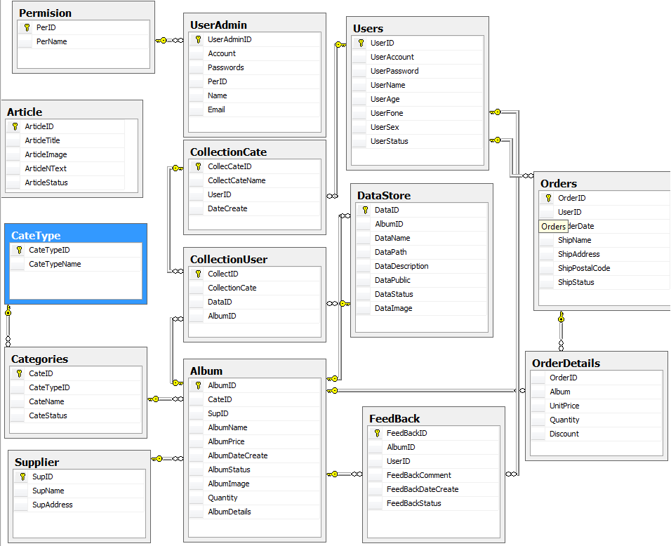

4.2. Database Design

Table Design
Table CateType
File Name | Data Type | Constraint | Description
CateTypeID | int | Primary Key | ID
CateTypeName | Nvarchar(10) |  | Name of categories type

Table Categories
File Name | Data Type | Constraint | Description
CateID | int | Primary key | ID
CateTypeID | Int | Foreign key | ID of Cate type
CateName | Nvarchar(35) |  | Name of categories
CateStatus | Bit |  | Status of categories

Table Article
File Name | Data Type | Constraint | Description
ArticleID | int | Primary key | ID
ArticleTitle | Varchar(100) |  | Title of article
ArticleImage | NVARCHAR(100) |  | Images of Article
ArticleNText | NVARCHAR(Max)
ArticleStatus | BIT |  | Status of article

Table Supplier
File Name | Data Type | Constraint | Description
SupID | Int | Primary key | Supplier Type
SupName | Varchar(50) |  | Supplier Name
SupAddress | Varchar(50) |  | Supplier address

Table Album
File Name | Data Type | Constraint | Description
AlbumID | Int | Primary key | Album ID
CateID | Int | Foreign key | Categories ID
SupID | Int | Foreign key | Supplier ID
AlbumName | NVARCHAR(200) |  | Album Name
AlbumPrice | DECIMAL |  | Album Price
AlbumDateCreate | NVARCHAR(30) |  | Album Date Create
AlbumStatus | BIT |  | Album Status
AlbumImage | NVARCHAR(100) |  | Album Image
Quantity | INT |  | Quantity
AlbumDetails | NVARCHAR(MAX) |  | Album Details

Table DataStore
File Name | Data Type | Constraint | Description
DataID | Int | Primary key | Data ID
AlbumID | Int | Foreign key | Album ID
DataName | NVARCHAR(100) |  | Data Name
DataPath | NVARCHAR(100) |  | Data Path
DataDescription | NVARCHAR(MAX) |  | Data Description
DataPublic | BIT |  | Data Public
DataStatus | BIT |  | Data Status
DataImage | NVARCHAR(200) |  | Data Image

Table Users
File Name | Data Type | Constraint | Description
UserID | Int | Primary key | User ID
UserAccount | NVARCHAR(20) |  | User Account
UserPassword | NVARCHAR(70) |  | User Password
UserName | NVARCHAR(30) |  | User Name
UserAge | NVARCHAR(5) |  | User Age
UserFone | NVARCHAR(20) |  | User Fone
UserSex | NVARCHAR(10) |  | User Sex
UserStatus | BIT |  | User Status

Table CollectionCate
File Name | Data Type | Constraint | Description
CollecCateID | Int | Primary key | CollectionCate ID
CollectCateName | NVARCHAR(100) |  | CollectionCate Name
UserID | Int | Foreign key | User ID
DateCreate | NVARCHAR(30) |  | Date Create

Table CollectionUser
File Name | Data Type | Constraint | Description
CollectID | Int | Primary key | Collection user ID
CollectCateID | Int | Foreign key | CollectionCate ID
DataID | Int | Foreign key | Data ID
AlbumID | Int | Foreign key | AlbumID

Table Feedback
File Name | Data Type | Constraint | Description
FeedBackID | INT | Primary key | FeedBack sID
AlbumID | INT | Foreign key | FeedBack ID
UserID | INT | Foreign key | User ID
FeedBackComment | NVARCHAR(MAX) |  | FeedBack Comment
FeedBackDateCreate | NVARCHAR(30) |  | FeedBack Date Create
FeedBackStatus | BIT |  | FeedBack Status

Table Orders
File Name | Data Type | Constraint | Description
OrderID | INT | Primary key | Order ID
UserID | INT | Foreign key | User ID
OrderDate | NVARCHAR(30) |  | Order Date
ShipName | NVARCHAR(30) |  | Ship Name
ShipAddress | NVARCHAR(100) |  | Ship Address
ShipPostalCode | NVARCHAR(20) |  | Ship Postal Code
ShipStatus | INT |  | Ship Status

Table OrderDetails
File Name | Data Type | Constraint | Description
OrderID | Int | Primary key | Order ID
AlbumID | Int | Foreign key | Album ID
UnitPrice | DECIMAL |  | Unit Price
Quantity | Int |  | Quantity
Discount | DECIMAL |  | Discount

Table Permission
File Name | Data Type | Constraint | Description
PerID | Int | Primary key | Permission ID
PerName | NVARCHAR(20) |  | Permission Name

Table UserAdmin
File Name | Data Type | Constraint | Description
UserAdminID | INT | Primary key | User Admin ID
Account | NVARCHAR(25) |  | Account
Passwords | NVARCHAR(100) |  | Passwords
PerID | INT | Foreign key | Permission ID
Name | NVARCHAR(50) |  | Name
Email | NVARCHAR(50) |  | Email

4.3. Algorithms

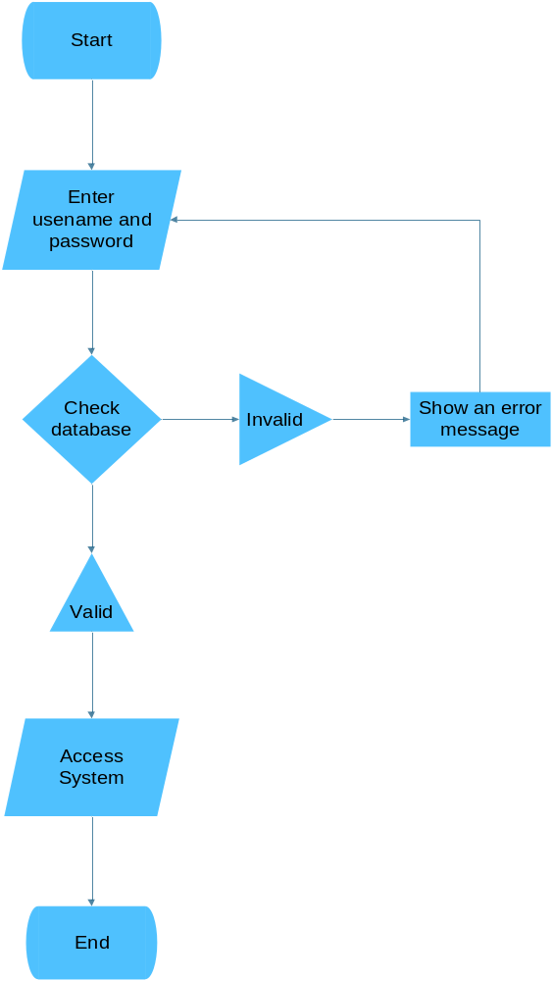

Flow Chart for Login

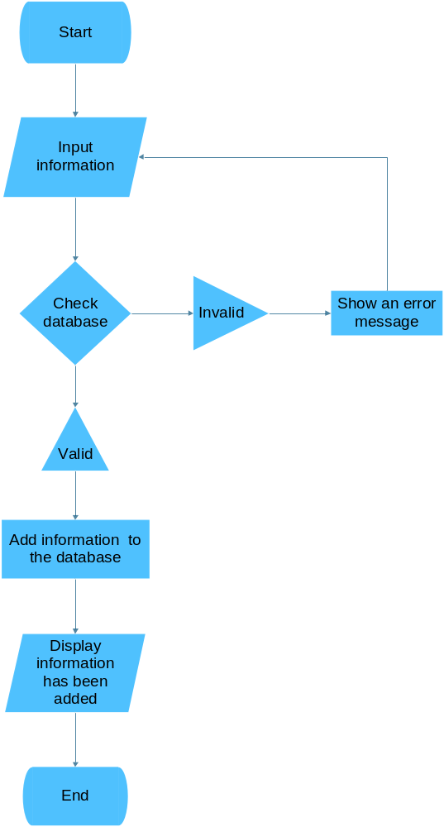

Flow Chart for Regiser Information

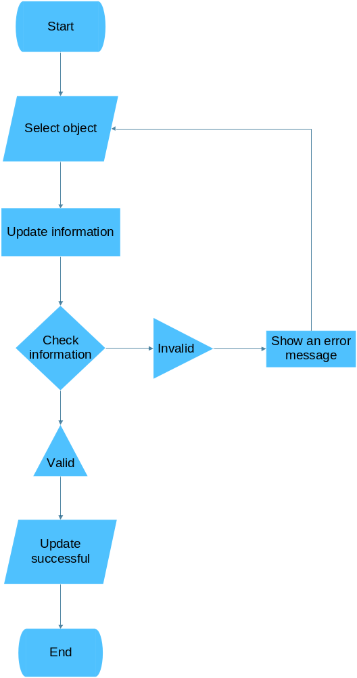

Flow Chart for Update Information

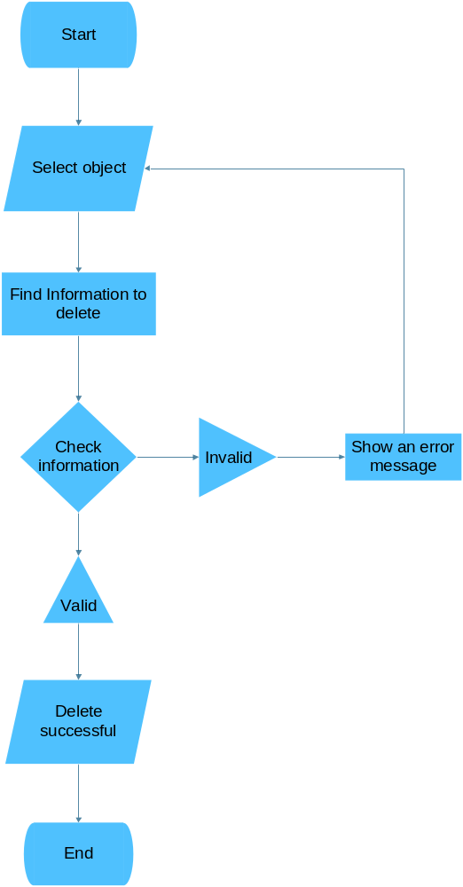

Flow Chart for Delete Information

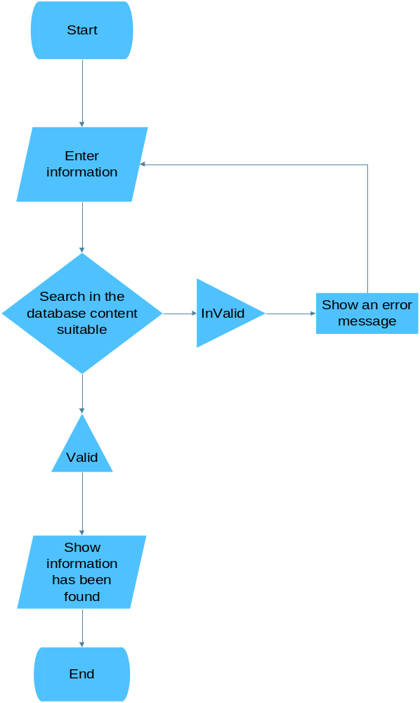

Flow Chart for Search Informatio

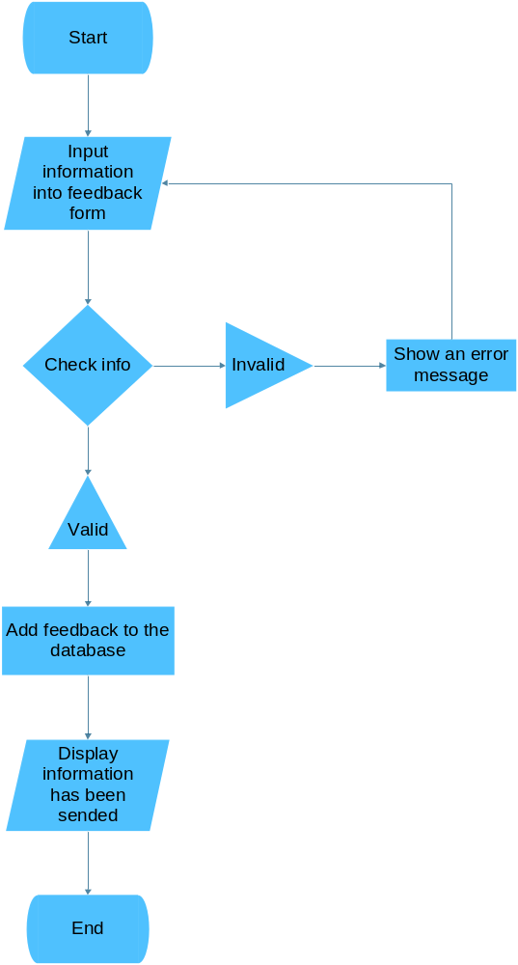

Flow Chart for Take Feedback

5. Management and Project Planning

5.1. Management Approach
The group members using PMS to manage the project code, assign tasks to team members and TortoiseSVN tool. When meeting in class, members tell the difficult issues and work together to solve that. In addition, members also use skype and yahoo to discuss with each other.

5.2. Task Sheet

Stt | Member Name | Task
1 | Phung Van Thuc
2 | Vu Hoang Chien
3 | Dinh Ngoc Hung

6. Screenshots

Figure: Home Page



Figure: Register Page

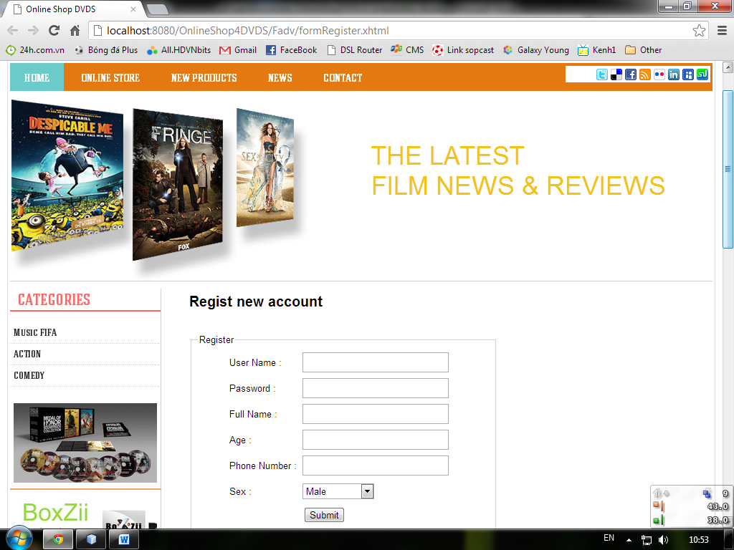

Figure: Default card

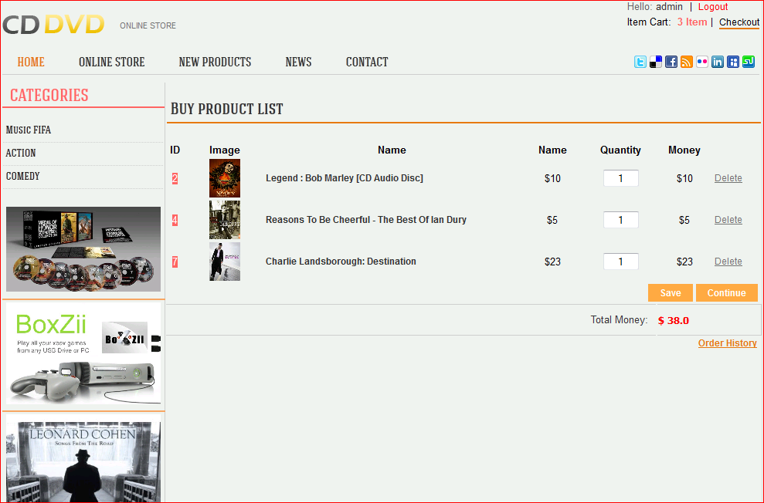

Figure : Personal Authentication Information

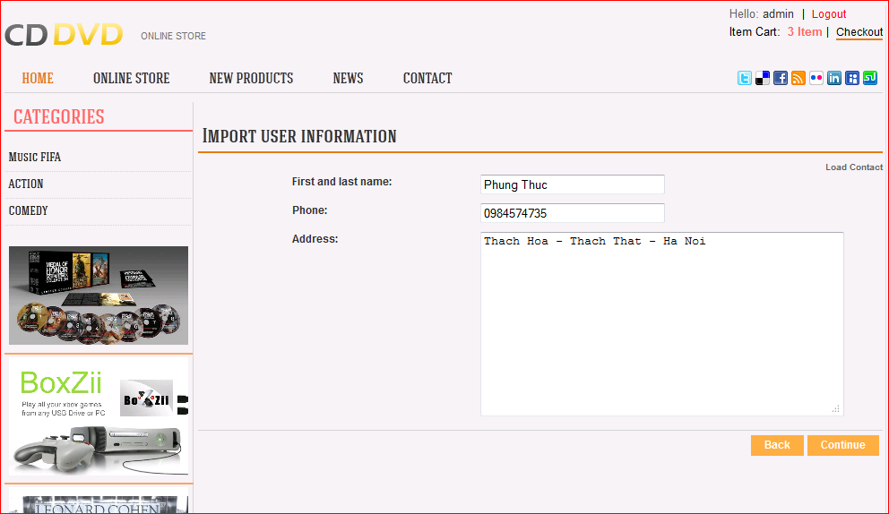

Figure : Preview Order

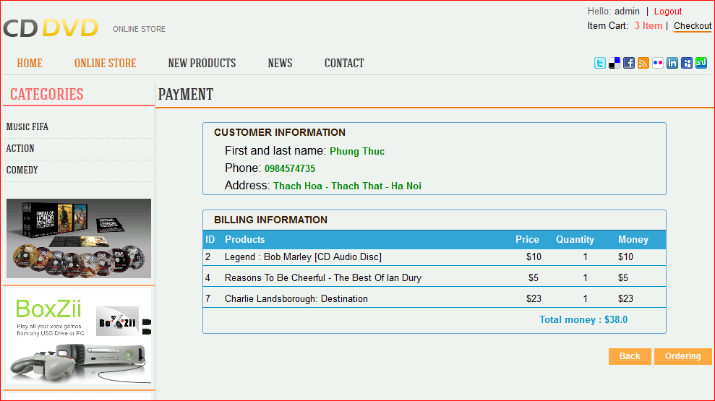

Figure : History Order

