IT VISIONARY
POST-DEPLOYMENT
CONFIGURATION GUIDE
WhatsApp AI Agent + RPA + SAP Integration on AWS
Manual configuration performed after CI/CD deployment
Repository Documentation
This document records the manual post-deployment configuration steps shown in the project screenshots. It is intended to accompany the repository and support repeatable setup and verification.

1. Connect WhatsApp Business
This section shows the WhatsApp Business account list, the option to add a phone number, the link to the Facebook/Meta onboarding flow, and the resulting active account and phone-number details.
In the AWS Console, open Amazon End User Messaging, select Social messaging, and then open WhatsApp business accounts.
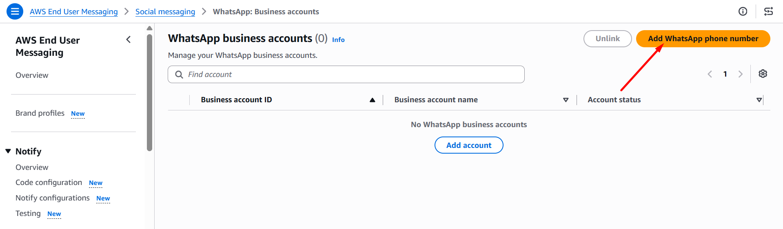
Select **Launch Facebook portal**. Complete the WhatsApp Business/Meta onboarding steps in the new window, then return to AWS to finish the setup.
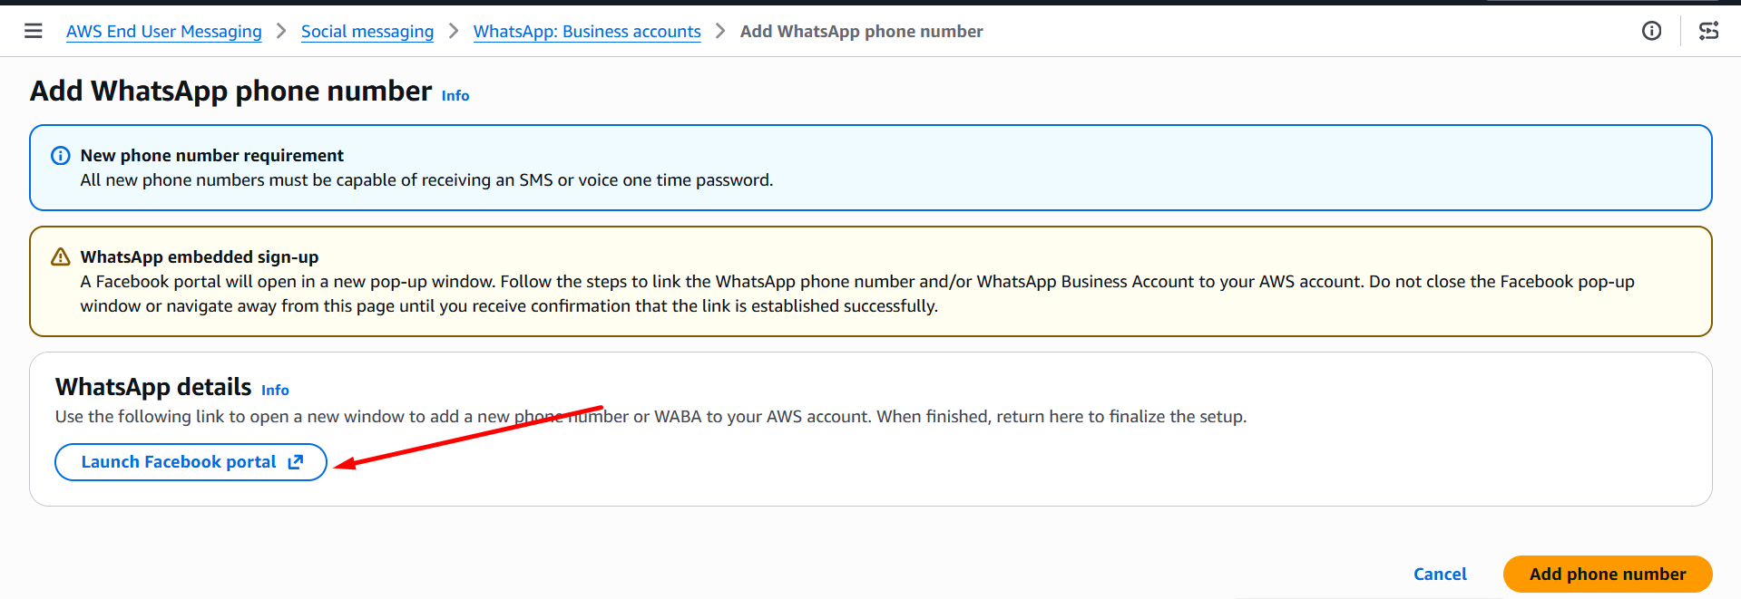
After completing the setup, confirm that the business account appears in the list and its status is **Active**.
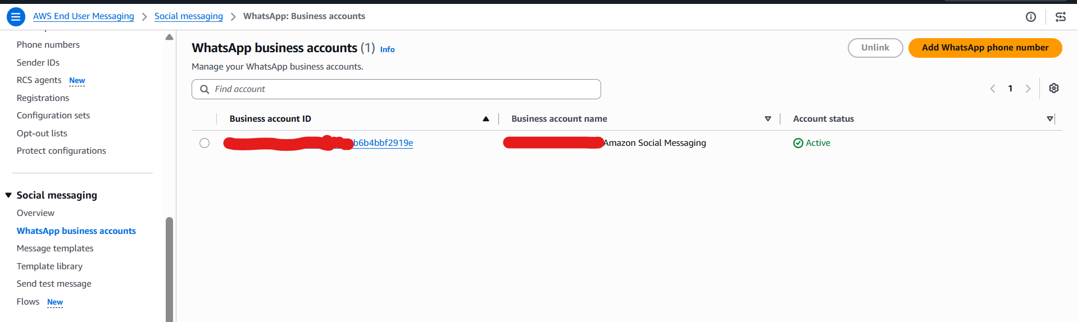
- Open the phone-number details and verify the linked phone number and its phone-number ID.
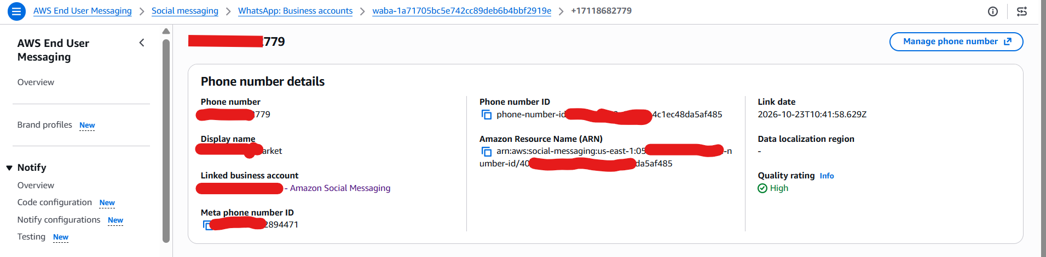
- Select **Add WhatsApp phone number** to start linking a phone number.
- Return to the AWS console and complete the remaining steps in the wizard.
- Open the phone-number details and verify the linked phone number and its phone-number ID.
The application uses the phone-number ID when sending WhatsApp responses. Use the ID for the correct environment, and retrieve the actual value from AWS rather than from a redacted screenshot.

2. Configure the inbound event destination
The screenshot shows the phone number's **Event destination** tab. The destination type is Amazon SNS, and event publishing is enabled.
In Amazon End User Messaging Social, open the WhatsApp phone number that is linked to your business account.
Open **Event destination**, then select **Edit destination**.
Set the destination type to **Amazon SNS**, then select the SNS topic created for the matching environment.
Save the configuration and verify that event publishing is enabled.
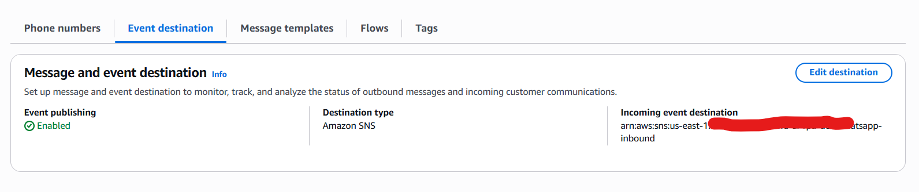

4. Review Lambda environment variables
The screenshots show the Lambda environment-variable list and its edit screen. The following variable names are visible:
- **BEDROCK_MODEL_ID** — identifies the foundation model used by the agent.
- **CHAT_HISTORY_TABLE_NAME** — names the DynamoDB table used to store conversation history.
- **CHECKPOINTER_TABLE_NAME** — names the table used to store agent checkpoints.
- **LOG_LEVEL** — sets the application's logging level.
- **MAPPING_TABLE_NAME** — names the table containing customer or external-system mappings.
- **META_API_VERSION** — specifies the Meta Graph API version used by the application.
- **ORDER_API_ENDPOINT** — specifies the endpoint used to connect to the order/RPA integration.
- **ORDER_API_KEY** — credential used to access the order API. Treat this value as sensitive.
- **USER_TABLE_NAME** — names the DynamoDB table containing customer or user records.
- **WHATSAPP_PHONE_NUMBER_ID** — identifies the WhatsApp phone number used by the application.
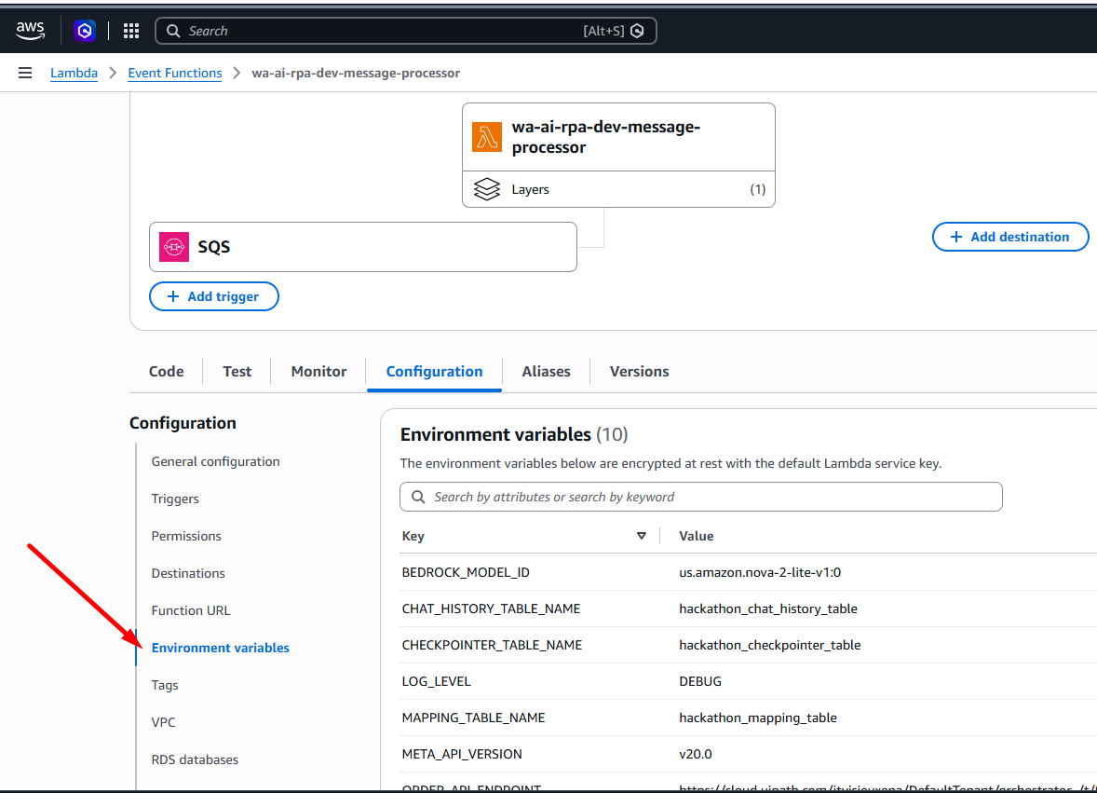
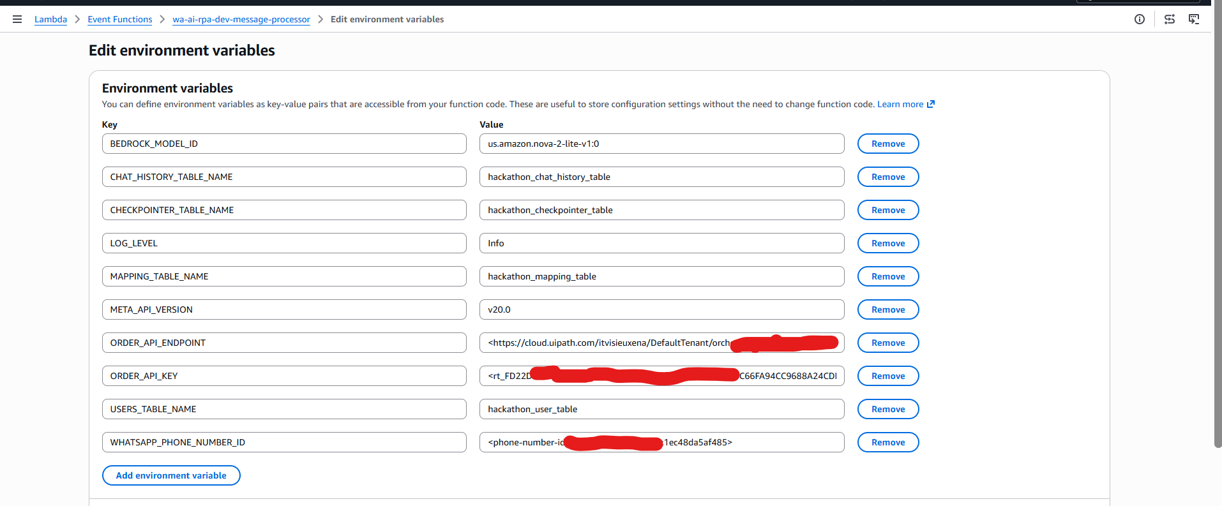

5. Review Lambda execution-role permissions
Screenshot 4 — The Lambda Permissions tab, the link to the execution role, and the related IAM policy view.
The final screenshots show **Lambda → Configuration → Permissions** and the linked IAM execution role. Because the policy text is not legible enough to transcribe accurately, refer to the IAM policy or Terraform source for the exact actions and resource ARNs.
- In the Lambda console, open **Configuration → Permissions**.
- Select the execution-role name to open the role in the IAM console.
- Compare the role's attached and inline policies with the permissions defined in Terraform.
- Confirm that the role has only the permissions the application needs, including access to CloudWatch Logs, SQS message consumption, the relevant DynamoDB tables, Bedrock invocation, and the approved order integration.
- If the application must publish to another AWS service, verify that the required permission is present and limited to the intended resource.
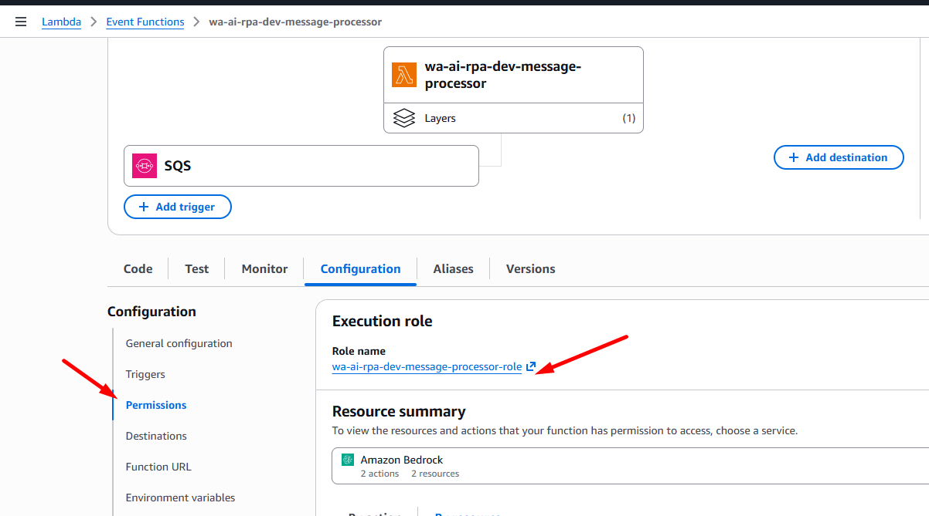
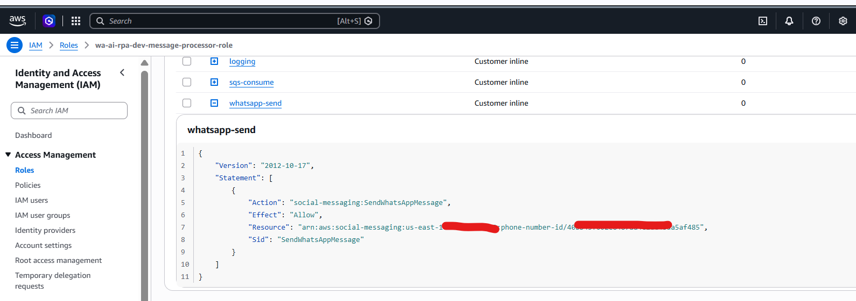
Do not recreate the policy by guessing from the screenshot. Before making changes, verify the complete policy in IAM or in the infrastructure-as-code (IaC) files.

8. Scope and limitations
This guide is limited to the information shown in the supplied screenshots: WhatsApp onboarding, the SNS event destination, the Lambda trigger and environment variables, and IAM execution-role review. The screenshots do not document the full Meta approval process, the complete IAM policy JSON, a successful end-to-end test, or the full UiPath/SAP configuration. Redacted or unreadable values have not been guessed.
Document title | Post-Deployment Configuration Guide
Solution | WhatsApp AI Agent + RPA + SAP Integration on AWS
Document type | Technical operations / configuration guide
Scope | Manual AWS Console configuration evidenced by the supplied screenshots
Version | 1.0

