Hostname via DHCP & SNMP

There are two implementations that need tested, hostname via DHCP and SNMP.

Hostname via DHCP
Ensure your DHCP server has a specific hostname up to 15 characters in length set for the MAC address of the Network Interface Card that is connecting to the DHCP server. Choose DHCP w/ hostname in the Setup Utility and check hostname when the connection completes. Reboot and check hostname. Go to the Host tab and check hostname.

SNMP
The implementation involves Hobart HT series product which listeners for data requests (The Agent) and the customer-developed software which requests data (The Manager).

You will have to setup these two parts: The Agent and The Manager. Let’s do The Manager first as it is the easiest. You can use any SNMP software to act as the manager for instance, PowerSNMP Free Manager from the internet. It is downloadable for free and offers multiple Agent monitoring where individual requests can be set to User’s intervals. You will load the MIB file into the manager and then choose which Objects (data pieces) you want to monitor and test that the Agent (scale) provides them to the Manager. Grab the MIB file named ITWFoodEquipmentGroup-MIB.mib from SVN in the Windux->3RDPartySoftware->snmp directory. You are responsible for acquiring the correct version of this single file as you test.
Load the file into your SNMP manager and go to the 1.3.6.1.4.1.51478 folder location as shown in one SNMP manager software below:
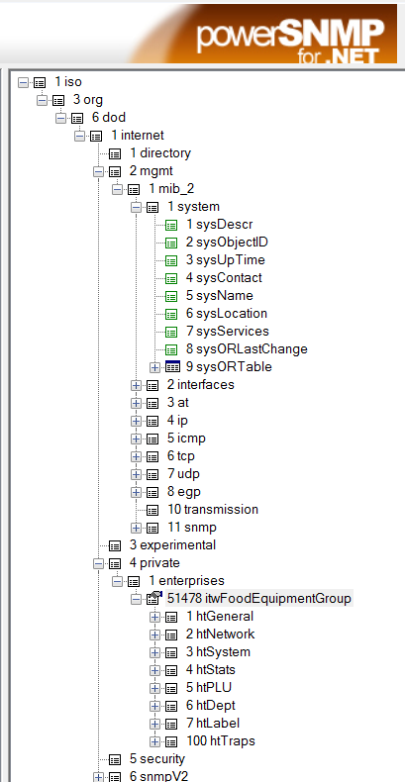

Once you go to that directory you can add watches and set request intervals for all of the OID Object Identifiers that the HT Series product provides. Add an agent by setting the IP address of the HT Series product IP address and then add object watches. Keep in mind all of this can be explained rather quickly, easily by Todd Davis who developed the SNMP feature.
No go to the setup Utility in the scale and get connected to a static IP and choose the SNMP tab. Here you will enter the IP of the machine you want to the traps (unsolicited messages) to go to and the port (This will be the IP of your Manager machine). It is best to leave the defaults as shown on the UI for the ports. Once filled in, click “Save Settings and Restart Agent”. Fairly soon the data should start reporting in your Manager software. Test the Stop Agent process too. Test restarting the scale to see if it automatically starts sending data that is requested. New OID’s will be added through time to increase this feature’s capability. All you have to do is grab the feature file and MIB from the PSS site as these are added. For this release you are testing the capability should be fixed. Mgmt. could update this decision and want to include new OID’s as they become available before release. This is where the PSS could become useful or SVN will hold the new feature upgrade files.
After you read this, Todd Davis can familiarize you with actions needed to test. It is the most prudent use of resources as opposed to writing a rather lengthy document for testing.

