User Manual
Black Box Device

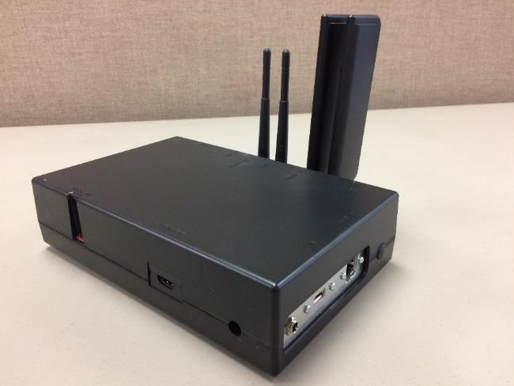

Overview
The Black Box is a network gateway device capable of connecting various ITW devices. Depending on the type of system support needed, the black box and other ITW devices can be configured using the Black Box Device Setup Utility.
Prerequisites – Customer Network Hardware
Introduction
The Black Box Device Setup Utility performs various setup functions for ITW Network devices. A laptop computer is required.
Benefits
- Preparation of configuration file use on ITW network devices.
- Save configuration files.
- Open and append configuration with new or updated values.

HTDST INSTALLATION
System Requirements
• Microsoft Windows 10

Black Box Device Setup Utility Installation Steps

- Double click the ‘itw-win-black_box_device_setup_utiltity-[version_number].exe.’ file. Select OK

- Allow software to install to the default directory ‘Program Files (x86). Select Install.

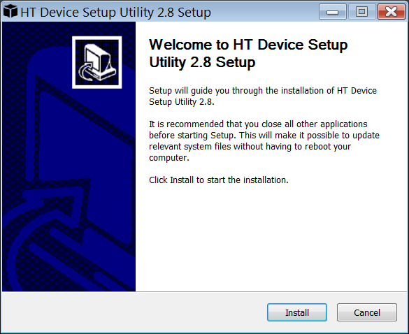

- Select Finish
Note: if you leave ‘Run HT Device Setup Utility’ checked it will automatically start.

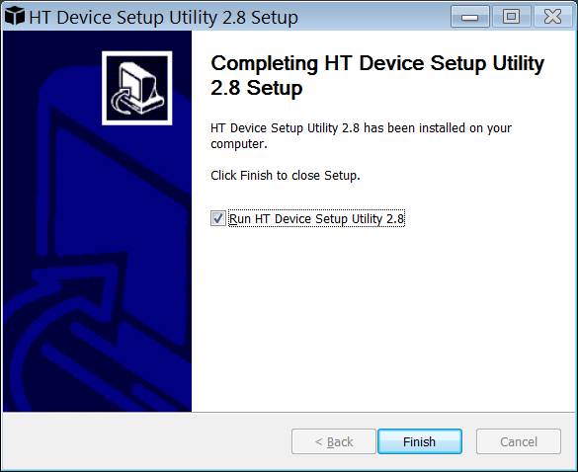

Hobart Remote Diagnostics System configuration


- Double click on the HTDST icon to start the tool. The tool will open showing the Initial HT Device Setup Tool screen.

- Select New or Open.

  - Start New Configuration File = Create New File
  - Open Configuration File = Open existing file for modification

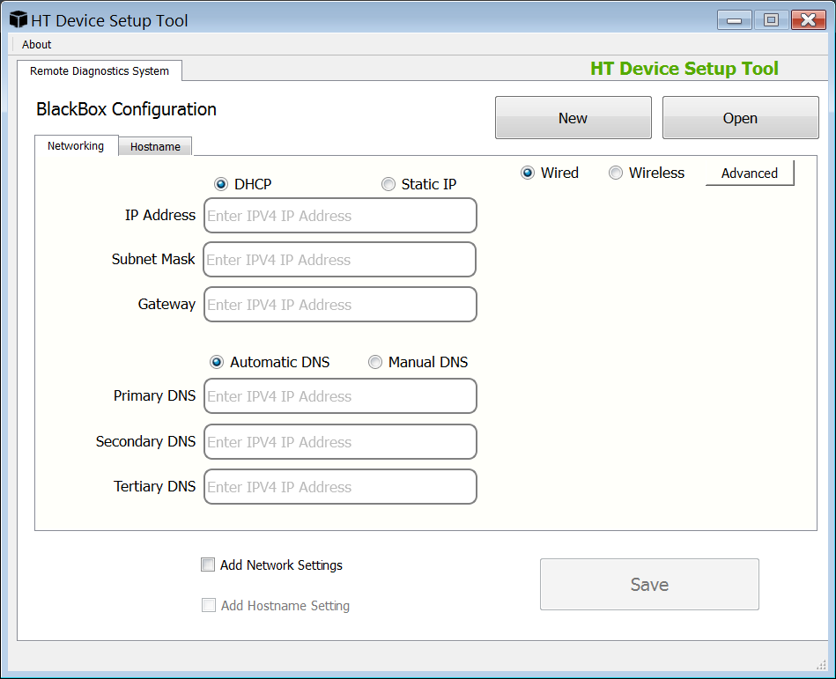

Select Tab for device you want to configure
- Select the Tab you want to configure settings for.
Note: Data must be entered in the Tab(s) screen to select settings to save in the configuration file.
Note: As data is entered for each Tab the ‘Add Settings’ check box options will display on the bottom left of the configuration screen.

- Check the ‘Add Settings’ check box for the settings you want to include in the configuration file.
Tab Selection | Add setting check box
Networking | Add Network Settings
Hostname | Add Hostname Settings

Avaialble Configuration settings
Basic Networking Settings for black box (Remote Diagnostics System)
- DHCP or Static IP address
- Wired or Wireless
DHCP / Wired
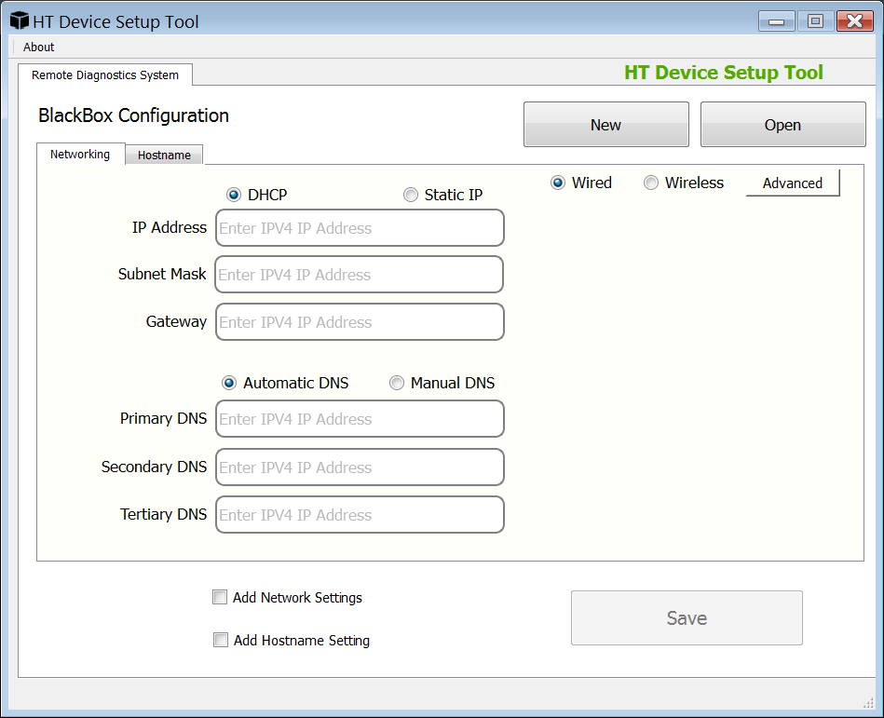

DHCP / Wireless
Note: Based on ‘Security Method’ selected - security options will change.
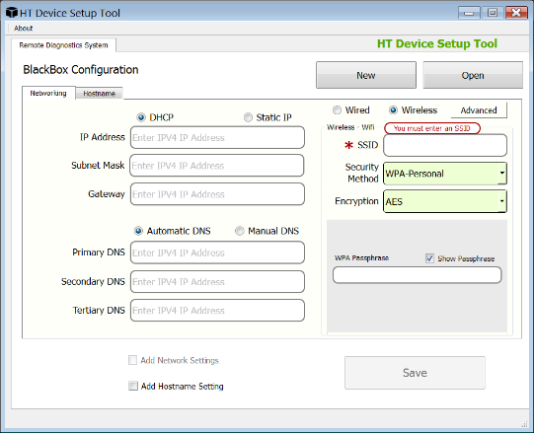
Security Method=WEP Security Method=WPA-Personal
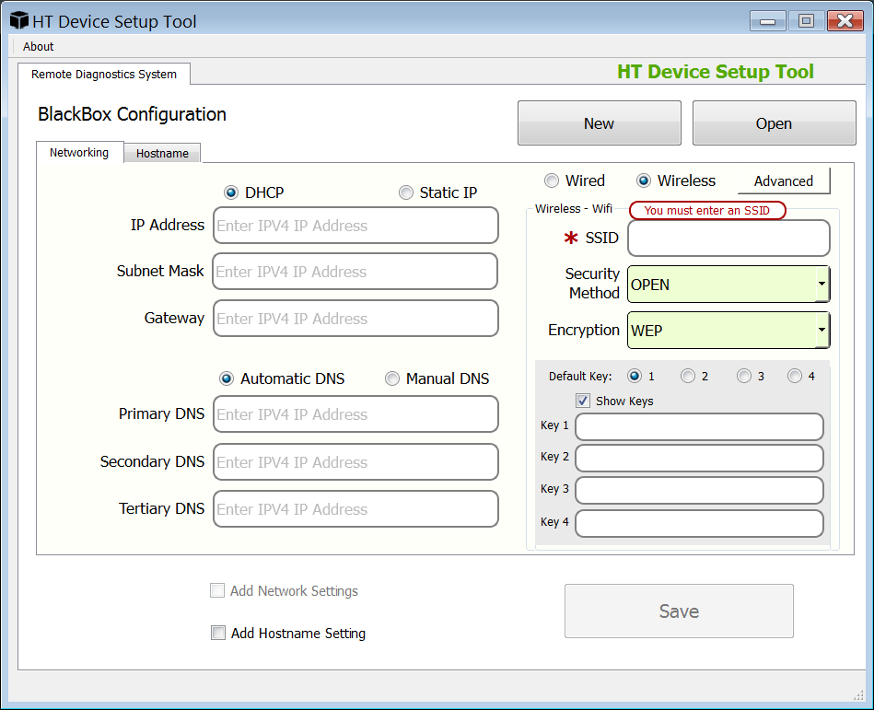

Static IP / Wired
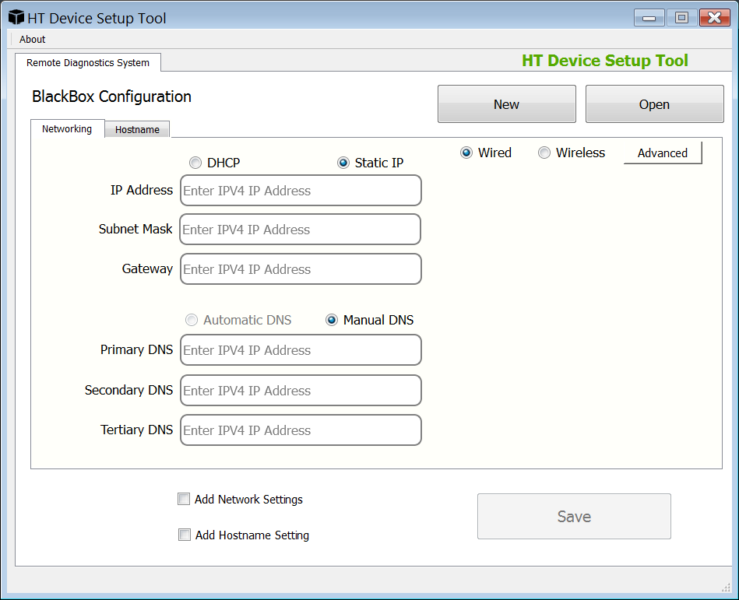

Static IP / Wireless
Note: Based on ‘Security Method’ selected - security options will change.
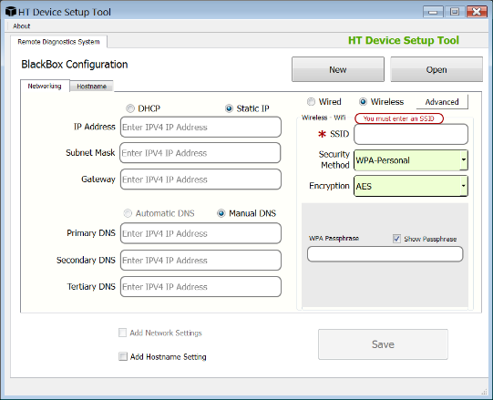
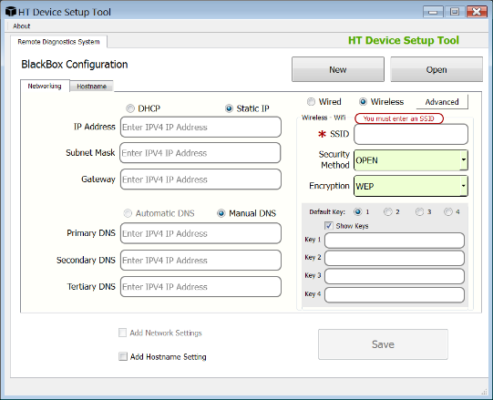
Security Method=WEP Security Method=WPA-Personal

Hostname
Note: ConfigureHostname as required by customer.

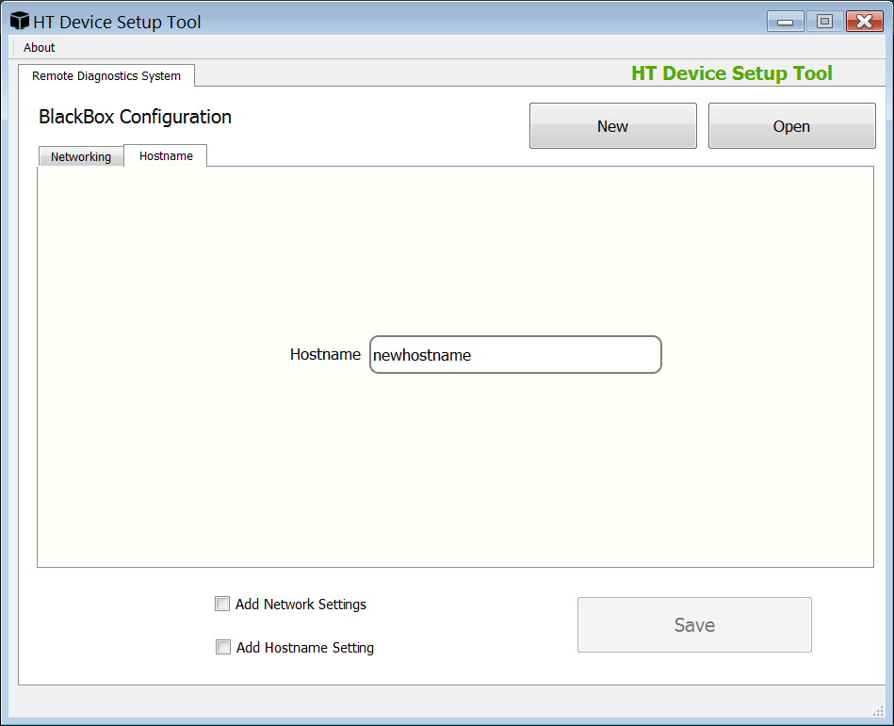

- Configure network settings as required for customer’s network.

- Select ‘Save’ to save configuration file (hdconfig).
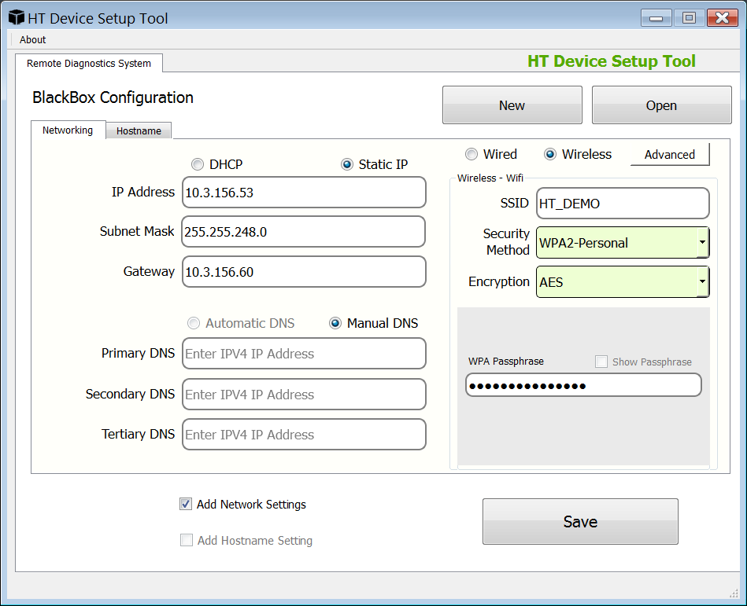

Note: Tool automatically seeks the ‘autoconfig’ folder when a USB drive is plugged in.
- Must have folder ‘autoconfig’ on root of USB drive.
- Does not have to be a Hobart Service Key.
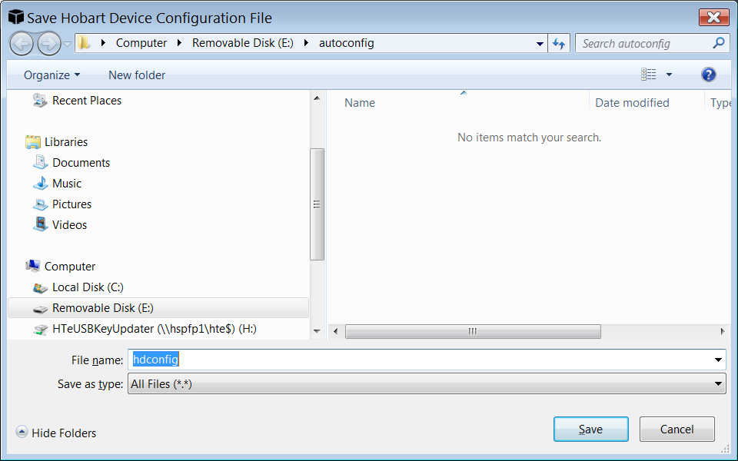

- Choose folder where you want to save the configuration file.

- Name the file something you will remember for the device you are configuring.
CustomerName_Device_Serialnumberofdevice_date
i.e. MainMarket_BB_451145053_10032017
  - BB=Black Box

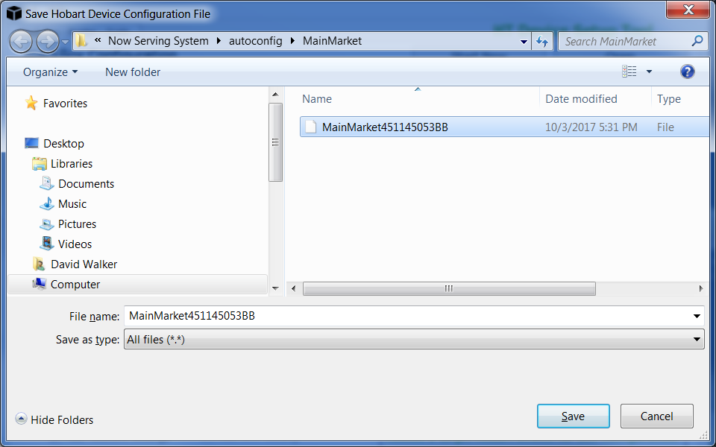
Note: You can save any number of configuration files, however you will be required to rename the file to ‘hdconfig’ prior to loading to a device.
Import configuration file to Black Box (Remote Diagnostics System)
Pre-import
- Create folder called ‘autoconfig’ on USB drive.
- Place configuration file for the device you are configuring in the ‘autoconfig’ folder.
- The device checks for a file called ‘hdconfig’ during auto configuration.
  - Wired connection - Network cable connection to hub/switch from BB.
  - Wireless connection – Available Access Point to connect BB.

Important: Make sure you have renamed the configuration file to ‘hdconfig’ before importing.

- Plug the ‘USB drive’ with the ‘network’ file into the USB port on the black box (Remote Diagnostics System).

- Wait for the Black Box (Remote Diagnostics System) to reboot. This process takes approx. 3 to 4 minutes.

- Once the Black Box (Remote Diagnostics System) has rebooted remove the ‘USB drive’.

