

Hobart Corporation


Linux Distribution Selection Criteria and Recommendation
06/03/2010
Revision: 0.1
Submitted by:
Bsquare Corporation
110 110th Ave NE Suite 200
Bellevue, WA 98004
(425) 519-5900 (Voice)
(425) 519-5999 (Fax)
To:
Hobart Corporation
701 S. Ridge Ave
Troy, OH 45374

Attn: Debra Dyer
Telephone #937-405-7922

IMPORTANT: This document is intended only for the use of the individual or entity to which it is addressed, and contains information, which is confidential and proprietary. If the reader of this document is not the intended recipient, or the employee or agent responsible for delivering the document to the intended recipient, you are hereby notified that any dissemination, distribution or copying of this document is strictly prohibited. If you have received this document in error, please notify the sender immediately and return the original document.

Project Name | HLX Access
Document ID
Author(s) | Minhaj Ahmed  Sr. Software Engineer II  Bsquare Professional Engineering Services (PES)  2100 Lakeside Blvd. St. 450  Richardson, TX 75080
Reviewed by | Michael Browne  Director of Engineering  Bsquare Professional Engineering Services (PES)  2100 Lakeside Blvd. St. 450  Richardson, TX 75080
Approved by: | Bsquare Project Manager:  John Imboden  Sr. Program Manager  3480 West Market Street, Suite 105  Fairlawn, Ohio 44333  Client Project Manager:  Name  Title  Division
Delivery Date

Revision History
Revision | Date | By | Comments
0.1 | 06/03/2010 | M. Ahmed | Initial draft

Contents
Introduction 5
Document Purpose 5
Definitions, Acronyms, and Abbreviation 5
Applicable Documents 5
Requirements 6
Hardware Requirements 6
Hardware layout 6
Software Requirements 8
GUI 8
Analysis of Available distros and Recommendations 9
Ubuntu 9.10 10
Ubuntu 10.04 LTS 11
redhat Enterprise Linux 5 12
Fedora13 14
Debian5.0 15
Puppy 16
Timesys LinuxLink 3.0 17

Introduction
A Linux distribution (distro) is a software package built on top of freely available Linux kernel with a particular assortment of software applications. Each distro is meant to provide an “out-of-box” solution for end-users. Typically the graphic support for a distro is provided by X Window System. Various distros are unique in their combination of software libraries, utilities and resource management schemes. According to some estimates there are currently over six hundred Linux distributions and over three hundred of those are in active development.

Bsquare is tasked with porting the Hobart HLX Scale application software from the Microsoft Windows XPe environment to the Linux environment. While Hobart team made their final decision on selecting the distro, the Bsquare team in consultation with Hobart began work using Ubuntu 9.10, the Karmic Koala. This distro was chosen for its availability and support of the AMD processor being used on this platform.

Document Purpose

Based on Hobart’s request the Bsquare development team has prepared this Linux assessment document to facilitate the effort of choosing an appropriate distro for Hobart Consoles.

Definitions, Acronyms, and Abbreviation
The following terms and acronyms are used throughout this document.

LVDS | Low Voltage Differential Signal
LCD | Liquid Crystal Display
OS | Operating System
APC | ARM7 based Peripheral Controller
FPU | Floating Point Unit

Applicable Documents
The following table contains documents that were referenced during the creation of this document.

Ref. # | Document Name | Document ID/Location
1 | HobartLinuxPort.docx | https://externalsvn.camelot.bsquare.com/svn/Hobart/Hobart_Linux_Port/branches/shared_code/Docs/Tech docs
2 | Overview of scale software architecture.doc | http://bportal/PES/Program%20Management%20Office/Project%20Documents/Forms/AllItems.aspx?RootFolder=http%3a%2f%2fbportal%2fPES%2fProgram%20Management%20Office%2fProject%20Documents%2fHobart%20%2d%2083322&FolderCTID=0x01200092446C2034BF074094EADD0BA1E7BAAD

Requirements

Hardware Requirements

Hardware layout
Hobart manufactures multiple consoles which allow Hobart peripheral devices to connect over USB interface. Equipped with an LCD display these consoles along with the connected devices provide complete user experience. Hobart currently manufactures two types of consoles

- HLX Console (HLX)
- Access Console (Access)

At a peripheral level, the HLX differs from Access in its inclusion of Printer and Weigher in the same system. Thus HLX console provides a standalone solution with the option of functional enhancements primarily via USB interfaces. Examples of additional peripheral devices include items such as hanging scales and elevated customer display. On the other hand Access provides a platform for controlling large and varying hardware peripheral configurations primarily via USB interface for various Pre-Pack solutions. While both consoles support serial and PCI buses the majority of the devices use a USB interface to communicate with the console.

At the circuit board level the HLX and Access consoles share many of the same components. However, in order to manage various peripherals, the HLX employs an ARM7 based peripheral Controller (APC) for processing peripheral I/O. This additional chip impacts the peripheral management and firmware update process at the software level. Overall, APC communicates via USB with a South Bridge to an x86 based LX800 AMD Geode processor. This AMD chip is the processor on which the Linux Operating System (OS) will execute.

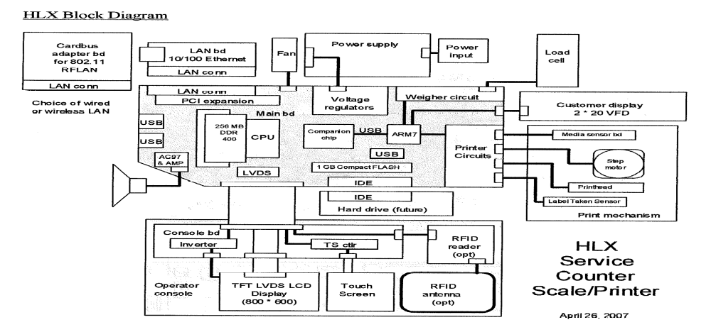
Figure 1.1 HLX Hardware component block diagram.

Geode LX800 is a low power 500 MHZ System-on-a-chip microprocessor with an integrated Floating Point Unit (FPU). It provides built in Graphics Processor (GP) and support for high resolution CRT and TFT outputs. Since both consoles use this microprocessor a distro supporting this architecture will be required.

Peripheral support
As depicted in Figure 1.2 the Geode processor supports built in PCI bridge module. Both consoles use the PCI bus to provide networking capability to the console and currently both wireless and wired network interfaces are supported using this Geode’s on-chip PCI module. The wireless cards use CardBus technology to operate over PCI bus. In future USB based wireless network cards may be used to provide network connectivity. Regardless of the exact interface used, network connectivity is the second most important interface for both HLX and Access consoles. System level security, system configuration, firmware update and device level synchronization are dependent on this interface.

The Geode processor depends on the South Bridge for majority of the peripheral communication. The South Bridge includes IDE, Compact Flash (CF), Serial interface, AC97 based audio interface in addition to a USB bus interface. Both consoles use Compact Flash to load the OS and the Hobart application. Optionally, software maybe loaded from the compact IDE Hard-Drives. At least 2G persistent memory is required for deploying Linux System. In the current configuration, the Hobart consoles support one (1) DDRAM slot providing 512MB of memory with the maximum possible capacity of 1 GB. These provisions remove some of the memory limitations from the distro selection.

Majority of the USB devices are ATMEL based and the distro should provide support for ATMEL firmware download solution currently deployed.

Following is the list of interfaces and buses requiring support
- SM-Bus (I2C)
- PCI Bus
- Serial Bus
- USB bus supporting 2.0 compliant devices
- ATA IDE Hard-Drive
- AC97 based Audio
- LCD Touch Screen Display over Serial interface
- LAN (Wired and Wireless)
- Compact Flash (2-4GB) multiplexed with IDE
- DDR RAM (512MB – 1GB)

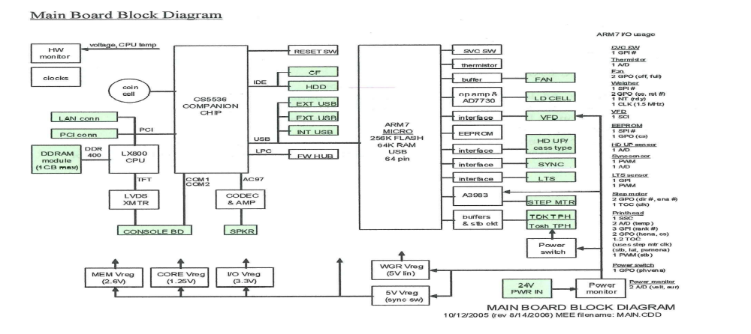
Figure 1.2 Peripheral management

Software Requirements

GUI
The HLX application suite uses a web browser based UI which interacts with the GoAhead Web server to provide the HLX user interface environment. This setup provides the facility for both local and remote access to the scale services allowing store personnel and Hobart Service Technicians to remotely connect with the scale when necessary. Java components provide the necessary backend interface with the native application software which works hand in hand with the connected devices and the Codebase database to provide the necessary services to the users. The Web UI stipulates the use of robust windows based environment. Since most applications are available for X Windows, the desktop solution supported by distro must include an X Window based solution. Additionally, Firefox and Foxit PDF viewer for PDF file viewing have been chosen by Hobart thus the selected distro must provide support for these applications.

The following is the list of Application software and services required to be supported by the distro.
- Java tools
- Firefox
- Foxit
- GCC (4.4.1 or higher)
- GNU make (3.81 or higher)
- Curl library for HTTP and FTP client support.
- Libusb and UDev for managing USB device and notifications
- X Windows based xrdb Virtual Keyboard.
- I2C tools support for SM-Bus.

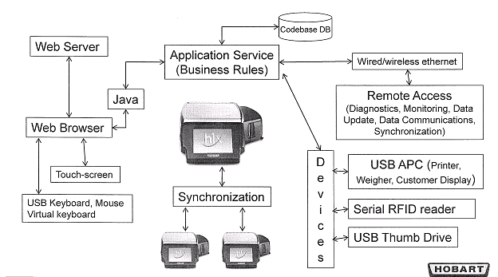

Figure 1.3 Software component of Hobart Application.

Analysis of Available distros and Recommendations
The following sections examine different Linux distributions for meeting the hardware and software requirements documented above. It is highly recommended that a hard drive or CF of at least 2 GB be used for Linux installations to obtain best results. The sizes provided below, particularly for disk space, do not accurately account for differences in file systems as well as space requirement for actual operation. Operations with full load must be tested for realistic analysis. Based on availability, support, and compatibility, Bsquare recommends the following three (3) distros be considered by Hobart for final selection. This recommendation is based on data collected from various sources as well as the recommendation received from AMD and the work performed in the first phase of the project. However as stated earlier, a final selection must be made by Hobart by actually testing the distro with full-load.

- Ubuntu 9.10
- Redhat Enterprise Linux 5
- Timesys LinuxLink 3.0

Ubuntu 9.10
Ubuntu is a Debian based OS which is distributed as free and open source software with additional proprietary software available. It is backed by UK based Canonical Ltd’s commercial services and support is available on both the desktop and server. Ubuntu provides an up-to-date OS and maintains a strong focus on usability and ease of installation. Web statistics suggest that Ubuntu's share of Linux desktop usage is about 50% with upward trending usage as a web server.
Ubuntu is composed of many software packages with the vast majority of these being distributed under a free software license (Open Source). Ubuntu itself is governed by GNU General Public License (GNU GPL) with Canonical providing commercial support and other related services. Canonical releases new versions of Ubuntu every six months and supports Ubuntu for eighteen months by providing security fixes, patches to critical bugs and minor updates to programs.
Ubuntu focuses on usability with various options available for installing the OS. In regards to emphasis on accessibility and internationalization, Ubuntu introduced UTF-8 as the default character encoding allowing support for variety of non-Roman scripts starting version 5.04. For security the utility sudo is used to assign temporary privileges for performing administrative tasks, allowing the root account to remain locked, preventing inexperienced users from inadvertently making catastrophic system changes or opening security holes. Additionally, PolicyKit is also being widely implemented into the desktop to further harden the system through the principle of least privilege.
Ubuntu’s focus on usability, accessibility and wide support, both commercial and community, makes it a very attractive candidate for this deployment. These were the reasons why the Bsquare development team started its work for the first phase on the latest Ubuntu version available. Due to vast availability of utilities the Bsquare development team was able to support various hardware requirements and parallel the functionality supported on Microsoft Windows for various features. Some basic testing with Ubuntu running from thumb driver without the full application load also provided reasonable performance benchmark.

System Specifications:

Memory Footprint | 32MB-512MB
Peripheral Support | All devices supported.
Disk Space Required | According to the packages installed with minimum being 600 MB.
Processor Specification | x86 architecture supported. Minimum 200MHz
Available Documentation | https://help.ubuntu.com/community/Installation/LowMemorySystems  https://hep.ubuntu.com/community/Installation/SystemRequirements

Software Specifications:

UDev Supports | Available
libusb Support | Available
i2c Tools Support | Available
Foxit Support | Available
Firefox Support | Available
GNU Tools | Available
Curl Library Support | Available
Tech Support | Vast community and commercial support available
Type | Open Source
Available Documentation | https://help.ubuntu.com/9.10/index.html  http://shop.canonical.com/product_info.php?products_id=530  http://www.canonical.com/about-ubuntu/for-business

Ubuntu 10.04 LTS
Ubuntu LTS (Long Term Support) versions are released every two years and are supported for three years on the desktop and five years for servers. The latest version of Ubuntu, 10.04 (Lucid Lynx), is such an LTS version, and was released on April 29, 2010. Carrying the same focus as the Ubuntu 9.10 with the additional support makes this version of Ubuntu a strong candidate for deployment. However, some questions remain regarding the disk space required for deployment and since this distro has not been tested with full application load this remains a serious concern. However, if Ubuntu 9.10 is chosen for deployment then the consoles can be upgraded to version 10.04 at a later date after proper testing.

System Specifications:

Memory Footprint | 256 MB-512MB
Peripheral Support | All devices supported.
Disk Space Required | According to the packages installed.
Processor Specification | X86 architecture supported. Minimum 500MHz
Available Documentation | https://help.ubuntu.com/10.04/installation-guide/i386/hardware-supported.html  http://www.pcworld.idg.com.au/review/software_and_services/ubuntu/10_04_lts_lucid_lynx/346594?pp=2#cb  http://www.dl4all.com/software/154098-linux-ubuntu-1004-lts-lucid-lynx-alpha-2.html

Software Specifications:

UDev Supports | Available
libusb Support | Available
i2c Tools Support | Available
Foxit Support | Available
Firefox Support | Available
GNU Tools | Available
Curl Library Support | Available
Tech Support | Vast community and commercial support available
Type | Open Source
Available Documentation | https://help.ubuntu.com/10.04/installation-guide/i386/index.html  http://www.canonical.com/about-ubuntu/for-business

redhat Enterprise Linux 5
Red Hat Enterprise Linux (RHEL) is a Linux distribution produced by Red Hat and targeted towards commercial market including mainframe and is released in server versions for x86, x86-64, Itanium, PowerPC and IBM Systems, and desktop versions for x86 and x86-64. RHEL is an attractive candidate for consideration for its support and certification program. Many vendors carry Redhat hardware certification allowing Redhat subscribers using certified hardware to receive full support to the extent of the subscription’s SLA and Redhat's relationships with the hardware vendors. The Redhat Hardware Catalog lists the hardware which has been tested and certified to work with Redhat Enterprise Linux. Systems which are not listed on the Hardware Catalog are supported on a commercially reasonable basis.
Additionally, Redhat Developer Subscriptions deliver expert advice spanning architecture, design, configuration, optimization, and tuning recommendations. In addition to technical support, developers are granted access to JBoss Developer Studio, as well as production-ready versions of all JBoss Enterprise Middleware Platforms and Redhat Enterprise Linux Advanced Platform for development use only.
On the OS front Redhat has extended Linux's security advantage by developing a layered defense scheme for keeping desktops secure. Additionally, Linux kernel performance has been enhanced by IPv4/IPv6 fragmentation offload and buffer management, dynamically switchable per-queue I/O schedulers and kernel buffer splice capability for improved I/O buffer operations.
For system management Redhat also provides a simple, rapidly-deployable tool that allows a systems administrator to manage a complex, geographically dispersed desktop deployment from a single web-based console. Redhat Network allows a system administrator to remotely update, group, deploy, and provision desktop systems.

System Specifications:

Memory Footprint | 128 MB-192MB
Peripheral Support | All devices supported.
Disk Space Required | According to the packages installed with minimum Custom Installation requiring 475MB.
Processor Specification | X86 architecture supported. Minimum 400MHz with graphical interface.
Available Documentation | http://www.redhat.com/docs/manuals/linux/RHL-9-Manual/release-notes/x86/  http://hardware.redhat.com/hcl/

Software Specifications:

UDev Supports | Available
libusb Support | Available
i2c Tools Support | Available
Foxit Support | Available
Firefox Support | Available
GNU Tools | Available
Curl Library Support | Available
Tech Support | Commercial support available from Redhat. Limited community support.
Type | Commercial
Available Documentation | https://www.redhat.com/apps/download/

Fedora13
Fedora is an RPM package management-based, general purpose Linux operating system, developed by the community-supported Fedora Project and sponsored by Redhat. One of the main objectives of Fedora is to be on the leading edge of technologies available through Open Source. According to some estimates Fedora is the second most popular Linux-based operating system as of early 2010, behind Ubuntu.
Fedora has a comparatively short life cycle. Each version is maintained only until one month after the 2nd new release with 6 months between new releases. Thus the maintenance period is about 13 months for each version. Fedora is targeted towards general purpose systems with no user base focus. Thus Fedora deployments generally require some customization.
Even though a large developer base provides updates to this project the overall support is not as extensive as Ubuntu and there is no additional advantage to Fedora for the given environment.

System Specifications:

Memory Footprint | 512 MB
Peripheral Support | All devices supported.
Disk Space Required | According to the packages installed with at least 5% of free disk space required for normal operation.
Processor Specification | X86 architecture supported. Minimum 200MHz with graphical interface.
Available Documentation | http://docs.fedoraproject.org/en-US/Fedora/13/html/Release_Notes/index.html#sect-Release_Notes-Hardware_Requirements

Software Specifications:

UDev Supports | Available
libusb Support | Available
i2c Tools Support | Available
Foxit Support | Available
Firefox Support | Available
GNU Tools | Available
Curl Library Support | Available
Tech Support | Community support available however does not compare with other options. Also only versions 11-13 are supported.
Type | Open Source
Available Documentation | http://docs.fedoraproject.org/en-US/Fedora/13/html/Installation_Guide/

Debian5.0
Debian is a project that develops a GNU/Linux operating system. Unlike other distributions Debian is a completely volunteer based project with no commercial sponsor and over a thousand (1000) members with official developer status. It has expanded to encompass over 20,000 'packages' of free and open-source applications and documentation.
From the support perspective, Debian has extensive community support however commercial support is not as extensive as some other options. Additionally, projects like Ubuntu are already based on Debian with much narrow user base and hardware architecture focus. For reasons similar to Fedora, Debian does not provide any substantial benefit over the other more attractive choices for distro documented here.

System Specifications:

Memory Footprint | 64 MB-512MB
Peripheral Support | All devices supported.
Disk Space Required | 250MB – 400 MB According to the packages installed.
Processor Specification | X86 architecture supported. Minimum 400MHz with graphical interface.
Available Documentation | http://www.debian.org/releases/stable/i386/ch03s04.html.en

Software Specifications:

UDev Supports | Available
libusb Support | Available
i2c Tools Support | Available
Foxit Support | Available
Firefox Support | Available
GNU Tools | Available
Curl Library Support | Available
Tech Support | Good community support available.
Type | Open Source.
Available Documentation | http://www.debian.org/support

Puppy
Puppy Linux is a lightweight Linux distribution, one of several similar operating systems classified as skinny Linux. Puppy Linux is most often run from a LiveCD or other removable media, which makes it easy to use on environments with limited persistent memory. Puppy’s architecture also allows for the entire system to be run from the RAM drastically reducing the persistent memory requirement. Despite its small size Puppy supports full set of GUI applications. This ability, along with its compact size, ease of use and fast boot-up and execution time makes Puppy Linux a reasonable choice for embedded environment.
Puppy un-compresses everything in its package into a RAM area, the "ramdisk", at bootup. Therefore the device needs to have at least 128 MB of RAM (with no more than 8 MB shared video) for all of Puppy to load into the ramdisk. However, with persistent memory available it is possible to run on Puppy on a device with only about 48 MB of RAM as part of the system can be kept on the hard drive. This ability along with the comprehensive functionality provided by Puppy are the greatest advantages for considering it. However, in order to reduce the memory and persistent memory footprint Puppy often does not include applications which are normally available with the rest of the distros by default. Additionally, Puppy is largely supported by community effort with limited commercial support available. Overall, its consideration would be advantageous in setups with limited memory or disk space availability.

System Specifications:

Memory Footprint | Minimum 128 MB
Peripheral Support | All devices supported.
Disk Space Required | Optional all persistent user data is saved in a single file making puppy highly flexible for disk space usage.
Processor Specification | X86 architecture supported. 300MHz.
Available Documentation | http://puppylinux.org/wikka/MinReq

Software Specifications:

UDev Supports | Not available by default
libusb Support | Available
i2c Tools Support | Available
Foxit Support | Available
Firefox Support | Not Available by default but can be added.
GNU Tools | Available
Curl Library Support | Available
Tech Support | Community support available.
Type | Open Source.
Available Documentation | http://www.freesoftwaremagazine.com/articles/puppy_linux_fast_yet_full_featured  http://www.desktoplinux.com/articles/AT7455536044.html

Timesys LinuxLink 3.0
LinuxLink is a robust software development framework for embedded Linux, by Timesys, which provides a comprehensive solution for a given platform. It enables consistent building and maintaining of the Linux platform, toolsets and application specific to a give requirement. Timesys gathers Linux components and patches from Kernel.org, hardware partners, common open source projects and generates recipes for building them for a wide range of popular embedded processors and development kits to ensure consistency. LinuxLink software development framework features award-winning build engine that empowers developers with extraordinary control and unmatched flexibility — not only in building a custom product based on open source Linux, but also in maintaining the product throughout its entire lifecycle.
Timesys promotes the concept of "Factory" which is LinuxLink's intelligent, automated embedded Linux build system. It enables LinuxLink subscribers to immediately configure, patch and consistently build their embedded Linux platform and associated toolbox from source.
The Factory build system offers two environments: (1) the Factory online build system — referred to as the “Factory Web Wizard” and (2) the desktop-hosted system — referred to as “Desktop Factory.” Figure 1.4 depicts the build process using the Factory.

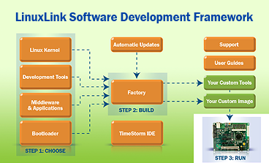
Figure 1.4 Factory - Automated Embedded Linux Build System

Overall LinuxLink provides an excellent facility of reliable code base which is highly customized for a given environment which provides this option a unique advantage over the rest of the distros. This, in addition to Timesys support service, makes the LinuxLink option a strong candidate for deployment.

System Specifications:

Memory Footprint | Depends on the configuration chosen
Peripheral Support | All devices supported.
Disk Space Required | Depends on the configuration chosen
Processor Specification | X86 architecture supported. Processor requirement depends on the configuration chosen.
Available Documentation | https://linuxlink.timesys.com/factory/factory_feature_benefits_summary  https://linuxlink.timesys.com/3/about_timesys

Software Specifications:

UDev Supports | Available
libusb Support | Available
i2c Tools Support | Available
Foxit Support | Available
Firefox Support | Available.
GNU Tools | Available
Curl Library Support | Available
Tech Support | Good commercial support available.
Type | Commercial.
Available Documentation | https://linuxlink.timesys.com/3/Docs/

