Patient Review Sentiment Analysis — Research Report
Generated: 2026-02-07 08:01:30Z (UTC)
Authors: Healthcare Analytics Team

Abstract
This report documents the design, preprocessing, sentiment-analysis method, and results for a patient review sentiment analysis system. The dataset contains 1512 reviews. Sentiment classification is rule-based using TextBlob polarity scores; descriptive statistics and visualizations are included. Mean polarity = 0.1507, median = 0.1036.

Introduction
Patient feedback is a critical input for measuring healthcare quality and patient satisfaction. This project implements an end-to-end pipeline: data ingestion, NLP preprocessing, polarity-based sentiment scoring (TextBlob), and visualization. The goal is to provide clear, reproducible analysis for clinical teams and researchers.

Data and Preprocessing
Input: CSV with a `review` column. Preprocessing steps implemented in the repository include: HTML stripping, contraction expansion, emoji demojization, tokenization, stopword removal, lemmatization/stemming, simple spell heuristics, and removal of empty/invalid rows (recorded in `patient_reviews_removed.csv`). The `patient_reviews_preprocessed.csv` contains cleaned text fields. The `patient_reviews_with_sentiment.csv` contains polarity scores and sentiment labels.

Methodology
Sentiment scoring uses TextBlob polarity in [-1.0, 1.0]. Thresholds used: polarity > 0.1 → Positive; polarity < -0.1 → Negative; otherwise Neutral. This is a lexicon-based, unsupervised approach. No supervised classifier was trained in this project. Because no labeled ground-truth dataset is available in the repository, evaluation is descriptive (distributions, central tendency).

Results
Total reviews analyzed: 1512

Sentiment Distribution
Sentiment | Count | Percentage | Avg Polarity
Positive | 818 | 54.10% | 0.5194
Negative | 396 | 26.19% | -0.4963
Neutral | 298 | 19.71% | -0.0016

Polarity Score Statistics
Measure | Value
Mean | 0.150689
Median | 0.103571
Std Dev | 0.500205
Min | -1.000000
Max | 1.000000

Top Tokens (no-stopwords)
Token | Count
experience | 314
staff | 261
nothing | 246
doctor | 202
care | 199
service | 175
average | 164
excellent | 164
healthcare | 156
rude | 150
highly | 146
poor | 144
terrible | 141
visit | 130
unhelpful | 124
special | 122
recommend | 120
adequate | 114
helpful | 111
wait | 109
times | 109
would | 103
facilities | 94
medical | 93
attention | 90
detail | 90
provided | 89
exceptional | 88
incredibly | 81
thorough | 81
doctors | 78
impressed | 73
empathy | 70
felt | 67
satisfied | 66
appointment | 65
team | 65
communication | 62
standard | 62
could | 62

Detailed Examples
Top 10 most positive reviews (by polarity):
patient_id | review | polarity
nan | Excellent care and attention to detail. | 1.000000
PATIENT_0005 | Best healthcare experience I've had. Very impressed! | 1.000000
nan | Excellent care and attention to detail. | 1.000000
nan | Excellent care and attention to detail. | 1.000000
PATIENT_0319 | Best healthcare experience I've had. Very impressed! | 1.000000
PATIENT_0313 | Best healthcare experience I've had. Very impressed! | 1.000000
nan | Excellent care and attention to detail. | 1.000000
nan | Excellent care and attention to detail. | 1.000000
nan | Excellent care and attention to detail. | 1.000000
nan | Excellent care and attention to detail. | 1.000000
Top 10 most negative reviews (by polarity):
patient_id | review | polarity
nan | Terrible wait times and no empathy. | -1.000000
nan | Terrible wait times and no empathy. | -1.000000
nan | Terrible wait times and no empathy. | -1.000000
nan | Terrible wait times and no empathy. | -1.000000
nan | Terrible wait times and no empathy. | -1.000000
nan | Terrible wait times and no empathy. | -1.000000
nan | Terrible wait times and no empathy. | -1.000000
nan | Terrible wait times and no empathy. | -1.000000
nan | Terrible wait times and no empathy. | -1.000000
nan | Terrible wait times and no empathy. | -1.000000
Ambiguous / borderline reviews (polarity near thresholds):
patient_id | review | polarity
PATIENT_0364 | Standard healthcare service. Met my basic needs. | 0.000000
PATIENT_0661 | Average service quality. Could be better or worse. | -0.016667
PATIENT_0490 | Dirty facilities and poor organization. Not impressed. | 0.000000
PATIENT_0264 | The experience was acceptable but unremarkable. | 0.000000
PATIENT_0820 | Top-notch medical services. Highly recommended! | 0.080000
nan | Average visit. Nothing special. | 0.103571
PATIENT_0859 | Average service quality. Could be better or worse. | -0.016667
PATIENT_0902 | It was just a regular doctor's visit. | 0.000000
PATIENT_0469 | Dirty facilities and poor organization. Not impressed. | 0.000000
PATIENT_0583 | Standard healthcare service. Met my basic needs. | 0.000000

Token-level Polarity Insights
Tokens appearing in at least 5 reviews were analyzed for average polarity. This helps identify words associated with positive or negative sentiment in this domain.
Token | Count | Avg Polarity | StdDev
best | 38 | 1.0000 | 0.0000
attention | 90 | 1.0000 | 0.0000
detail | 90 | 1.0000 | 0.0000
excellent | 164 | 0.9009 | 0.1328
welcome | 34 | 0.9000 | 0.0000
well | 34 | 0.9000 | 0.0000
taken | 34 | 0.9000 | 0.0000
knowledgeable | 31 | 0.8000 | 0.0000
support | 31 | 0.8000 | 0.0000
care | 199 | 0.7296 | 0.3186
felt | 67 | 0.7030 | 0.2000
clean | 39 | 0.6833 | 0.0000
everyone | 39 | 0.6833 | 0.0000
great | 60 | 0.6067 | 0.1999
recommend | 120 | 0.5798 | 0.0718
impressed | 73 | 0.5342 | 0.4919
incredibly | 81 | 0.5300 | 0.0000
thorough | 81 | 0.5300 | 0.0000
healthcare | 156 | 0.5256 | 0.3291
rushed | 33 | 0.5000 | 0.0000
provided | 89 | 0.5000 | 0.0000
exceptional | 88 | 0.5000 | 0.0000
adequate | 114 | 0.4620 | 0.0699
doctor | 202 | 0.4297 | 0.2376
okay | 30 | 0.4286 | 0.0000
fine | 36 | 0.4167 | 0.0000
complain | 36 | 0.4167 | 0.0000
treated | 29 | 0.4000 | 0.0000
respect | 29 | 0.4000 | 0.0000
compassion | 29 | 0.4000 | 0.0000

Visualizations
Figure 1: Sentiment distribution (pie chart)
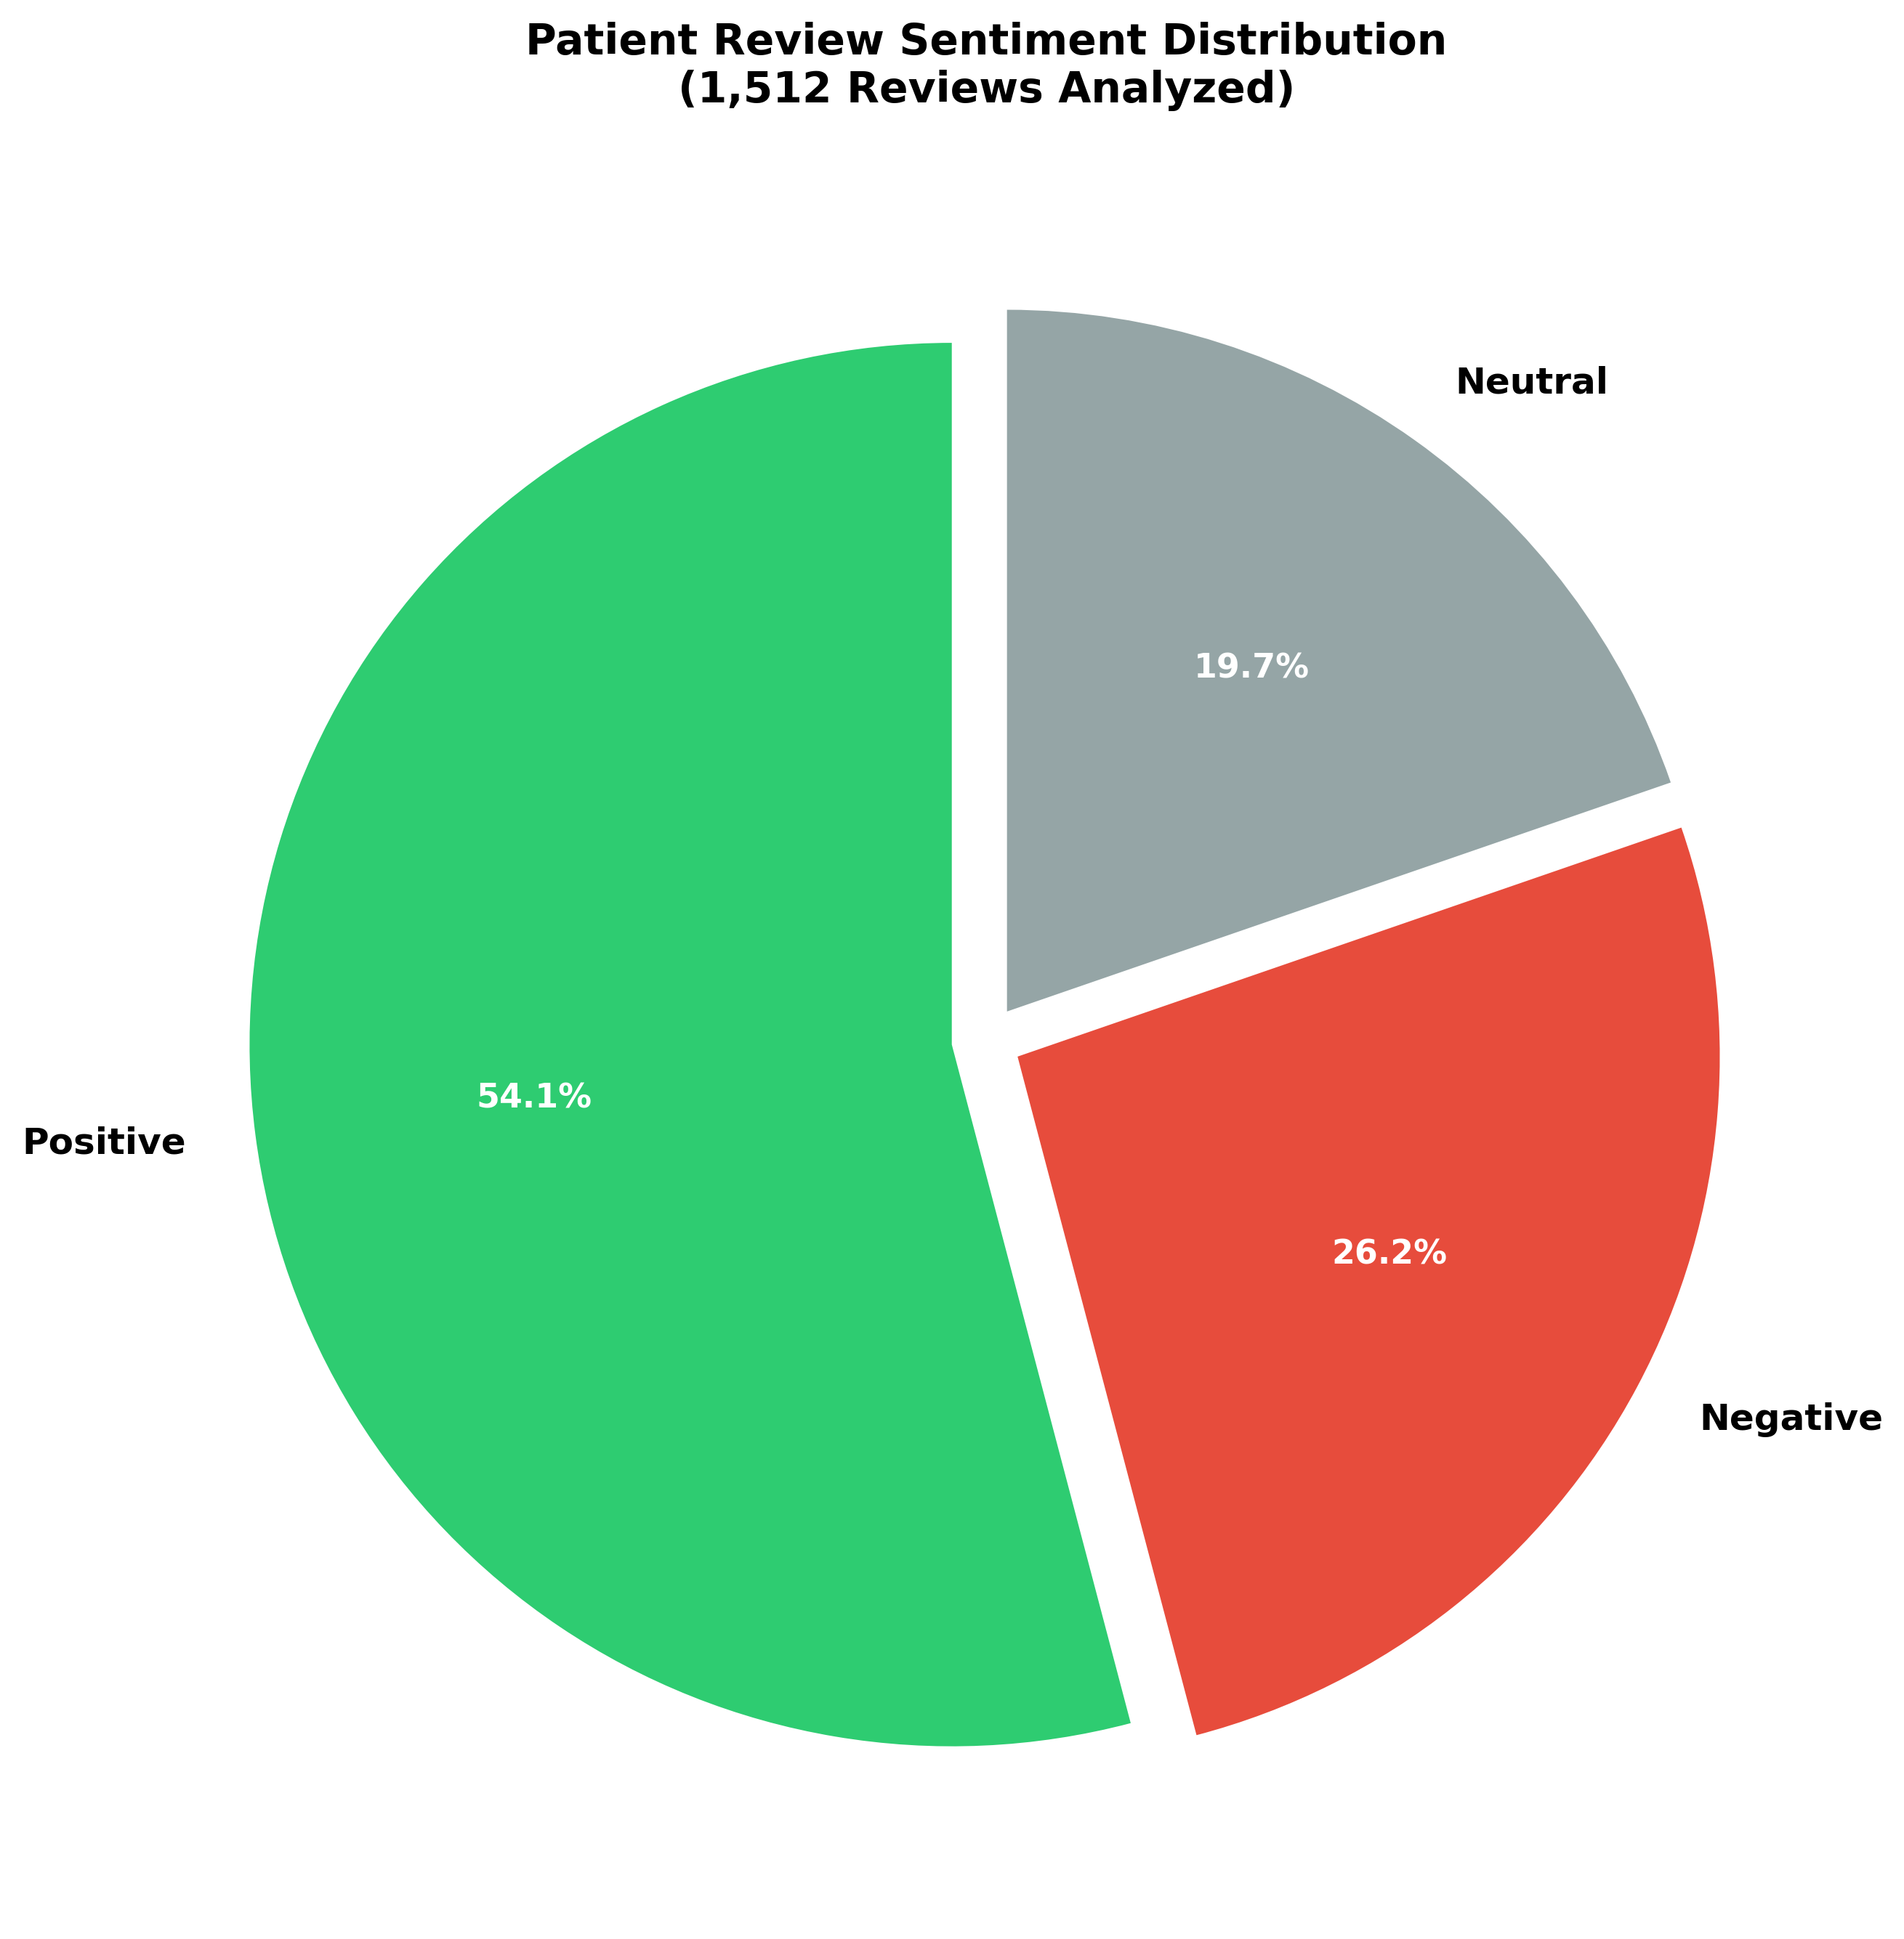
Figure 2: Sentiment counts (bar chart)
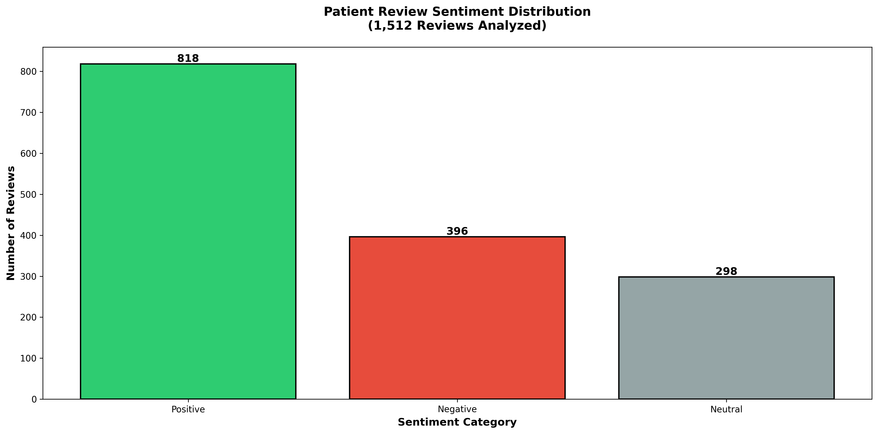
Figure 3: Polarity histogram
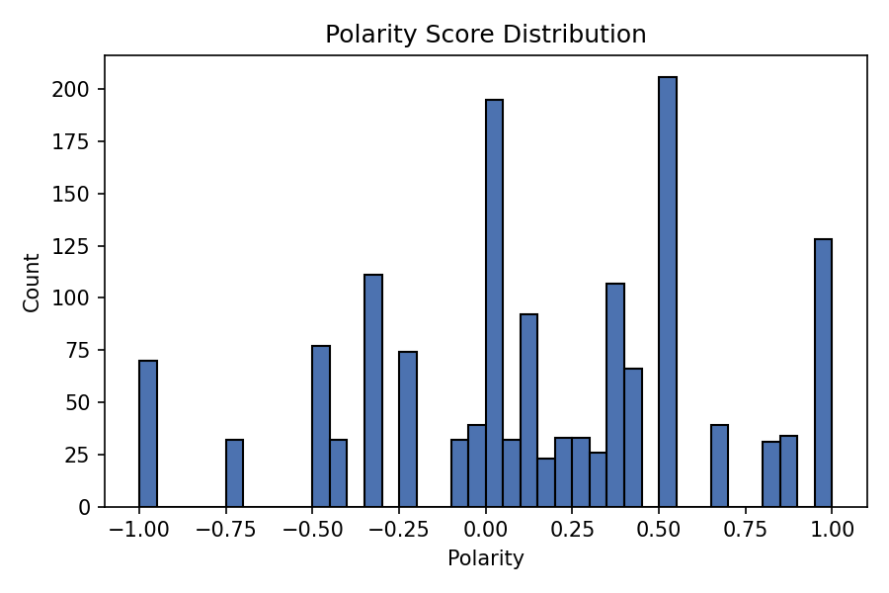
Figure 4: Polarity boxplot by sentiment
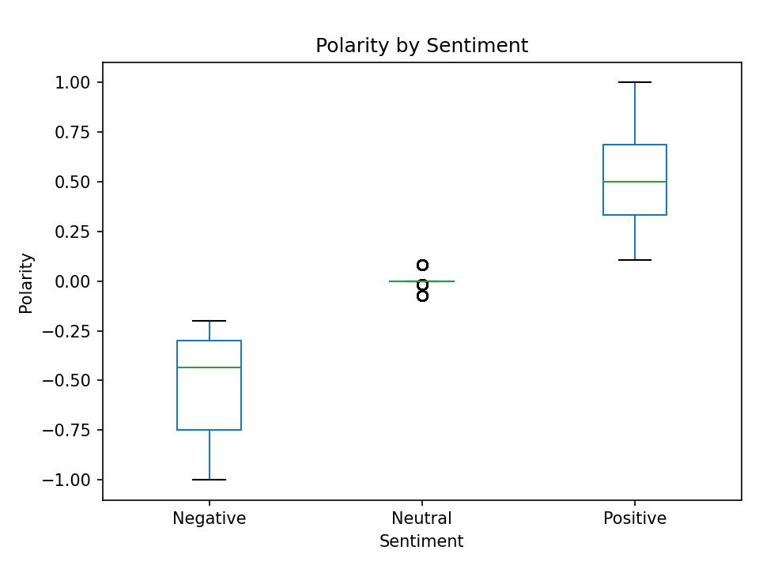

Discussion
The current approach is simple, interpretable, and fast because it uses TextBlob polarity. However, lexicon-based polarity has limitations: it can miss context, sarcasm, and domain-specific meanings. For more robust performance, we recommend: (1) collecting human-labeled ground truth to compute accuracy/precision/recall/F1; (2) training supervised classifiers (logistic regression, transformer-based models) and comparing performance; (3) performing error analysis to identify systematic failure modes (negation, multi-aspect reviews, etc.).

Conclusion and Future Work
This report presents a comprehensive summary of an end-to-end patient review sentiment analysis pipeline. The descriptive statistics show the distribution and central tendencies of polarity scores. Future work should focus on collecting labeled data, applying supervised models, and integrating aspect-based sentiment analysis for richer clinical insights.

Appendix: Sample Reviews (first 30 rows)
patient_id | review | polarity_score | sentiment
PATIENT_0001 | Very disappointed with the service. Would not return. | -0.750000 | Negative
PATIENT_0002 | It was an okay experience. Nothing special. | 0.428571 | Positive
PATIENT_0003 | Waste of time and money. Very unhelpful staff. | -0.200000 | Negative
PATIENT_0004 | Very disappointed with the service. Would not return. | -0.750000 | Negative
PATIENT_0005 | Best healthcare experience I've had. Very impressed! | 1.000000 | Positive
PATIENT_0006 | The treatment was ineffective and expensive. | -0.500000 | Negative
PATIENT_0007 | Terrible experience. Long wait times and rude staff. | -0.450000 | Negative
PATIENT_0008 | The doctor was very professional and caring. Highly satisfied! | 0.300000 | Positive
PATIENT_0009 | The doctor was dismissive and didn't listen to my concerns. | 0.000000 | Neutral
PATIENT_0010 | It was just a regular doctor's visit. | 0.000000 | Neutral
PATIENT_0011 | Terrible experience. Long wait times and rude staff. | -0.450000 | Negative
PATIENT_0012 | Amazing doctors and nurses. They really care about patients. | 0.400000 | Positive
PATIENT_0013 | The doctor was dismissive and didn't listen to my concerns. | 0.000000 | Neutral
PATIENT_0014 | Waste of time and money. Very unhelpful staff. | -0.200000 | Negative
PATIENT_0015 | Very knowledgeable doctor. Great communication and support. | 0.800000 | Positive
PATIENT_0016 | The clinic is well-organized and the staff is friendly. | 0.375000 | Positive
PATIENT_0017 | The appointment was standard. Service was average. | -0.075000 | Neutral
PATIENT_0018 | The clinic is well-organized and the staff is friendly. | 0.375000 | Positive
PATIENT_0019 | Felt very welcome and well taken care of. Excellent experience! | 0.900000 | Positive
PATIENT_0020 | The appointment was standard. Service was average. | -0.075000 | Neutral
PATIENT_0021 | Average service quality. Could be better or worse. | -0.016667 | Neutral
PATIENT_0022 | Would give negative stars if possible. Terrible experience. | -0.433333 | Negative
PATIENT_0023 | Average service quality. Could be better or worse. | -0.016667 | Neutral
PATIENT_0024 | The appointment was standard. Service was average. | -0.075000 | Neutral
PATIENT_0025 | Felt rushed during my appointment. Not satisfied. | 0.500000 | Positive
PATIENT_0026 | The clinic is well-organized and the staff is friendly. | 0.375000 | Positive
PATIENT_0027 | The appointment was standard. Service was average. | -0.075000 | Neutral
PATIENT_0028 | Amazing doctors and nurses. They really care about patients. | 0.400000 | Positive
PATIENT_0029 | Excellent service and clean facilities. Would recommend to everyone. | 0.683333 | Positive
PATIENT_0030 | Amazing doctors and nurses. They really care about patients. | 0.400000 | Positive

