Abdul Samad

abdul.samad@wakambi.net

Overview

The E-book Library project aims to streamline library operations by providing a digital platform for book cataloging, member management, and secure book issuing. It features advanced search capabilities, user-friendly interfaces, and secure authentication. Compatible with multiple devices and supporting local mobile payments, this project enhances the digital reading experience while reducing staff workload.

SRS Document

E-Book Library

Table of Contents

Abstract: 2

1. INTRODUCTION: 2

1.1 PROJECT AIMS AND OBJECTIVES 2

1.2 BACKGROUND OF PROJECT 2

1.3 OPERATION ENVIROMENT 3

1.4 MAJOR FEATURES 3

2. Elicitation: 3

2.1 INTERVIEW 4

2.2 Prototyping: 6

3. Functional and Non-Functional Requirements 9

3.1 Functional Requirements: 9

3.2 Non-functional requirements: 9

3.3 System requirements: 9

3.4 System Constraints: 10

3.5 Requirements Traceability Matrix (RTM): 10

3.6 Prioritization Technique 10

4. DIAGRAMS 12

4.1 Use Case Diagram 12

4.2 Use Case Scenarios 13

4.3 Class Diagram 16

4.4 Sequence Diagram 17

4.5 Activity Diagram 18

## Abstract:

E- book Library is a system which maintains the information about the books present in the

library, their authors, the members of library to whom books are issued, library staff and all. This is very difficult to organize manually. Maintenance of all this information manually is a very complex task. Owing to the advancement of technology, organization of an Online Library becomes much simple. The Online Book Library has been designed to computerize and automate the operations performed over the

information about the members, book issues and returns and all other operations. This computerization of library helps in many instances of its maintenances. It reduces the workload of management as most of the manual work done is reduced.

# 1. INTRODUCTION:

A book publication made available in electronic form, consisting of text, images, or both, readable on the flat-panel display of computers or other electronic devices.

## 1.1 PROJECT AIMS AND OBJECTIVES

* + - Online book reading.
    - A search column to search availability of books.
    - Services is to offer free book reading facilities to all.
    - An Admin login page where admin can add books, videos or page sources

## 1.2 BACKGROUND OF PROJECT

The E-book Library project aims to provide a comprehensive online platform for users to access a vast collection of digital books in various genres and subjects. As the name suggests, the platform primarily deals with electronic books, allowing users to read them conveniently in PDF format. The project is designed to cater to the growing demand for digital reading materials, offering a convenient and accessible alternative to traditional printed books.

## 1.3 OPERATION ENVIROMENT

|  |  |
| --- | --- |
| **Digital platform** | A digital platform where you can store, organize, and read e-books. You can access it through a website or apps on different devices. |
| **Internet connectivity** | Good internet connection is really important so you can read your e- books anytime, anywhere without any interruptions. It makes sure  everything runs smoothly when you're browsing, downloading, or reading. |
| **Device compatibility** | The platform works with lots of devices like phones, tablets  readers, and computers. That means you can read your e-books no  matter which device you like to use. |
| **User support** | Get help easily with online guides, FAQs, and customer service whenever you need assistance using the e-book library. |

## 1.4 MAJOR FEATURES

* + - User Authentication and Authorization
    - Reading Experience Enhancement
    - A Web Portal of E-books for all users.
    - A database to store all books data and receive updates for the new added books in the library.
    - Secure online book issuing system to issue books to all staff and students.
    - Web portal for librarian to manage Library data features.

# 2. Elicitation:

Requirement elicitation is the process of collecting the requirements of a system or requirement gathering from user, customers and stakeholders by conducting meetings, **interviews**, and **prototyping**.

## 2.1 INTERVIEW

Interview techniques are a valuable approach to gathering in-depth insights and specific requirements from stakeholders or client in an E-Book Library project. The major reason of doing interviews is that we have the live client and we only the solution to get requirement through interviews just because the customer/client from **Zimbabwe**.

Why we are using Interviews Technique?

User interviews have become a popular technique for getting user feedback, mainly because they are fast and easy. Use them to learn about users’ perceptions of your design, not about its usability.

**Questions**

**Q1. Do you want a login System?**

Yes, user’s and the other staff will use their ID’s to login.

**Q2. How many copies of a single book should be stored in the database?**

There will be three copies of every book, if possible, stored in the library.

**Q3. How long should the system be active?**

The system will work 24/7.

**Q4. What kind of security you want for your system?**

The system shall not allow access to any kind of book without the approval of the librarian.

**Q.5 How many people can edit and update the library system database?**

The Librarian, Deputy Librarian and the library assistant are the only one how can edit and update the system database.

**Q6. Who are the people having authority to edit and update user’s data?**

The librarian, Deputy Librarian are the only ones who can edit and update user’s data.

**Q7. What are the ways in which a person can search for books?**

The possibility of search for books is by title, author or subject by the member.

**Q8. What colors would you prefer for the system interference?**

The colors must have red color.

**Q9. What type of books do we need to add to our library?**

E BOOKS: PDF, E PUB, ...

**Q10. Is there any membership for reading books?**

Yes, I have already mentioned this...

**Q11. Is the person able to download the book in PDF format or not?**

Some books downloadable, some books read online. Members should be able to download always....

**Q12. Is there any physical location for our library?**

Yes, there will be, but the first step is virtual....

**Q13. How can a person search the book?**

Obviously on the library site...

## 2.2 Prototyping:

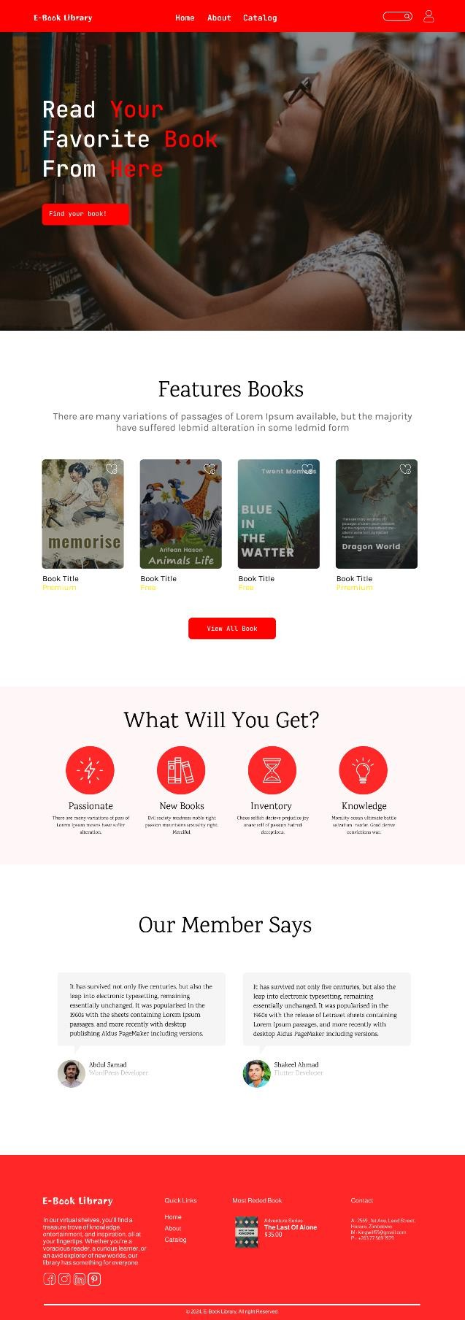 Home:

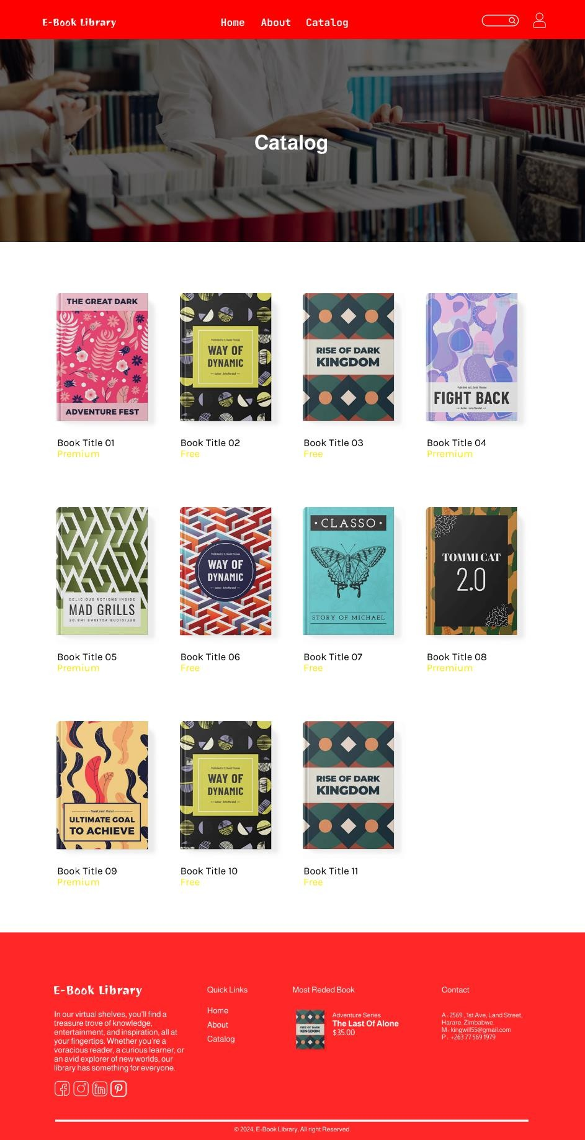Catalog:

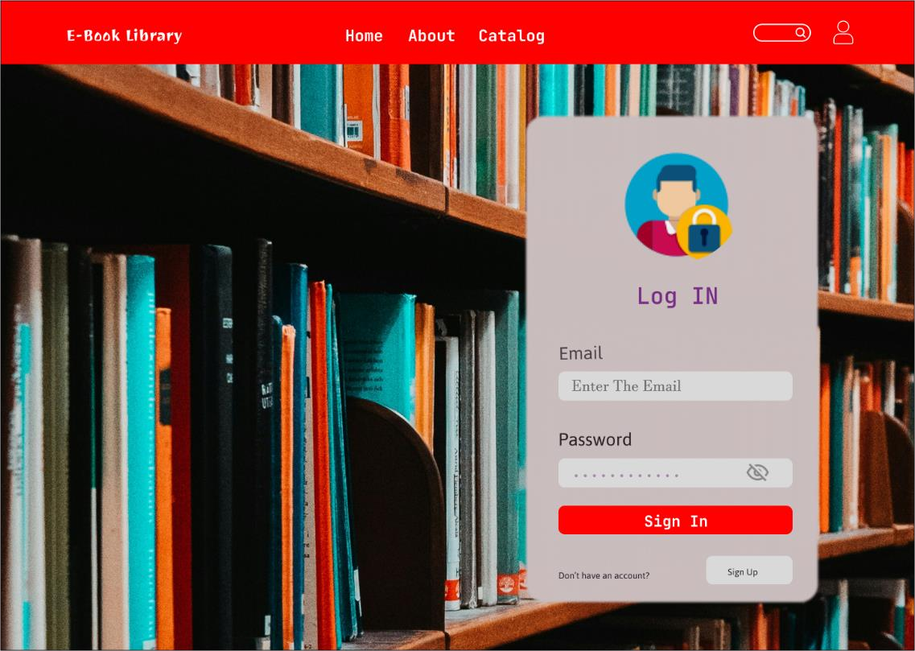Login:

Sign Up:

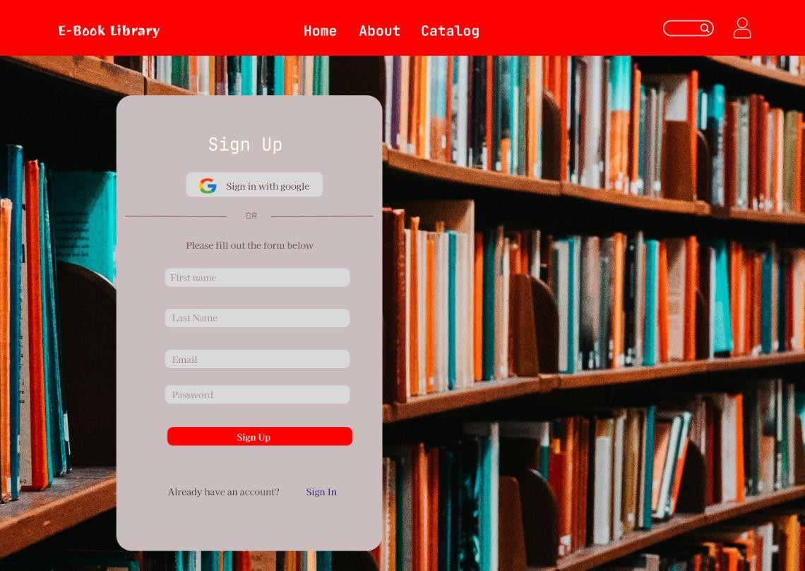

# 3. Functional and Non-Functional Requirements

## 3.1 Functional Requirements:

* It'll be a library with online purchasing/shopping cart. **FR1**
* Local (Zimbabwe) mobile money payment is to be included. **FR2**
* Allow the admin to add, remove, and manage members. **FR3**
* User registration and login functionality. **FR4**
* Role-based access control (admin, librarian, member, guest). **FR5**
* Allow users to search for books by title, publication date, author, genre, etc. **FR6**
* Display book details, including description, author, publication date, and availability status. **FR7**
* Allow admins/librarians to upload and manage eBooks in various formats (PDF). **FR8**
* Categorize books into different categories. **FR9**
* The guest can able to view/read the online books. **FR10**
* Some books downloadable, some books read online. Premium members should be able to download books always. **FR11**
* There shall be an announcement panel for a member. **FR12**
* Allow users to leave feedback or report issues. **FR13**
* The system able to track visitor data. **FR14**
* Admin can set permission for users. **FR15**

## 3.2 Non-functional requirements:

* To have fast loading times and responsiveness design. **NF1**
* To have interested display and user friendly (easy to understand by user). **NF2**
* The system should support the HTML browser (Google, Opera, Firefox etc..). **NF3**
* The system should be compatibility with various devices (PCs, tablets, smartphones). **NF4**
* To have the secure payment processing. **NF5**
* To have secure login authentication system for different type of users (Admins, Librarians, Members, guests). **NF6**
* Clean and well-documented code. **NF7**

## 3.3 System requirements:

* We do not want plugins and software from third parties. We want our own code to make our own software and systems. **SR1**

## 3.4 System Constraints:

* To download or view e-books, users must have a dependable internet connection. **C1**
* Implementing local mobile money payment systems (such as Eco Cash in Zimbabwe). **C2**

## 3.5 Requirements Traceability Matrix (RTM):

|  |  |  |  |  |  |  |  |  |  |  |  |  |  |  |  |  |
| --- | --- | --- | --- | --- | --- | --- | --- | --- | --- | --- | --- | --- | --- | --- | --- | --- |
|  | **R1** | **R2** | **R3** | **R4** | **R5** | **R6** | **R7** | **R8** | **R9** | **R10** | **R11** | **R12** | **R13** | **R14** | **R15** |  |
| **R1** |  | **x** |  | **x** |  |  |  |  |  |  |  |  |  |  |  |  |
| **R2** | **x** |  |  |  |  |  |  |  |  |  |  | **x** |  |  |  | **NF5** |
| **R3** |  |  |  |  |  |  |  |  |  |  |  |  |  |  |  |  |
| **R4** | **x** |  |  |  | **x** |  |  |  |  |  |  |  |  |  |  | **NF6** |
| **R5** |  |  |  | **x** |  |  |  |  |  |  |  |  |  |  |  |  |
| **R6** |  |  |  |  |  |  | **x** |  |  |  |  |  |  |  |  |  |
| **R7** |  |  |  |  |  | **x** |  |  | **x** |  |  |  |  |  |  |  |
| **R8** |  |  |  |  |  |  |  |  |  | **x** |  |  |  |  |  |  |
| **R9** |  |  |  |  |  |  | **x** |  |  |  |  |  |  |  |  |  |
| **R10** |  |  |  |  |  |  |  | **x** |  |  |  |  |  |  |  |  |
| **R11** |  |  |  |  |  |  |  |  |  |  |  |  |  |  |  |  |
| **R12** |  |  |  |  | **x** |  |  |  |  |  |  |  |  |  |  |  |
| **R13** |  |  |  |  |  |  |  |  |  |  |  |  |  |  |  |  |
| **R14** |  |  |  |  |  |  |  |  |  |  |  |  |  |  |  |  |
| **R15** |  |  |  |  |  |  |  |  |  |  |  |  |  |  |  |  |

## 3.6 Prioritization Technique

* **Must have (M)**

1. User registration and login functionality **(FR4)**
2. Role-based access control (admin, librarian, member, guest) **(FR5)**
3. Allow users to search for books by title, publication date, author, genre, etc. **(FR6)**
4. Display book details, including description, author, publication date, and availability status **(FR7)**
5. Allow admins/librarians to upload and manage eBooks in various formats (PDF) **(FR8)**
6. Categorize books into different categories **(FR9)**
7. The guest can able to view/read the online books **(FR10)**
8. Some books downloadable, some books read online. Premium members should be able to download books always **(FR11)**
9. The system should support the HTML browser (Google, Opera, Firefox, etc.) **(NF3)**
10. The system should be compatibility with various devices (PCs, tablets, smartphones) **(NF4)**
11. To have a secure login authentication system for different types of users (Admins, Librarians, Members, guests) **(NF6)**

* **Should have (S)**

1. Online purchasing/shopping cart **(FR1)**
2. Local (Zimbabwe) mobile money payment **(FR2)**
3. Allow the admin to add, remove, and manage members **(FR3)**
4. Allow users to leave feedback or report issues **(FR13)**
5. The system should have fast loading times and responsiveness design **(NF1)**
6. To have an interesting display and user-friendly interface (easy to understand by user) **(NF2)**
7. To have secure payment processing **(NF5)**
8. Clean and well-documented code **(NF7)**

* **Could have (C)**

1. Announcement panel for members **(FR12)**
2. The system able to track visitor data **(FR14)**
3. Admin can set permission for users **(FR15)**

* **Won't have (W)**

1. Third-party plugins and software. We want our own code to make our own software and systems. **(SR1)**
2. To download or view e-books, users must have a dependable internet connection **(C2)**
3. Implementing local mobile money payment systems (such as Eco Cash in Zimbabwe) **(C3)**

# 4. DIAGRAMS

## 4.1 Use Case Diagram

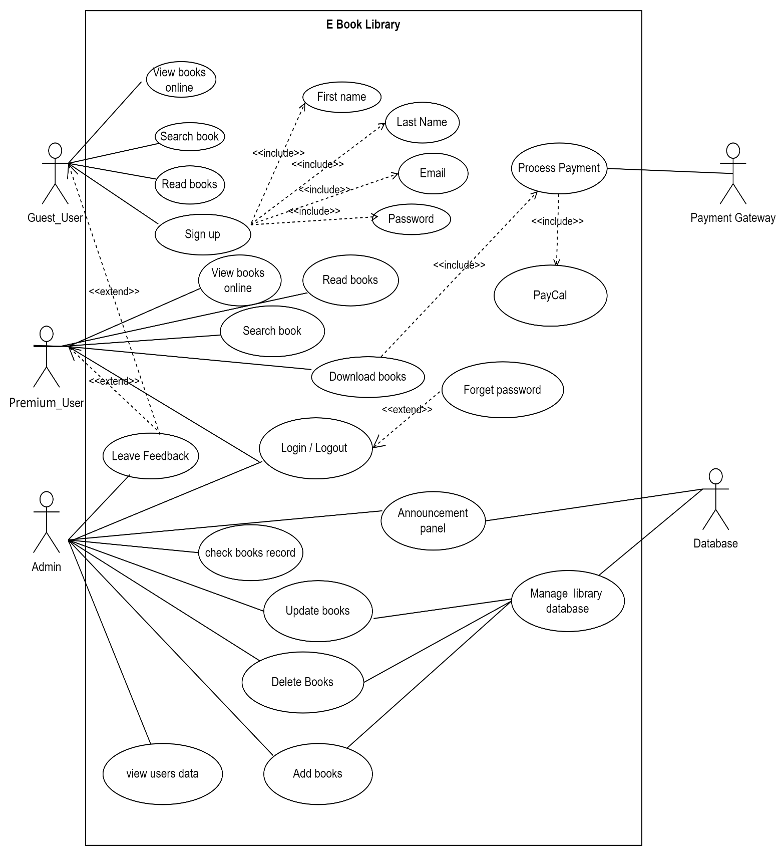

## 4.2 Use Case Scenarios

* **Guest User**

|  |  |
| --- | --- |
| **Use Case Name:** | View Books Online, Search books, Read books |
| **Actors:** | Guest User |
| **Pre-Condition** | Guest User access E book. |
| **Post Condition** | Guest User can view read and search the provided books. |
| **Trigger:** | * View Books Button * Search books Button * Read books Button |
| **Normal Flow:** | * User views Books catalogue. * Read Books from catalogue. |
| **Alternative Flow** | * If he Download Books, then first sign up. * Leave Feedback |
| **Description:** | A guest user can only view books from the catalog and read them, but cannot download them. If they want to download a book, they must first sign up. |

* **Premium User**

|  |  |  |
| --- | --- | --- |
| **Use Case Name:** | | View Books Online, Search books, Read books & Download Books . |
| **Actors:** | | Premium User |
| **Pre-Condition** | | User should be member |
| **Post Condition** | | Book has been downloaded. |
| **Trigger:** | | * View Books Button * Search books Button * Read books Button * Download Button. |
| **Normal Flow:** | | * User login to the system. * User browse through the catalogue * User request for a book to download. |
| **Alternative Flow** | | * Book is not available. * User cannot login. * Leave Feedback. |
| **Description:** | In this use case user must login to the system then browse through the books then request for a specific book to be download, which then will be approved by system. | |

* **Admin**

|  |  |  |
| --- | --- | --- |
| **Use Cases Name:** | Check book record, View User Data, Edit Books, Delete Books, | |
| **Actor:** | Admin | |
| **Pre-Conditions** | * Admin wants to check book records * Admin can view the book details * Admin login through system. | |
| **Post Conditions** | Admin access throughout the system. | |
| **Trigger:** | * Edit Books Details Button * View User Data Button * Edit Books Button * Delete Books Button. | |
| **Normal Flow:** | * Admin can View User Data * Admin check all the books in the database | |
| **Alternative Flow** | * Admin has checked the books records. * Book is not edited, fails and receive error. * Book data is corrupted | |
| **Description:** | | * Admin check all the books in the database to see if all the books are available for the users request to download. * In this use case admin must login to the system then browse through the books then edit the book details and update the data. * In this use case user must login to the system then browse through the books then request for a specific book to be issued, which then will be approved by system. |

## 4.3 Class Diagram

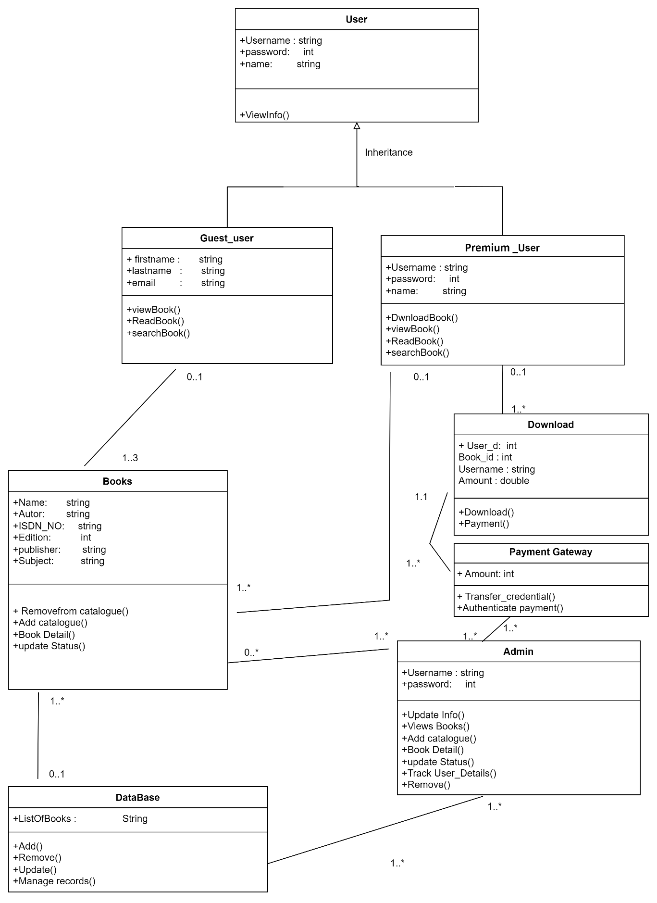

## 4.4 Sequence Diagram

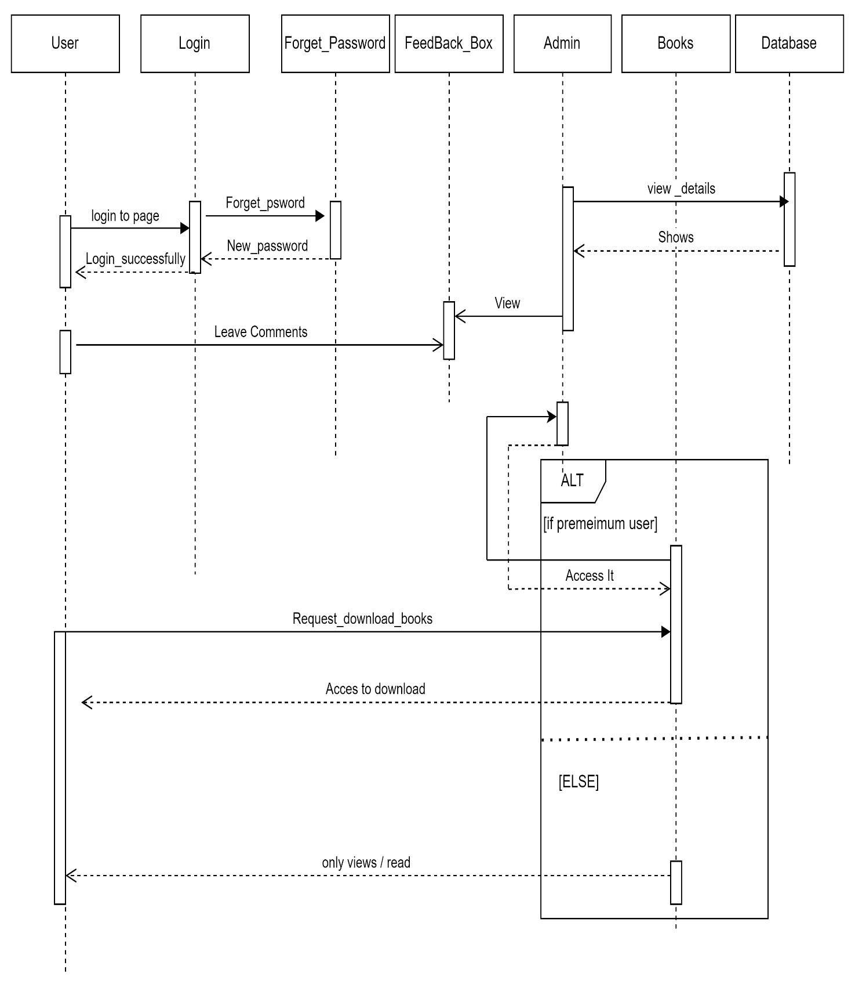

## 4.5 Activity Diagram

