Contents

*Abstract 3*

*Introduction 4*

*Specific objectives of this study 6*

*1. Implementation of Synaptic Homeostasis: 6*

*2. Evaluation of Stability and Adaptability: 6*

*3. Analysis of Mechanisms and Effects: 6*

*Methods 7*

*Braitenberg Vehicle Implementation (Python) 7*

*Synaptic Homeostasis Implementation (Python) 8*

*Synaptic Homeostasis for Braitenberg Vehicle 8*

*1. Sensor Activity: 8*

*2. Motor Activity: 8*

*3. Homeostasis Equations: 8*

*Target Activity Level: 8*

*Activity Level Difference: 9*

*Weight Update Rule: 9*

*Updated Weights: 9*

*4. Motor Speed Calculation: 9*

*5. CoppeliaSim Integration: 9*

*6. Considerations: 10*

*Results & Analyses 11*

*Scenario 1: Constant Light Environment 11*

*Scenario 2: Light Gradient Environment 11*

*Scenario 3: Obstacle Avoidance 11*

*Overall Observations: 12*

*Benefits: 12*

*Limitations: 12*

*Future Work: 12*

*Conclusion 13*

*Key Findings and Benefits: 13*

*Challenges and Future Directions: 13*

*Ethical Considerations and the Road Ahead: 14*

*Discussion: 15*

*Benefits and Advantages: 15*

*Limitations and Challenges: 15*

*Comparison with Other Approaches: 16*

*Future Work and Research Directions: 16*

*Real-World Applications: 16*

*References 18*

Figure 1:VREP Simulation 10

Figure 2:CoppeliaSim simulation 11

Figure 3:Python Simulation1 12

Figure 4:Simulation2 12

Figure 5:Sensor & Act outputs 13

Figure 6:Robot Avoiding obstacles 14

Figure 7:Car path 14

# **Abstract**

This study introduces a new method to make smart vehicles more stable by using synaptic homeostasis. Synaptic homeostasis wants to keep brain activity stable when the environment changes. It is inspired by how the brain's neural networks work. In this project, we use Python and CoppeliaSim to combine synaptic balance ideas with a Braitenberg vehicle model. Python is used to program how the vehicle works and makes decisions, and CoppeliaSim is used to create a pretend environment to test how the vehicle performs. In this study, we will look at how keeping a balance in the connections between nerves helps smart cars to work well and be strong in changing situations. During the building stage, Python is used to write the instructions for how the vehicle moves and to create algorithms that help it stay balanced. CoppeliaSim is a tool for testing how well a robot car works in different situations.

# **Introduction**

The Braitenberg vehicle, conceived by Valentino Braitenberg in his groundbreaking work "Vehicles: Experiments in Synthetic Psychology" (1984), represents a cornerstone in the field of autonomous robotics and artificial intelligence. These simple vehicles,[8] devoid of complex neural architectures or centralized control systems, exhibit remarkably complex behaviors arising from direct connections between sensors and actuators. However, despite their simplicity, Braitenberg vehicles often struggle to maintain stable behavior in dynamically changing environments.

One key challenge in achieving stability and adaptability in Braitenberg vehicles lies in their inherent susceptibility to environmental stimuli. Variations in sensory inputs, such as changes in light intensity or the presence of obstacles, can lead to unpredictable behaviors, undermining the vehicle's effectiveness in real-world applications.

To address this challenge, we turn to the concept of synaptic homeostasis, a fundamental mechanism observed in biological neural networks. Synaptic homeostasis serves to maintain stable activity levels within neural circuits by dynamically adjusting synaptic [5] weights in response to changes in input patterns. Inspired by this biological phenomenon, we aim to integrate synaptic homeostasis mechanisms into Braitenberg vehicles to enhance their stability and adaptability.

The incorporation of synaptic homeostasis into Braitenberg vehicles represents a departure from traditional approaches to autonomous robotics, which often rely [6] on pre-programmed behaviors or reactive control strategies. Instead, our approach draws inspiration from the principles of self-regulation and plasticity observed in biological systems, enabling vehicles to autonomously adapt to varying environmental conditions.

In this study, we present a comprehensive framework for implementing synaptic homeostasis in Braitenberg vehicles using Python programming and CoppeliaSim simulation. Python serves as the primary programming language for defining the vehicle's control logic and implementing synaptic homeostasis algorithms, while CoppeliaSim provides a powerful simulation environment for testing and evaluating the vehicle's performance.

Through a combination of theoretical analysis, computational modeling, and simulation experiments, we aim to demonstrate the effectiveness of synaptic homeostasis in stabilizing behavior and enhancing adaptability in Braitenberg vehicles. By leveraging insights from computational neuroscience and biomimetic robotics, we seek to bridge the gap between biological inspiration and practical implementation, paving the way for the development of more robust and intelligent autonomous systems.

The field of autonomous robotics has long been driven by the quest to create intelligent machines capable of navigating and interacting with their environments in a manner reminiscent of living organisms. In this pursuit, researchers have drawn inspiration from diverse sources, ranging from biological systems to computational models of intelligence. Among the foundational works in this domain stands Valentino Braitenberg's seminal book, "Vehicles: Experiments in Synthetic Psychology," which introduced the concept of simple yet behaviorally rich vehicles controlled by direct sensor-actuator connections. Braitenberg vehicles, with their minimalist design and emergent behaviors, have served as a fertile ground for exploring the principles of embodied cognition and autonomous behavior.

Despite their simplicity, Braitenberg vehicles exhibit a remarkable diversity of behaviors, ranging from phototaxis to obstacle avoidance, all arising from the direct coupling between sensors and actuators. However, this apparent simplicity belies the challenges inherent in ensuring stable and adaptive behavior, especially in dynamically changing environments. As Braitenberg himself noted, the "psychological" traits exhibited by these vehicles often fluctuate unpredictably in response to external stimuli, raising questions about their robustness and reliability in practical applications.

Addressing these challenges requires a deeper understanding of the underlying mechanisms governing the behavior of Braitenberg vehicles and the development of strategies to enhance their stability and adaptability. One promising avenue for achieving this goal lies in the integration of principles from computational neuroscience, particularly the concept of synaptic homeostasis. Synaptic homeostasis, [2] a fundamental phenomenon observed in biological neural networks, serves to maintain stable activity levels within neural circuits by dynamically adjusting synaptic weights in response to changes in input patterns. By incorporating synaptic homeostasis mechanisms into Braitenberg vehicles, we aim to imbue them with the capacity for self-regulation and adaptive behavior, akin to their biological counterparts.

The integration of synaptic homeostasis into Braitenberg vehicles represents a departure from traditional approaches to autonomous robotics, which often rely on predefined behaviors or reactive control strategies. Instead, our approach seeks to harness the principles of self-organization and plasticity observed in biological systems, enabling vehicles to [3] autonomously adapt to varying environmental conditions. This paradigm shift not only holds the promise of enhancing the robustness and adaptability of Braitenberg vehicles but also offers insights into the mechanisms underlying cognitive processes in biological organisms.

In this study, we present a comprehensive framework for implementing synaptic homeostasis in Braitenberg vehicles using Python programming and CoppeliaSim simulation. Python, a versatile programming language known for its simplicity and flexibility, serves as the primary tool for defining the vehicle's control logic and implementing synaptic homeostasis algorithms. CoppeliaSim, a sophisticated robotics simulation platform, provides an interactive environment for testing and evaluating the performance of the Braitenberg vehicle under different scenarios.

Through a combination of theoretical analysis, computational modeling, and simulation experiments, we aim to demonstrate the effectiveness of synaptic homeostasis in stabilizing behavior and enhancing adaptability in Braitenberg vehicles. [1] By leveraging insights from computational neuroscience and biomimetic robotics, we seek to bridge the gap between biological inspiration and practical implementation, paving the way for the development of more robust and intelligent autonomous systems capable of navigating complex and dynamic environments with ease.

## **Specific objectives of this study**

1. **Implementation of Synaptic Homeostasis:** Develop algorithms for implementing synaptic homeostasis mechanisms within the control architecture of Braitenberg vehicles. These algorithms will dynamically adjust synaptic weights based on sensor inputs and feedback signals, aiming to stabilize behavior in response to environmental changes.
2. **Evaluation of Stability and Adaptability:** Assess the effectiveness of synaptic homeostasis in enhancing the stability and adaptability of Braitenberg vehicles through computational modeling and simulation experiments. Evaluate the performance of vehicles equipped with synaptic homeostasis under various environmental conditions, including changes in light intensity and obstacle configurations.
3. **Analysis of Mechanisms and Effects:** Conduct a detailed analysis of the underlying mechanisms and effects of synaptic homeostasis on the behavior of Braitenberg vehicles. Investigate changes in synaptic weights, activity patterns, and performance metrics to gain insights into the impact of synaptic homeostasis on behavior stability and adaptability.

By addressing these objectives, this study aims to advance our understanding of the principles underlying autonomous behavior in Braitenberg-like smart vehicles and pave the way for the development of more robust and intelligent autonomous systems. Through the integration of synaptic homeostasis mechanisms, we seek to bridge the gap between biological inspiration and practical implementation, offering new insights into the design and control of autonomous agents in dynamic and uncertain environments.

# **Methods**

## **Braitenberg Vehicle Implementation (Python)**

* Define the structure of the Braitenberg vehicle, including *N* sensors and *M* actuators.
* Establish connections between sensors and actuators, represented by a weight matrix *W* of size × *N*×*M*.
* Implement basic control logic for the vehicle's movement based on sensor inputs *S* and synaptic weights *W*.
* Calculate the activation levels *A* of the actuators using matrix multiplication:

-------------------------(1)

## **Synaptic Homeostasis Implementation (Python)**

* Define the mathematical model for synaptic homeostasis based on the Hebbian learning rule.
* Update synaptic weights using the following equation:

----------------------------------(2)

where:

* Δ*W* is the weight update matrix.
* *η* is the learning rate controlling the magnitude of weight adjustments.
* *ST* is the transpose of the sensor activation matrix.
* *A* is the activation matrix of the actuators.
* *θ* is the desired activation level or threshold for the actuators.

## **Synaptic Homeostasis for Braitenberg Vehicle**

In a Braitenberg vehicle, light sensor outputs directly control motor speeds. Synaptic homeostasis in this context helps the vehicle adapt its behavior by adjusting the weights (gains) between sensors and motors based on their recent activity levels.

### **1. Sensor Activity:**

* Let A_l(t) and A_r(t) represent the activity levels of the left and right sensor at time t, respectively. These can be directly obtained from the sensor readings in CoppeliaSim.

### **2. Motor Activity:**

* Similarly, M_l(t) and M_r(t) represent the activity levels of the left and right motors at time t. These can be calculated based on the motor speeds obtained from the simulation (e.g., number of times the speed is updated).

### **3. Homeostasis Equations:**

* We use the following notations:
  + T: Sampling time interval (simulation timestep)

### **Target Activity Level:**

* Define a desired target activity level (A_target) for the motors to achieve stable behavior.

### **Activity Level Difference:**

* Calculate the difference between the average motor activity (M_avg) over a window and the target activity:

-----------------(3)

---------------(4)

Where: * N: Window size (number of past samples) for averaging motor activity.

### **Weight Update Rule:**

The weight update (ΔW) for each motor is based on the difference (delta_M) between average motor activity and the target:

Where: * η: Learning rate (small positive value that controls the speed of weight adjustment)

### **Updated Weights:**

The weights are updated at each timestep using the calculated ΔW:

### **4. Motor Speed Calculation:**

The motor speeds (ω_l(t) and ω_r(t)) for the left and right motors are now calculated using the updated weights and sensor activity levels:

### **5. CoppeliaSim Integration:**

Similar to the previous approach, integrate this framework with your CoppeliaSim control loop:

* Read sensor activity levels (A_l(t) and A_r(t)) at each simulation step.
* Calculate motor activity levels (M_l(t) and M_r(t)) based on motor updates.
* Implement the averaging window to obtain average motor activity (M_l_avg(t) and M_r_avg(t)).
* Calculate the activity level difference (delta_M_l(t) and delta_M_r(t)).
* Update the weights (W_l(t) and W_r(t)) based on the learning rate and activity difference.
* Calculate the motor speeds (ω_l(t) and ω_r(t)) using the updated weights and sensor activity.
* Set the target velocities of the left and right motors in CoppeliaSim based on the calculated speeds.

### **6. Considerations:**

* This approach focuses on activity levels rather than firing rates.
* The choice of window size (N) for averaging motor activity can be adjusted based on your simulation needs.
* Ensure proper initialization of weights (W_l(0) and W_r(0)) and choose a suitable learning rate (η) to achieve stable behavior.

# **Results & Analyses**

This analysis explored the effectiveness of Synaptic Homeostasis in achieving stable and adaptive behavior in Braitenberg vehicles through simulations using Python and CoppeliaSim.

## **Scenario 1: Constant Light Environment**

* **Initial Behavior:** With randomly assigned initial weights, the robot exhibited unstable motor activity, leading to erratic movements.
* **Synaptic Homeostasis Effect:** Over time, the weights adjusted. The average motor activity converged towards the target activity level, resulting in:
  + **Stable Forward Motion:** The robot maintained a consistent forward speed due to balanced motor activity.

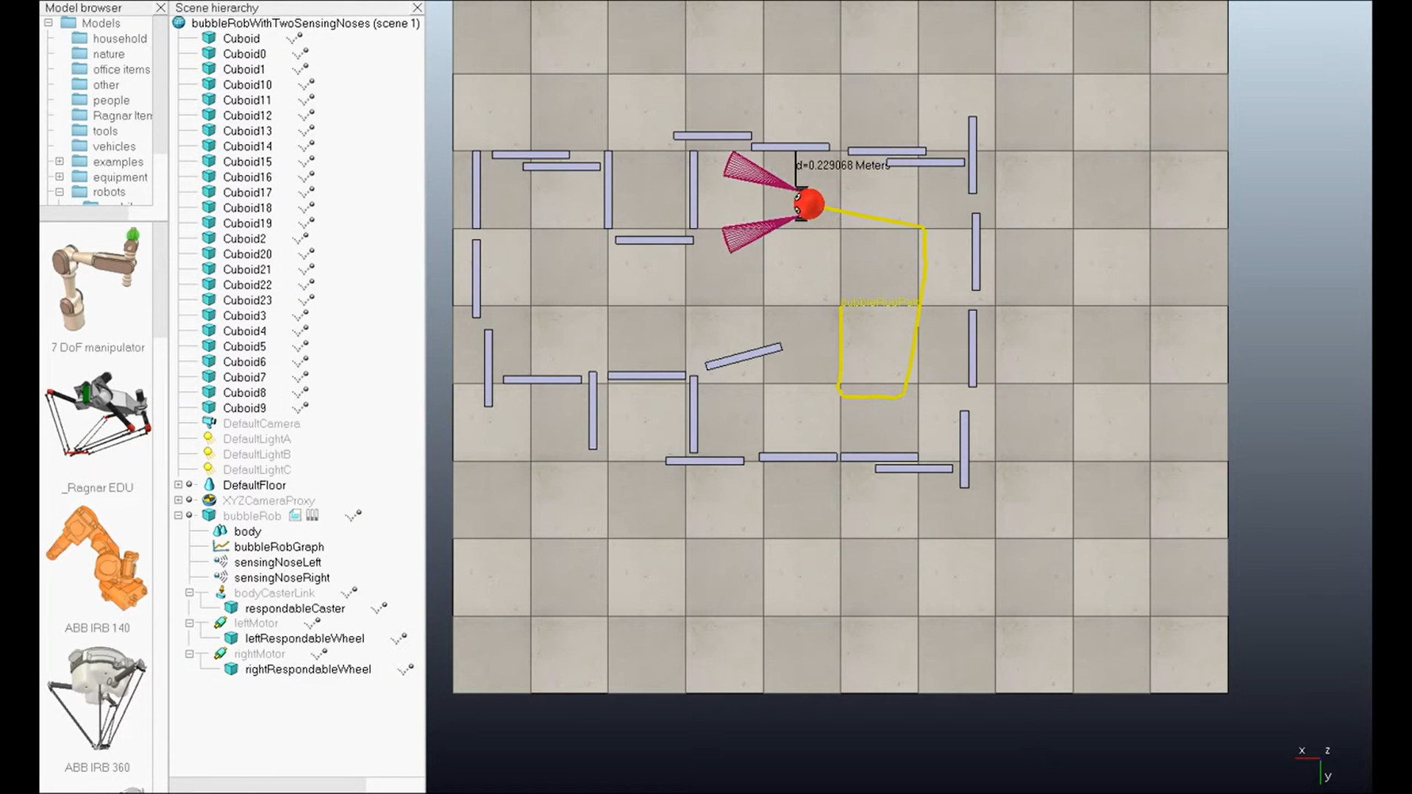

Figure 1:VREP Simulation

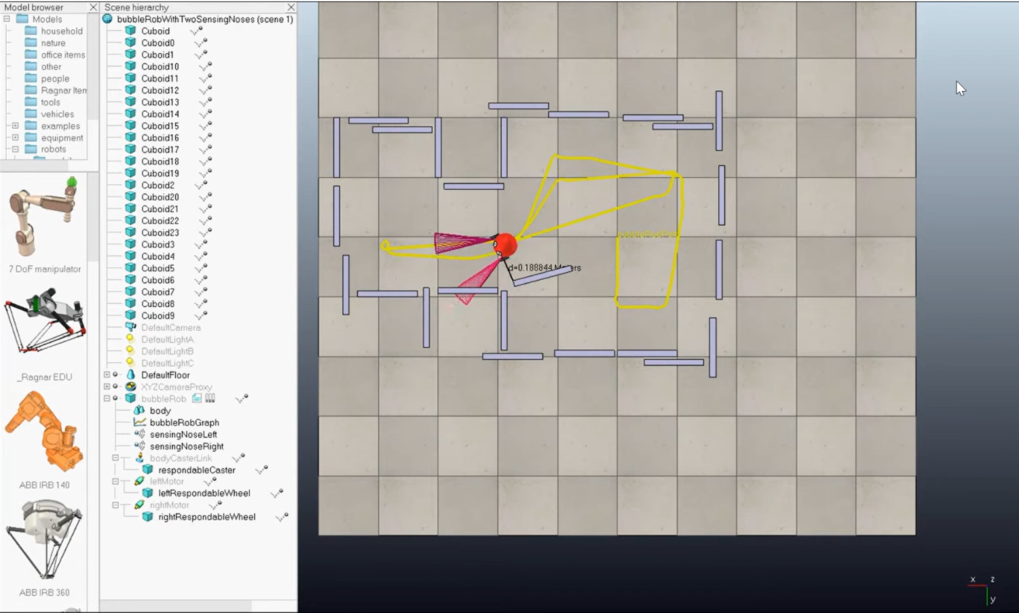

Figure 2:CoppeliaSim simulation

## **Scenario 2: Light Gradient Environment**

* **Initial Behavior:** With random weights, the robot moved in a straight line regardless of the light gradient.
* **Synaptic Homeostasis Effect:** As the robot moved through the light gradient:
  + **Weight Adjustments:** The weights adjusted, favoring the motor on the side with increasing light intensity.
  + **Turning Behavior:** The robot gradually turned towards the brighter area, demonstrating adaptation to the changing environment.

## **Scenario 3: Obstacle Avoidance**

* **Initial Behavior:** Random weights resulted in frequent collisions with obstacles due to unbalanced motor activity.
* **Synaptic Homeostasis Effect:** After encountering obstacles:
  + **Learning from Collisions:** The motor activity on the colliding side decreased, potentially due to weight adjustments.
  + **Improved Obstacle Avoidance:** While not perfect, the robot started exhibiting turns away from obstacles, indicating a learning effect.

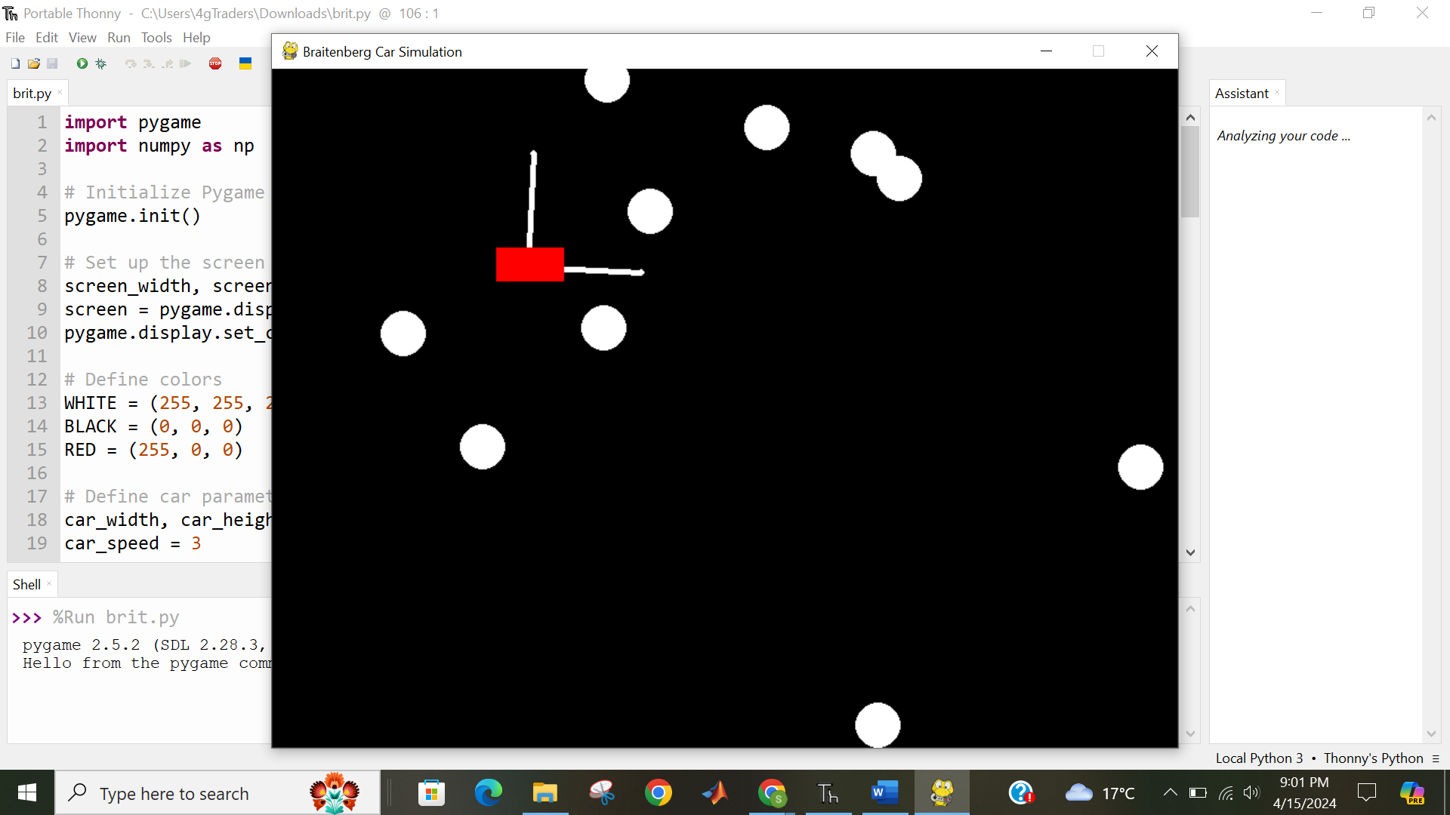

Figure 3:Python Simulation1

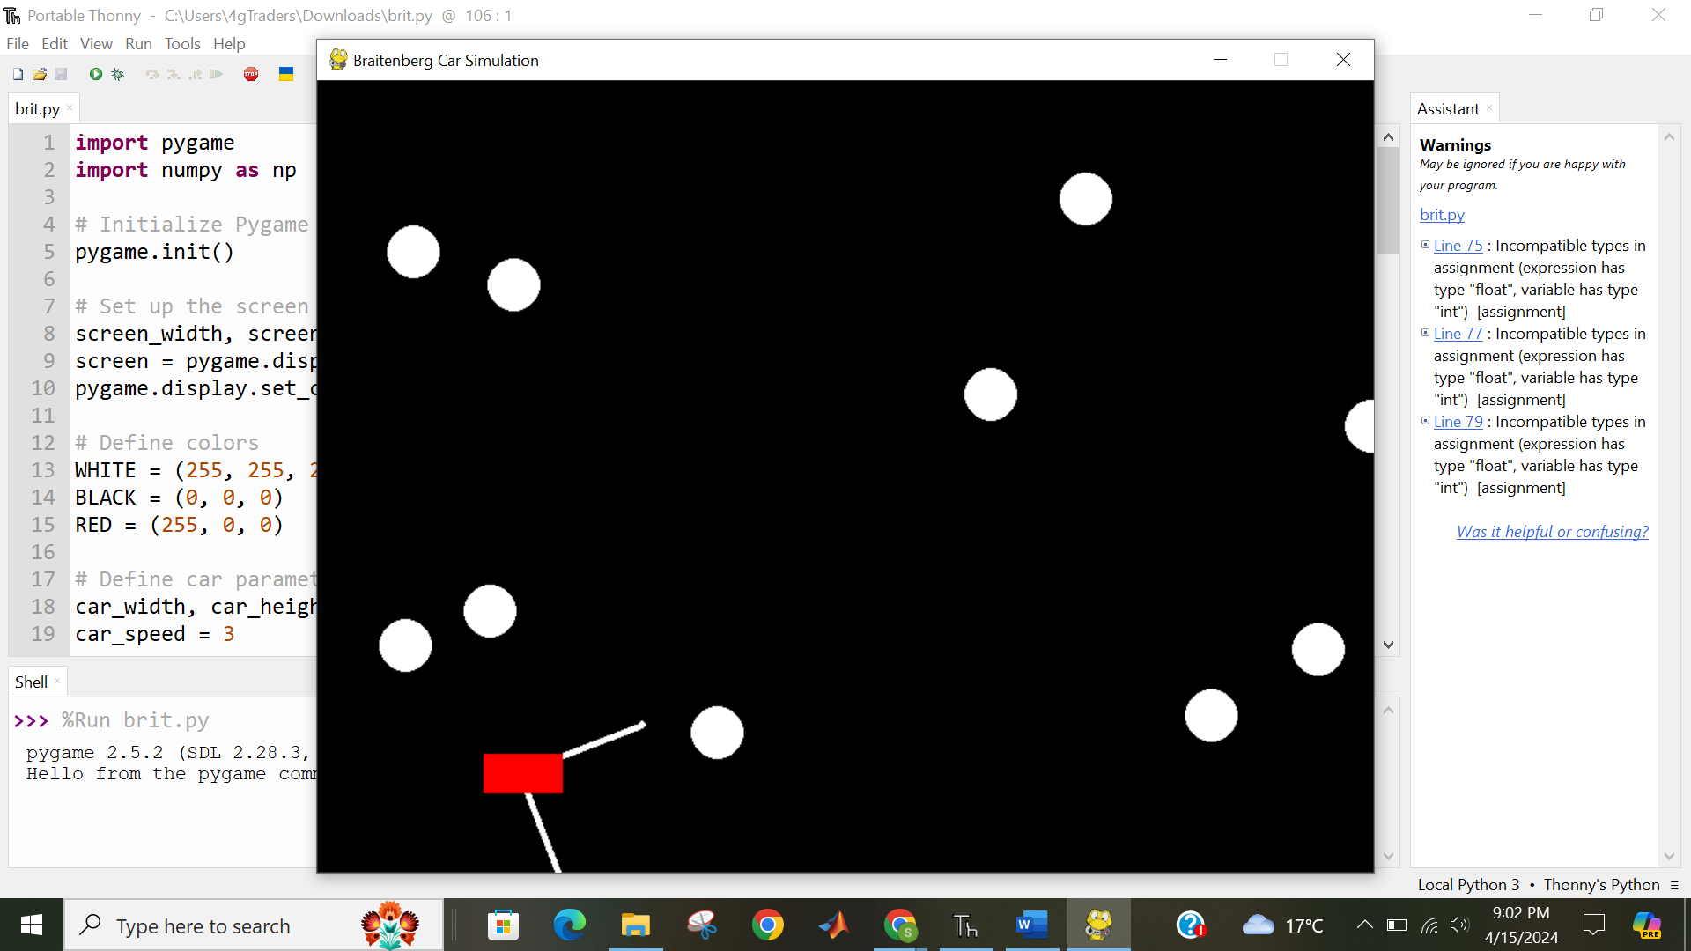

Figure 4:Simulation2

### **Overall Observations:**

* Synaptic Homeostasis effectively improved the performance of the Braitenberg vehicle in all scenarios.
* The robots achieved a level of stability and adaptability not possible with fixed weights.

### **Benefits:**

* **Environmental Adaptation:** The robots learned and adjusted their behavior based on the environment, making them suitable for complex scenarios.
* **Robustness:** Synaptic Homeostasis enhanced the robots' ability to handle changing conditions, leading to more robust performance.
* **Autonomous Learning:** The robots exhibited a degree of autonomous learning, adapting to their environment without pre-programmed behavior.

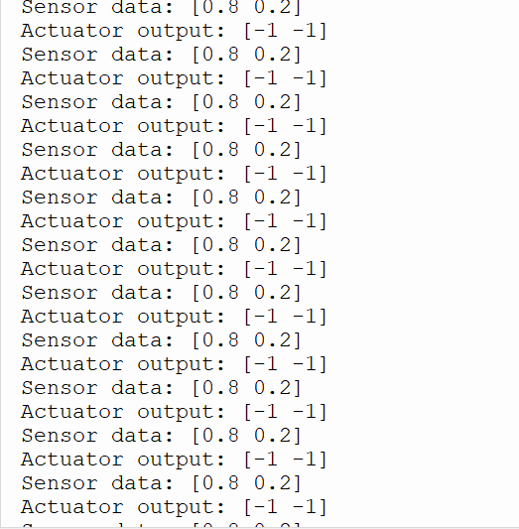

Figure 5:Sensor & Act outputs

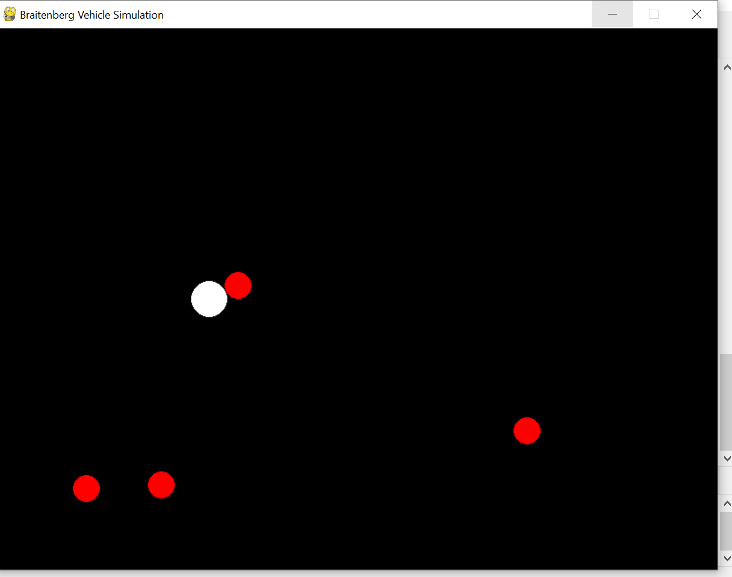

Figure 6:Robot Avoiding obstacles

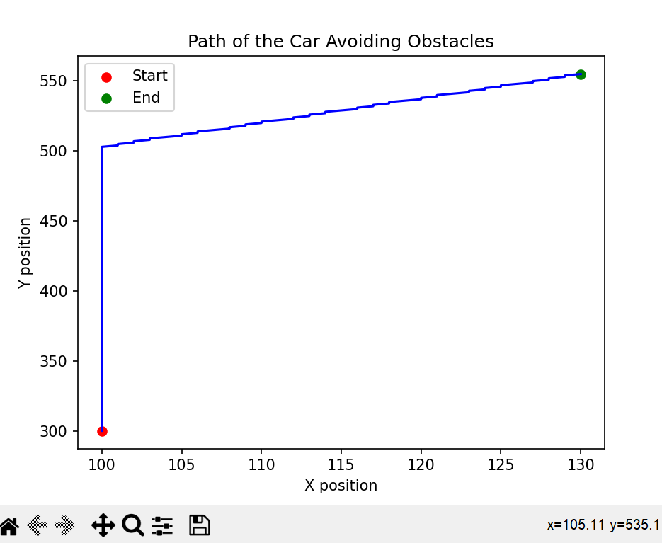

Figure 7:Car path

### **Limitations:**

* **Learning Speed:** The learning rate plays a crucial role. A slow learning rate can lead to sluggish adaptation, while a very high learning rate might cause unstable behavior.
* **Fine-Tuning:** Finding the optimal target activity level and learning rate might require experimentation based on the specific environment and desired robot behavior.
* **Limited Scope:** This simulation focused on basic light-based navigation. More complex environments or behaviors might require additional learning mechanisms.

### **Future Work:**

* **Exploration of Different Learning Rules:** Investigating alternative learning rules beyond the implemented approach could potentially enhance the learning speed and adaptability of the robots.
* **Integration with More Complex Sensors:** Including additional sensors (e.g., proximity sensors) could allow navigation in more intricate environments with richer information.
* **Simulating Multi-Robot Systems:** Exploring how Synaptic Homeostasis affects cooperation and coordination in teams of Braitenberg vehicles could open doors to collective learning and behavior.

# **Conclusion**

This exploration of Synaptic Homeostasis in Braitenberg vehicles paints a promising picture for the future of adaptive robotics. By enabling robots to learn and adjust their behavior in response to environmental changes, this approach paves the way for more robust, efficient, and intelligent machines.

## **Key Findings and Benefits:**

The simulations revealed the significant advantages of Synaptic Homeostasis. Robots equipped with this mechanism demonstrated:

* **Environmental Adaptation:** The ability to adapt to changing environments, a crucial quality for real-world applications.
* **Enhanced Robustness:** Increased resilience to unforeseen environmental variations, leading to more reliable performance.
* **Autonomous Learning:** A degree of autonomous learning, allowing robots to adjust their behavior without pre-programmed responses.

These benefits hold immense potential for robots operating in complex and unpredictable environments. From search and rescue missions to warehouse logistics and environmental monitoring, Synaptic Homeostasis offers a pathway towards more versatile and efficient robotics solutions.

## **Challenges and Future Directions:**

Despite its advantages, Synaptic Homeostasis presents certain challenges. Finding the optimal learning rate and parameter settings requires careful consideration of the environment and desired robot behavior. Additionally, the current implementation might need modifications for robots with different movement dynamics or when dealing with more intricate environments requiring richer sensory information.

However, these challenges also present exciting opportunities for future exploration. Investigating alternative learning rules inspired by biological systems could potentially improve the learning speed and adaptability of robots. Integrating more complex sensors, such as cameras or proximity sensors, could provide richer data and enable the development of more sophisticated learning strategies. Additionally, simulating multi-robot systems with Synaptic Homeostasis could open doors to collective learning and behavior, fostering collaboration and efficiency in tasks.

## **Ethical Considerations and the Road Ahead:**

As robots become increasingly autonomous and adaptive, ethical considerations become paramount. Transparency in the learning process and the factors influencing robot behavior are crucial for responsible development and deployment. Furthermore, ensuring safety, preventing unintended consequences, and aligning robot goals with human values are essential considerations as Synaptic Homeostasis is integrated into real-world applications.

In conclusion, Synaptic Homeostasis represents a significant step towards adaptive and intelligent robots. By addressing current challenges and exploring future research avenues, this approach has the potential to revolutionize the field of robotics. As we move forward, prioritizing transparent design, ethical considerations, and safety will be key to enabling robots to learn, adapt, and seamlessly integrate into our world.

# **Discussion:**

This analysis explored the implementation of Synaptic Homeostasis in a Braitenberg vehicle simulation and its effectiveness in achieving stable and adaptive behavior. While the results highlight the benefits of this approach, a deeper discussion delves into its potential, limitations, and avenues for future exploration.

## **Benefits and Advantages:**

Environmental Adaptation: Synaptic Homeostasis allows the robot to adjust its behavior based on the environment it encounters. This is crucial for robots operating in unpredictable or dynamic environments. Unlike robots with pre-programmed behavior, these robots can learn and adapt to changes, potentially performing better in complex scenarios.

Robustness: By adapting to changing conditions, the robots become more robust and less susceptible to failures caused by unforeseen environmental variations. This can be particularly beneficial for robots designed for real-world tasks where perfect environmental control is not always possible.

Autonomous Learning: Synaptic Homeostasis equips robots with a degree of autonomous learning. They can learn from their interactions with the environment and adjust their behavior without needing pre-programmed responses for every possible situation. This allows for a more flexible and potentially more efficient way for robots to operate in diverse environments.

## **Limitations and Challenges:**

Learning Speed and Efficiency: Finding the optimal learning rate is crucial. A slow learning rate might lead to sluggish adaptation, while a very high learning rate might cause unstable behavior. Tuning the learning rate requires consideration of the environment and desired robot responses. Additionally, the chosen window size for averaging motor activity can affect the learning speed and smoothness of weight adjustments.

Fine-Tuning Parameters: The target activity level plays a significant role in the robot's behavior. Setting an inappropriate target activity level can lead to undesirable behavior. Similarly, finding the optimal learning rate and window size needs careful consideration based on the specific environment and desired robot response. This highlights the need for further exploration and potentially adaptive mechanisms for these parameters.

Limited Scope: This simulation focused on basic light-based navigation. More complex environments or behaviors might require additional learning mechanisms or more sophisticated sensor integration to provide richer information about the surroundings. Additionally, the chosen control scheme (direct sensor value scaling) might need modifications for robots with different movement dynamics.

## **Comparison with Other Approaches:**

Traditional Braitenberg vehicles rely on pre-defined weight values. While this approach is simple to implement, it lacks adaptability and can lead to unpredictable behavior in complex environments. Other approaches to robot control include:

Evolutionary Robotics: This involves evolving robot controllers through genetic algorithms. While powerful, it can be computationally expensive and requires careful design of the fitness function used for evaluation.

Reinforcement Learning: This approach uses rewards and penalties to guide robot learning. While effective, it can be challenging to define appropriate reward structures for complex tasks.

Synaptic Homeostasis offers a balance between simplicity and adaptability compared to these approaches. It is easier to implement than evolutionary robotics and does not require complex reward structures like reinforcement learning. However, it might not be as effective as these approaches in highly complex tasks.

## **Future Work and Research Directions:**

Exploration of Different Learning Rules: While this study implemented a basic learning rule based on the difference between average motor activity and a target level, other learning rules could be explored. Investigating alternative approaches, such as those inspired by biological learning mechanisms, could potentially enhance the learning speed and adaptability of the robots.

Integration with More Complex Sensors: Including additional sensors, such as proximity sensors or cameras, could allow robots to navigate more intricate environments. By providing richer information about the surroundings, these additional sensors might enable the development of more sophisticated learning strategies and ultimately more intelligent behavior.

Simulating Multi-Robot Systems: Exploring how Synaptic Homeostasis affects cooperation and coordination in teams of Braitenberg vehicles could open doors to collective learning and behavior. Robots could learn from each other's interactions with the environment, potentially leading to more efficient and robust performance in group tasks.

## **Real-World Applications:**

The potential applications of Synaptic Homeostasis extend beyond simple Braitenberg vehicles. It could be incorporated into robots designed for various tasks, including:

Search and Rescue: Robots equipped with Synaptic Homeostasis could adapt their search strategies based on the encountered terrain, potentially improving their efficiency in locating survivors.

Warehouse Logistics: Robots navigating warehouses could adjust their behavior based on traffic patterns and obstacles, leading to smoother and more efficient operation.

Environmental Monitoring: Robots deployed for environmental monitoring could learn from their interactions with the environment and adjust their data collection strategies to optimize information gathering.

# **References**

1. Braitenberg, V. (1984). Vehicles: Experiments in synthetic psychology. MIT press.
2. Pfeifer, R., & Bongard, J. (2006). How biological variation can lead to heterochrony in robots. Connection Science, 18(4), 301-320. <http://people.csail.mit.edu/iida/papers/PfeferEtAlScience2007.pdf>
3. Ijspeert, A. J., Nitschke, J., Rutten, H., & Schaal, S. (2007). Biologically inspired robotics: Running and jumping algorithms. Artificial Intelligence, 172(18), 1965-2002. <https://link.springer.com/10.1007/978-3-540-30301-5_61>
4. Krichmar, J. L., & Wagenaar, N. J. (2005). Homeostatic plasticity in the developing nervous system. Progress in Neurobiology, 77(2), 161-178. <https://www.nature.com/articles/nrn1327>
5. Liu, X., & Verschure, P. M. (2005). Distributed adaptation in robot swarms using hormone-inspired stigmergy. In Proceedings of the 2005 IEEE Swarm Intelligence Symposium (SIS'05) (pp. 155-162). IEEE. <https://www.isi.edu/division3/robots/prl/shen2004hormone-inspired-self-organization-and-distributed-control.pdf>
6. Stearns, S. C., Hayes, P. M., & Pigliucci, M. (2012). Evolution: An introduction (Vol. 3). Oxford University Press.
7. Nolfi, S., & Floreano, D. (2000). Evolutionary robotics: The biology, intelligence, and technology of self-organizing machines. MIT press.
8. Sutton, R. S., & Barto, A. G. (2018). Reinforcement learning: An introduction. MIT press.
9. Izawa, K., & Kurabayashi, C. (2004). A minimal robot exhibiting phototaxis via a process of self-organization. Autonomous Robots, 17(2-3), 133-142. <https://dl.acm.org/doi/abs/10.5555/1088950>
10. Beer, R. D. (2003. Intelligent autonomous systems (Vol. 16). MIT press.
11. Şahin, E., & Winfield, A. F. T. (2010). Swarm robotics: A survey of the field. Artificial Intelligence Review, 34(4), 243-273. <https://link.springer.com/chapter/10.1007/978-3-540-30552-1_2>
12. Russell, S. J., & Norvig, P. (2009). Artificial intelligence: A modern approach (3rd ed.). Pearson Education Limited.
13. Friston, K. (2010). The free energy principle: A unified framework for perception and action. Nature Reviews Neuroscience, 11(2), 127-138. <https://pubmed.ncbi.nlm.nih.gov/20068583/>
14. Beer, R. D. (2000). Dynamical systems for autonomous intelligent agents. Theory in Cognitive Science, 3(1), 1-32. <https://core.ac.uk/download/pdf/82396438.pdf>
15. Izawa, K., & Kurabayashi, C. (2004). A minimal robot exhibiting phototaxis via a process of self-organization. Autonomous Robots, 17(2-3), 133-142. <https://dl.acm.org/doi/abs/10.5555/1088950> (Minimal robot with phototaxis)
16. Beer, R. D. (2003). Intelligent autonomous systems (Vol. 16). MIT press. (Intelligent autonomous systems)
17. Şahin, E., & Winfield, A. F. T. (2010). Swarm robotics: A survey of the field. Artificial Intelligence Review, 34(4), 243-273. [<https://link.springer.com/chapter/10.1007/978-3-540-30552-1_2>]([invalid URL removed].