
COMSATS University Islamabad
Wifi File Transfer App
Project Screens Documentation
Course: Mobile Application Programming
Teacher: M. Jamshed Iqbal
Group Members
Name | Registration No.
Muneeb Farid | FA24-BCS-380
Tabia Nasir | SP24-BCS-024
Figure 1: Splash Screen
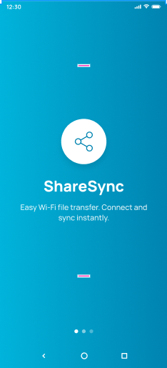
The splash screen introduces the ShareSync app with its logo and tagline. It sets the visual theme of the app with a blue gradient background and page indicators for the onboarding flow.
Figure 2: Onboarding Screen
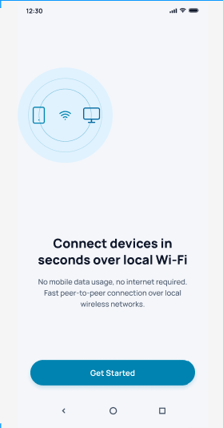
This screen explains that devices can connect in seconds over local Wi-Fi without mobile data or internet. The Get Started button takes the user into the main app.
Figure 3: Home Screen
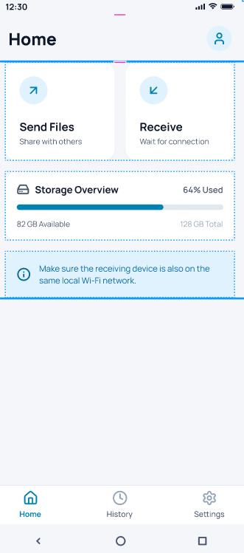
The home screen provides the Send Files and Receive options as the two main actions. It also shows a storage overview with used and available space and a reminder that both devices must be on the same Wi-Fi network.
Figure 4: Permissions Dialog
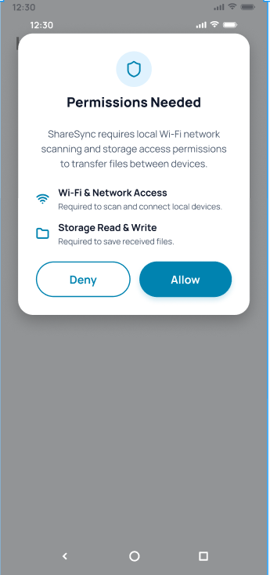
This dialog asks the user to allow Wi-Fi and network access and storage read/write access. These permissions are needed to discover nearby devices and to save received files.
Figure 5: Discovering Devices
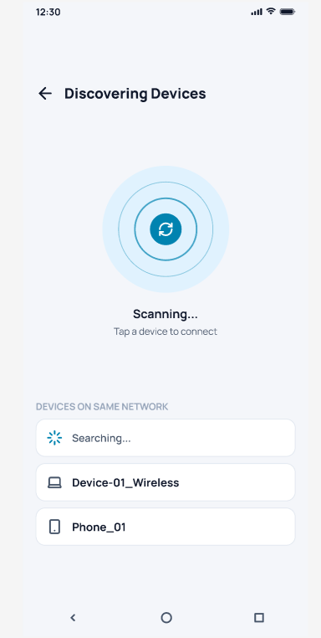
The app scans the local network and lists available devices such as computers and phones in real time. The user taps a device from the list to start connecting to it.
Figure 6: Confirm Connection
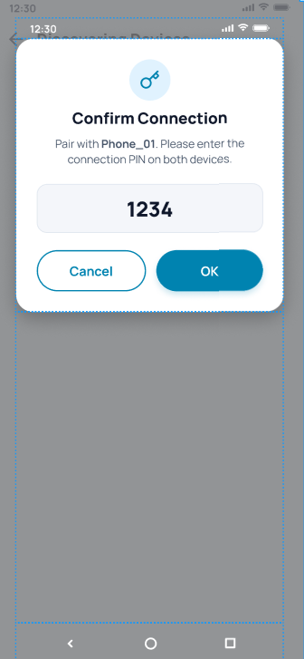
Before pairing, a dialog asks the user to confirm a PIN on both devices. This adds a simple security check so files are only shared with the intended device.
Figure 7: File Manager
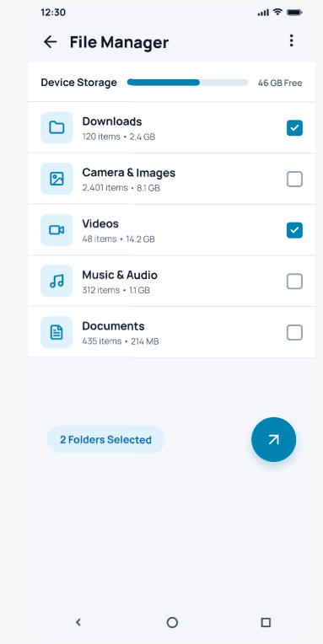
The file manager shows device storage and categorized folders such as Downloads, Images, Videos, Music and Documents. The user selects one or more folders using checkboxes and starts the transfer with the send button.
Figure 8: Sending Files
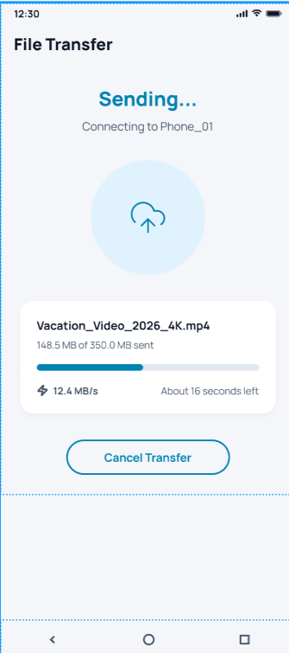
This screen shows live progress while a file is being sent, including file name, data sent, speed and estimated time left. The user can stop the process at any time with the Cancel Transfer button.
Figure 9: Receiving Files
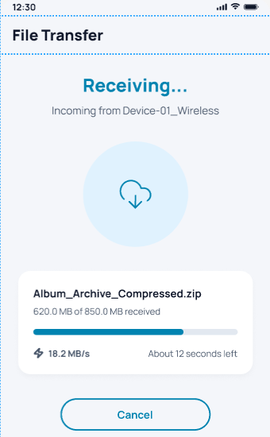
This screen displays the progress of an incoming file, showing the sender device name, amount received, transfer speed and remaining time. A Cancel button allows the user to stop the download.
Figure 10: Transfer History
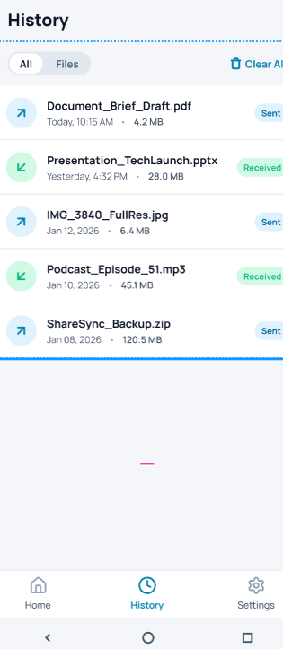
The history screen lists previously sent and received files with their date, time and size. Each item is labeled Sent or Received, and the user can filter the list or clear it.
Figure 11: Settings Screen
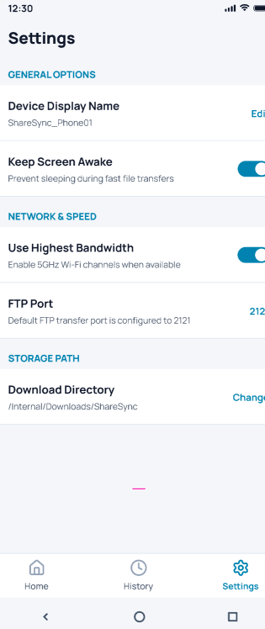
The settings screen lets the user edit the device display name, keep the screen awake during transfers and use the highest Wi-Fi bandwidth. It also shows the FTP port and the default download directory.
Figure 12: FTP Server Screen
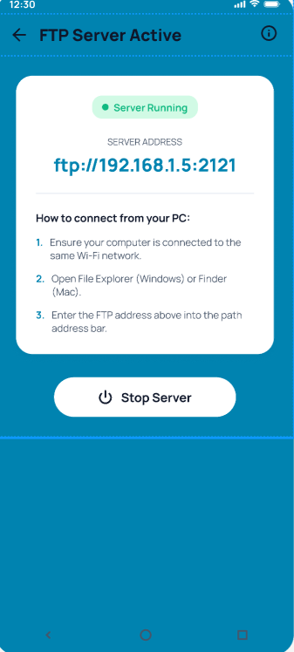
This screen shows that the FTP server is running along with its address. It gives step-by-step instructions to connect from a PC on the same Wi-Fi, and a Stop Server button to shut it down.

