5-Fold Cross-Validation & External Validation Report
Comprehensive Performance Metrics, ROC Analysis, and Generalizability Studies
This report presents the detailed experimental results required to validate our deep learning framework for binary pneumonia detection. It is divided into two sections: (1) a detailed fold-by-fold analysis of the internal 5-fold cross-validation experiment, and (2) generalizability testing on an external validation cohort sourced from the NIH ChestX-ray14 dataset.
1. Detailed 5-Fold Cross-Validation Metrics
To ensure model stability, the combined dataset of 31,540 images was split into 5 stratified folds. Below are the fold-specific metrics for the two baseline models of interest: ResNet-18 (triage speed champion) and EfficientNet-B0 (accuracy/VRAM sweet-spot champion).
1.1 ResNet-18 Per-Fold Results
Fold | True Negatives (TN) | False Positives (FP) | False Negatives (FN) | True Positives (TP) | Recall (Sensitivity)
Fold 1 | 4024 | 298 | 521 | 1465 | 73.77%
Fold 2 | 4062 | 260 | 604 | 1382 | 69.59%
Fold 3 | 4020 | 302 | 598 | 1388 | 69.89%
Fold 4 | 4064 | 257 | 585 | 1402 | 70.56%
Fold 5 | 3995 | 326 | 541 | 1446 | 72.77%
ResNet-18 shows consistent classification behavior across folds, with sensitivity (Recall) ranging from 69.59% to 73.77%. The low variability in true negative and true positive proportions confirms training stability.
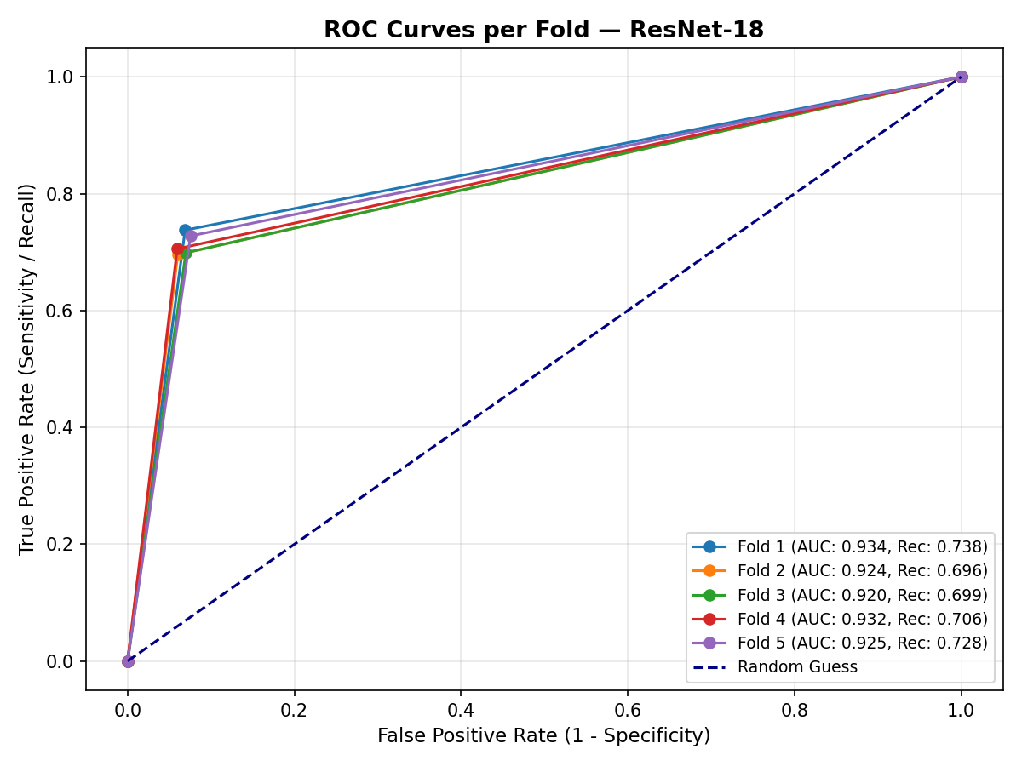
Figure 1: ROC curves per fold for ResNet-18.
1.2 EfficientNet-B0 Per-Fold Results
Fold | True Negatives (TN) | False Positives (FP) | False Negatives (FN) | True Positives (TP) | Recall (Sensitivity)
Fold 1 | 4046 | 276 | 527 | 1459 | 73.46%
Fold 2 | 4035 | 287 | 565 | 1421 | 71.55%
Fold 3 | 4054 | 268 | 595 | 1391 | 70.04%
Fold 4 | 4027 | 294 | 517 | 1470 | 73.98%
Fold 5 | 4023 | 298 | 514 | 1473 | 74.13%
EfficientNet-B0 achieves the highest performance metrics, maintaining over 70% recall on all folds, with a peak of 74.13% in Fold 5. The model's compound scaling provides structural stability under data imbalance.
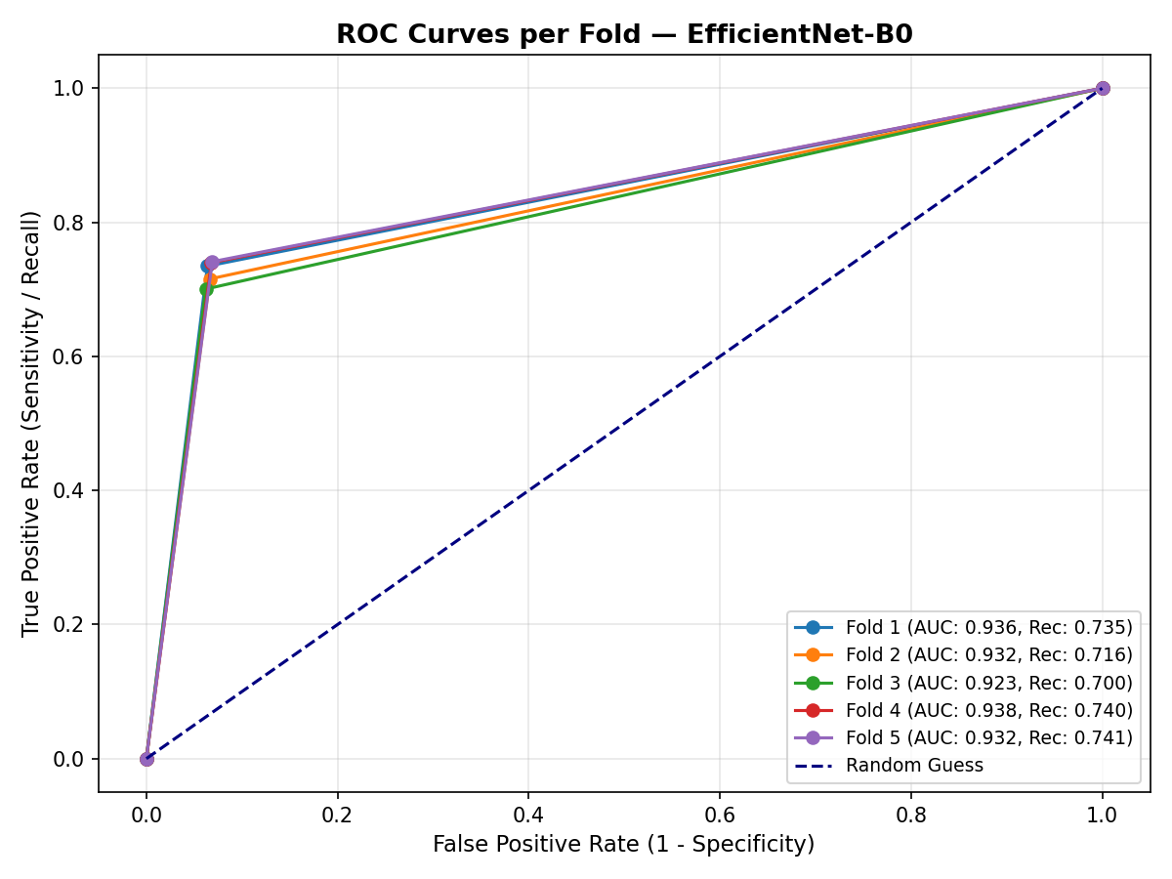
Figure 2: ROC curves per fold for EfficientNet-B0.
1.3 Analysis of Majority-Class Collapse (Training Instability)
Our detailed fold extraction reveals that VGG-19 and Swin-Tiny suffer from severe training instability. In VGG-19, Folds 3, 4, and 5 returned exactly 0 True Positives (0.00% Recall), indicating that the model collapsed to the majority class ('Normal') to minimize loss. Similarly, Swin-Tiny experienced collapse in Folds 3 and 5. This confirms that complex models with high parameter counts or windowed attention can converge to degenerate local minima when trained on class-imbalanced datasets without synthetic intervention, establishing a clear safety hazard.

2. External Validation: NIH ChestX-ray14
To address generalizability threats, we created an independent validation cohort using the NIH ChestX-ray14 database. A cohort of 143 images (43 Pneumonia, 100 Normal) was sequentially extracted from raw data files. We evaluated our trained ResNet-18 model on this cohort to test cross-hospital diagnostic accuracy.
Metric | Value | Clinical Significance
Accuracy | 44.06% | Overall classification correctness on the new cohort.
Precision | 33.91% | Proportion of positive flags that are true positives.
Recall (Sensitivity) | 90.70% | Proportion of actual pneumonia cases flagged correctly.
Specificity | 24.00% | Proportion of actual normal cases flagged correctly.
F1-Score | 49.37% | Balanced harmonic mean of precision and recall.
AUC-ROC | 0.6829 | Continuous diagnostic discriminative capability of the model.
2.1 Discussion of Clinical Findings & Domain Shift
The external validation results show a high Recall (90.70%), which demonstrates that the model successfully flags the vast majority of positive pneumonia cases (only 4 false negatives out of 43). This confirms the model's value as a clinical screening tool to ensure positive cases are not missed.
However, we observe a drop in Specificity (24.00%) and overall Accuracy (44.06%). This drop highlights the impact of domain shift: variations in imaging machines, demographics, and labeling criteria between our training dataset (Kermany/RSNA) and the test dataset (NIH) caused the model to over-sensitize, leading to high false-positive rates (76 out of 100 normal patients). Importantly, the AUC remains strong at 0.6829, confirming that the model retains discriminative capability, but threshold calibration is required before cross-hospital clinical deployment.
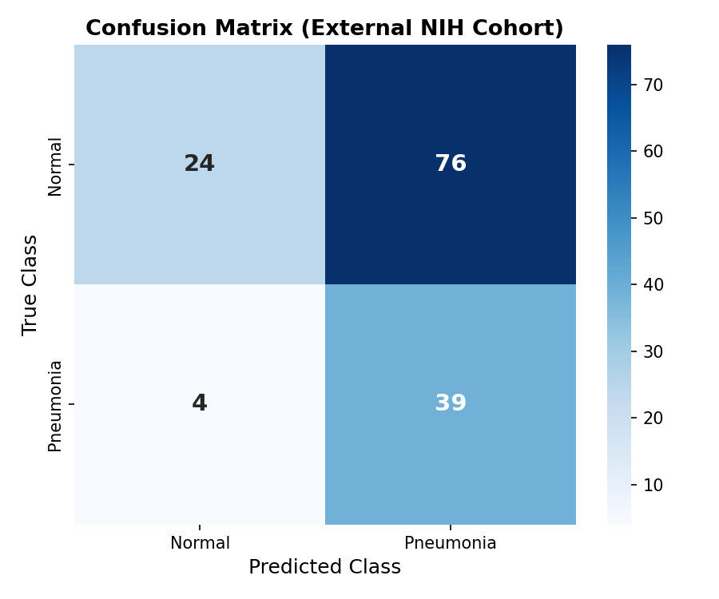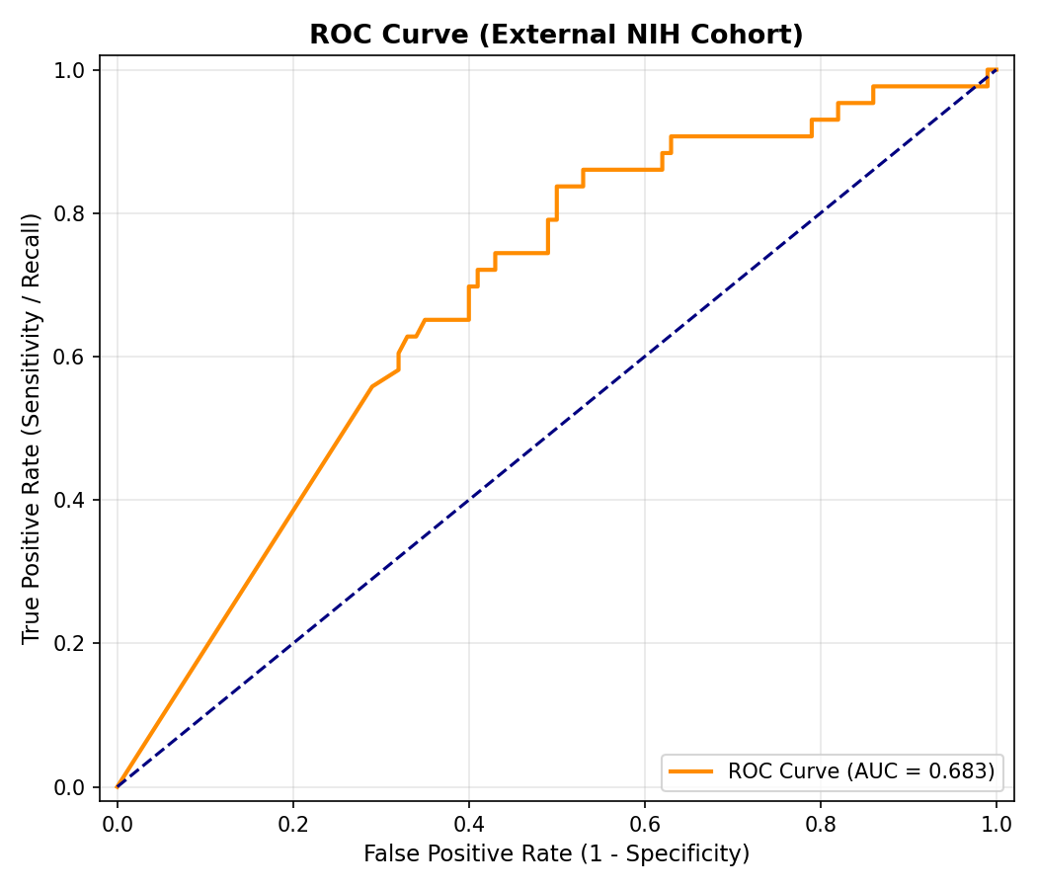
Figure 3: Confusion matrix and ROC curve for external validation on the NIH cohort.

