Image Preprocessing Pipeline Details
Methodology Details for Phase 2 Pneumonia Detection Research
To ensure robust fine-tuning of deep learning models originally pretrained on the ImageNet dataset, a standardized image preprocessing pipeline was implemented. This document defines the three key stages of this pipeline: RGB Conversion, Resizing and Cropping, and Image Normalization, along with their clinical rationales, PyTorch code implementations, and visual illustrations.
1. RGB Conversion
Standard deep learning architectures (e.g., ResNet, EfficientNet, Vision Transformers) are constructed to receive three-channel RGB inputs. However, clinical chest X-rays—specifically those sourced from the RSNA Pneumonia Detection Challenge—are typically stored as single-channel grayscale images. To bridge this architectural gap, single-channel inputs are converted to three-channel representations by replicating the grayscale intensity values across all three color channels (R = G = B).
Clinical & Technical Rationale: Replicating the single channel does not add new color information or alter the diagnostic content of the radiograph. However, it is mathematically required to utilize ImageNet-pretrained weights, allowing models to leverage general features (like edges, textures, and shapes) learned from natural image databases.
# Code implementation in ChestXrayDataset class (kfold_trainer.py):
from PIL import Image
def load_image(img_path):
# Opens image and explicitly converts grayscale/monochrome to 3-channel RGB
img = Image.open(img_path).convert("RGB")
return img
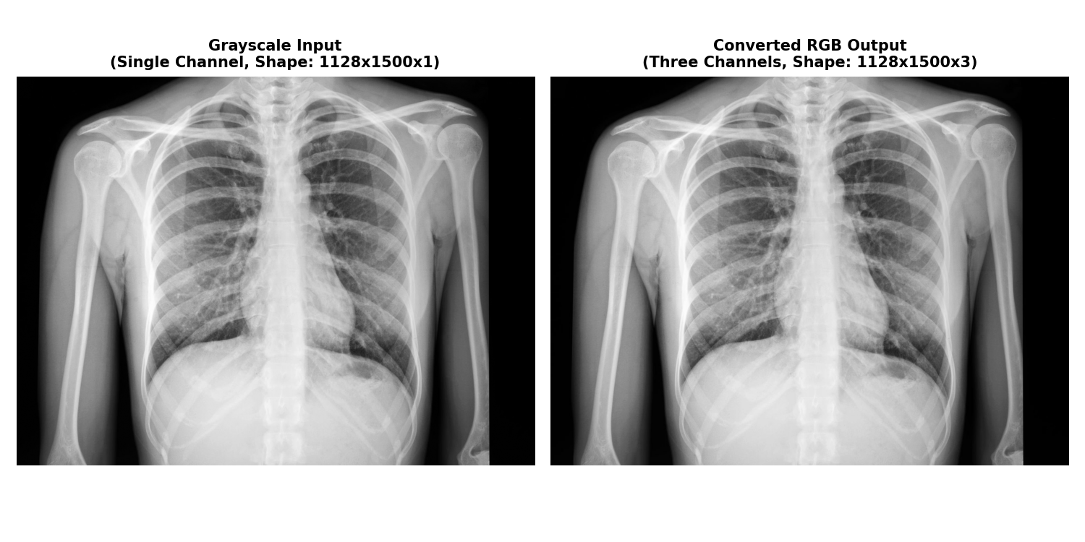
Figure 1: Grayscale input representation mapped to 3-channel RGB dimensions.
2. Resizing and Cropping
Chest X-rays in raw formats can have resolutions as high as 1024×1024 pixels. Direct training on these high resolutions imposes prohibitive computational costs and memory overhead. To mitigate this, images are resized to a standard bounding box. During training, a random resized crop is used for spatial data augmentation. During validation and testing, center cropping is used to obtain a clean, deterministic focal area containing the lung fields.
Clinical & Technical Rationale: Resizing to a uniform size ensures the model processes images with matching spatial hierarchies. Center cropping removes peripheral areas containing scan markers, labels, or scanner borders that could introduce bias, while keeping the clinical focus centered on the lung parenchyma.
# Transforms implementation (kfold_trainer.py):
import torchvision.transforms as transforms
# 1. Training Transforms (Includes Spatial Augmentation)
train_transform = transforms.Compose([
transforms.Resize(256), # Resize short side to 256
transforms.RandomResizedCrop(224, scale=(0.8, 1.0)), # Crop random 224x224 patch
transforms.RandomHorizontalFlip(p=0.5), # Data augmentation
transforms.RandomRotation(15) # Rotate by +/- 15 degrees
])
# 2. Validation & Inference Transforms (Deterministic)
val_transform = transforms.Compose([
transforms.Resize(256), # Resize short side to 256
transforms.CenterCrop(224) # Extract central 224x224 region
])
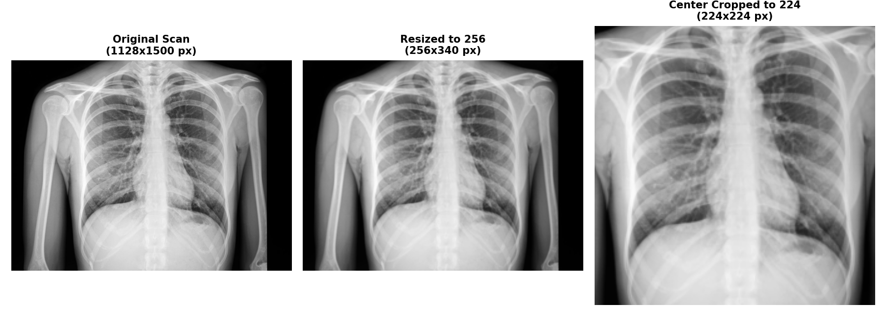
Figure 2: Resizing and cropping operations mapping input scans to standard 224x224 format.
3. Image Normalization
Pixel intensity values of raw radiographs typically range from 0 to 255. Normalization standardizes these intensities by subtracting the channel mean and dividing by the standard deviation. Specifically, the normalization is aligned with the ImageNet dataset distribution parameters to match the weights used during initialization.
Normalization Formula:
x_norm = (x - mean) / std
Where the parameters for the three color channels are defined as:
• Mean (μ): [0.485, 0.456, 0.406]
• Standard Deviation (σ): [0.229, 0.224, 0.225]
Clinical & Technical Rationale: Applying ImageNet-specific normalization shifts the radiograph's intensity distributions to match those the model expects. This prevents gradient explosion or vanishing, stabilizes the optimization process, and accelerates loss convergence during transfer learning.
# PyTorch Normalization implementation (kfold_trainer.py):
import torchvision.transforms as transforms
normalize_transform = transforms.Compose([
transforms.ToTensor(), # Converts PIL Image (0-255) to FloatTensor (0.0-1.0)
transforms.Normalize(
mean=[0.485, 0.456, 0.406], # ImageNet mean
std=[0.229, 0.224, 0.225] # ImageNet standard deviation
)
])
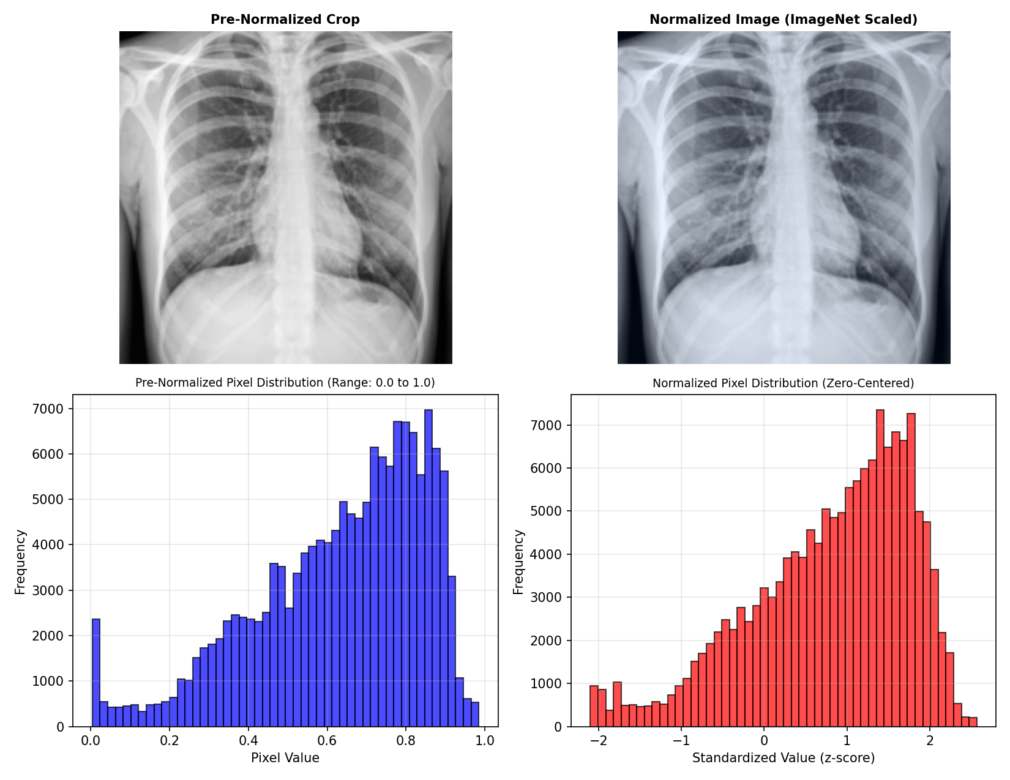
Figure 3: Pre-normalized vs. normalized image views and their corresponding pixel distribution shifts.

