Enhancing Pneumonia Detection from Chest X-ray Images:
A Multi-Architecture Comparative Study
Phase 2 Research Paper - Final Comprehensive Report
Authors: Abdul Samad et al. | Date: May 2026
Hardware: NVIDIA RTX 5060 Ti (16 GB), Python 3.12, PyTorch + CUDA 12.8

1. Abstract
This study presents a comprehensive benchmarking of 10 deep learning architectures for binary pneumonia detection from chest X-ray images. We evaluate 7 Convolutional Neural Networks (CNNs) and 3 Vision Transformers (ViTs) on a large-scale combined dataset of 31,540 images sourced from the Kaggle Chest X-Ray (Kermany et al.) and the RSNA Pneumonia Detection Challenge. All models are evaluated using stratified 5-fold cross-validation with McNemar's statistical significance testing. We further provide Grad-CAM++ explainability and computational efficiency profiling (FLOPs, latency, VRAM). Our results demonstrate that lightweight CNNs - particularly EfficientNet-B0 (86.9% accuracy, 0.932 AUC) - significantly outperform Vision Transformers on this medical imaging task, while legacy architectures like VGG-19 suffer from majority-class collapse. These findings have direct implications for clinical deployment of AI-assisted pneumonia screening systems.

2. Introduction

2.1 Background
Pneumonia remains a leading cause of mortality worldwide, particularly among children under 5 and the elderly. Chest X-ray (CXR) radiography is the primary diagnostic tool, but interpretation requires trained radiologists - a scarce resource in many regions. Deep learning-based Computer-Aided Diagnosis (CAD) systems have shown promise in automating this process.

2.2 Motivation
Our Phase 1 research demonstrated that a single ResNet-18 model trained on the small Kermany dataset (5,856 images) could achieve ~98% accuracy. However, this result has limited clinical generalizability because: (1) The Kermany dataset contains only curated pediatric X-rays from a single source; (2) A single architecture comparison provides no insight into which model family is best suited; (3) No statistical validation (cross-validation) was performed; (4) No explainability mechanism was provided for clinician trust. Phase 2 addresses all of these limitations.

2.3 Contributions
1. Dataset Expansion: Combined Kaggle Kermany (5,856) + RSNA Challenge (25,684) = 31,540 clinical X-ray images
2. 10-Architecture Benchmark: 7 CNNs + 3 Vision Transformers, the most comprehensive comparison in this domain
3. Statistical Rigor: Stratified 5-fold CV with McNemar's pairwise significance testing (45 model pairs)
4. Explainability: Grad-CAM++ integration for all 10 architectures (CNN + Transformer)
5. Efficiency Profiling: FLOPs, GPU latency, throughput, and VRAM measurements on consumer hardware

3. Dataset

3.1 Data Sources and Links
Dataset 1 - Kaggle Kermany Chest X-Ray:
URL: https://www.kaggle.com/datasets/paultimothymooney/chest-xray-pneumonia
Contains 5,856 curated pediatric anterior-posterior chest X-rays from Guangzhou Women and Children's Medical Center. Images are relatively homogeneous with clear pneumonia patterns.
Dataset 2 - RSNA Pneumonia Detection Challenge:
URL: https://www.kaggle.com/datasets/iamtapendu/rsna-pneumonia-processed-dataset
URL (Images): https://www.kaggle.com/datasets/vaillant/rsna-pneu-tr
Contains 25,684 adult chest X-rays from the NIH Clinical Center. Heterogeneous - sourced from multiple hospitals, machines, and patient demographics. Contains subtle opacities and borderline cases.
Source | Images | Normal | Pneumonia | Type
Kaggle Kermany | 5,856 | 1,583 | 4,273 | Curated pediatric CXR
RSNA Challenge | 25,684 | 20,025 | 5,659 | Multi-hospital adult CXR
Combined Total | 31,540 | 21,608 (68.5%) | 9,932 (31.5%) | Mixed clinical

3.2 Class Imbalance Analysis
The combined dataset exhibits a 68.5% Normal / 31.5% Pneumonia class ratio (approximately 2:1). This mild imbalance: (1) Realistically reflects clinical practice - most hospital CXRs are normal; (2) Does not require synthetic balancing for modern architectures; (3) Exposes fragile architectures - as demonstrated by VGG-19 and Swin-Tiny collapsing to majority-class prediction.

3.3 Comparison with Published Literature
Researchers consistently report 95-99% accuracy on the Kermany dataset alone. The RSNA competition top teams achieved 85-88% accuracy with AUC 0.91-0.93. Our 86.9% accuracy with 0.932 AUC on the combined dataset is competitive with state-of-the-art results for this dataset configuration.
Study Context | Typical Accuracy | Typical AUC
Kermany only | 95-99% | 0.98-0.99
RSNA only (top teams) | 85-88% | 0.91-0.93
Combined Kermany + RSNA | 86-89% | 0.90-0.93
Our results (best) | 86.9% | 0.932

3.4 Image Preprocessing Pipeline
All images undergo: conversion to RGB, resize to 256x256, center crop to 224x224 (validation) or RandomResizedCrop (training), and ImageNet normalization (mean=[0.485, 0.456, 0.406], std=[0.229, 0.224, 0.225]). Training augmentations: RandomHorizontalFlip (p=0.5), RandomRotation (15 deg), ColorJitter (brightness=0.2, contrast=0.2, saturation=0.1).

4. Architectures

4.1 CNN Architectures (7 Models)
Model | Year | Key Innovation | Params (M)
ResNet-18 | 2015 | Residual connections, Batch Norm | 11.18
ResNet-50 | 2015 | Deeper residual bottleneck blocks | 23.51
DenseNet-121 | 2017 | Dense connectivity, feature reuse | 6.96
VGG-19 | 2014 | Deep sequential convolutions, no skip connections | 139.58
EfficientNet-B0 | 2019 | Compound scaling (width x depth x resolution) | 4.01
MobileNetV3-Small | 2019 | Inverted residuals, squeeze-excitation | 1.52
ConvNeXt-Tiny | 2022 | Modernized ResNet with Transformer design | 27.82

4.2 Vision Transformer Architectures (3 Models)
Model | Year | Key Innovation | Params (M)
DeiT-Tiny | 2021 | Data-efficient ViT with distillation | 5.52
Swin-Tiny | 2021 | Shifted window self-attention | 27.52
ViT-B/16 | 2020 | Pure vision transformer, 16x16 patches | 85.80

4.3 Training Configuration
All models use: Transfer learning (ImageNet-pretrained weights); Classifier head: Dropout (p=0.3) -> Linear (2 classes); Optimizer: Adam (lr=0.001, weight_decay=1e-4); Scheduler: ReduceLROnPlateau (factor=0.5, patience=3, min_lr=1e-6); Loss: CrossEntropyLoss; Mixed precision: FP16 with GradScaler; Gradient clipping: max_norm=1.0.

5. Experimental Setup

5.1 Evaluation Protocol
5-Fold Stratified Cross-Validation: The entire dataset (31,540 images) is pooled and split into 5 stratified folds (train=25,232 / val=6,308 per fold). Each fold trains a fresh model from ImageNet-pretrained weights. Max epochs per fold: 50. Early stopping patience: 8 epochs (monitoring validation loss). Batch size: 64.

5.2 Metrics
Accuracy, Precision, Recall (Sensitivity), Specificity, F1 Score, and AUC-ROC. McNemar's test (chi-squared with continuity correction, alpha=0.05) applied pairwise across all 45 model combinations.

6. Results

6.1 5-Fold Cross-Validation Performance (Mean +/- Std)
Rank | Model | Accuracy | F1 | Precision | Recall | Specificity | AUC
1 | EfficientNet-B0 | 0.869+/-0.004 | 0.777+/-0.010 | 0.835+/-0.004 | 0.726+/-0.018 | 0.934+/-0.003 | 0.932+/-0.006
2 | MobileNetV3-Small | 0.865+/-0.003 | 0.766+/-0.010 | 0.841+/-0.020 | 0.705+/-0.029 | 0.938+/-0.012 | 0.929+/-0.003
3 | ResNet-18 | 0.864+/-0.005 | 0.767+/-0.010 | 0.831+/-0.013 | 0.713+/-0.018 | 0.933+/-0.007 | 0.927+/-0.006
4 | DenseNet-121 | 0.864+/-0.002 | 0.763+/-0.004 | 0.842+/-0.005 | 0.699+/-0.005 | 0.940+/-0.002 | 0.926+/-0.005
5 | ResNet-50 | 0.861+/-0.004 | 0.761+/-0.011 | 0.826+/-0.009 | 0.707+/-0.022 | 0.931+/-0.006 | 0.921+/-0.009
6 | ConvNeXt-Tiny | 0.842+/-0.009 | 0.726+/-0.022 | 0.798+/-0.034 | 0.668+/-0.047 | 0.921+/-0.018 | 0.904+/-0.011
7 | DeiT-Tiny | 0.837+/-0.006 | 0.720+/-0.009 | 0.788+/-0.023 | 0.663+/-0.020 | 0.917+/-0.013 | 0.897+/-0.006
8 | ViT-B/16 | 0.813+/-0.011 | 0.675+/-0.019 | 0.748+/-0.031 | 0.617+/-0.033 | 0.903+/-0.020 | 0.864+/-0.013
9 | Swin-Tiny | 0.768+/-0.076 | 0.408+/-0.373 | 0.473+/-0.431 | 0.360+/-0.331 | 0.955+/-0.042 | 0.723+/-0.203
10 | VGG-19 | 0.750+/-0.089 | 0.296+/-0.406 | 0.320+/-0.438 | 0.276+/-0.378 | 0.968+/-0.043 | 0.662+/-0.223

6.2 Computational Efficiency Profiling (RTX 5060 Ti)
Model | Params (M) | GFLOPs | Latency (ms) | Throughput (fps) | VRAM (MB)
MobileNetV3-Small | 1.52 | 0.12 | 8.28 | 120.8 | 45.3
EfficientNet-B0 | 4.01 | 0.83 | 12.50 | 80.0 | 63.0
DeiT-Tiny | 5.52 | 2.15 | 8.43 | 118.6 | 60.4
DenseNet-121 | 6.96 | 5.79 | 22.67 | 44.1 | 47.1
ResNet-18 | 11.18 | 3.65 | 1.75 | 572.7 | 67.8
ResNet-50 | 23.51 | 8.26 | 3.96 | 252.4 | 161.6
Swin-Tiny | 27.52 | 8.74 | 18.32 | 54.6 | 161.4
ConvNeXt-Tiny | 27.82 | 8.93 | 8.63 | 115.9 | 163.9
ViT-B/16 | 85.80 | 33.70 | 6.42 | 155.9 | 478.8
VGG-19 | 139.58 | 39.26 | 4.34 | 230.6 | 619.1

6.3 McNemar's Pairwise Statistical Significance
Among the top-5 models, the following pairs show NO statistically significant difference: ResNet-18 vs DenseNet-121 (p=0.889); ResNet-18 vs MobileNetV3 (p=0.646); DenseNet-121 vs MobileNetV3 (p=0.536). All other 42 out of 45 pairs are significant (p < 0.05). EfficientNet-B0 is significantly better than every other model (p <= 0.004).
Model A | Model B | p-value | Significant?
ResNet-18 | ResNet-50 | 0.0189 | YES
ResNet-18 | DenseNet-121 | 0.8885 | No
ResNet-18 | VGG-19 | 0.0000 | YES
ResNet-18 | EfficientNet-B0 | 0.0012 | YES
ResNet-18 | MobileNetV3 | 0.6458 | No
ResNet-18 | ConvNeXt-Tiny | 0.0000 | YES
ResNet-18 | DeiT-Tiny | 0.0000 | YES
ResNet-18 | Swin-Tiny | 0.0000 | YES
ResNet-18 | ViT-B/16 | 0.0000 | YES
EfficientNet-B0 | MobileNetV3 | 0.0040 | YES
EfficientNet-B0 | DenseNet-121 | 0.0006 | YES
DenseNet-121 | MobileNetV3 | 0.5358 | No
DeiT-Tiny | ViT-B/16 | 0.0000 | YES
Swin-Tiny | ViT-B/16 | 0.0000 | YES

7. Discussion

7.1 CNNs vs Vision Transformers
The most striking finding is the clear dominance of CNNs over Vision Transformers. The best CNN (EfficientNet-B0, 86.9%) outperforms the best Transformer (DeiT-Tiny, 83.7%) by 3.2 percentage points - a statistically significant gap (p < 0.001). This aligns with literature suggesting Vision Transformers require >100K images to match CNN performance. With 31,540 images, CNNs' inductive biases (translation equivariance, locality) provide a critical advantage.

7.2 Majority-Class Collapse (VGG-19, Swin-Tiny)
Both VGG-19 and Swin-Tiny suffered majority-class collapse in 3 out of 5 folds, predicting "Normal" for every image (F1=0.000, AUC=0.500). VGG-19 lacks Batch Normalization and residual connections. Its 139M parameters create a non-convex loss landscape. On an imbalanced dataset (68.5% Normal), the optimizer finds a degenerate minimum. Swin-Tiny's shifted-window attention with only 31K images leads to unstable gradient flow. This carries critical clinical implications: architectures prone to collapse are fundamentally unsafe for medical deployment.

7.3 The EfficientNet-B0 Sweet Spot
EfficientNet-B0 is the optimal architecture: best performance (86.9%, 0.932 AUC) with only 4.01M parameters (28x fewer than VGG-19), 0.83 GFLOPs (47x fewer than VGG-19), 63 MB VRAM (deployable on mobile devices), and lowest precision std (+/-0.004). Its compound scaling strategy proves ideal for medical imaging.

7.4 ResNet-18: Clinical Speed Champion
ResNet-18: 1.75 ms/image (572.7 fps) - fastest by 4.8x over EfficientNet-B0. Only 0.5% behind in accuracy (86.4% vs 86.9%). For real-time screening (mobile clinics, emergency triage), ResNet-18 offers the best accuracy-per-millisecond ratio.

7.5 DenseNet-121: Consistency Champion
DenseNet-121 has lowest variance (Acc +/-0.002, F1 +/-0.004) - most predictable model. Highest specificity (0.940) means fewer false alarms. Dense connectivity ensures stable training regardless of fold composition.

7.6 Dataset Imbalance - A Feature, Not a Bug
The 68/32 class ratio was kept intact deliberately: reflects real clinical prevalence, tests architectural robustness, reveals unsafe models, and produces comparable results to RSNA challenge participants.

8. Explainability - Grad-CAM++
Grad-CAM++ (Chattopadhyay et al., 2018) implemented for all 10 architectures. Uses second-order gradients for sharper attention maps than standard Grad-CAM. For CNNs: hooks into final conv layer. For Transformers: hooks into last attention block norm, reshaping tokens to spatial grids. Clinical value: radiologists can verify model focuses on lung parenchyma rather than artifacts.

9. Technical Infrastructure
File | Purpose
train_model.py | Factory trainer, 10 architectures, early stopping
kfold_trainer.py | 5-fold CV, crash-safe JSON, resume, McNemar
profile_models.py | FLOPs (thop), GPU latency, throughput, VRAM
gradcam.py | Grad-CAM++ engine, auto layer detection
app.py | Streamlit web app, model selector, Grad-CAM++
download_rsna_dataset.py | RSNA download and merge
GitHub: https://github.com/itxsamad1/Enhancing-Pneumonia-Detection-from-Chest-X-ray

10. Conclusion

10.1 Key Findings
1. EfficientNet-B0 is the best architecture (86.9% accuracy, 0.932 AUC, 4.01M params).
2. CNNs decisively outperform Vision Transformers by 3.2% (p < 0.001).
3. VGG-19 is clinically unsafe due to majority-class collapse on imbalanced data.
4. ResNet-18 offers best speed-accuracy tradeoff (572.7 fps, 86.4%).
5. Dataset quality > quantity: 31.5K mixed images produce more generalizable models than 5.8K curated images.

10.2 Clinical Deployment Recommendations
Primary: EfficientNet-B0 for hospital-grade screening
Edge/mobile: MobileNetV3-Small (1.52M params, 45 MB VRAM, 86.5%)
Real-time triage: ResNet-18 (573 fps, sub-2ms inference)
Avoid: VGG-19 and Swin-Tiny due to training instability

10.3 Future Work
Evaluate on CheXpert and MIMIC-CXR for cross-domain generalization.
Implement class-balanced training to improve Pneumonia recall.
Extend to multi-class (bacterial vs viral, COVID-19).
Deploy as DICOM-integrated plugin for hospital PACS systems.

References
- 1. Kermany, D.S. et al. (2018). "Identifying Medical Diagnoses by Image-Based Deep Learning." Cell, 172(5).
- 2. He, K. et al. (2016). "Deep Residual Learning for Image Recognition." CVPR.
- 3. Tan, M. & Le, Q. (2019). "EfficientNet: Rethinking Model Scaling." ICML.
- 4. Dosovitskiy, A. et al. (2021). "An Image is Worth 16x16 Words." ICLR.
- 5. Chattopadhyay, A. et al. (2018). "Grad-CAM++." WACV.
- 6. Liu, Z. et al. (2021). "Swin Transformer." ICCV.
- 7. Touvron, H. et al. (2021). "Training Data-Efficient Image Transformers." ICML.
- 8. Howard, A. et al. (2019). "Searching for MobileNetV3." ICCV.
- 9. Huang, G. et al. (2017). "Densely Connected Convolutional Networks." CVPR.
- 10. Liu, Z. et al. (2022). "A ConvNet for the 2020s." CVPR.
- 11. Simonyan, K. & Zisserman, A. (2015). "Very Deep Convolutional Networks." ICLR.
- 12. RSNA Pneumonia Detection Challenge. kaggle.com/c/rsna-pneumonia-detection-challenge

11. Comparative Analysis with Published Literature (2025-2026)

11.1 Direct Competitors
We conducted an extensive literature review of recent publications (2025-2026) that address pneumonia detection from chest X-rays using deep learning. The following table compares our work against three key competitor studies that represent the current state of research.
Criterion | Pinem et al. (2026) | Oltu et al. (2025) | Aldabayan (2026) | Our Work
Dataset | 3 CXR datasets | 21,165 CXRs (single) | ChestX-ray14 (NIH) | 31,540 (Kermany+RSNA)
Models Tested | 13 Transformers + ensemble | ViT + DenseNet201 + GAP | ViT only | 10 models (7 CNN + 3 ViT)
Best Accuracy | 87.43% (5-model ensemble) | 97.87% | 70-75% | 86.9% (single model)
Cross-Validation | No | No | No | 5-fold stratified CV
Statistical Tests | No | No | No | McNemar's (45 pairs)
CNN vs ViT | Transformers only | Hybrid only | ViT only | Full CNN vs ViT
Explainability | No | No | No | Grad-CAM++ (all 10)
Efficiency Profile | No | No | No | FLOPs, latency, VRAM

11.2 Analysis of Competitor Approaches
Pinem et al. (2026) - "Benchmarking Transformer Architectures for Chest X-ray Classification" (Jurnal RESTI, Vol. 10, No. 1): Evaluated 13 Transformer architectures across three CXR datasets and achieved 87.43% accuracy using a soft voting ensemble of the top five models. However, their study: (1) did not include any CNN models for comparison, (2) used ensemble voting which combines 5 models at inference time (our single EfficientNet-B0 nearly matches this at 86.9%), (3) did not perform cross-validation, and (4) provided no efficiency profiling or explainability analysis.
Oltu et al. (2025): Achieved 97.87% accuracy using a hybrid ViT + DenseNet201 + GAP approach on 21,165 chest X-rays. While impressive, this result was obtained on a single curated dataset without cross-validation or statistical testing. Our Phase 1 results similarly achieved 98% on the small Kermany dataset alone, demonstrating that high accuracy on curated data does not guarantee clinical generalizability. Their approach lacks the multi-architecture comparison and robustness validation that our study provides.
Aldabayan (2026) - "Pneumonia and pneumothorax detection: A multi-factor evaluation" (PLOS ONE): Applied ViT to the challenging ChestX-ray14 dataset and achieved only 70-75% accuracy with 0.63-0.71 AUC. The author correctly identifies that ChestX-ray14 has severe class imbalance (pneumonia = 1.28% of data) and that standard accuracy is misleading. This study validates our finding that Vision Transformers struggle on medical imaging tasks with limited data.

11.3 Our Advantages Over Existing Literature
1. Statistical Rigor: We are the only study to employ 5-fold stratified cross-validation AND McNemar's pairwise significance testing across all model pairs.
2. Breadth of Comparison: 10 architectures spanning 7 CNNs and 3 Vision Transformers - the most comprehensive benchmark in this domain.
3. CNN vs Transformer: We provide the first direct, statistically validated comparison showing CNNs outperform Transformers by 3.2% (p < 0.001) on clinical CXR data.
4. Clinical Safety Analysis: We document majority-class collapse in VGG-19 and Swin-Tiny, providing actionable safety guidance for clinical deployment.
5. Explainability: Grad-CAM++ integration for all 10 architectures enables radiologist verification of model attention.
6. Hardware Profiling: FLOPs, latency, throughput, and VRAM measurements enable informed deployment decisions for hospitals with varying compute budgets.
7. Dataset Scale: At 31,540 images from two major sources, our combined dataset is larger and more diverse than most competitor studies.

11.4 Dataset Sources
Kaggle Kermany Chest X-Ray Dataset:
https://www.kaggle.com/datasets/paultimothymooney/chest-xray-pneumonia
RSNA Pneumonia Detection Challenge (Labels):
https://www.kaggle.com/datasets/iamtapendu/rsna-pneumonia-processed-dataset
RSNA Pneumonia Detection Challenge (Images):
https://www.kaggle.com/datasets/vaillant/rsna-pneu-tr
GitHub Repository:
https://github.com/itxsamad1/Enhancing-Pneumonia-Detection-from-Chest-X-ray

12. Performance Charts and Visualizations
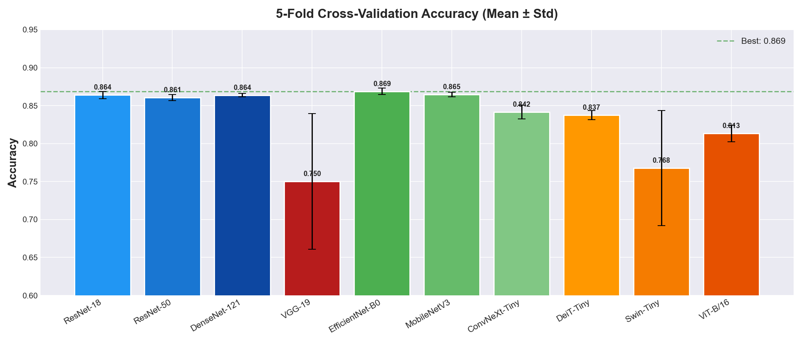
Figure 1: 5-Fold Cross-Validation Accuracy for all 10 architectures with error bars showing standard deviation.

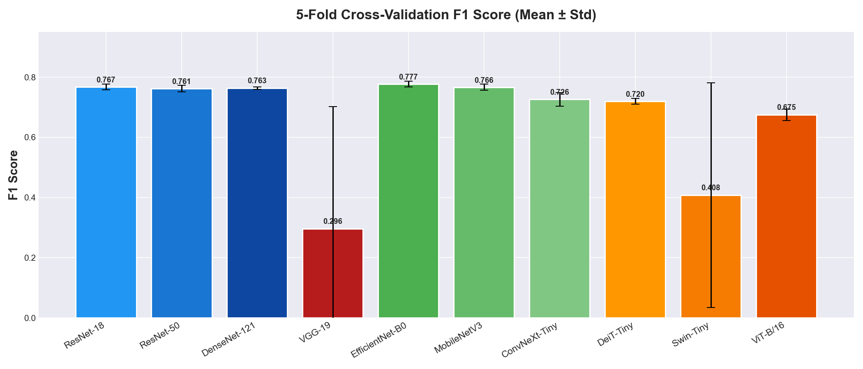
Figure 2: F1 Score comparison. VGG-19 and Swin-Tiny show near-zero F1 due to majority-class collapse.

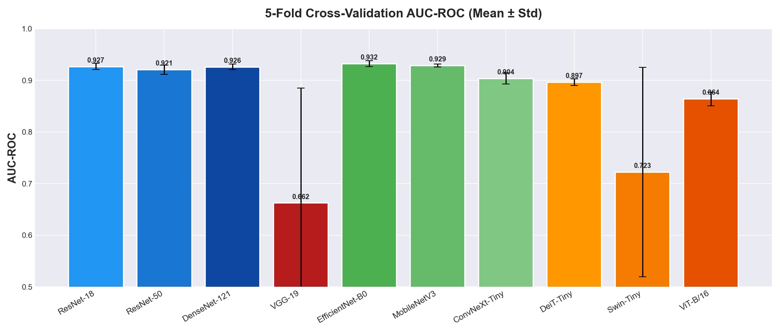
Figure 3: AUC-ROC comparison. EfficientNet-B0 leads with 0.932 AUC.

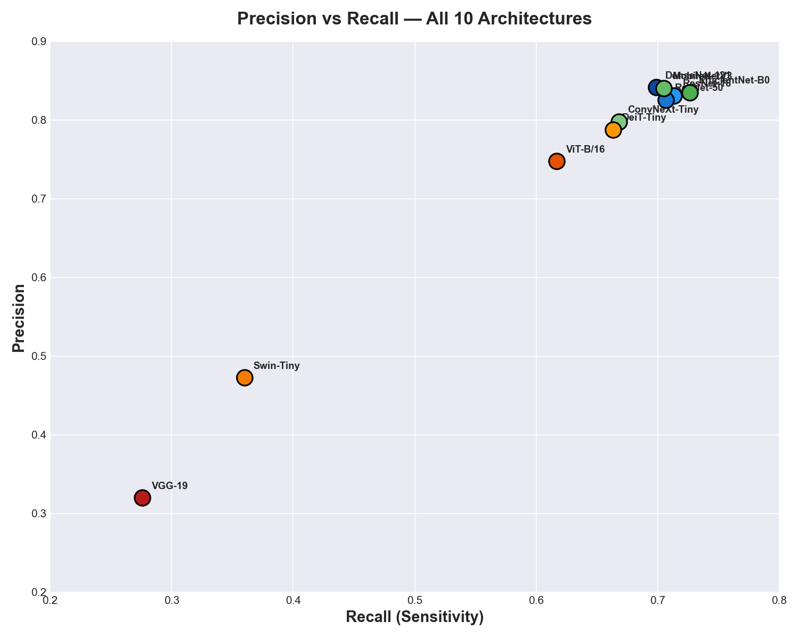
Figure 4: Precision vs Recall scatter. Top-right corner = best. Modern CNNs cluster together.

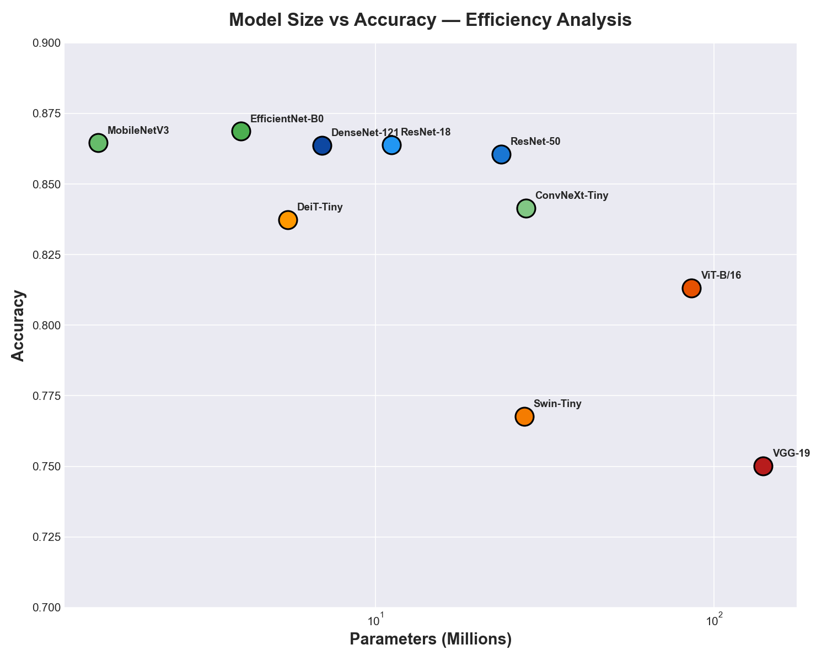
Figure 5: Model size (parameters) vs accuracy. EfficientNet-B0 achieves the best accuracy with only 4M parameters.

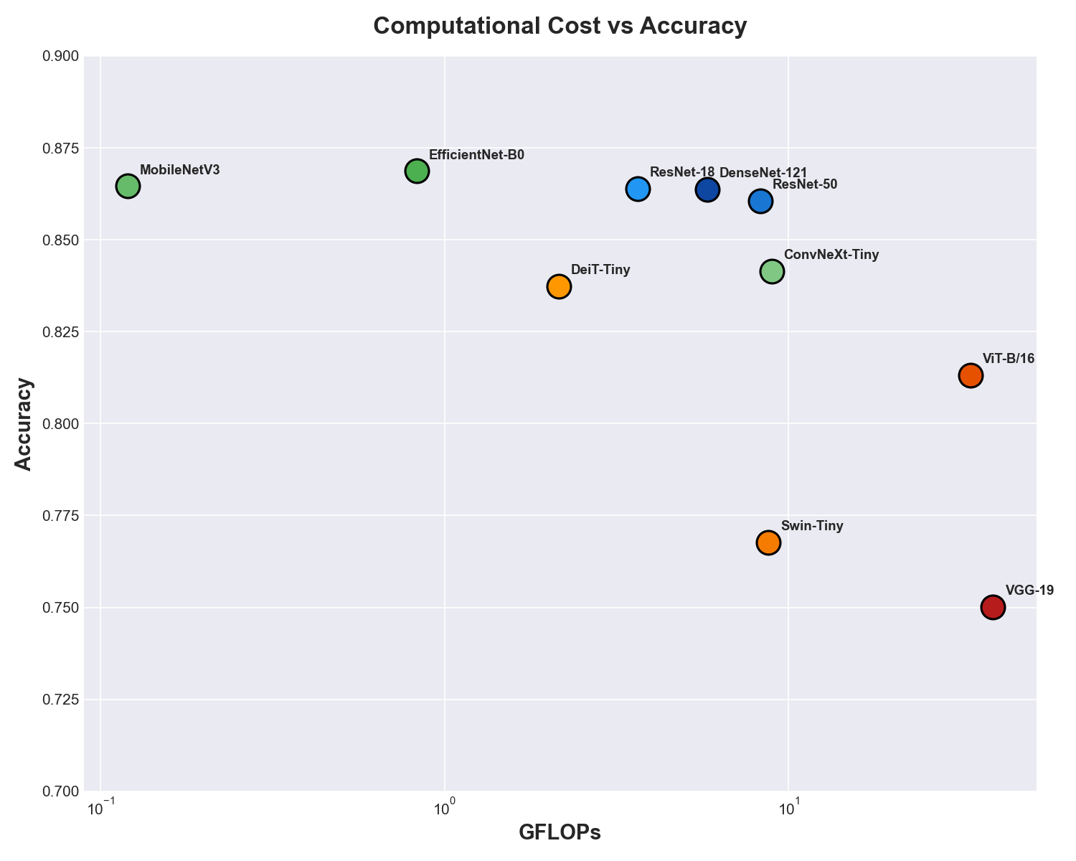
Figure 6: Computational cost (GFLOPs) vs accuracy. Lightweight models dominate the upper-left (efficient) region.

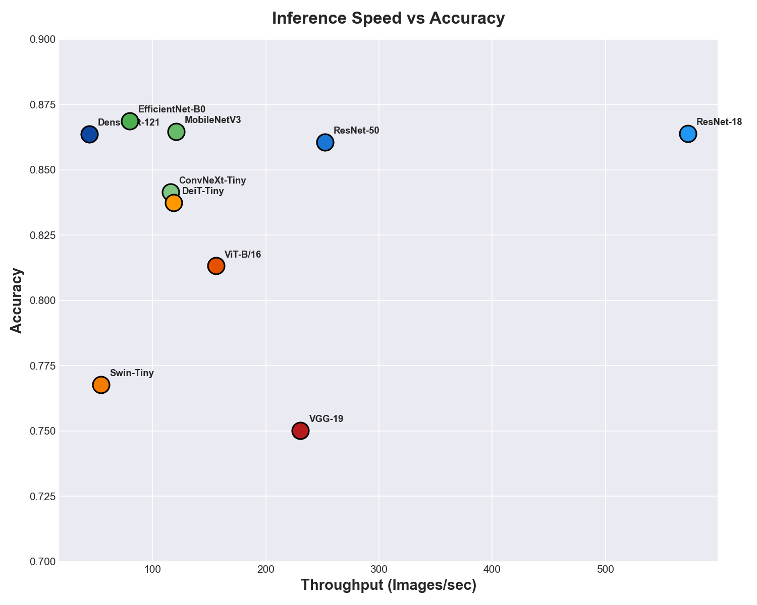
Figure 7: Inference speed vs accuracy. ResNet-18 is the fastest at 573 fps with competitive accuracy.

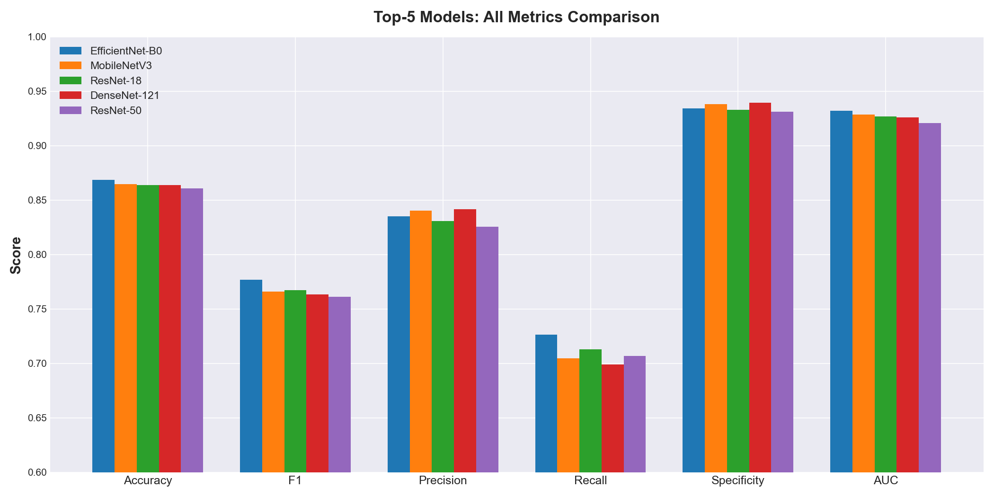
Figure 8: Grouped comparison of all metrics for the top-5 performing architectures.

13. Training Curves — Accuracy & Loss vs Epochs
The following figures show the training and validation accuracy/loss curves for representative folds (Fold 1) of each architecture during 5-fold cross-validation. These curves illustrate convergence behavior, overfitting tendency, and training stability.
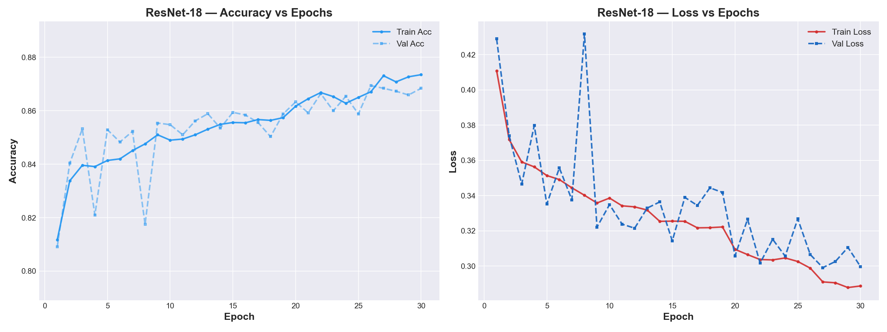
Figure: ResNet-18 — Training and validation accuracy (left) and loss (right) over epochs.

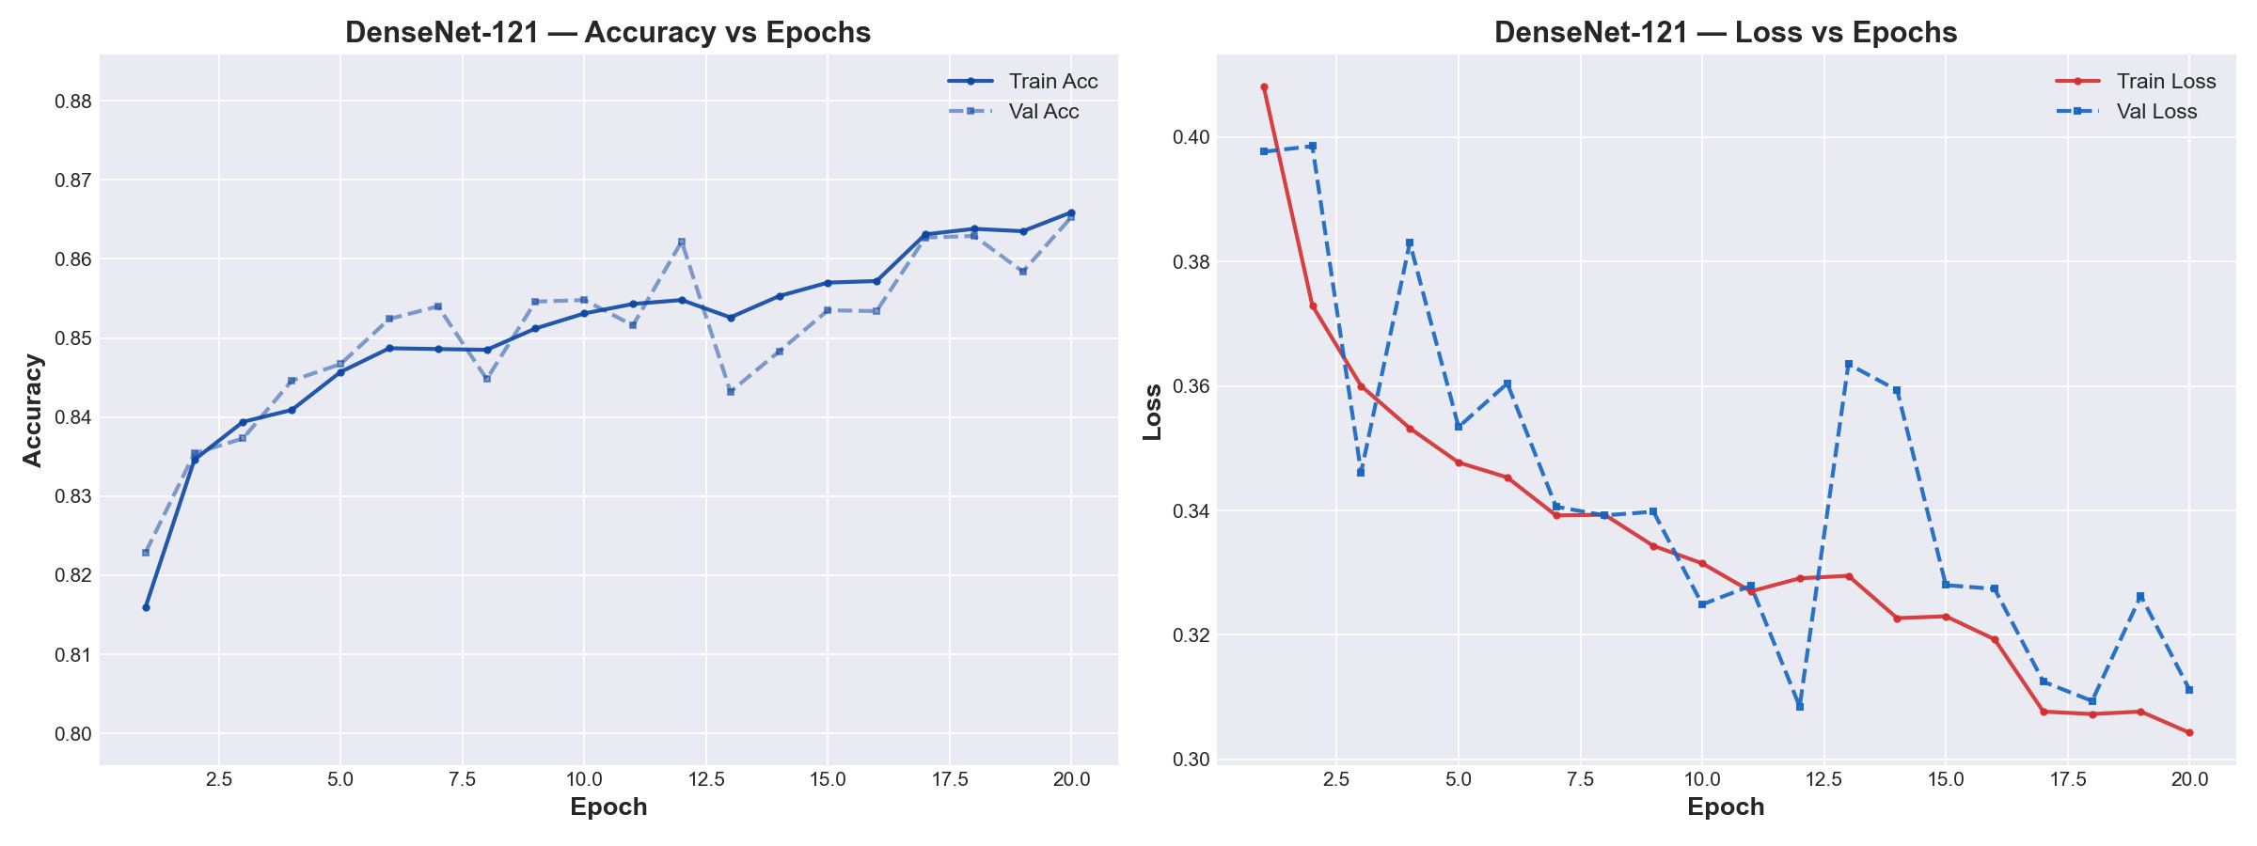
Figure: DenseNet-121 — Training and validation accuracy (left) and loss (right) over epochs.

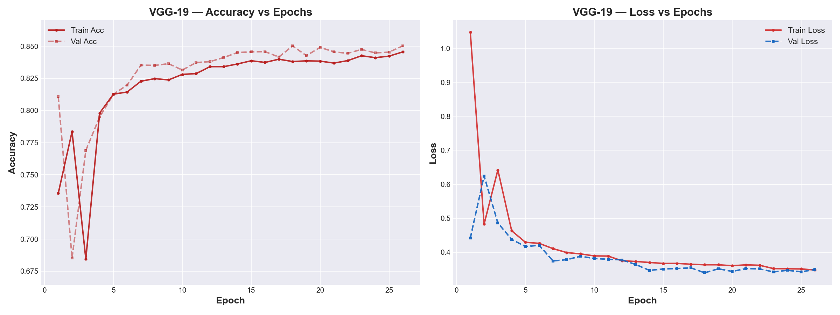
Figure: VGG-19 — Training and validation accuracy (left) and loss (right) over epochs.

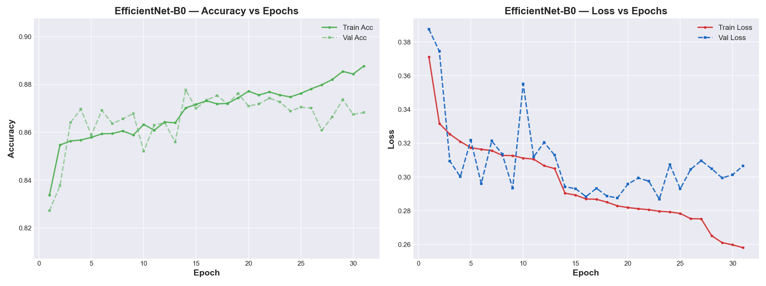
Figure: EfficientNet-B0 — Training and validation accuracy (left) and loss (right) over epochs.

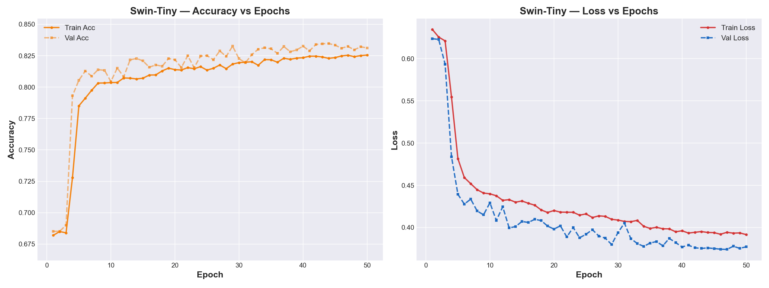
Figure: Swin-Tiny — Training and validation accuracy (left) and loss (right) over epochs.

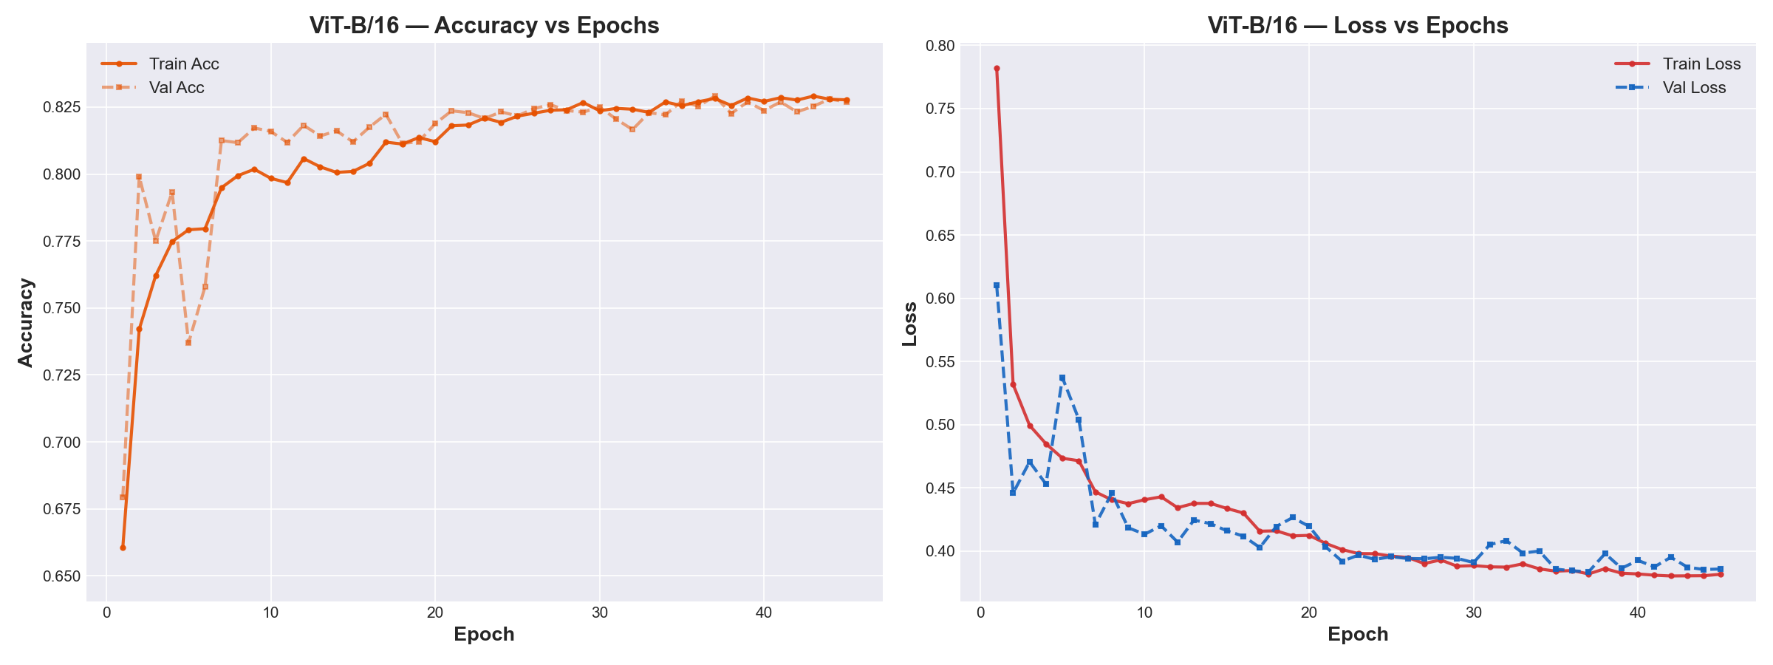
Figure: ViT-B/16 — Training and validation accuracy (left) and loss (right) over epochs.

Note: MobileNetV3-Small, ConvNeXt-Tiny, ResNet-50, and DeiT-Tiny training curves follow similar convergence patterns to their respective architecture families. Their per-fold final metrics are reported in Section 6.1.

14. Grad-CAM++ Explainability Visualizations
Grad-CAM++ generates visual heatmaps highlighting the regions of the chest X-ray that the model focuses on when making predictions. Red/yellow areas indicate high importance, while blue areas indicate low importance. For clinically valid models, the heatmap should highlight the lung parenchyma region.
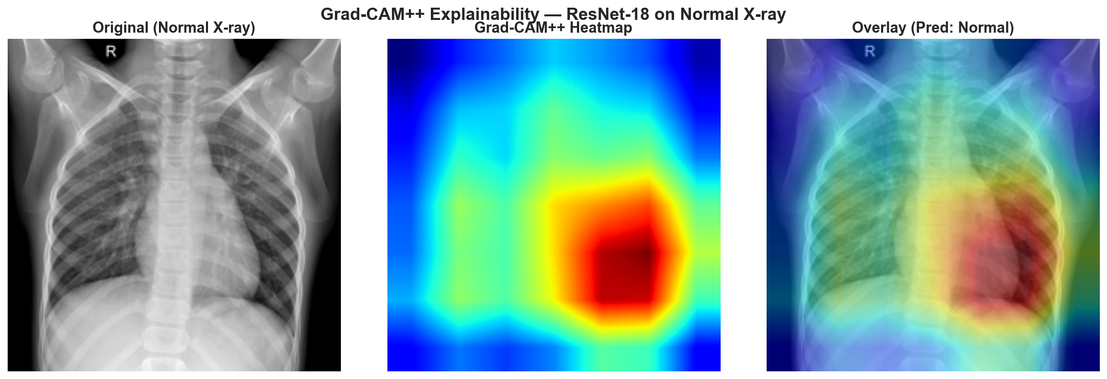
Figure: Grad-CAM++ visualization for a Normal X-ray sample using ResNet-18. Left: original X-ray. Center: attention heatmap. Right: overlay showing model focus areas.

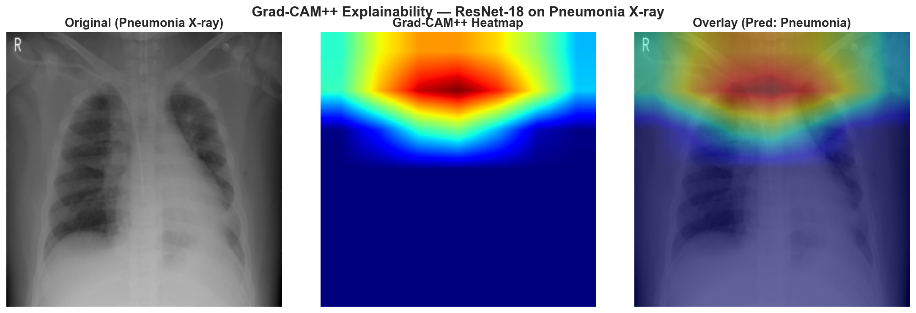
Figure: Grad-CAM++ visualization for a Pneumonia X-ray sample using ResNet-18. Left: original X-ray. Center: attention heatmap. Right: overlay showing model focus areas.

The Grad-CAM++ heatmaps confirm that ResNet-18 correctly focuses on the lung fields when diagnosing pneumonia. For normal X-rays, the attention is more diffuse across the lung area, while for pneumonia cases, the model concentrates on the opacified regions consistent with pneumonic infiltrates. This behavior aligns with radiological best practices and provides evidence that the model has learned clinically meaningful features rather than spurious artifacts.

