## Automated Testing Exercise

This is your chance to show your abilities with automated testing. It is more important that you show your experience and skills during the exercise than actually finishing it.

### Part 1

As a Google User, I would like to perform a ‘Search by Image’ and visit the result specified on a configuration file (i.e. VISIT_RESULT=“3” to visit the third result). Use Selenium Webdriver or any alternative framework to complete this exercise.

*Requisites*

- Must store an screen shot of the last visited page

- Should validate that the search results are related to the used image

### Part 2

Document any possible test case that you would perform in order to test the following form embedded in a website. Include testing about functionality, security, performance, etc.

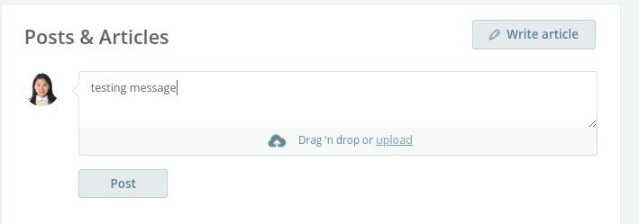

Please share your developed solution with us via email. However for your code, a link to a public Github repository will be the preferred option.