Assignment -1

Database Systems and Web(15B11CI312)

Q1. [C212.4]Consider the following relations containing airline flight information: Flights(flno: integer, from: string, to: string, distance: integer, departs: time, arrives: time)

Aircraft(aid: integer, aname: string, cruisingrange: integer)

Certified(eid: integer, aid: integer)

Employees(eid: integer, ename: string, salary: integer. Solve the following queries using relational algebra.

1. Find the eids of pilots certified for some Boeing aircraft
2. Find the names of pilots certified for some Boeing aircraft.
3. Find the aids of all aircraft that can be used on non-stop flights from Bonn to Madras.
4. Identify the flights that can be piloted by every pilot whose salary is more than $100,000.
5. Find the names of pilots who can operate planes with a range greater than 3,000 miles but are not certified on any Boeing aircraft

Q2. [C212.3] You have a database of a social networking site containing two table. Table 1 comprised of 2 attributes: friends name and conversation. Table 2 contains attributes: which food friends like, considering a person can like more than one variety of food.

Create GUI and using db connectivity for solving the following case: The user can select as many words as he/she wants, using checkboxes. When user presses the “Search” Button on home.php, the system should display the list of friends who have liked it and the relevant conversations. Also, for a particular food, the user should be able to list all his/her friends who have liked that particular food.

Q3. [C212.2] Consider the following EER diagram that describes computer systems at a company. Provide your own attributes and key for each entity type. Supply max cardinality constraints justifying your choice. Write a complete narrative description of what this EER diagram represents. Also map the given EER diagram in to relational schema. 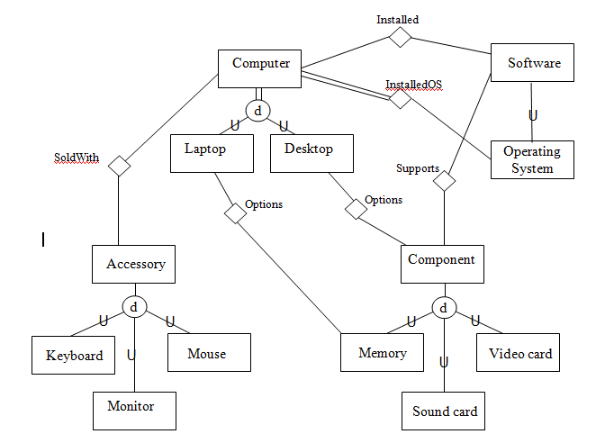

Q4.[C212.1](a) What is the difference between logical data independence and physical data

Independence? Which one is harder to achieve? Why?

Q5. [C212.5](a) Consider the universal relation R = {A, B, C, D, E, F, G, H, I,}} and the set of functional dependencies

F = {{A, B} -> {C}, {A} -> {D, E}, {B} -> {F}, {F} -> {G, H}, {D}-> {I, J}}. What is the key for R? Decompose R into 2NFand then 3NFrelations.

(b) Suppose a relational schema R(P, Q, R, S), and set of functional dependency as following

F : { P-> QR, Q-> R, P ->Q, PQ-> R }

Find the minimal cover of functional dependencies